From: CAmos@wnhydro.com
Sent: June-18-13 6:59 AM
To: RRF
Cc: mtucci@eda-on.ca
Subject: RRFE Adjustment for Smart Meter Plant

Good Morning,

In reviewing PEG's spreadsheets, it was noted that in File 'TFP and BM Database
Calculation 2', Tab 'Capital Contributions for BM', Column C Adjust for Deferred Smart
Meter Plant - some LDC's have '0' and some have '1'. It is our understanding that the
assignment of '0' or '1' depends on how the company responded to the data request
question about whether their smart meter cost has been approved by the OEB and that
PEG only made the adjustment ('1') for the companies that have not had their cost
approved yet.

We are inquiring as to whether '0' should be applied in the year that the Smart Meter
Disposition is Approved, as well as subsequent years, rather than all years being shown
as a '0' if it has been approved. The previous years' would be shown as a '1'.

I have shown an example below for your review:

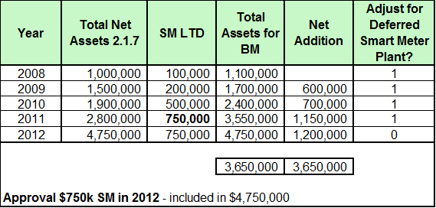

Thank you,

Chris Amos

Chris Amos, CPA CA
Regulatory Consultant for
Waterloo North Hydro Inc.
519-888-5541 or
519-886-5090 x 541

This transmission is confidential and intended for the person(s) or organization(s) to whom it is
addressed. It may contain privileged and/or confidential information. If you are not the intended recipient,
you are not authorized to copy, distribute or take any action in reliance on it. If you have received this
transmission in error, please notify the sender by reply e-mail and delete this transmission. Thank you for
your cooperation.

CONFIDENTIALITY DISCLAIMER: This e-mail message, including any attachments, is confidential and
intended only for the person(s) named above. This material may contain confidential, privileged or
personal information which may be subject to the provisions of the Personal Information Protection &
Electronic Documents Act (PIPEDA). Any unauthorized use or disclosure is strictly prohibited. If you are
not the intended recipient or have received this message in error, please notify the sender or Waterloo
North Hydro immediately and permanently delete the original message including any attachments and
copies. Thank you for your cooperation. This message has not been encrypted. Special arrangements
can be made for encryption upon request.

** PLEASE CONSIDER THE ENVIRONMENT BEFORE PRINTING THIS EMAIL **

