VIA E-MAIL, RESS & COURIER TO THE BOARD

July 12, 2013

Ontario Energy Board
P.O. Box 2319
27th Floor
2300 Yonge Street
Toronto ON M4P 1E4

Attn: Kirsten Walli, Board Secretary

RE: EB-2012-0451 GTA Reinforcement – FRPO IR’s to TCPL

Please find attached the interrogatories of the Federation of Rental-housing Providers of Ontario (FRPO) to TCPL .

Respectfully Submitted on Behalf of FRPO,

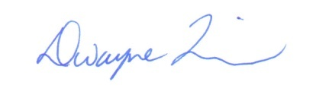
Dwayne R. Quinn
Principal
DR QUINN & ASSOCIATES LTD.

c. Interested Parties – EB-2012-0451

