**West Coast Huron Energy’s responses to the following Intervenors second round of questions:**

|  |  |
| --- | --- |
| **REQUESTOR NAME**  **REQUESTOR NAME**  **REQUESTOR NAME** | **VECC**  **SEC**  **STAFF** |
| **REQUESTOR NAME**  **INFORMATION REQUEST ROUND NO**: | **AMPCO**  **# 2** |
| **TO:** | **West Coast Huron Energy Inc. (Goderich Hydro or WCHE)** |
| **DATE:** | **July18, 2013** |
| **CASE NO:** | **EB-2012-0153** |
| **APPLICATION NAME** | **2013 Cost of Service Electricity Distribution Rate Application** |

**1. GENERAL (Exhibit 1)**

***1 Staff 58s Updates***

There will be a number of changes that flow from the following Board staff interrogatories. Please provide a schedule similar to Appendix 1 which was in response to 1 VECC 1, and update the following:

RRWF

Chapter 2 Appendix

Cost Allocation

Rate Design

EDDVAR Continuity Sheet

Smart Meter Model

Please provide all models in a live Excel format.

WCHE reply to 1.Staff.58

Please see Appendix 1, 2, 3, 4, 5, 6, 7

**1.0-VECC- 52 Reference: Exhibits All**

* 1. Please provide a tracking sheet (table) showing all adjustments arising from the interrogatories (include Reference IR #.; Item description; area of change, i.e. return on capital/rate base/working capital allowance/amortization/PILS/OM&A/ etc.).
  2. Please update the RRWF Excel Live spreadsheet for these adjustments.

WCHE reply to 1.Vecc.52

1. Please see Appendices 1 – 7
2. Please see Appendices 1 – 7

**1-SEC-23s**

[1-VECC-1]Please provide a full response to Interrogatory 1-VECC-1.

WCHE reply to 1.Sec.23

Please see Appendices 1 – 7

**1.0-AMPCO-59s**

**Reference:** 1.0 AMPCO 3.0

1. WCHE’s response to part (c) indicates that WCHE does not track momentary outages as it is not mandatory. Please confirm WCHE experiences momentary outages and discuss how WCHE responds to these outages with respect to its large use customer.
2. WCHE’s response to part (h) shows that its 2010 indicators are significantly below its cohorts in all areas. In WCHE’s view, what factors contribute to this difference?

WCHE reply to 1.AMPCO.59

1. West Coast Huron Energy does not track momentary outages. WCHE has an open dialogue on an ongoing basis with its’ large user
2. Historically, WCHE’s system has been well maintained from both the maintenance and capital spend. WCHE’s system has not expanded over the years, yet there has been some infill which has not stressed the system. As we are unsure of our cohorts process and methodology, we are unable to comment on why we are significantly lower than said cohorts.

**1.0-AMPCO-60s**

**Reference:** Appendix 1, 20130614, 2013 Revenue Offsets Column

1. Please provide the Board Staff IR that adjusts Revenue Offsets i.e. that corresponds to Changes from Board Staff IR - “Reallocation of SSS admin out of base revenue requirement” equal to $11,277.
2. Please provide a summary of the categories & revenues that make up Revenue Offsets = $104,600.

WCHE reply to 1.AMPCO.60

1. The Board Staff IR that resulted in the reallocation of SSS admin out of distribution revenue account 4080 and into account 4086 was 3 Staff 27 Revenue Offsets.



**2. RATE BASE (Exhibit 2)**

***2 Staff 59s Cost of Power***

**Reference 2 Staff 2**

<http://www.ontarioenergyboard.ca/OEB/_Documents/EB-2004-0205/RPP_Price_Report_May2013_20130405.pdf>

WCHE responded to Board staff request by updating the cost of power for the cost of transmission. Please update cost of power for the most recent RPP cost found in the referenced link.

WCHE reply to 2.Staff.59

1. See Appendix 8

**2.0-VECC- 53**

**Reference: Exhibit 2, Tab 2, Schedule 1 – Continuity Schedules**

*Pre-amble: Exhibit WCH-APP4 Revised Capital Projects Table 20130516 shows a change in the building amount from $200,000 (and as described at Exhibit 2, Tab 3, Schedule 1) to $450,000. It also shows $90,000 in land purchase in 2012. Yet the response to the Board Staff interrogatory indicated the Utility is purchasing no land.*

1. Please provide a detailed explanation of the $910,000 in building costs shown in the revised Capital Projects table, the $90,000 in land values and the $450,000 in costs in 2013.
2. What portions of these amounts are included in the 2012 and 2013 Continuity Schedules (i.e. 2013 rate base)?
3. Please provide the analysis which showed leasing from the Town was a better economic choice for the Utility (i.e. the lease vs. own analysis). If no such analysis was undertaken please explain the basis for the statement that the lease option was the most cost effective.
4. Are any other tenants sharing the new building with WCHE?

Please explain how an annual rental rate of $54,000 was determined. Please show the comparable rental rates or other analysis that were used to make this determination.

WCHE reply to 2.Vecc.53

1. WCHE is not purchasing the building, therefore the $910,000 for the building cost and the $90,000 in land values are no longer applicable. The $450,000 are lease hold improvements which are being spent in 2013.
2. The $910,000 and $90,000 have been removed from the 2012 continuity schedules and the $200,000 that was initially in the 2013 schedule has been updated to $450,000.
3. The savings to the utility on the lease versus buy was approximately $10,000 per annum. This took into consideration the purchase price, interest rates, depreciation, and ROE. There have been two major weather events in the last 20 years which has severely affected the LDC. In the last instance with the tornado, if the utility had not been a 40 to 60, debt to equity, it would have had a severe financial ramification. Keeping this in mind, the shareholder felt that it prudent for them to own the building, freeing up potential future debt.
4. No.

The current commercial rate in the Town of Goderich is in the $8-$12 per square foot range. WCHE’s cost is $5.40 per square foot, which is far below the going rate. Included in the $54,000 is approximately 2 acres of land, which would not be normally available in that price range. This will facilitate WCHE moving it’s outside storage to one property.

## 2 Staff 60s Net Book Value

### References: Application Appendix 2 – (Chapter 2 Appendices)

**Intervenor Interrogatory Responses Appendix 3 – (Chapter 2 Appendices)**

**Board staff Interrogatory Response Appendix 2 – (Chapter 2 Appendices)**

**Application RRWF**

**Intervenor Interrogatory Responses Appendix 2 – (RRWF)**

**Board staff Interrogatory Response Appendix 1a – (RRWF)**

**Exhibit 2 Tab 2 Schedule 2; Rate Base Summary Table**

**Intervenor Interrogatory Responses Appendix 27 – (Rate Base Summary Table)**

**Board staff Interrogatory Responses Appendix 1, Tab: Rate Base-Cost of Capital.**

**2 VECC 4 Appendix 4**

**2 Staff 8**

From the respective documents referenced above and as identified by the column headings below, Board staff has developed the following table:

Board staff have concerns over the inconsistencies found in the respective evidence as set out in columns 1 – 3. Columns 4 – 6 show the inconsistencies in the variances. For clarification, column 1 is from the Appendix 2-B Fixed Asset Continuity Schedule, column 2 is the Revenue Requirement Work Form, and column 3 is the Rate Base Summary Table found at Exhibit 2 Tab 2 Schedule 2, and adjusted in the subsequent interrogatories. The following questions are to set a clear and understandable record.

In Board staff Interrogatory Response Appendix 1, Tab: Rate Base-Cost of Capital, WCHE details the adjustments to the Gross Book Assets (“GBA”), Net Book Assets (“NBA”) and Depreciation arising from the interrogatories of the intervenors and of Board staff. The starting point in the table is a GBA of $11,797,335 which is not the value shown in the Application Exhibit 2 Tab 2 Schedule 2, or the Chapter 2 Appendix 2–B (MIFRS 2013). From line 1 of the above table it is still unclear as to what WCHE considered its 2013 asset related values to be when it filed the application.

1. In regards to line 1 from the Application, please state which value is the GBA. If it is not $11,797,335, please state why, and show complete details with a full explanation making it clear as to why the number is different from the asset continuity table, Appendix 2.

Interrogatories posed by Intervenors and Board staff resulted in the adjustments shown in Board staff Interrogatory Response Appendix 1, Tab: Rate Base-Cost of Capital. The first adjustment is ($1,738,856) to reflect 2012 actual fixed asset additions and deferrals from 2012 into 2013.

1. Please provide a detailed and itemized calculation of the ($1,738,856) adjustment to the GBA, and the calculation of the depreciation adjustment.
2. Please reconcile the ($1,738,856) adjustment to 2 VECC 4 Appendix 4.

The second adjustment is in response to 2 Staff 8

1. It appears that only half of the proceeds are considered on the adjustment. Please state the date that the proceeds were received, or are expected to be received.

For the purposes of establishing rate base, the net book value included in rate base is the opening 2013 balance plus ½ of the total 2013 capital expenditures for assets that were placed into service in 2013 recognizing the half year rule.

1. Please show a detailed trail from the opening 2013 GBA balance and accumulated depreciation in Board staff Appendix 2 to the NBA that WCHE proposes as the NBA to be included in the 2013 rate base. Please state the reference for the opening values, include the two adjustments arising from the intervenors interrogatory responses and Board staff interrogatory responses, showing any adjustments flowing from all supplemental interrogatories, and show the determination of the depreciation, including the depreciation for contributions.

WCHE reply to 2.Staff.60

1. The starting point of the table is the average fixed asset value and average accumulated depreciation value from the initial application filed. The ending figures on the table agree to the average asset and depreciation values after adjustments.





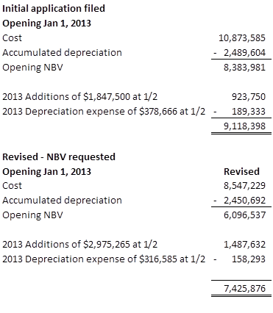

1. The adjustments made on Appendix one represent the change in average fixed asset value to reflect the adjustment of 2012 to actual and the update of 2013 capital additions to reflect some carryover of 2012 capital projects.

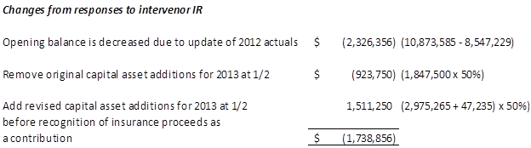



Appendix 4 – Capital Projects table shows capital asset additions before capital contributions

2013 Revised capital projects total of $3,297,500 less capital contributions of $275,000 less insurance proceeds of $47,235 equals additions of $2,975,265

1. Refer to answer 2.Staff.60 b)
2. Refer to answer 2.Staff.60 b)
3. The average accumulated depreciation has been updated in a similar fashion. Depreciation for 2013 is calculated using the half year rule and rates consistent with those shown in App 2 CG 2013 MIFRS Depreciation revised tab. Capital contributions are depreciated using rates consistent with the corresponding asset category and the half year rule.

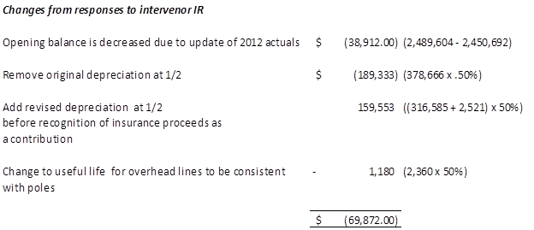

The remaining two small adjustments are made to reflect amortization of insurance and adjustment to UG conductor useful lives using a factor of ½.

**2.0-AMPCO-61s**

**Reference:** 2.0 AMPCO 14.0

1. *Please confirm the number of poles to be replaced in 2013 and the cost.*

WCHE reply to 2.AMPCO.61

It is anticipated that approximately 40 poles will be replaced during 2013 at an average cost of $10,000 per pole. To date, we have changed out 20 poles at a cost of $300,000.

**2.0-AMPCO-62s  
Reference:** 2 Staff 4(a)

In response to part (a), WCHE indicates that as a result of the damage and indirect impact from the tornado, certain other capital projects have to be completed. For 2014, WCHE indicates works required at Transformers 275, 355, and 335 is not included until the scope is better defined.

Please confirm the above work is not included in the forecast capital budget of $350,000 for 2014.

WCHE reply to 2.AMPCO.62

That is correct. This is to confirm that this work is not in the budget of $350,000.

**2-SEC-24s**

[2-Staff-4] Please explain how the “results of the damage and indirect impacts from the tornado” require the burying of all wiring, primary and secondary on South Str. from Elgin Ave to the Square in 2015?

WCHE reply to 2.SEC.24

The area on South St from Elgin St to the Square has been serviced by rear lot access. With the new buildings being constructed since the tornado, it has impeded Goderich Hydro’s ability to service using its current equipment. Because of this, the decision was made to bury the primary and secondary both in conduit caballing. With this approach, padmounts were also used.

**2-SEC-25s**

[2-Staff-7] Please provide a detailed explanation for the difference between the 2012 actual and budgeted capital amounts.

WCHE reply to 2.SEC.25



The difference in the initial budget was in two major areas:

* The removal of the building at a reduction of $1,000,000
* The portion of the tornado rebuild that got deferred to 2013 due to designs taking more time to produce than was originally anticipated and late arrivals of materials.

***2 Staff 61s CAPEX***

**References: 2 Staff 4**

**Exhibit 2 Tab 2 Schedule 1 Table <>, Capital Spending**

**2 VECC 4 Appendix 4**

Board staff is still concerned about the continuation of investments that are categorized as storm damages from the Tornado. In response to Board staff, WCHE states that it has prioritized investments due to the extent of the damages. To Board staff, it is also clear that WCHE was not able to deliver on its 2012 CAPEX of $5,015,000, and only invested $2,708,007 as shown in 2 VECC 4 Appendix 4. In the referenced Exhibit 2 table, CAPEX tapers to $722,500 in 2016.

In Appendix 4 WCHE has revised CAPEX for 2013 to $3,297,500. The 2013 CAPEX amount is also greater than it has managed in its past. Board staff is concerned that the amount proposed in 2013 will overstate the rates over the next 4 years. Staff feels that given the somewhat arbitrariness of labelling work as storm damage related, and WCHE’s statement that it can prioritize the CAPEX, Board staff would like to see a levellized amount for CAPEX in the 2013 additions that reflect the anticipated expenditures through to the next rebasing year. Please provide a detailed calculation, stating the work to be done by year and the levellized amount for inclusion in 2013.

WCHE reply 2.Staff.61

WCHE understands the concern to be the plan for the amount of the capital expenditure over the IR period and whether WCHE will in fact spend such amounts and whether the annual forecast during the test year is appropriate given the spend levels. As such, WCHE has prioritized its capital spend and has provided an analysis of what an average or levelized spend would be given the most current forecast spend.

The current forecast differs from the original filing as a result of certain events that have transpired since the filing.

2012In 2012 WCHE had a total capital spend of $3,738,007. This amount is comprised of $2,708,007 of capital projects and an additional $1,030,000 project for capital spent by way of contribution for Hydro One. This $1,030,000 was the construction of an additional breaker position at the Goderich TS. WCHE has not included the breaker position in our rate base.

In 2012 WCHE did not meet its 5 million budgeted capital spend. The decision to lease the building accounted for $1,000,000 reduction in our capital spend. This was going to be the purchase of land and building.

2013

WCHE had originally intended to complete the municipal road construction [of Highway 21] in 2014. However, the municipality has executed the tender for completion in 2013. This has forced WCHE to complete the work in 2013 rather than 2014. As such, WCHE has moved the $500,000 capital spend for this project from 2014 to 2013. This movement has in effect exacerbated the situation. The utility has been able to respond to this change and the municipal road project is currently approximately 50% complete and on budget. The addition of the municipal road project to 2013 has increased our total projected capital spend to $3,797,000.

WCHE is in the process of making leasehold improvements to its newly leased facility [when occupying?] and has forecasted spending $450,000 in 2013. As noted this expenditure is amortized over a 10 year period based upon the advice of the auditors.

2014

See 2013. The movement of the municipal road project will reduce WCHE 2014 capital budget to $911,500.

Given the above, WCHE remains confident that it forecast capital expenditures are appropriate.

**2-SEC-26s**

[2-SEC-5] Please provide an update to the expected completion dates for all 2013 capital projects.

WCHE reply to 2.SEC.26

|  |  |  |
| --- | --- | --- |
| **Expected Completion Dates 2013 Capital Projects** | |  |
|  |  |  |
| Leasehold improvements | May 2013 |  |
|  |  |  |
| Ongoing upgrades due to tornado | November 2013 |  |
|  |  |  |
| Conversions and upgrades | 85% complete - May 2013 | |
|  | Remainder - late fall 2013 | |
|  |  |  |
| Meter service point | May 2013 |  |
|  |  |  |
| Line extension | May 2013 |  |
|  |  |  |
| New Customer connections | ongoing throughout year | |
|  |  |  |
| Replacement of Line Truck | December 2013 |  |
|  |  |  |
| Purchase of spider system | September 2013 |  |
|  |  |  |
| Miscellaneous | ongoing throughout year | |

**2.0-AMPCO-63s  
  
Reference:** 2 Staff 7

Please provide a breakdown of the projects in 2012 carried over to 2013.

WCHE reply to 2.AMPCO.63

|  |  |
| --- | --- |
| **Total capital projects for 2013** |  |
| **Original submission( test)** | **2,122,500** |
|  |  |
| Adjust estimate for operations |  |
| building work | 250,000 |
|  |  |
| Carryover - ongoing upgrades | 750,000 |
| due to tornado |  |
|  |  |
| Carryover - upgrades and conversions |  |
| CPR station | 40,000 |
| Elevators | 20,000 |
|  |  |
| Carryover - meter service point | 100,000 |
|  |  |
| Carryover - purchase of spyder tension |  |
| stringing equipment | 15,000 |
|  |  |
|  | **3,297,500** |

**2.0-AMPCO-64s  
  
Reference:** 2 Staff 13

The response indicates that the eleven microFit applications as mentioned in the OPA’s report have all lapsed and the two FIT applications have not proceeded.

Please provide more details on why the eleven microFit applications have lapsed and the FIT applications have not proceeded.

WCHE reply to 2.AMPCO.64

As stated in our Green Energy Plan - WCHE was not able to connect any generation to our system due to system constraints at Hydro One's Goderich TS as stated in a letter from Hydro One Networks (HON) in Feb 2011. The OPA either terminated the microFIT applications at the customer's request due to no known date of when WCHE would be able to connect the generation or due to time limit lapse in the pending contracts with the OPA. The FIT application was still sitting in the application database as WCHE was not able to connect them due to HON system constraints.

Not one of these applicants submitted an 'offer to connect' application to WCHE before receiving this HON letter was received by WHCE. The OPA contacted the applicants to confirm whether they wanted to continue on with their applications in the MicroFIT application database or terminate.

**3. LOAD FORECAST (Exhibit 3)/ OPERATING REVENUE (Exhibit 3)**

**3.0-VECC- 54**

**Reference: 3.0-VECC- 15 a) & c)**

**3-Staff- 19, Appendix 9**

1. The response to 3.0 – VECC – 15 a) shows an updated IESO energy growth rate for 2013 of -0.6%. However, Appendix 9 (Tab “IESO Load Forecast”) shows a value of -0.4%. Please reconcile and correct VECC 15 and/or Staff 19, Appendix 9 as required.
2. Please confirm that the IESO % Growth rates are based on weather normalized loads (per 3 – Staff – 19, Appendix 9, Tab “IESO Load Forecast”).
3. Please update 3.0 – VECC – 15 c) for 2012.
4. Are the WCHE % Growth rates shown in 3.0 – VECC – 15 c) based on actual or weather normal loads?
5. If the response to part (d) is actual loads, please revise the response such that the WCHE values for 2008-2012 are also weather normalized values.

WCHE reply to 3.VECC.54

1. The response to 3.0 – VECC -15 a) was prepared on May 1, 2013. At that time the most up to date version of the IESO’s 18 Month Outlook was the February 28, 2013 issue which shows the energy growth rate for 2013 of -0.6 %. Appendix 9 was prepared on June 14, 2013 using the May 24, 2013 version of the IESO’s 18 Month Outlook which shows a value of -0.4%. WCHE’s reply to 3.Staff.19 used the most up to date version of the IESO’s 18 Month Outlook dated May 24, 2013.
2. Yes
3. The impacts of CDM for WCHE consumption in 2012 and 2013 are shown in the table below. The 2012 consumptions are weather adjusted actual values. The 2013 consumptions are forecast values.

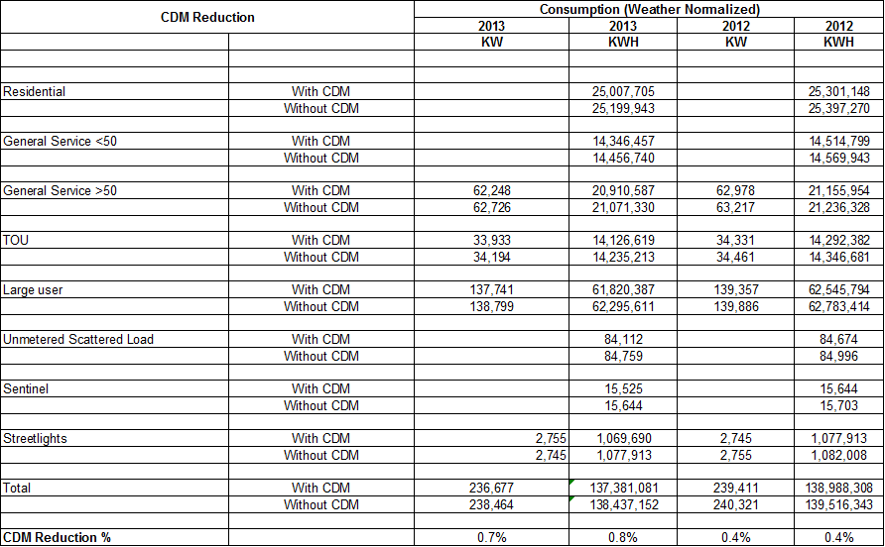

The details of the CDM adjustments for 2012 and 2013 are shown in the tables below. For 2012, WCHE already has the actual kWh which included the CDM impact. The 2012 CDM Load Adjustment shown below was used to calculate the kWh without CDM adjustment.

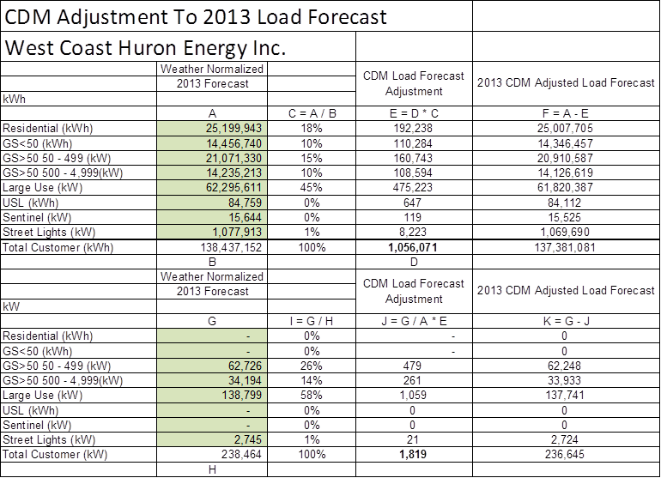

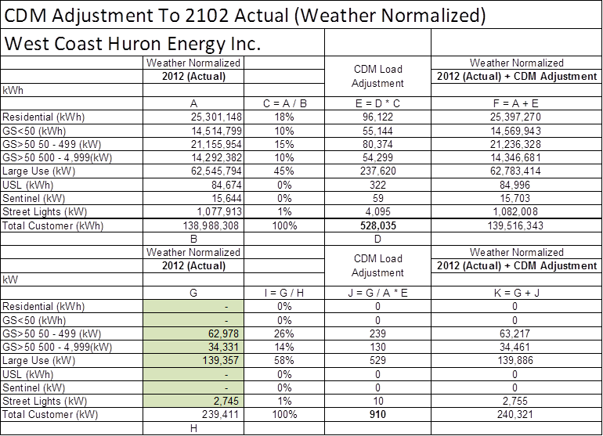

1. They are based on actuals.
2. The tables below shows the comparison of weather normal growth rates of IESO and WCHE.

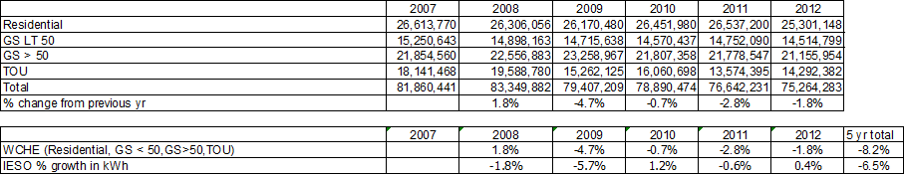

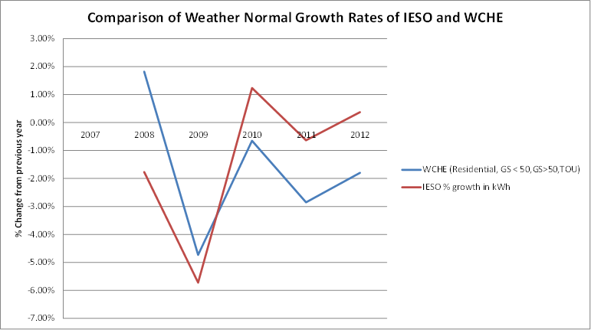

**3.0-VECC- 55**

**Reference: 3-Staff- 19, Appendix 9**

**3.0-VECC- 19**

1. Please confirm that Appendix 9 (Tab “Summary”) contains WCHE’s proposed load forecast for 2013.
2. Please confirm that:

* In the initial load forecast (Exhibit 3, Tab 2, Schedule 1) the 2012 and 2013 load forecasts for the GS>50 and TOU classes were developed by taking the 2011 weather normalized values and applying both the IESO energy growth rates and CDM savings assumptions.
* In the revised load forecast (Appendix 9) the 2013 load forecasts for these two customer classes were based on the 2012 weather normalized values adjusted only for CDM.

Please explain the reason for the change in approach.

1. Please confirm that the updated Large User load forecast does not include any “New Mine” load and explain why.

WCHE reply to 3.VECC.55

1. Yes
2. The IESO energy growth rates should have been applied for both customer classes in the load forecast (Appendix 9). These errors have been corrected and the revised Appendix 9 is attached with this response. Since the IESO’s 2013 growth rate was only -0.4%, there were no significant impacts to the overall forecast.

The tables below show the comparison of the revised forecast for these two customer classes.

GS>50

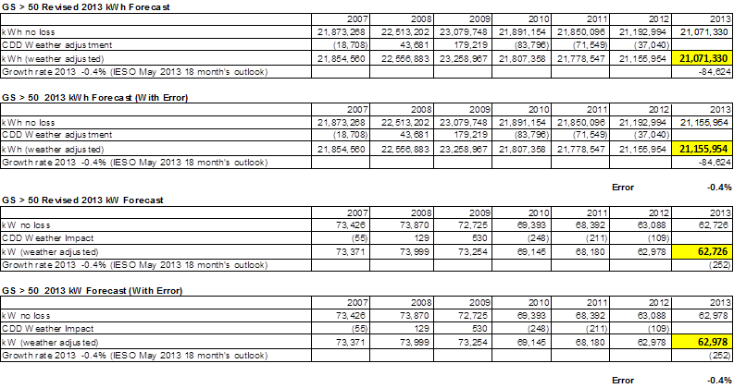

TOU

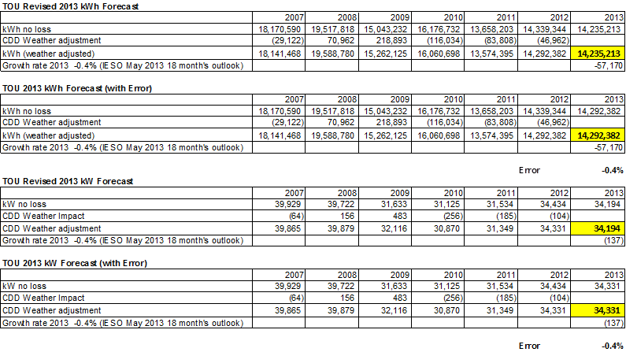

1. There is only one Large Customer in WCHE. This customer informed WCHE that the originally projected “New Mine” load did not materialized due to change of business plan.

**3.0-VECC- 56**

**Reference: 3.0-VECC- 20**

**3-Staff- 19, Appendix 9 (Tab “Summary”)**

1. Please explain why the customer counts for 2013 are held constant at the 2012 actual values.

WCHE reply to 3.VECC.56

The forecast does not use customer counts for load projection. It was assumed that the 2013 growth mainly comes from CDM initiatives.

**3.0-VECC- 57**

**Reference: 3- Staff - 21 b)**

**7.0- VECC- 37 f)**

1. The response to Staff 21 b) states that WCHE has 1,298 Street Lighting fixtures with 60% in a daisy-chain configuration involving 30 fixtures per connection whereas the updated Cost Allocation model (VECC 37 f) and Staff IRR, Appendix 3, Tab I6.2) indicates that there are 1,298 Street Light connections. Please reconcile.

WCHE reply to 3.VECC.57

In our response we state that 60% of the streetlights are in a daisy chain configuration. However, each fixture is connection directly to the system through the neutral. Historically, because of this method, each streetlight has been deemed to be directly to the system, hence the 1,298 streetlight connections. WCHE is willing to discuss this methodology if there is another consistent approach used by LDCs.

**3.0-VECC- 58**

**Reference: 3-Staff- 23**

1. Please reconcile the CDM adjustment shown on page 29 of 76 (response to part c)) with the load forecast and CDM adjustments set out in 3-Staff-19, Appendix 9.
2. Please confirm that WCHE’s proposed manual CDM adjustment for 2013 is 1,056,071 kWh. If not, what is the value?
3. What is WCHE’s proposed LRAMVA kWh value for 2013? If it is other than 2,600,477 kWh, please explain why.

WCHE reply to 3.VECC.58

1. The 2013 CDM adjustment should be 1,056,071 kWh as shown in Appendix 9.

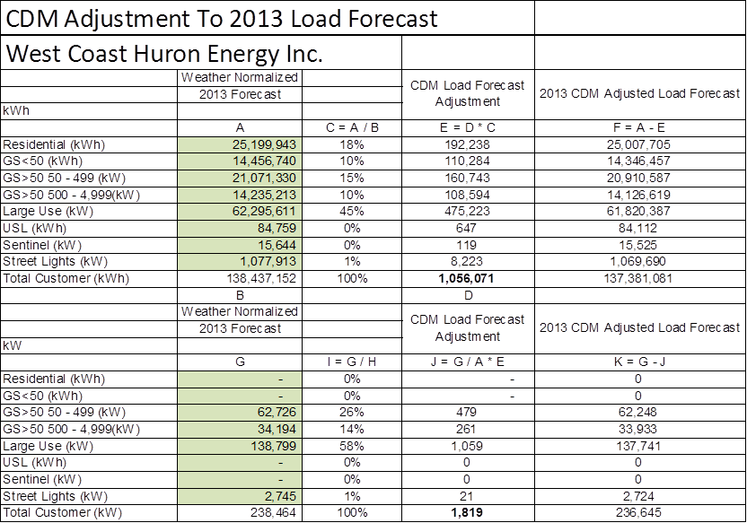

1. Yes.
2. This is to confirm that the 2,600,477 kWh is correct.

**3.0-VECC- 59**

**Reference: 3-Staff- 24**

1. After the CDM adjustment, what is the aggregate 2013 growth rate for the Residential, GS<50, GS>50 and TOU classes combined?

WCHE reply to 3.VECC.59

After the CDM adjustment the weather adjusted aggregate growth rate is -1.2%.



The table below shows the average 5 year growth rate of WCHE was -1.7 % tracking the IESO growth rate.



**3.0-VECC- 60**

**Reference: 3.0-VECC- 21 a)**

1. Please confirm that the Revenue Offsets of $115,877 in the updated RRWF (Staff IRR, Appendix 1 a)) do not include any Interest and Dividend Income (Account 4405) or any Non-Utility Rental Income (Account 4385).
2. If yes, please explain why these revenues have been excluded.

WCHE reply to 3.VECC.60

1. The revenue offset figure of $115,877 does not include interest or non-utility rental income.
2. Non-utility rental revenue relates to water heater rental revenue and is budgeted at $8,600 for 2013. Interest revenue is budgeted at $1,500 for 2013.

**4. OPERATING COSTS (Exhibit 4)**

**4.0-VECC- 61**

**Reference: 4.0-VECC- 22 / 4-SEC- 9 / 4-Staff- 30**

The purpose of the interrogatory was to understand why meter reading costs have not declined in light of smart meter installation costs. Specifically, the intent of Part (b) of the question was to get a description and comparison of the components of 2009 meter reading costs with those in 2013. (We also note from Appendix 2-J that the additional meter reading point appears to have added only $7,200 in OM&A costs). Please a breakdown of the meter reading costs to which help us understand why meter reading costs have not declined subsequent to the installation of smart meters.

WCHE reply to 4.VECC.61

On reviewing the Meter cost from the 2009 Board approved rate Payroll has reduced from $55,574 to projects costs of $32,500 (2013) which is a saving of $23,074. The other cost increases are in Wholesale settlement which increased by $8,000 and the new costs of Smart Meter points/Wan collectors of $23,200. The overall costs have increased but there is a large saving in the internal costs.

**4-SEC-27s**

[4-Staff-29] Please explain why costs related to answering interrogatories where not included in the Applicant’s original regulatory budget.

WCHE reply to 4.SEC.27

The costs for the rate making process have greatly exceeded our original estimation, hence the short fall on the budget.

**4.0-AMPCO-65s**

**Reference:** 4 Staff 30 (d)

The response shows that $50,000 for the Harris Upgrade has been reallocated from 2012 to 2013. An additional upgrade to Harris in the amount of $15,000 is shown in 2013. Please explain the difference between the two upgrades.

WCHE reply 4.AMPCO.65

The $50,000 represents the cost of the upgrade of the Harris system to version 6.3.1. The additional $15,000 represents cost estimates for upgrading financial reporting modules.

**4.0-AMPCO-66s**

**Reference:** 4 Staff 32

WCHE provides a summary of Outside Services for the years 2009 to 2013 Test Year. Please provide 2012 actuals.

WCHE reply to 4.AMPCO.66



**4.0-AMPCO-67s**

**Reference:** 4 Staff 33 (c)

In the response to part (c), WCHE provides a breakdown of $141,000 in Consulting Fees but the year is not clear. Please confirm the year and provide the necessary information to show a breakdown of consulting fees for 2012 actual and 2013 forecast, and confirm the amount spent to date.

WCHE reply to 4.AMPCO.67

|  |  |
| --- | --- |
|  | Budget |
| Design tech | 75,000 |
| Mapping Firm | 20,000 |
| Computer consulting | 25,000 |
| Engineering | 21,000 |
|  | 141,000 |

**4.0-VECC- 62**

**Reference: 4.0-VECC- 23**

* + 1. In respect to the Harris Upgrade costs shown in the response to a) of this interrogatory, please explain if this $15,000 is a one-time cost or an annual fee.
    2. Please explain the reasons for the increase in data processing contract fees since 2009.

WCHE reply to 4.VECC.62

1. The $15,000 is a one-time cost.
2. The increase in the data processing contract fees is mainly due to the implementation of monthly billing.

**4.0-VECC- 63**

**Reference: 4-VECC- 24 / 4-AMPCO- 42**

* + 1. Please explain what the annual $141,000 in consulting fees are for.

WCHE reply to 4.VECC.63

The annual consulting fees consist of the following:



**4-SEC-28s**

[4-AMPCO-24] Please explain the $141,000 ‘Consulting Fees’ cost for 2012 and 2013.

WCHE reply to 4.SEC.28

See WCHE reply to 4.VECC.63

Cost to June 30, 2013 are as follows:

Design Tech $36,000

Mapping $14,000

Computer $ 5,554

Engineering $12,000

Total $67,554

**4-SEC-29s**

[4-SEC-21, Ex, 4/2/4]Please provide a full response to Interrogatory 4-SEC-21. Exhibit 4/2/4 does not provide a descriptive analysis of the OM&A cost drivers.

WCHE reply to 4.SEC.29

See Appendix 12

**4.0-VECC- 64**

**Reference: 4-AMPCO -50**

Please show the calculation for the expected $2,000 in LEAP costs.

WCHE reply to 4.VECC.64

Goderich Hydro’s percentages for LEAP contribution falls below the $2,000 threshold, hence the utility must contribute the minimum to the program.

**Cost of Capital (Exhibit 5)**

**5-SEC-30s**

[5-Staff-35] Please provide an update on the $500,000 loan from the Applicant’s affiliate scheduled to be paid out in June.

WCHE reply to 5.SEC.30

The loan has been repaid.

**5.0- VECC- 65**

**Reference: Exhibit 5, Tab 1, Schedule 3**

* + 1. Appendix 1a 20130614 shows at Tab 9 (Rev Reqt), deemed interest expense of $264,743 and Return on Equity costs of $378,323. These figures do not match the amounts shown at Tab 7 of the same Exhibit (whether using Initial Application or Interrogatory Response). And neither of these responses match Appendix 2-OA shown in IRR_Appendix11_20130614. Please reconcile these difference Exhibits and show the 2013 Cost of Capital being sought.
    2. Please update Appendix 28 to show the derivation of the weighted debt cost rate for 2013 (see for example Lakeland 2013 Cost of Service EB-2012—0145, Exhibit 5, Tab 1, Schedule 2, page 7 for an example of a table which shows this derivation).

WCHE reply to 5.VECC.65

1. The deemed interest of $264,743 and return on equity of $378,323 figures referenced relate to the initial application amounts. Adjustments made throughout the interrogatory questions have resulted in a decrease in requested deemed interest to $207,418 and return on equity of $311,735. The utility had not entered any data into the Board decision columns of the model. The interest and return on equity calculation appears to be defaulting to the rates in the original application which is resulting in different figures in the Per Board Decision column. Appendix 11_20130614 had been updated for changes made during the interrogatory process and agrees with the interrogatory response column of Appendix 1A.









**5.0-VECC- 66**

**Reference: 5.0-VECC- 34**

* + 1. Please confirm the following are the regulated rates of return as reported in WCH_App29_20130516. If these are incorrect please provide the correct figures.

|  |  |  |  |
| --- | --- | --- | --- |
| **2009** | **2010** | **2011** | **2012** |
| **6.04%** | **19.19%** | **18.12%** | **9.67%** |

WCHE reply to 5.VECC.66

WCHE confirms that the rates are the actual rates of return earned by the utility shown in Appendix 29_2013516.

**5.0-VECC- 67**

**Reference: 5.0-VECC- 33**

CWH states that the infrastructure Ontario lending rates were not significantly different from the WCHE demand facility. At WCH_App26_Infrastructure Ontario Lending Rates_20130516 its shows that the 15-25 year rates offered were between 2.74% and 3.76%. This would appear to be significantly low the affiliated and demand payable note with the Town of Goderich. Please explain why WCHE did not exercise its option to replace the higher cost affiliated debt. Please file the municipal loan agreement.

WCHE reply to 5.VECC.67

The conditions of WCHE’s promissory note states that the note shall bear interest at 7.25% and is only repayable on written notice by the Town of Goderich. We have attached the Town of Goderich BY-LAW NO. 101 of 2002 (Appendix 12 – Municipal Loan Agreement). These terms and conditions were those entered into by most LDC’s in the early 2000’s and were consistent with the policy of the day.

See Appendix 13

**5.0-AMPCO-68s**

**Reference:** 5 Staff 35 (a)

The response to part (a) indicates that at this stage the utility intends to negotiate an additional demand facility and expects to pay interest at a rate just in excess of prime.

Please provide an update on this proposal.

WCHE reply to 5.AMPCO.68

WCHE plans on initially using the additional demand facility from its Financial Institution to finance 2013 capital spending. The facility will be structured to take into account our increase requirement during the balance of 2013. Our Capital program will dictate both the timing and the amount required throughout the remained of the year. This is one of the advantages for WCHE in dealing with its F.I. Once the year end borrowing level has been determined, the utility intends to convert approximately $3 million into long-term debt. The bank has currently provided an estimated long term borrowing rate of 4.3%

***5 Staff 62s Depreciation***

**Reference 5 Staff 34 Appendix 11**

**5 Staff 35 Chapter 2 Appendix OB-Debt 2013 (revised)**

In Appendix 11, WCHE has a weighted long term debt rate of 4.12% for 2013. In Chapter 2 Appendix OB-Debt 2013, WCHE calculates a weighted long term debt rate of 3.68% for 2013. The weighted cost of debt should be based on the estimate of the debt financing for the test year found in Chapter 2 Appendix OB-Debt 2013.

1. Please structure the debt to meet WCHE’s 2013 requirements in Chapter 2 Appendix OB-Debt 2013 (revised), and use that in Chapter 2 Appendix 2-OA, Appendix 11, and in the RRWF.
2. Please confirm that the principal amounts and interest rates.
3. Does line 1 “start date” of Jan 1, 00 in Chapter 2 Appendix OB-Debt 2013 refer to January 1, 2000? If not please explain.

Please explain line 6 start date “above” in Chapter 2 Appendix OB-Debt 2013.

Please explain any changes to the table.

WCHE reply to 5.Staff.62

1. WCHE has not updated Chapter 2 appendix OA and the RRWF to reflect the 3.68% weighted average borrowing rate previously submitted. The utility has made further enquiries regarding their borrowing rate for long term. The bank has provided an estimated lending rate of 4.3%. This rate change results in weighted average lending rate for the utility in excess of the Board deemed rate of 4.12%.
2. The principal amounts for 2013 are as follows:

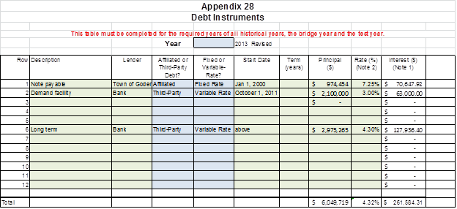

WCHE has reflected an increase of $500,000 to the demand facility as compared to 2012 for the repayment of the loan from the Town of Goderich. Capital work in 2013 is also shown as an increase to the utility’s borrowings $2,975,265 and represents an estimate of the amount of long-term debt.

1. The initial note was issued in 2000. It was subsequently been updated in 2002.

The utility intends to increase its credit facility as capital projects require financing. A long term borrowing arrangement will be negotiated once the capital work is completed. The expected borrowing rate for the long term debt with the bank is approximately 3%.

**5-SEC-31s**

[5-VECC-33] The Applicant states that Infrastructure Ontario rates were not significantly different from WCHE demand facility rates. Please explain in greater detail why the Applicant believes that considering the rates set out in Appendix 26 would seem to be significantly lower than the WCHE demand facility rate.

WCHE reply to 5.SEC.31

The initial rate appears to be lower but the note for the 20 year amortization rate from Infrastructure Ontario is 4.04%, which brings it in line with the current rate offered by our financial institution.

**5-SEC-32s**

[5-AMPCO-54] Please confirm the Applicant’s actual ROE has been greater than the Board’s allowed ROE from 2010-2012? Please explain the drivers for the actual ROE being greater than the Board’s allowed ROE.

WCHE reply to 5.SEC.32

See WCHE reply 5.VECC.66

**COST ALLOCATION (Exhibit 7)**

**7.0-VECC- 68**

**Reference: 1-Staff- 1, Appendices 2P and 3**

**7-SEC- 19**

**7.0-VECC- 38 a)**

1. The Status Quo Revenue to Cost ratios set out in (revised) Appendix 2P do not match those in Appendix 3 (Tab O1). Please provide a corrected version of Appendix 2P.
2. Please update Appendix 2P to include WCHE’s proposed Revenue to Cost Ratios for 2014 and 2014 (i.e., Part D).

WCHE reply to 7.VECC.68

1. WCHE has revised tab 2P to agree with the revised Cost Allocation. See Appendix 3 - Tab 2P - revised
2. WCHE has provided the revenue to cost ratios for 2014 or 2015. See Appendix 2 - Tab 2P - revised

**7.0-VECC- 69**

**Reference: 1-Staff- 1, Appendix 3**

1. Other than updating the revenue requirement and the load forecast, what other changes were made to the original cost allocation run for purposes of the run provided in Appendix 3?

Please explain the significant drop in the status quo ratio for Residential as between the initial Application (93.67%) and the revised cost allocation provided in Appendix 3 (86.14%).

WCHE reply to 7.VECC.69

1. The change reflected the move to monthly billing, which also explained the change in the residential ratio.

**RATE DESIGN (Exhibit 8)**

**8.0-VECC- 70**

**Reference: 8-VECStaff- 38**

**Staff IRR - Appendix 2R**

What is the basis for the values entered at Line D of Appendix 2R?

WCHE reply to 8.VECC.70

WCHE has revised Appendix 2R with the current data available to the utility. WCHE has also provided data in a table as provided by the Board in 8 Staff 63s as Appendix 9.

The utility would request that the current approved loss factors remain in effect in order for WCHE to further investigate the accuracy its loss factor data.

***8 Staff 63s Loss Factors***

**Reference 8 VECC 41**

**8 Staff 38**

**Appendix 2 to Board staff Interrogatory Responses**

Board staff would like clarification of WCHE’s comments on loss factors. Staff is concerned about the physical behaviour of the distribution system, and therefore uses the simple logic that volumes delivered to the customer are less than the volumes delivered to the distributor. Although the LU customer is a market participant, WCHE still moves its energy. Board staff has developed the following table from Appendix 2. The line identification is consistent with Appendix 2. However line F is redefined as Gross.

1. Does the LU own and operate the line from the TS to its metering point?
2. Please explain the negative losses found in line G.

WCHE reply to 8.Staff.63

1. The LDC owns and operates the line from the TS to its metering point.
2. See Appendix 9

The utility would request that the current approved loss factors remain in effect in order for WCHE to further investigate the accuracy of its loss factor data.

**Deferral and Variance Accounts (Exhibit 9)**

***9 Staff 64s Account 1592 – sub-account HST/OVAT ITCs***

**References: 9 Staff 40 (e)**

**Chapter 2 Filing Requirements Section 2.12.2**

WCHE indicated in Appendix 13 of its response that it is proposing to recover $22,305 for account 1592, sub-account HST/OVAT ITCs.

The Provincial Sales Tax (“PST”) and the Federal Goods and Services Tax were harmonized into the Harmonized Sales Tax (“HST”) effective July 1, 2010. As a result of this harmonization, applicants benefitted from an overall net reduction in costs in the form of Input Tax Credits (“ITCs”). This arose due to cost decreases from the receipt of additional ITCs on the purchases of goods and services previously subject to PST that became subject to HST. The balance in this account would generally be a credit balance, i.e. refund to the customers, and not a debit balance which is a recovery from the customers.

1. Please review the variances record in the sub-account of Account 1592 to cover the period from July 1, 2010 to April 30, 2013 and make the proper adjustments and re-file the amended evidence, as necessary.
2. When re-filing the amended evidence for the balance in account 1592, please include an analysis to support the calculation of the balance in account 1592 per Section 2.12.2 of the Filing Requirements using the example shown in the FAQ #4 December 2010 APH FAQs.

WCHE reply to 9.Staff.64

1. WCHE has revised the EDDVAR schedule to reflect the corrected balance.



***9 Staff 65s Account 1590 – Recovery of Regulatory Asset Balances***

**Reference: 9 Staff 41 (b)**

WCHE has not provided the reason(s) to continue to have balance in account 1590 after Board ordered its disposition in EB-2009-0254 and again in EB-2010-0120. Please confirm and provide assurance to the Board that:

1. The residual balance requested for disposition of a credit amount of $40,567 will be moved out of account 1590 in its entirety, from the principal and carrying charges, if approved by the Board.
2. There will be zero balance left in account 1590 once the approved balances have been transferred out of this account and WCHE will not record any balances under this account moving forward.

WCHE reply to 9.Staff.65

1. WCHE confirms that the residual balance requested for recovery of $40,567 will be moved out of account 1590 in its entirety if approved by the Board.
2. WCHE confirms that there will be a zero balance left in account 1590 once the approved balances have been transferred out of this account. No further balances will be recorded in account 1590 going forward.

***9 Staff 66s Deferral Account Balance Rate Riders***

**Reference: 9 Staff 42 (a) and (b)**

WCHE did not provide the rate rider calculations with amounts properly allocated to each rate class, as requested in the Board staff IR. Instead, it provided two versions of the EDDVAR model, one where accounts 1580 and 1588 Power were excluded from allocations and the amounts were allocated to all rate classes. The second EDDVAR model allocated accounts 1580 and 1588 Power to rate classes, excluding the LU customer class.

WCHE did not provide the reasons or references to the Board as guidance for permitting the exclusion of the LU customers from allocation of balances in accounts 1580 and 1588 Power. However, WCHE stated that it does not bill its LU customers for power or WMS and therefore does not have a RSVA variance amount that this class participates in for power and WMS.

1. Please indicate how many of WCHE’s LU customers are Wholesale Market Participants (WMP) customers where these WMP customers have an arrangement with the IESO for the commodity and wholesale market service charges and settle directly with the IESO for these items. Please identify these WMP customers.
2. What is the justification for excluding the LU customer class from the variance account allocations of 1580 and 1588 Power? Please provide reference to any Board guidance permitting to exclude the LU from such allocations.
3. Please explain why WCHE’s LU customers should not contribute to the disposition of the difference between actual line losses and those recovered in rates.
4. Please provide an estimate of the amount of line losses included in account balance for account 1588 Power that is attributable to the LU customer(s). Please comment on its materiality.
5. Please provide a rate rider calculation including all accounts (except GA), with amounts allocated to all rate classes, per the Board’s EDDVAR report.

WCHE reply to 9.Staff.66

1. WCHE has one large user. This user is a wholesale market participant that is invoiced for power and wholesale market directly by the IESO. The large user is Sifto Canada Corp.
2. WCHE has revised its calculation of the deferral variance recovery for accounts 1588 and 1580 to include its large user. WCHE has submitted a revised EDDVAR spreadsheet reflecting this change.
3. Please refer to answer 9.Staff.66 b)
4. The large user represents approximately 40 - 45% of the utility’s total kwh delivered - See response to 8 Staff 63.
5. Please refer to answer 9.Staff.66 b)

**9.0-VECC- 71**

**Reference: 9.0-VECC- 43**

1. Please show the actual derivation of the $130,000 in lost revenue. In doing this please explain does how the normal difference in consumption, weather and customer additions as between July and September was controlled for in calculating this estimate.

WCHE reply to 9.VECC.71



**9.0-VECC- 72**

**Reference: 9-VECC- 44 / 2- Staff- 8**

1. It is unclear how the chattel claim of $330,000 is factored into the request for recovery. Please explain.

WCHE reply to 9.VECC.72

All expenses related to the $330,000 have not been factored in to the cost of service application. All of the costs have been offset against the insurance proceeds.

**9.0-VECC- 73**

**Reference: 9-Staff- 55**

Given that WCHE has deferred adoption of IFRS why is the Utility not using Account 1576 instead of Account 1575 to book PP&E adjustments as outlined in the Board’s letter of July 17, 2012?

WCHE reply to 9.VECC.73

The utility will comply with the Board guidance and use account 1576.

## 9 Staff 67s Account 1575 – Transitional PP&E

### Reference: *9 Staff 55(a)*

### 9 SEC 22 Appendix 17

Board staff requested WCHE to provide a detailed breakdown and an explanation for the change in balance in account 1575 from a credit of $207,733 to a credit of $145,015. The information provided was insufficient. Please explain and reconcile the additions in Appendix 2-EB per the pre-filed evidence of $3,015,000 to the revised evidence per Appendix 17.

WCHE reply 9.Staff.67



## 9 Staff 68s Acount 1562 PILs

### Reference: 9 VECC 42 Appendix 21

Appendix 21 shows that the evidence is for Erie Thames. Please explain the purpose of filing this evidence.

WCHE reply to 9.Staff.68

WCHE will answer 9.Staff.68, 9.Staff.69, and 9.Staff.70 using the Board’s updated PILS model.

## 9 Staff 69s Acount 1562 PILs

### Reference: Letter of the Board, September 13, 2011 re: Disposition of Account 1562 deferred PILs

The Board, in its letter of September 13, 2011 established that the evidence required for a stand-alone PILs 1562 application consists of:

* Rate models from 2002, 2004 and 2005 applications.
* Board decisions and rate orders for 2002, 2004 and 2005 and any others that may have been issued during this period.
* PILs proxy models from the 2002 (for 2001 & 2002) and 2005 applications.
* Federal T2 and Ontario CT23 tax returns with supporting schedules for the 2001 through 2005 tax years.
* Notices of assessments, reassessments and statements of adjustments.
* Audited financial statements for 2001-2005 that were sent with the tax returns or were used in the preparation of the tax returns.
* SIMPIL models for 2001 through 2005 tax years that compare the PILs proxy data supporting the Board’s 2002, 2004 and 2005 decisions with the data from the tax returns filed with the tax authorities.

Please file the missing evidence.

WCHE reply to 9.Staff 69

WCHE will answer 9.Staff.68, 9.Staff.69, and 9.Staff.70 using the Board’s updated PILS model.

## 9 Staff 70s Acount 1562 PILs

### Reference: 9 VECC 42 Appendix 21

In Appendix 21 for the PILs 1562 continuity workbook, WCHE has used $197,248 as the 2001 PILs proxy and $155,069 for 2002, 2003 and 2004 PILs proxies. In the Board’s 2002 Decision and Order the Board approved a 2001 PILs proxy of $16,728 and a 2002 PILs proxy of $155,069.

1. Please explain why WCHE did not use the PILs proxy amount stated in the Board’s Decision and Order for 2001.

WCHE reply 9.Staff.70 a-p

WCHE will answer 9.Staff.68, 9.Staff.69, and 9.Staff.70 using the Board’s updated PILS model.

In the Board’s 2002 Decision and Order the Board also reduced the claim for interim transition cost recovery from $195,582 to $10,533.61.

1. Please explain why WCHE did not use the approved interim transition cost amount of $10,533.61 in the 2002 SIMPIL.

On January 14, 2003 the Board issued an order which rescinded its decision and order in RP-2002-0063/EB-2202-0072. The Board advised WCHE that the rates in effect were the rates as set out in Appendix B of the rate order issued in RP-2000-0263/EB-2000-0563. Board staff has filed these decisions and the orders to assist WCHE to reply to the interrogatories.

1. Please confirm that WCHE complied with this order.
2. Please confirm which rates WCHE used to bill its customers for the period from November 16, 2001 through April 1, 2004.

Since the date of rates when PILs were first approved to be collected from customers was April 1, 2004, WCHE did not have the entitlement to bill, nor the ability to collect PILs from its customers.

In its compendium, staff has included the following decisions to assist WCHE in answering staff’s interrogatories.

* EB-2011-0146 Fort Frances Power Corporation
* EB-2011-0187 North Bay Hydro Distribution Ltd.
* EB-2012-0061 Veridian Connections Inc.
* EB-2012-0197 Thunder Bay Hydro Electricity Distribution
* EB-2012-0196 St. Thomas Energy Inc.

1. Is WCHE familiar with the Board’s many decisions on the subject of delayed implementation of rates with respect to the recalculation of PILs 1562 balance?
2. Does WCHE believe that it should comply with previous decisions of the Board in other proceedings?
3. If WCHE believes it should not comply with previous decisions of the Board in other proceedings, please provide the regulatory reasons with references supporting WCHE’s position.

The PILs proxy approved by the Board at WCHE’s request in its 2004 application was only $18,000 and this amount was included in rates. In Appendix WCHE has used $197,248 as the 2001 PILs proxy, $155,069 for 2002, 2003 and 2004, and $46,689 as the 2005 PILs proxy.

In the rate adjustment model (“RAM”) filed by WCHE in 2004 the following note appears on sheet 7.

“Enter the 2002 PILs proxy amount as approved by the OEB in 2002 and shown on your 2002 RAM model at Sheet 8. $18,000

Due to delays caused by a motion made in 2001 by Sifto Canada Inc., for a rate hearing on the Large User Rates, 2002 RAM Rates although approved in principle, by the OEB, for West Coast to recover 2nd year MARR, transition costs and PILs for 2001 and 2002 PILs Proxy, were not approved as a rate freeze was legislated by the Province on Dec. 9, 2002. West Coast has paid PILs to Dec. 31, 2002 of $28,500 but was erroneously identified in 2002 Financials. This will be adjusted in 2003 financials as a Regulatory Asset. PILs Proxy for 2004 is expected to be the same as 2002 actual of $18,000.”

1. Does WCHE accept that the PILs proxy is zero for 2002, 2003 and the period up to April 1, 2004, $18,000 for 2004 and $46,689 for 2005?
2. If WCHE disagrees, please explain the regulatory reasons for WCHE’s disagreement and provide the supporting documents and references.

In the 2005 SIMPIL it shows that WCHE used the minimum income tax rate of 18.62% in its 2005 rate application. However, in the SIMPIL true-up section of sheet TAXCALC WCHE has used 33.28% and 32.16% in different places.

WCHE’s rate base for that period was $5,186,158. Rate base is a Board approved proxy for taxable capital. When taxable capital is below $10,000,000 the taxpayer is eligible to claim the small business deductions.

1. Please explain how WCHE calculated the tax rates of 33.28% and 32.16%.
2. Please explain why the minimum income tax rate of 18.62% should not be used. Please provide regulatory references to support WCHE’s position.
3. Please refer to the table of minimum tax rates on page 17 of the Decision in the Combined Proceeding and note that the tax rate to calculate the tax impact is different than the tax rate used to gross up the tax impact. The gross-up tax rate is derived by deducting 1.12% from the combined tax rate.

In its 2004 application, WCHE requested a PILs recovery of only $18,000 based its own tax forecast. A PILs proxy model was not used to calculate the PILs amount.

1. Since a PILs proxy model was not used, does WCHE agree that there can be no true-up calculations between the amount included in rates and the tax returns?

In 2005 WCHE had a loss for tax purposes of $391,776. WCHE carried this loss back and recovered taxes paid in 2004, 2003 and 2002.

1. Does WCHE agree that it paid no income taxes for the period 2001 through 2005?

Staff has prepared a continuity schedule based on staff’s understanding of the prior Board decisions and WCHE’s evidence as filed in its applications.

1. Please provide comments on staff’s approach.
2. Please describe how WCHE has reflected the unbilled revenue accrual as at April 30, 2006 in its calculations. Please refer to Issue #6 in the Settlement Agreement of the Combined Proceeding EB-2008-0381.

## 9 Staff 71s Depreciation

### Reference: 9 Staff 58

In response to the stated interrogatory, WCHE adjusted its depreciation rates to reflect economic life. Board staff needs clarification. WCHE is depreciating Account 1840; Conduits over 50 years, while it is depreciation Account 1845: Underground Conductors and Devices over 45 years.

1. Does WCHE replace the retired underground conduits and devices by placing new equipment into old conduits that it only expects to last another 5 years?
2. If not, please align the depreciation to reflect the actual useful lives from an economic perspective.

WCHE reply to 9.Staff.71

1. WCHE agrees with Staff that aligning the 1840 and the 1845 to be consistent over 45 years makes prudent business sense.
2. The depreciation schedules have been realigned.

## 9 Staff 72s Lost Revenues from the Tornado

### Reference: 9 Staff 44 e)

Board staff requested a determination of lost volumes and a calculation by class of the lost revenues. The response does not provide sufficient rationale and details for setting lost volumes; for example a note to the schedule only states “18 months at 4%” as a description.

1. What was the normalized volume base that was established to determine the lost volumes? By way of understanding what is required, the base may have been a series of Augusts dating back to a certain year or a series of contiguous months for a certain period.
2. What alternatives were also considered?
3. Why did WCHE choose the alternative that they did?
4. Please show by customer class the number of customers and estimated volumes applied to the respective billing factors, which WCHE claims totals to $127,878.

WCHE reply to 9.Staff.72

1. WCHE used the month of July, 2011 as the base for all calculations as it most fairly represented the circumstance. This methodology was deemed to be most accurate as it reflected both the current customer level as well as current usage.
2. The aforementioned approach was felt to give WCHE a reasonable estimate without spending significant time and resources.
3. Please see response to b)



## 9 Staff 73s Smart Meter Costs

### Reference 9 Staff 47

The referenced interrogatory requested an explanation why no capital or repairs for smart meter infrastructure was included for 2012. The answer is not clear. It only stated that the costs were for the initial implementation.

1. Were there any Smart Meter capital costs incurred in 2012?
2. Were there any costs of operating and maintaining the smart meters and related infrastructure incurred in 2012?
3. Were there any smart meters remaining to be installed at the end of 2011?
4. If so, have they all been installed?
5. If there are 2012 costs, please update the model with the 2012 audited costs.

WCHE reply to 9.Staff.73

1. There was $53,735 of smart meters purchased in 2012. This cost was included in capital asset account 1860 as the utility interpreted the purpose of Account 1555 smart meter variance to be a tracking of costs for the initial deployment of smart meters. The utility had completed its initial deployment by the end of 2011.
2. The utility had completed its initial install of smart meters by the end of 2011. The maintenance costs incurred related to meters in 2012 was recorded in account 5175.
3. There were no smart meters remaining to be installed at the end of 2011.
4. N/A
5. The capital costs noted in a) have not been added to the smart meter model as they have been included in the utility’s rate base.

## 9 Staff 74s Stranded Meters

### Reference: 9 Staff 46

Board staff requested that the stranded meters be allocated to the customer classes using the 2009 weighted factors from the cost allocation study. The allocator used allocated costs to all unmetered classes. Please explain the rational for allocating costs to these classes.

WCHE reply to 9.Staff.74

WCHE applied the weighted allocators to all classes in error. The stranded meter rider has been recalculated below using the relative proportion of only the Residential and GS< 50 classes.



## 9 Staff 75s Z-Factor

### Reference: 9 Staff 57

In its response to part c) WCHE has included interest of $11,348 at line 33 of the table;

1. Please show a detailed calculation of the interest.

In the response, WCHE provided its own table, including interest for 2011, 2012, and January 13 to April 2013.

1. Please show a detailed the calculation of the interest.

WCHE reply to 9.Staff.75



1. See response to a)