September 17th, 2013

Ms. Kirsten Walli
Board Secretary
Ontario Energy Board
Suite 2700
2300 Younge Street
Toronto, On
M4P 1E4

Dear Ms. Walli:

Re: Board File No. ED-2012-0175 Cost Claims

WCHE wishes to comment on the costs put forward by the Intervenors in our COS Application.

Both SEC ($11934.00) and AMCO ($11,593.00) are in line with our expectations, and were filled in a timely manner as per the Boards direction.

We do however think that the costs submitted late by PIAC ($21,505.08) which is almost double the costs of the other two Intervenors too be high. We would suggest that a reduction to bring the costs into a comparable range would be acceptable.

WCHE is happy to abide by the Board’s decision in this matter.

Yours truly
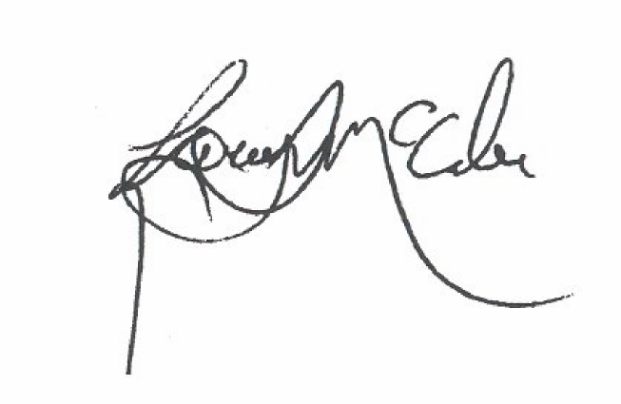
Larry McCabe
President
WCHE

