September 20, 2013
Sent via E-mail (boardsec@ontarioenergyboard.ca)

Ms. Kirsten Walli, Board Secretary
Ontario Energy Board
P.O. Box 2319
2300 Yonge Street, 27th Floor
Toronto ON M4P 1E4

RE: TORONTO HYDRO-ELECTRIC SYSTEM LIMITED APPLICATION EB-2013-0234 – SHAW COMMUNICATIONS INC. REQUEST FOR OBSERVER STATUS
Dear Ms. Walli:
Pursuant to the Ontario Energy Board Rules of Practice and Procedure, Shaw Communications Inc. (“Shaw”) requests Observer status in the hearing of application EB-2013-0234.
Shaw is aware that requests for Observer status are placed on the public record. Shaw understands that it will not be a party to the above-noted proceeding but that it will be entitled to automatically receive documents issued by the Ontario Energy Board throughout the hearing. Similarly, Shaw understands that Observers may request and receive documents filed by parties involved the hearing, provided that proper reimbursements, if applicable, are paid to the recipient of any such request.
Shaw respectfully asks that all correspondence related to this request be sent to the following coordinates:
Chris Ewasiuk
Director, Access Regulatory Affairs
SHAW COMMUNICATIONS INC
2400 32 Avenue NE
Calgary, Alberta T2E 9A7
(tel) 403-648-5724
(email) Chris.Ewasiuk@sjrb.ca
Yours very truly,
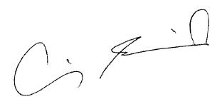
Chris Ewasiuk
Director, Access Regulatory Affairs

