Westario Power Inc.

Conservation and Demand Management
2012 Annual Report

Submitted to:
Ontario Energy Board

Submitted on September 30, 2013

TABLE OF CONTENTS

1 Conservation Framework 5

1.1 Current Framework 5

1.2 Future Framework 5

2 Board-Approved CDM Programs 6

2.1 Introduction 6

2.2 TOU Pricing 6

2.2.1 BACKGROUND 6

2.2.2. TOU PROGRAM DESCRIPTION 6

2.3 Westario Power Inc.’s Application with the OEB 7

3. OPA-Contracted Province-Wide CDM 8

3.1. Introduction 8

3.2 Program Descriptions 11

3.2.1 RESIDENTIAL PROGRAMS 11

3.2.2 COMMERCIAL AND INSTITUTIONAL PROGRAM 15

3.2.3 INDUSTRIAL PROGRAM 18

3.2.4 LOW INCOME INITIATIVE (HOME ASSISTANCE PROGRAM) (Schedule E-1) 22

3.2.5 PRE-2011 PROGRAMS 22

4. 2012 LDC CDM Results 22

4.1. Participation and Savings 22

3.2 Spending 27

5 Combined CDM Reporting Elements 30

5.1 Progress Towards CDM Targets 30

5.2 Variance from Strategy 32

6.0 Conclusion 35

Executive Summary

This annual report is submitted by Westario Power Inc. in accordance with the filing requirements set out in the CDM Code (Board File No. EB-2010-0215), specifically Appendix C Annual Report Template, as a progress report and modification to Westario Power Inc. Strategy. Accordingly, this report outlines Westario Power Inc.’s CDM activities for the period of January 1, 2012 to December 31, 2012. It includes net peak demand and net energy savings achieved from 2011 and 2012, discussion of the current/future CDM framework, CDM program activities, successes and challenges, as well as forecasted savings to the end of 2014.
Westario Power Inc. did not apply for any Board-Approved CDM Programs during 2012; however, as noted in the CDM guidelines, released April 26, 2012, the Ontario Energy Board (OEB) has deemed Time-of-Use (TOU) pricing a Province-wide Board-Approved CDM Program. The Ontario Power Authority (OPA) is to provide measurement and verification on TOU. At the time of this report the OPA has not released any verified results of TOU savings to Westario Power Inc.
In 2011, Westario Power Inc. contracted with the Ontario Power Authority (OPA) to deliver a portfolio of OPA-Contracted Province-Wide CDM Programs to all customer segments including residential, commercial, institutional, industrial and low income. These programs were rolled-out by the OPA in June 2011. In 2011 Program activities were centered on building a foundation for full program execution over the next three years of the program term, including staffing, procurement, and program delivery.
In 2012
Westario Power Inc. has achieved 0.9 MW of net incremental peak demand savings and 15.5 GWh of net incremental energy savings in 2012. A summary of the achievements towards the CDM targets is shown below:
Table of progress toward target
The updated forecast prepared for this report shows that there will be a shortfall of approximately 1.5 MW versus Westario Power Inc.’s 2014 peak demand reduction target of 4.2. Although, the peak demand savings are below target, Westario Power Inc. expects to achieve the electricity energy savings 2014 target. Given the expected shortfall, Westario Power Inc. continues to work actively on participant engagement. In addition Westario Power Inc. has partnered with other LDCs, and has been working with the Ontario Power Authority (“OPA”) and the Electrical Distribution Association (“EDA”) to improve program effectiveness; however it is Westario Power Inc.’s position that in its self will not fully overcome the forecasted peak demand savings shortfall.

Background
On March 31, 2010, the Minister of Energy and Infrastructure of Ontario, under the guidance of sections 27.1 and 27.2 of the Ontario Energy Board Act, 1998, directed the Ontario Energy Board (OEB) to establish Conservation and Demand Management (CDM) targets to be met by electricity distributors. Accordingly, on November 12, 2010, the OEB amended the distribution license of Westario Power Inc. to require Westario Power Inc., as a condition of its license, to achieve 20.950 GWh of energy savings and 4.240 MW of summer peak demand savings, over the period beginning January 1, 2011 through December 31, 2014.
In accordance with the same Minister’s directive, the OEB issued the Conservation and Demand Management Code for Electricity Distributors (the Code) on September 16, 2010. The code sets out the obligations and requirements with which electricity distributors must comply in relation to the CDM targets set out in their licenses. To comply with the Code requirements, Westario Power Inc. submitted its CDM Strategy on June 13th 2011 which provided a high level of description of how Westario Power Inc. intended to achieve its CDM targets.
The Code also requires a distributor to file annual reports with the Board. This is the second Annual Report by Westario Power Inc. and has been prepared in accordance with the Code requirement and covers the period from January 1, 2012 to December 31, 2012.
Westario Power Inc. submitted its 2011 Annual Report on September 30th 2012 which summarized the CDM activities, successes and challenges experienced by Westario Power Inc. for the January 1, 2011 to December 31, 2011 period. The OEB’s 2011 CDM Results report identified that the delay in the full suite of CDM Programs being made available by the OPA, and the absence of some programs negatively impacted the final 2011 results for the LDCs. This issue was also highlighted in Volumes I & II of the Environmental Commissioner’s Report on Ontario’s Annual Energy Conservation Progress.
On December 21, 2012, the Minister of Energy directed the Ontario Power Authority (OPA) to fund CDM programs which meet the definition and criteria for OPA-Contracted Province-Wide CDM Programs for an additional one-year period from January 1, 2015 to December 31, 2015.
The Ministerial Directive did not amend the timelines for LDCs to achieve their energy savings and demand savings targets. Therefore, the main focus of the LDCs remains the achievement of CDM targets by December 31, 2014.

- Conservation Framework
  - Current Framework
Ontario’s current CDM framework is a key step towards creating a culture of conservation in the Province. The Government’s Directive to the OEB to establish CDM targets that would be met by electricity distributors recognizes the importance of CDM for both electricity customers and the electricity system. CDM helps customers manage rising energy costs, support the provincial integrated supply plan, as well as address local distribution and transmission supply constraints. The current framework was intended to enable customers to benefit from a suite of both Board-Approved and OPA Province-Wide programs and be a portfolio that would meet both broad and specific customer needs.
The state of Board-Approved programs and the current suite of Province-Wide OPA programs have limited CDM offerings to customers. This has produced limited savings and has restricted the associated opportunity for LDCs to meet their targets. The process to introduce changes to current program Initiatives or to pilot new Initiatives has been challenging, taking considerable cost and effort, which has resulted in limited benefits to customers and CDM savings.
Moving forward, the future CDM framework should address the challenges of the current framework and build on its strengths. Currently overbuilt governance and excessive legal requirements results in a slow, bureaucratic process, with a burdensome administrative process. There is a misalignment of control and risk where LDCs have the accountability to achieve their respective CDM targets as a condition of distribution license, but the authority for design and funding are controlled substantially by the OPA.
The Ministerial Directive provides continuality of the conservation programs and associated compensation for the participants; however the subsequent savings would not be attributed to any LDC target and in effect would be ‘lost’ due to misalignment of the current CDM framework and LDC Targets. In addition, the establishment of defined administrative funding for 2015 is required to avoid a “stop and start” process.
  - Future Framework
LDCs are supportive of government’s renewed commitment for conservation and demand management in Ontario. LDCs are committed to working with the government and other stakeholders to develop the next framework for CDM in the Province.
Long-term commitment for CDM funding and a confirmation of the role of the LDC are needed. This will allow LDCs to maintain current program infrastructure including LDC staff and third party contracts through 2015.
Providing clarity and continuity into the next framework is critical for all customers. To ensure a seamless and smooth transition that maintains and builds upon CDM momentum beyond 2014, a new CDM framework should be in place well before the expiry of the current one. Work involving key parties including LDCs, government, customer groups and OEB should start in 2013 to allow for a new framework to be in place by early 2014. The remainder of 2014 would be utilized for program development and design, economic analysis, procurement and launching of new CDM program initiatives.

- Board-Approved CDM Programs
  - Introduction
In its Decision and Order dated November 12 2010 (EB-2010-0215 & EB-2010-0216), the OEB ordered that, (to meet its mandatory CDM targets), “Each licensed electricity distributor must, as a condition of its license, deliver Board-Approved CDM Programs, OPA-Contracted Province-Wide CDM Programs, or a combination of the two”.
At this time, the implementation of Time-of-Use (“TOU”) Pricing has been deemed as a Board-Approved Conservation and Demand Management (“CDM”) program that is being offered in Westario Power Inc.’s service area.

  - TOU Pricing

    - BACKGROUND
In its April 26, 2012 CDM Guidelines, the OEB recognizes that a portion of the aggregate electricity demand target was intended to be attributable to savings achieved through the implementation of TOU Pricing. The OEB establishes TOU prices and has made the implementation of this pricing mechanism mandatory for distributors. On this basis, the OEB has determined that distributors will not have to file a Board-Approved CDM program application regarding TOU pricing. The OEB has deemed the implementation of TOU pricing to be a Board-Approved CDM program for the purposes of achieving the CDM targets. The costs associated with the implementation of TOU pricing are recoverable through distribution rates, and not through the Global Adjustment Mechanism (“GAM”).
In accordance with a Directive dated March 31, 2010 by the Minister of Energy and Infrastructure, the OEB is of the view that any evaluations of savings from TOU pricing should be conducted by the OPA for the province, and then allocated to distributors. Westario Power Inc. will report these results upon receipt from the OPA.
At the time of preparation of this report the OPA had retained the Brattle Group as the evaluation contractor and will be working with an expert panel convened to provide advice on methodology, data collection, models, etc. The initial evaluations were conducted with 5 LDCs – Hydro One, THESL, Ottawa Hydro, Thunder Bay and Newmarket.
As of September 30, 2013, the OPA has not released any verified results of TOU savings to Westario Power Inc... Therefore Westario Power Inc. is not able to provide any verified savings related to LDC’s TOU program at this time.

    - TOU PROGRAM DESCRIPTION

Target Customer Type(s): Residential and small business customers (up to 250,000 kWh per year)
Initiative Frequency: Year-Round
Objectives: TOU pricing is designed to incent the shifting of energy usage. Therefore peak demand reductions are expected, and energy conservation benefits may also be realized.
Description: In August of 2010, the OEB issued a final determination to mandate TOU pricing for Regulated Price Plan (“RPP”) customers by June 2011, in order to support the Government’s expectation for 3.6 million RPP consumers to be on TOU pricing by June 2011, and to ensure that smart meters funded at ratepayer expense are being used for their intended purpose.
The RPP TOU price is adjusted twice annually by the OEB. A summary of the RPP TOU pricing is provided below:
RPP TOU |  | Rates (cents/kWh)
Effective Date | On Peak | Mid Peak | Off Peak
November 1, 2010 | 9.9 | 8.1 | 5.1
May 1, 2011 | 10.7 | 8.9 | 5.9
November 1, 2011 | 10.8 | 9.2 | 6.2
May 1, 2012 | 11.7 | 10.0 | 6.5
November 1, 2012 | 11.8 | 9.9 | 6.3
May 1, 2013 | 12.4 | 10.4 | 6.7

Delivery: The OEB set the rates; LDCs install and maintain the smart meters; LDCs convert customers to TOU billing.
Initiative Activities/Progress:
Westario Power Inc. began transitioning its RPP customers to TOU billing on May 1, 2012. At December 31st, 2012, 22,223 RPP customers were on TOU billing.

  - Westario Power Inc.’s Application with the OEB
There were no LDC programs approved by the OEB in 2012.

- OPA-Contracted Province-Wide CDM
  - Introduction

Effective November 1st 2010, WESTARIO POWER INC. entered into an agreement with the OPA to deliver CDM programs extending from January 1, 2011 to December 31, 2014, which are listed below. Program details are included in Appendix A. In addition, results include projects started pre 2011 which were completed in 2011:
Initiative | In Market Date | Schedule | Date schedule posted | Customer Class
Residential Program
Appliance Retirement | January 2011 | Schedule B-1, Exhibit D | Jan 26,2011 | All residential rate classes
Appliance Exchange | March 2011 | Schedule B-1, Exhibit E | Jan 26, 2011 | All residential rate classes
HVAC Incentives | February 2011 | Schedule B-1, Exhibit B | Jan 26, 2011 | All residential rate classes
Conservation Instant Coupon Booklet | February 2011 | Schedule B-1, Exhibit A | Jan 26, 2011 | All residential rate classes
Bi-Annual Retailer Event | March 2011 | Schedule B-1, Exhibit C | Jan 26, 2011 | All residential rate classes
Retailer Co-op | January 2011 | n/a | n/a | All residential rate classes
Residential Demand Response | October 2012 | Schedule B-3 | Aug 22, 2011 | All general service classes
New Construction Program | March 2011 | Schedule B-2 | Jan 26, 2011 | All residential rate classes
Commercial & Institutional Program
Efficiency: Equipment Replacement | March 2011 | Schedule C-2 | Jan 26, 2011 | All general service classes
Direct Install Lighting | January 2011 | Schedule C-3 | Jan 26, 2011 | General Service < 50 kW
Existing Building Commissioning Incentive | January 2011 | Schedule C-6 | Feb 2011 | All general service classes
New Construction and Major Renovation Initiative | March 2011 | Schedule C-4 | Feb 2011 | All general service classes
Energy Audit | January 2011 | Schedule C-1 | Jan 26, 2011 | All general service classes
Commercial Demand Response (part of the Residential program schedule) | October 2012 | Schedule B-3 | Jan 26, 2011 | All general service classes

Industrial Program | In Market Date
Process & System Upgrades | November 2011 | Schedule D-1 | May 31, 2011 | General Service 50 kW & above
Monitoring & Targeting | November 2011 | Schedule D-2 | May 31, 2011 | General Service 50 kW & above
Energy Manager | August 2011 | Schedule D-3 | May 31, 2011 | General Service 50 kW & above
Key Account Manager (“KAM”) | August 2011 | Schedule D-4 | May 31,2011 | General Service 50 kW & above
Efficiency: Equipment Replacement Incentive (part of the C&I program schedule) | March 2011 | Schedule C-2 | May 31, 2011 | General Service 50 kW & above
Demand Response 3 | January 2011 | Schedule D-6 | May 31, 2011 | General Service 50 kW & above
Home Assistance Program
Home Assistance Program | June 2013 | Schedule E-1 | May 9, 2011 | All residential rate classes
In addition, results were realized towards LDC’s 2011-2014 target through the following pre-2011 programs:
Pre-2011 Programs
Electricity Retrofit Incentive Program | n/a | n/a | All general service classes
High Performance New Construction | n/a | n/a | All general service classes
Toronto Comprehensive | n/a | n/a | All general service classes
Multifamily Energy Efficiency Rebates | n/a | n/a | All general service classes
Data Centre Incentive Program | n/a | n/a | All general service classes
EnWin Green Suites | n/a | n/a | All general service classes
As per the table below, several program initiatives are no longer available to customer or have not been launched in 2012.
As per the table below, several program initiatives are no longer available to customer or have not been launched in 2012.
Initiative Not in Market in 2012 | Objective | Status
Residential Program
Midstream Electronics | The objective of this initative is to encourage retailers to promote and sell high efficency televisions, and for distributors to distribute high efficiency set top boxes. | Never launched and removed from Schedule in Q2, 2013.
Midstream Pool Equipment | The objective of this initiative is to encourage pool installers to sell and install efficient pool pump equipment in residential in-ground pools. | Never launched and removed from Schedule in Q2, 2013.
Aboriginal Conservation Program | First Nations programs are delivered by the OPA and results are attributed to LDCs for reporting. | Launched in 2013 by OPA.
Home Energy Audit Tool | This is a provincial online audit tool to engage customers in conservation and help drive customer participation to CDM programs. | Never launched and removed from Schedule in Q2, 2013.
Commercial & Institutional Program
Direct Service Space Cooling | The objective of this initiative is to offer free servicing of air conditioning systems and refrigeration units for the purpose of achieving energy savings and demand reduction. | Not launched to market in 2011/2012. As per the OPA there no plans to launch this Initiative in 2013.
Demand Response 1 (“DR1”) | This initiative allows distribution customers to voluntarily reduce electricity demand during certain periods of the year pursuant to the DR 1 contract. The initiative provides DR payment for service for the actual electricity reduction provided during a demand response event. | No customer uptake for this initiative. As a result this Initiative was removed from the Schedule in Q4, 2012.
Industrial Program
DR1 | As above | No customer uptake for this initiative. Removed in Q4, 2012.

The Master CDM Program Agreement includes program change management provision in Article 3. Collaboration between the OPA and the Local Distribution Companies (LDCs) commenced in 2011, and continued in 2012, as the change management process was implemented to enhance the saveONenergy program suite. The change management process allows for modifications to the Master Service Agreement and initiative Schedules. The program enhancements give LDCs additional tools and greater flexibility to deliver programs in a way that meets the needs of customers and further drives participation in the Initiatives.

  - Program Descriptions

Westario Power Inc. is offering all Residential Programs Efficiency: Equipment Replacement, Direct Install Lighting, Existing Building Commissioning Incentive, New Construction and Major Renovation Initiative, Energy Audit, Commercial Demand Response (part of the Residential program schedule), and the Demand Response 3 (part of the Industrial program schedule).
Full OPA-Contracted Province-Wide CDM Program descriptions are available on the OPA’s website at http://www.powerauthority.on.ca/ldc-province-wide-program-documents and additional initiative information can be found on the saveONenergy website at https://saveonenergy.ca. The targeted customer types, objectives, and individual descriptions for each Program Initiative are detailed in Appendix A

RESIDENTIAL PROGRAMS

Description: Provides residential customers with programs and tools to help them understand and manage the amount of energy they use throughout their entire home and help the environment.
Objective: To provide incentives to both existing homeowners and developers/builders to motivate the installation of energy efficiency measures in both existing and new home construction.
Discussion:
The inclusion of LED technology into the Biannual Retailers events in 2012 and the annual coupons in 2013, as well as some LDC custom coded coupons, has had a positive effect on consumer engagement. The revamped PeaksaverPLUS program is the main Residential Initiative which drives savings for LDCs and has been well received by consumers eager to utilize an In Home Display to help manage their energy consumption.
The Residential Program Portfolio is predominately a carryover of Initiatives from previous programs. It is mostly driven by retailers and contractors who many not have fully delivered what was anticipated. Three new initiatives were never launched and subsequently removed from schedule in 2013 with no new additions. Delays in communication with regards to Initiative offerings and results reporting have hampered LDCs abilities to engage customers and promote participation. Provincial wide advertising has provided limited value due to inconsistency and non-specific messaging.
Work to revitalize and increase the effectiveness and breadth of the Initiatives through the Residential Program needs to be a high priority. There are opportunities within the Residential marketplace that need to be identified, developed and offered to customers. A revised home audit and other Initiatives which could engage an average residential customer could be considered. Increased control by the LDCs such as 100% attributable coupons for LDCs and/or LDC hosted exchange events may present an opportunity for improved saving.

Appliance Retirement Initiative (Exhibit D)

Initiative Activities/Progress:
Westario Power Inc. retired 339 Appliances in 2012
Additional Comments:
- With the increase in appliance age to 20 years in 2013, Westario Power Inc. increased marketing and outreach throughout 2012 in an effort to increase uptake and achieve savings.
- Due to the duration of the program, and the revised eligibility requirements to a minimum of 20 years old, this Initiative appears to have reached market saturation and has been under consideration for removal from the Portfolio.
- Rather than strictly remove this Initiative from the schedules, the OPA and LDCs could review what opportunities there are to include other measures such as stoves, dishwashers, washers and dryers. The framework of this Initiative may be a suitable foundation for a more holistic residential appliance retirement program. As such, the Residential portfolio could be straightened through program evolution rather than weakened through diminished program offerings.
- As results are very responsive to province wide advertising OPA provincial marketing should continue to play a key role.
- The OPA and LDCs can continue working to establish partnerships with Independent retailers and municipalities.

Appliance Exchange Initiative (Exhibit E)

Initiative Activities/Progress:
Westario Power Inc. exchanged 38 Appliances in 2012

Additional Comments:
- This Initiative, eligible measures and incentive amounts are influenced by the retail partner with no direct involvement from the LDCs. The restrictive, limited and sometimes non-participation of local stores can diminish the savings potential for this Initiative.
- To date there has only been one retailer participant in the Appliance Exchange Initiative. The Fall events have not had retailer participation, therefore savings budgeted by the LDCs have not materialized.
- Evaluation, Measurement, and Verification (EMV) results indicated that the value of savings for retired room AC has dropped resulting in the retail participant not accepting window a/c’s during the Spring 2013 event.
- Notification regarding retailer participation and eligible measures continues to be delayed. Improved communications will aid in appropriate resource allocation and marketing of the Initiative.
- This Initiative may benefit from the disengagement of the retailer and allowing LDCs to conduct these events, possibly as part of a larger community engagement effort, with the backing of ARCA for appliance removal.
- The initiative appears to require more promotion from retailers and LDCs.

HVAC Incentives Initiative (Exhibit B)

Initiative Activities/Progress:
Westario Power Inc. is credited with 321 HVAC applications in 2012
Additional Comments:
- Incentive levels appear to be insufficient to prompt Participants to upgrade HVAC equipment prior to end of useful life. It is hoped that the introduction of an Air Miles incentive in 2013 may help with this.
- This Initiative is contractor driven with LDCs responsible for marketing efforts to customers. More engagement with the HVAC contractor channel should be undertaken to drive a higher proportion of furnace and CAC sales to eligible units.
- Channel partners require timeliness of the Rebate process to maintain a positive relationship between consumers, contractors, the OPA, and the participating LDC. Due to a contracting delay no applications were processed from approximately the end of October 2012 to February 2013.
- LDC HVAC reports have been delayed and are not as complete and accurate as are required by LDCs to make adjustments to their marketing strategies.
- In an effort to build capacity, mandatory training has been instituted for all participating HVAC contractors. This could present too much of a barrier for participation for some contractors as the application process already presents a restriction to contractor sales. It has been noted that there are approximately 4500-5000 HVAC contractors in the Province, however only 1500 are participating in program.
- There are cases where non-participating contractors are offering their own incentives (by discounting their installations to match value of the OPA incentive) to make the sale. As this occurs outside of the Initiative, these installations should be attributed to the appropriate LDC.

Conservation Instant Coupon Initiative (Exhibit A)

Initiative Activities/Progress:
Westario Power Inc. is credited with 167 coupons in 2012
Additional Comments:
- This Initiative was ineffective for most of 2012 as the Instant coupons (annual) were not available to consumers until September 2012. As such, savings budgeted by LDCs did not materialize.
- The timeframe for retailer submission of redeemed coupons vary from retailer to retailer and in some cases has been lengthy. The delays and incomplete results reporting limits the ability to react and respond to Initiative performance or changes in consumer behavior. This also resulted in the delayed launch of the Initiative in 2012.
- Coupon booklets were not printed and mailed out in 2012. As such, Coupons were not widely available to consumers without the ability to download and print them.
- Without Provincial coupon distribution, and delay in Initiative launch, consumers may not have been aware of the online coupons. This Initiative could benefit from provincial marketing as a substitute to distribution.
- LDCs should be able to custom code all coupons to provide 100% allocation and push specific coupons based on localized needs.
- The product list could be distinctive from the Bi-Annual Retailer Event Initiative in order to gain more consumer interest and uptake.
- Program evolution, including new products and review of incentive pricing for the coupon Initiatives, should be a regular activity to ensure continued consumer interest.

Bi-Annual Retailer Event Initiative (Exhibit C)

Initiative Activities/Progress:
Westario Power Inc. is credited with 5,741 in 2012
Additional Comments:
- This Initiative is strongly influenced by the retail participants and has no direct involvement from the LDCs.
- The Product list has changed very little over the past four years.
- Limited engagement of local retailers can restrict the savings potential for this Initiative.
- Program evolution, including new products and review of incentive pricing for the coupon Initiatives, must be a regular activity to ensure continued consumer interest.
- The Product list could be distinctive from the Conservation Instant Coupon Initiative in order to gain more consumer interest and uptake.
- A review conducted by the Residential Working Group in Q4 2011 identified three areas of need for Initiative evolution: 1) introduction of product focused marketing; 2) enhanced product selection and 3) improved training for retailers as retail staff tend not to be knowledgeable regarding the products or promotion.
- LDCs should be able to custom code all coupons to provide 100% allocation and push specific coupons based on localized needs.
- Communications regarding retailer participation continues to be delayed. Improved communications will aid in appropriate resource allocation and marketing of the Initiative.
- This Initiative may benefit from a more exclusive relationship with a retailer appropriate to the program. There should be a value proposition for both the retailer and LDC.

Retailer Co-op

Initiative Activities/Progress:

Additional Comments:
- This is a retailer Initiative with no direct benefit to the LDCs
- Limited engagement of local retailers can restrict the savings potential for this Initiative.
- The availability of retailer and/or LDC staff with product knowledge and the ability to conduct demonstration in store during the events would be an asset. This could be a valuable role for LDCs, however many LDCs are limited by available resources and unable to participate.

New Construction Program (Schedule B-2)

Initiative Activities/Progress:
There has been no interest from builders in our service territory to participate in this Program
Additional Comments:
- This Initiative provides incentives to home builders for incorporating energy efficiency into their buildings. To support this, LDCs need to provide education to the consumers regarding the importance of choosing the energy efficient builder upgrade options without an immediate benefit to the consumer.
- Following limited Provincial participation in 2011, the application process was revisited in 2012 to streamline administration in response to builder feedback. Participation is not expected in our service territory after speaking with local contractors who tried to participate in the past. Provincially there will be a lag to when results materialize as homes pre-approved could take a year or more to be completed.
- Administrative requirements, in particular individual home modeling, must align with perceived stakeholder payback. As per the Electricity Distributors Association (“EDA”) Working Groups, changes are being processed through change management for 2013. However, the lengthy change management process has resulted in continued non-participation from builders.

Residential Demand Response Program (Schedule B-3)

Initiative Activities/Progress:
Although Westario launched RDR in October 2012 installations id not commence until 2013.
Additional Comments:
- The schedule for Peaksaver Plus was posted in August 2011, but this did not provide adequate time for product procurement for 2011, and part of 2012. The product procurement process uncovered that the In Home Display units that communicate with installed smart meter technology were still in development and not ready for market deployment.
- Smart Meters installed by Westario Power Inc. have the capability to communicate directly to an In Home Display, as the availability of technology to complete the load control portion of the requirement was not available until early 2012.
- Introduction of new technology requires incentives for the development of such technology. Appropriate lead times for LDC analysis and assessment, product procurement, and testing and integration into the Smart Meter environment are also required. Making seemingly minor changes to provincial technical specifications can create significant issues when all LDCs attempt to implement the solution in their individual environments.
- This is the main Initiative within the Residential portfolio that drives savings for LDCs.
- Given the different LDCs smart meter environments, and needs, each LDC is positioning the Initiative slightly different. As such, greater program flexibility is required to address unique LDC needs. Provincial wide marketing needs to be sensitive to the variations of the Initiative and provide solid, consistent messaging.
- There currently is not an avenue for participants without the ability to provide demand response capabilities to obtain an IHD and gain energy saving benefits.

COMMERCIAL AND INSTITUTIONAL PROGRAM

Description: Provides commercial, institutional, agricultural and industrial organizations with energy-efficiency programs to help reduce their electrical costs while helping Ontario defer the need to build new generation and reduce its environmental footprint. Programs to help fund energy audits, to replace energy-wasting equipment or to pursue new construction that exceeds our existing codes and standards. Businesses can also pursue incentives for controlling and reducing their electricity demand at specific times.

Targeted Customer Type(s): Commercial, Institutional, Agricultural, Multi-family buildings, Industrial

Objective: Designed to assist building owners and operators as well as tenants and occupants in achieving demand and energy savings, and to facilitate a culture of conservation among these communities as well as the supply chains which serve them.
Discussion:

Throughout 2011 and 2012 the Commercial and Institutional (C&I) Working Group has strived to enhance the existing C&I programs and rectify identified program and system deficiencies. This has proven to be a challenging undertaking, normally taking months to complete sometimes relatively minor changes due to the current CDM framework. Overbuilt governance, numerous initiative requirements, complex program structure and lengthy change management have restricted growth without providing the anticipated improved Measurement and Verification results. In addition, Evaluation, Measurement and Verification (EM&V) has not yet achieved transparency. LDCs are held accountable for these results yet are mostly completely removed from the process.

LDC program management has been hampered by varying rule interpretation, limited marketing ability, a somewhat inflexible online system of checks and balances and revolving OPA support personnel.

Despite these challenges the C&I Working Group, working in cooperation with the OPA, have managed to iron out many of the issues which could be rectified. In particular, an accomplishment of 2012 was the advent of the expedited change management as means to accelerate certain program changes.

Looking ahead there is minimal opportunity to make valuable changes to the current program suite and have these changes reflected in LDC 2014 results. LDCs and the OPA should look beyond the current Initiatives and work to launch new programs, built on the strengths of the 2011-2014 programs, which will meet the needs of the industry and consumers.

Efficiency: Equipment Replacement Incentive (ERII) (Schedule C-2)

Initiative Activities/Progress:
Additional Comments:
- It appears that the marketplace largely understands the programs now and a large proportion of LDC savings are attributed to ERII.
- The centralized process review used for 2012 project payment has been streamlined by the OPA and payments for projects were greatly improved – faster and more consistent compared to 2011.
- Capability building programs from Industrial programs have had very positive contributions to ERII program.
- This Initiative is limited by the state of the economy and the ability of commercial/institutional facility to complete capital upgrades.
- A number of customer facing issues in CRM (the OPA centralized application system) have been resolved; however key LDC administrative back office processing issues continue to be a challenge.
- Applicants and Applicant Representatives continue to express dissatisfaction and difficulty with the online application system. This issue has been addressed by LDCs through application training workshops, Key Account Managers, channel partner/contractor training and LDC staff acting as customer Application Representatives. Although this has been an effective method of overcoming these issues and encouraging submissions, it also reflects on the complexity and time consuming nature of the application process. As such, Applicant Representatives continue to influence the majority of applications submitted. Continued development of Channel Partners is essential to program success.
- Lighting is still the most popular measure. Other market sectors are not as engaged yet, specifically the mechanical world. There continues to be significant barriers to program participation from HVAC (Unitary AC) and compressed air channel partners
- Prescriptive and Engineered worksheets provide a much needed simplified application process for customers. However, the eligible measures need to be updated and expanded in both technology and incentive amounts to address changing product costs and evolution of the marketplace.
- Expanding the capacity of the engineered applications can offer customers an opportunity to maximize savings and incentives. Recognizing this, Toronto Hydro and London Hydro worked together to develop and provide the OPA with compressed air engineered worksheets for inclusion in the Initiative in Q3, 2012. To date, these have not been accepted and provided to LDCs for use.
- An identified deficiency in the various renditions of the equipment replacement is the “hard stop” of the program as of a specific date. Without a streamlined transition into a new program, many customers become frustrated and refused to participate. LDCs struggle to repair customer and channel partner relationships and gain momentum in the market place once again.
- While the Ministerial Directive provides continuality of the conservation programs for the participant, unclear direction on LDC administrative funding could result in many LDCs ‘ramping down’ programs in 2015. The establishment of defined administrative funding for 2015 is required to avoid a “stop and start” process.

Direct Install Initiative (DIL) (Schedule C-3)

Initiative Activities/Progress:
Additional Comments:
- Successful execution of the previous rendition of this Initiative has resulted in diminished potential for the 2011-2014 Initiative in some LDC’s territories.
- The inclusion of a standard incentive for additional measures increased project size and drove higher energy and demand savings results in some situations.
- Electrical contractor’s margins have been reduced due to no labour rate increase, increase cost of materials, greater distances between retrofits, more door knocking required before a successful sale and no funding for lifts. This has led to a reduction in vendor channel participation in some regions.
- Ambiguity with regard to eligibility resulted in large lists of customers rejected following installation due to preserved ineligibility. Due to this, some LDCs were forced to carry considerable financial burden while this was worked through.
- The eligibility requirements have now been revamped and expanded however there has been limited communication and documentation of this to the marketplace.
- Currently LDCs are unable to offer these standard incentives to prior participants. The ability to return to prior participants and offer a standard incentive on the remaining measures has potential to provide additional energy and demand savings.

Existing Building Commissioning Incentive Initiative (Schedule C-6)

Initiative Activities/Progress:
Additional Comments:
- Initiative name does not properly describe the Initiative.
- There was minimal participation for this Initiative. It is suspected that the lack of participation in the program is a result of the Initiative being limited to space cooling and a limited window of opportunity (cooling season) for participation.
- Participation is mainly channel partner driven, however the particulars of the Initiative have presented a too significant of a barrier for many channel partners to participate.
- The customer expectation is that the program be expanded to include a broader range of measures for a more holistic approach to building recommissioning and chilled water systems used for other purposes should be made eligible and considered through Change Management.
- This initiative should be reviewed for incentive alignment with ERII, as currently a participant will not receive an incentive if the overall payback is less than 2 years.

New Construction and Major Renovation Initiative (HPNC) (Schedule C-4)

Initiative Activities/Progress:
Additional Comments
- There is typically a long sales cycle for these projects, and then a long project development cycle. As the program did not launch until mid-2011 and had limited participation, results did not appear in 2011. Minimum results are expected to appear in 2012. The majority of the results are expected in 2013-2014, with a reduced benefit to cumulative energy savings targets.
- With the Ministerial Directive facilities with a completion date near the end of 2014 currently have some security that they will be compensated for choosing efficient measures.
- Participants estimated completion dates tend to be inaccurate and are usually 6 months longer. This could result in diminished savings towards target when facilities are not substantially completed by December 31, 2014.
- The custom application process requires considerable customer support and skilled LDC staff. As there has been no defined administrative funding beyond 2014, many LDCs are unsure how these project applications will be finalized.
- The effort required to participate through the custom stream exceeds the value of the incentive for many customers.
• This Initiative has a very low Net-to-Gross ratio, which results in half the proposed target savings being ‘lost’.

Energy Audit Initiative

Initiative Activities/Progress:
- Customer uptake was limited in 2011, however improved throughout 2012 especially with the new audit component for one system (i.e. compressed air).
- The energy audit Initiative is considered an ‘enabling’ Initiative and ‘feeds into’ other saveONenergy Initiatives. There are no savings attributed to LDC targets from an audit.
- Audit reports from consultants vary considerably and in some cases, while they adhere to the Initiative requirements, do not provide value for the Participant. A standard template with specific energy saving calculation requirements should be considered.
- Customers look to the LDCs to recommend audit companies. A centralized prequalified list provided by the OPA may be beneficial.
- Participants are limited to one energy audit which restricts enabling and direction to the other Initiatives. This Initiative should be evaluated for additional customer participation when presented with a new scope of work.

INDUSTRIAL PROGRAM

Description: Large facilities are discovering the benefits of energy efficiency through the Industrial Programs which are designed to help identify and promote energy saving opportunities. It includes financial incentives and technical expertise to help organizations modernize systems for enhanced productivity and product quality, as wells as provide a substantial boost to energy productivity. This allows facilities to take control of their energy so they can create long-term competitive energy advantages which reach across the organization.

Targeted Customer Type(s): Industrial, Commercial, Institutional, Agricultural

Objective: To provide incentives to both existing and new industrial customers to motivate the installation of energy efficient measures and to promote participation in demand management.

Discussion:

The Industrial Program Portfolio has been able to provide valuable resources to large facilities such as Energy Managers and enabling Engineering Studies. The Engineering Studies in particular provide a unique opportunity for a customer to complete a comprehensive analysis of an energy intensive process that they would not otherwise be able to undertake. Energy Managers provide customers with a skilled individual whose only role is to assist them with conservation initiatives. To date these Energy Managers have played a key role in customer participation.

Due to the size, scope and long lead time of these Initiatives and associated projects, the Ministerial Directive provides some security for the continuation of the conservation programs and associated compensation for the participant; however the subsequent savings would not be attributed to any LDC target.

Extensive legal documents, complex program structure and lengthy change management have restricted the change and growth of this Portfolio. While the expedited change management has benefited the Commercial Portfolio, the Industrial Portfolio has not seen the same results due to the narrow scope of the process. For 2013, a change to the threshold for small capital projects and a new small capital project agreement are expected to improve the number of projects and savings achieved within PSUI. Likewise, a decision to proceed with natural gas load displacement generation projects will also increase uptake although results may not be counted towards LDC targets due to in-service dates beyond 2014. Looking ahead there is minimal opportunity to make additional valuable changes to the current program suite and have these changes reflected in LDC 2014 results

Process & Systems Upgrades Initiative (PSUI) (Schedule D-1)

Initiative Activities/Progress:
Additional Comments:
- Approximately 100 engineering study applications have been submitted. This is a strong indication that there is the potential for large projects with corresponding energy savings. Most of these studies have been initiated through the Energy Manager and KAM resources.
- This Initiative is limited by the state of the economy and the ability of a facility to complete large capital upgrades.
- There is typically a long sales cycle for these projects, and then a long project development cycle. As such, limited results are expected to be generated in 2012. The majority of the results are expected in 2013-2014, with a much reduced benefit to cumulative energy savings targets.
- Delays with processing funding payments have caused delayed payments to Participants beyond contract requirements. In some cases, LDCs have developed a separate side agreement between the LDC and Participant acknowledging that the Participant cannot be paid until the funds are received.
- The contract required for PSUI is a lengthy and complicated document. A key to making PSUI successful is a new agreement for ‘small’ projects which is a simplified with less onerous conditions for the customer.
- To partially address this, changes were made to the ERII Initiative which allowed smaller projects to be directed to the Commercial stream. . Most industrial projects to-date have been submitted as ERII projects due to less onerous contract and M&V requirements.
- A business case was submitted by the Industrial Working Group in July 2012 which would change the upper limit for a small project from 700 MWh to 1 million dollars in incentives. This would allow more projects to be eligible for the new small capital project agreement and increase participant uptake, while still protecting the ratepayer. To date this change has not been implemented. (OR the small capital project agreement was finalized through change management in XX 2013).
- While there is considerable customer interest in on-site Load Displacement (Co-Generation) projects, in 2012 the OPA was accepting waste heat/waste fuel projects only. Natural gas generation projects were on hold awaiting a decision on whether PSUI will fund these types of projects. In June 2013, a decision was made to allow natural gas load displacement generation projects to proceed under PSUI. It is expected that a number of projects will proceed although results may not be counted towards LDC targets due to in-service dates beyond 2014.

Monitoring & Targeting Initiative (Schedule D-2)

Initiative Activities/Progress:
Additional Comments:
    - The M&T initiative is targeted at larger customers with the capacity to review the M&T data. This review requires the customer facility to employ an Energy Manager, or a person with equivalent qualifications, which has been a barrier for some customers. As such, a limited number of applications have been received to date.
    - The savings target required for this Initiative can present a significant challenge for smaller customers.
- Through the change management process in 2013, changes are being made to ERII to allow smaller facilities to employ M&T systems.

Energy Manager Initiative (Schedule D-3)

Initiative Activities/Progress:
Additional Comments:
- The Energy Managers have proven to be a popular and useful resource for larger customers. There are approximately 70 Embedded Energy Managers (EEMs) and 25 Roving Energy Managers (REMs) being utilized by customers across the province.
- LDCs that are too small to qualify for their own REM are teaming up with other utilities to hire an REM to be shared by the group of utilities.
- At the beginning, it took longer than expected to set up the energy manager application process and unclear communication resulted in marketing and implementation challenges for many LDCs.
- Some LDCs and Customers are reporting difficulties in hiring capable Roving and Embedded Energy Managers (REM/EEM), in some instances taking up to 7 months to have a resource in place.
- New energy managers require training, time to familiarize with facilities and staff and require time to establish “credibility”. Energy Managers started filling their pipeline with projects but few projects were implemented in 2012.
- Delays with processing EEM payments causing LDCs to delay payments to Participants beyond contract requirements.
- There have been a number of studies identified by Energy Managers and they have been able to build capacity and deliver energy saving projects within their respective large commercial/industrial facilities.
- Requirement that 30% of target must come from Non-incented projects is identified as an issue for most REMs, although final targets not due to 2013. Working group has proposed to remove this requirement for REM’s only as they are not resident full time at a customer facility to find the non-incented savings.
- A decision on extending funding for EM’s is required in 2013 for this important Initiative, which should continue beyond 2014, failing which these expert resources will be lost in favour of full-time employment elsewhere.

Key Account Manager (Schedule D-4)

Initiative Activities/Progress:
Additional Comments
- Customers appreciate dealing with a single contact to interface with an LDC, a resource that has both the technical and business background who can communicate easily with the customer and the LDC.
- Finding this type of skill set has been difficult. In addition, the short-term contract and associated energy targets discourage some skilled applicants resulting in longer lead times to acquire the right resource.
- This resource has been found by some LDCs to be of limited value due to the part-time nature of the position and limited funding. In addition, the position role has been too narrow in scope to provide assistance to the wider variety of projects LDCs may be struggling with.
- A decision on extending funding for KAM’s is required in 2013 for this important Initiative, which should continue beyond 2014, failing which these expert resources will be lost in favour of full-time employment elsewhere.

Demand Response 3 (D-6)

Initiative Activities/Progress:
Additional Comments:
- Until early 2013 customer data was not provided on an individual customer basis due to contractual requirements with the aggregators. This limited LDCs’ ability to effectively market to prospective participants and verify savings.
    - No program improvements were made in 2012 however, it was accepted that prior participants who renew their DR3 contract within the 2011-2014 term will contribute to LDC targets.
    - As of 2013, Aggregators are able to enter into contracts beyond 2014. This has allowed them to offer a more competitive contract price (5 year) than if limited to 1 or 2 year contracts.
    - Metering and settlement requirements are expensive and complicated and can reduce customer compensation amounts, and present a barrier to smaller customers.
    - Compensation amounts for new contracts and renewals have been reduced from the initial launch of this program (premium zones and 200 hour option have been discontinued) and subsequently there has been a corresponding decrease in renewal revenue.

LOW INCOME INITIATIVE (HOME ASSISTANCE PROGRAM) (Schedule E-1)

Initiative Activities/Progress:
Additional Comments:
- Awareness of the program amongst social agencies took time to develop. Benefits started to become evident in late 2012.
- Centralized payment processes were not developed in 2011. The payment process was established in 2012.
- The process for enrolling in social housing was complicated and time consuming. This was addressed in late 2012 and is showing benefits in 2013.
- The financial scope, complexity, and customer privacy requirements of this Initiative are challenging for LDCs and most have contracted this program out. This Initiative may benefit from an OPA contracted centralized delivery agent.

PRE-2011 PROGRAMS

Savings were realized towards LDC’s 2011-2014 target through pre-2011 programs. The targeted customer types, objectives, descriptions, and activities of these programs are detailed in Appendix B

- 2012 LDC CDM Results
  - Participation and Savings

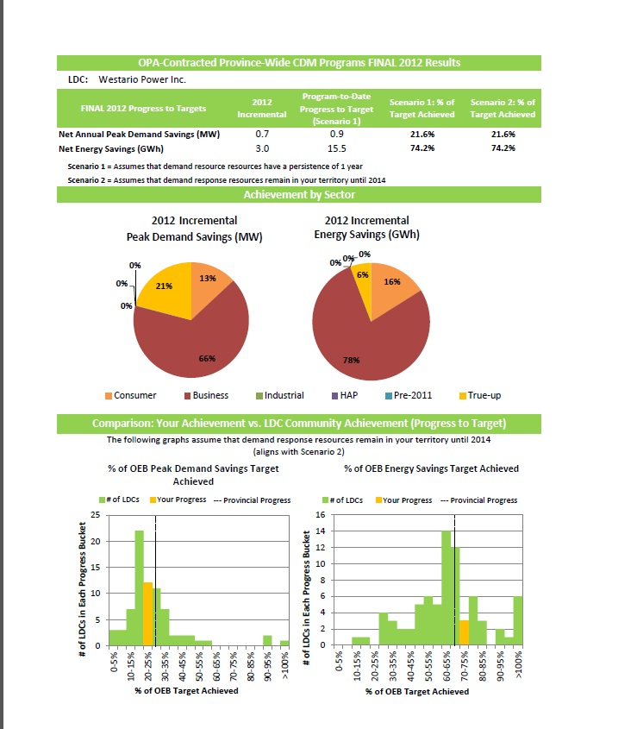

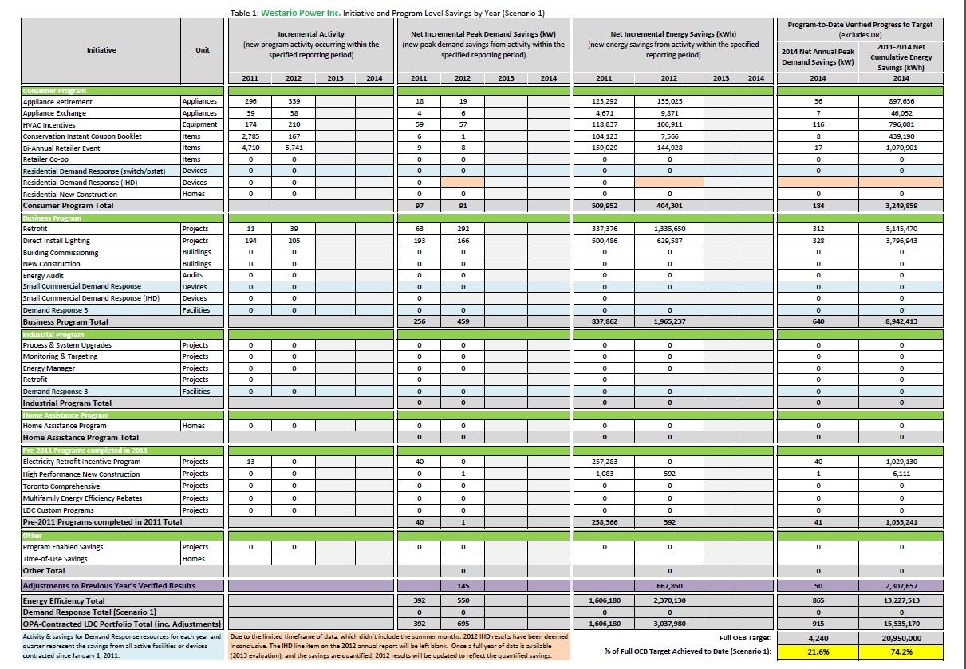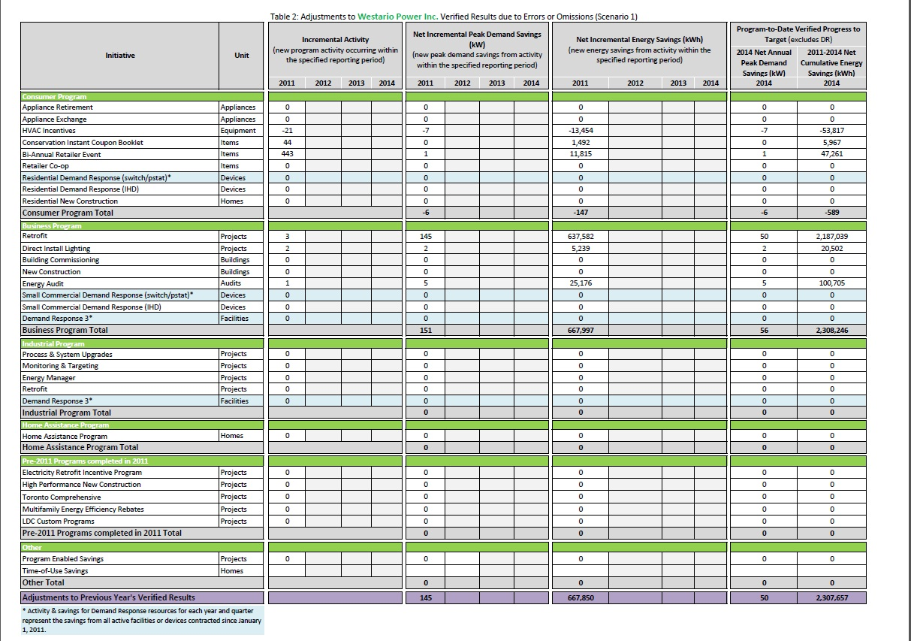

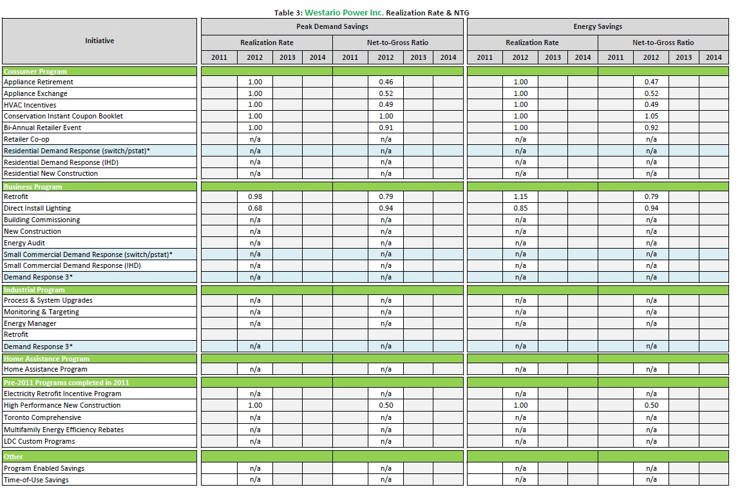
  - Spending
Table 3: 2012 Spending
Initiative |  | Program Administration Budget (PAB) |  | Participant Based Funding (PBF) |  | Participant Incentives (PI) |  | Capability Building Funding (CBF) | TOTAL
Consumer Program
Appliance Retirement |  | 13,029.69 |  |  |  |  |  |  | 13,029.69
Appliance Exchange
HVAC Incentives
Conservation Instant Coupon Booklet
Bi-Annual Retailer Event
Retailer Co-op
Residential Demand Response
New Construction Program
Business Program
Efficiency: Equipment Replacement |  | 129,571.17 |  |  |  | 20,093.00 |  |  | 435893.42
Direct Installed Lighting |  |  |  | 57,375.00 |  | 226,094.25
Existing Building Commissioning Incentive
New Construction and Major Renovation Initiative |  |  |  |  |  | 2,760.00
Energy Audit |  |  |  |  |  | 5100.00
Small Commercial Demand Response (part of the Residential program schedule)
Demand Response 3 (part of the Industrial program schedule)
Industrial Program
Process & System Upgrades |  | 3,960.20 |  |  |  |  |  |  | 3,960.20
a) preliminary engineering study
b) detailed engineering study
c) program incentive
Monitoring & Targeting
Energy Manager
Key Account Manager (“KAM”)
Efficiency: Equipment Replacement Incentive (part of the C&I program schedule)
Demand Response 3
Home Assistance Program
Home Assistance Program |  | 1,372.58 |  |  |  |  |  |  | 1,372.58
Pre 2011 Programs
Electricity Retrofit Incentive Program
High Performance New Construction
Toronto Comprehensive
Multifamily Energy Efficiency Rebates
Data Centre Incentive Program
EnWin Green Suites
Initiatives Not In Market
Midstream Electronics
Midstream Pool Equipment
Demand Service Space Cooling
Demand Response 1 (Commercial)
Demand Response 1 (Industrial)
Home Energy Audit Tool
TOTAL Province-wide CDM PROGRAMS

Table 4: Cumulative Spending (2011-2014)
Initiative |  | Program Administration Budget (PAB) |  | Participant Based Funding (PBF) |  | Participant Incentives (PI) |  | Capability Building Funding (CBF) | TOTAL
Consumer Program
Appliance Retirement |  | 20,127.16 |  |  |  |  |  |  | 20,127.16
Appliance Exchange
HVAC Incentives
Conservation Instant Coupon Booklet
Bi-Annual Retailer Event
Retailer Co-op
Residential Demand Response
New Construction Program
Business Program
Efficiency: Equipment Replacement |  | 220,147.70 |  |  |  | 217,765.55 |  |  | 623524.50
Direct Installed Lighting |  |  |  | 24,255.00 |  | 161386.30
Existing Building Commissioning Incentive
New Construction and Major Renovation Initiative
Energy Audit
Small Commercial Demand Response (part of the Residential program schedule)
Demand Response 3 (part of the Industrial program schedule)
Industrial Program
Process & System Upgrades |  | 8541.96 |  |  |  |  |  |  | 8541.96
a) preliminary engineering study
b) detailed engineering study
c) program incentive
Monitoring & Targeting
Energy Manager
Key Account Manager (“KAM”)
Efficiency: Equipment Replacement Incentive (part of the C&I program schedule)
Demand Response 3
Home Assistance Program
Home Assistance Program |  | 1372.58 |  |  |  |  |  |  | 1372.58
Pre 2011 Programs
Electricity Retrofit Incentive Program
High Performance New Construction
Toronto Comprehensive
Multifamily Energy Efficiency Rebates
Data Centre Incentive Program
EnWin Green Suites
Initiatives Not In Market
Midstream Electronics
Midstream Pool Equipment
Demand Service Space Cooling
Demand Response 1 (Commercial)
Demand Response 1 (Industrial)
Home Energy Audit Tool
TOTAL Province-wide CDM PROGRAMS

- Combined CDM Reporting Elements
  - Progress Towards CDM Targets

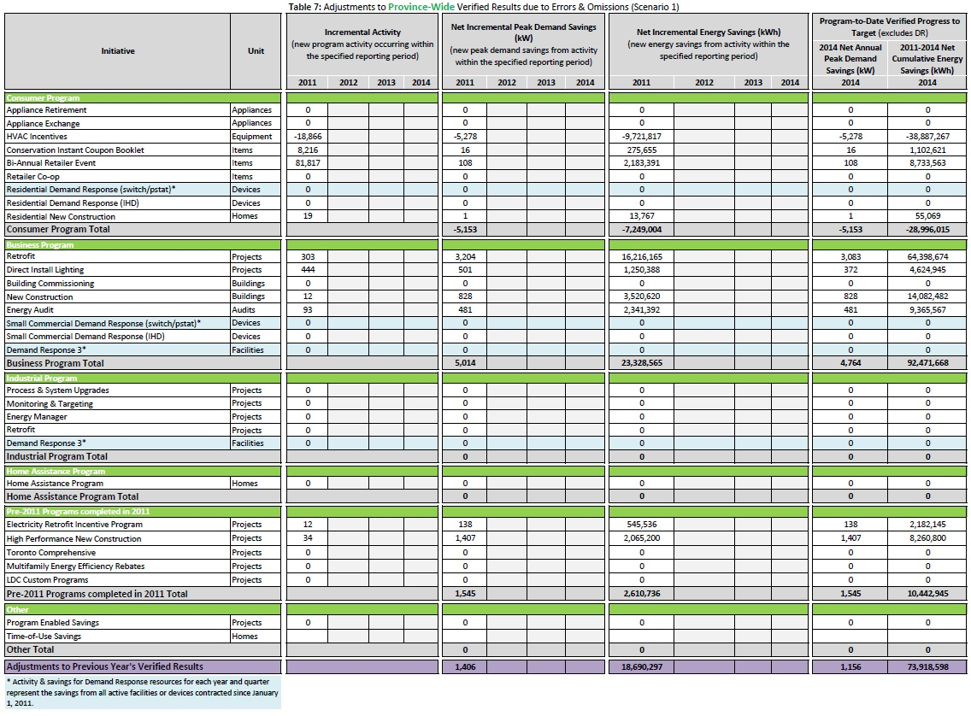

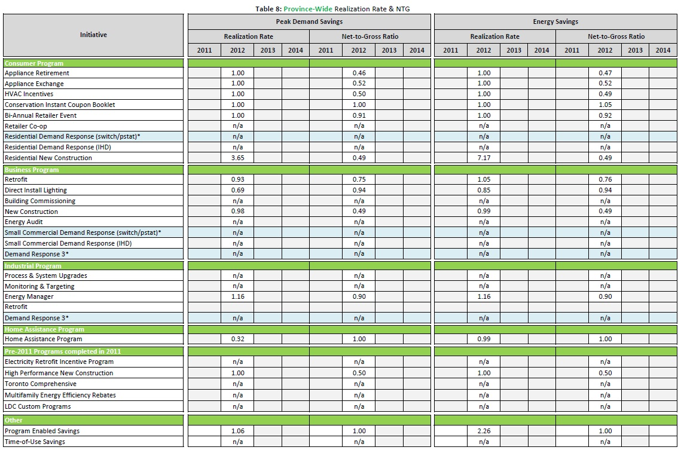

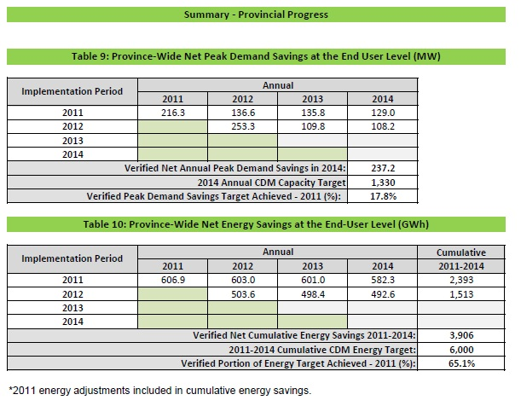
  - Variance from Strategy
Westario Power Inc. has not deviated from its amended strategy submitted on June 23rd 2011.

  - Outlook to 2014 and Strategy Modifications
Westario Power Inc. does not have plans to modify our strategy in 2013

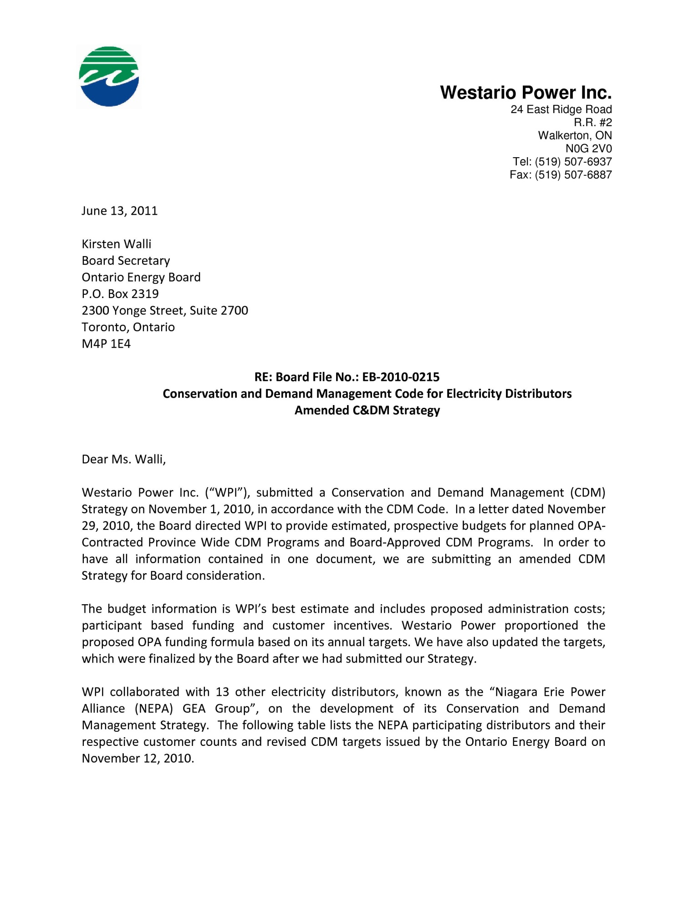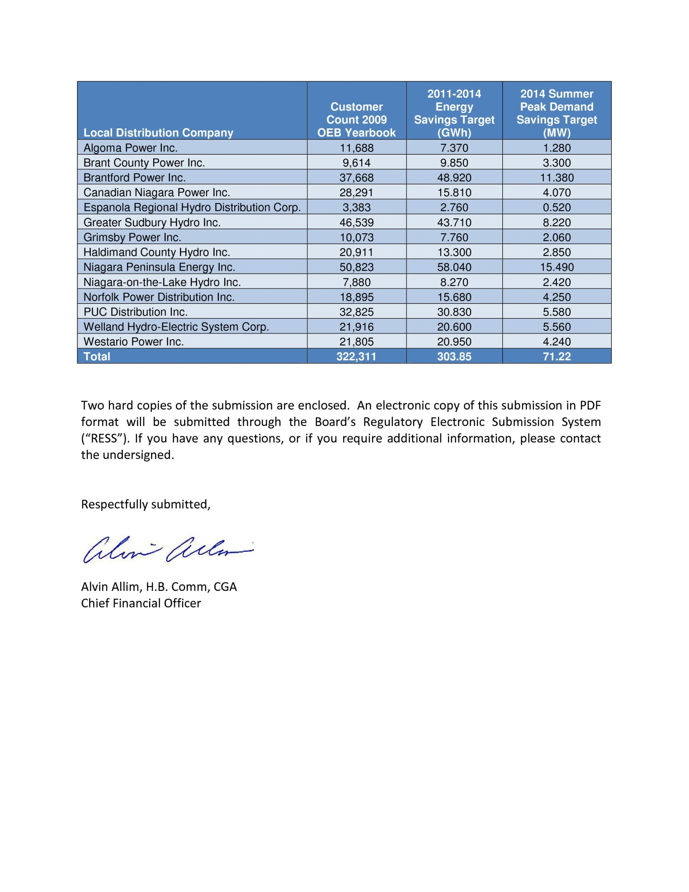

6.0 Conclusion

Over the course of 2012, Westario Power Inc. has achieved 0.9 MW in peak demand savings and 15.5 GWh in energy savings, which represents 21.6% and 74.2% of Westario Power Inc. 2014 target, respectively. These results are representative of a considerable effort expended by LDC Name, in cooperation with other LDCs, customers, channel partners and stakeholders to overcome many operational and structural issues that limited program effectiveness across all market sectors. This achievement is a success and the relationships built within the 2011-2014 CDM program term will aid results in a subsequent CDM term.
However, despite continuing improvements to existing programs Westario Power Inc. faces challenges in the remaining years of the current CDM framework. With the current slate of available OPA Programs, and the current forecast of implementation and projected savings, Westario Power Inc. expects to meet its consumption target but will struggle to meet its savings target. Westario Power Inc. expects a shortfall to its target in savings by the end of 2014.
Looking ahead there is limited opportunity to make valuable changes to the current program portfolios and have these changes reflected in LDC 2014 results. However, LDCs and the OPA can build on the strengths and key successes of the 2011-2014 programs to launch new programs which will meet the needs of the industry and consumers.

