Innisfil Hydro Distribution Systems
Interrogatory Response – EB-2013-0144
October 17, 2013

Innisfil Hydro Distribution Systems Limited (IHDSL)
EB-2013-0144
Interrogatory Response

RTSR Model
Interrogatory #1
Ref: RTSR Model, Tab 4 – “RRR Data”
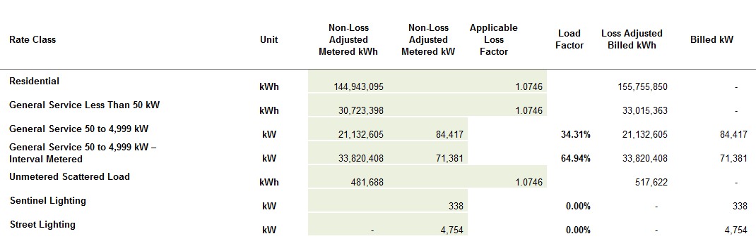
- Please confirm that the data entered in columns “Non-Loss Adjusted Metered kWh” and “Non-Loss Adjusted Metered kW” are not adjusted by Innisfil Hydro’s Board approved loss factor.

IHDSL Response
Interrogatory #1
IHDSL confirms that the data entered in the columns “Non-Loss Adjusted Metered kWh” and “Non-Loss Adjusted Metered kW” are not adjusted by IHDSL’s Board approved loss factor.

~Respectfully Submitted~

