November 22, 2013

Board Secretary

Ontario Energy Board
PO Box 2319
27th Floor 2300 Yonge Street
Toronto ON M4P 1E4

Attn: Kirsten Walli

RE: Collus PowerStream Corp. (License ED-2002-0518)
2013 Electricity Distribution Rates Application EB-2012-0116
Objection to School Energy Coalition cost claims

Collus PowerStream (Collus) is withdrawing their objection to cost claims as filed by School Energy Coalition.

If you have any questions please do not hesitate to contact the undersigned at gmcallister@collus.com or (705)445-1800 ext 2274.

Yours truly,
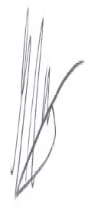

Glen McAllister, B.Sc., CMA
Manager, Billing & Regulatory
Collus PowerStream

