March 30, 2014

File No: EB-2013-0439 (K2 Wind Ontario Limited Partnership - Application for Electricity Generating Licence)

Ontario Energy Board
P.O. Box 2319
27th Floor
2300 Yonge Street
Toronto, ON M4P 1E4
Attention: Kirsten Walli - Board Secretary - email: boardsec@ontarioenergyboard.ca

Dear Sirs;

With regard to the ongoing application of K2 Wind for a generating licence, the residents of Ashfield-Colborne-Wawanosh would like to provide the OEB with an update of the situation as it is unfolding in the Township.

1. Drainage Issue

As previously noted in our comments to the Board, it is our understanding that the Township had advised K2 Wind in writing to cease its illegal collection and direction of water onto the Township road allowance by February 5, 2014. A copy of the Council Report on this incident is contained in Appendix A. In response to this directive, a load of gravel was dumped at the outlet to the ditch that had been dug. On Friday March 7, 2014, subsequent to this direction from the Township, a high-hoe was present at the K2 Wind lands where the drainage problems have been created for the adjacent landowner. This high-hoe proceeded to re-open the outlet in apparent contravention and disregard of the Township’s direction.

It is also our understanding that District MOE staff have now issued a Provincial Officer’s Order to both K2 Wind and HONI for the site requiring that they take all necessary steps to prevent the discharge of surface water to neighbouring properties and roadways. However, this directive and that of the Township appear to have been violated again as recently as March 28 when the berm on the site was disturbed and water allowed to flow onto the neighbouring farm.

The amount of water present on this property is such that tanker trucks were being used to pump water on March 21 and truck it to another dumping site. Photos of the high-hoe and the water tanker in operation are included in Appendix A. This pumping of water has continued since that time. With the milder weather and rainfall which we experienced late last week, the water issues at the switchyard site increased and there was a great deal of activity over the weekend (March 28-30). That activity continues. K2 Wind’s REA approval allowed for a maximum water taking of 50,000 litres per day. On Friday night four large tanker trucks left the site. Their combined capacity would easily exceed 50,000 litres. A large water pump ran all Friday night diverting water illegally from one watershed to another. This pump appears to be capable of exceeding 50,000 litres per HOUR by itself.

K2 Wind has now brought forward a petition to the Township for the installation of a municipal drain to address the water issues on this site. This is a clear indication that the scope of the drainage and surface water problems associated with this site is far beyond the picture initially portrayed by K2 Wind in submissions to the OEB for Leave to Construct and to the MOE as part of their REA application. The residents would point out to the Board that the proposed drainage solution could involve municipal drain works (that require ongoing maintenance) crossing a buried 230 kV transmission line as approved by the OEB directive in EB-0458-2012. This buried 230 kV transmission line, as approved, has no mechanical protection incorporated into its design.

2. Trespass Incident

On Friday March 14, 2014 another disturbing incident of trespass occurred in ACW involving the contractors working for K2 Wind. A truck and attached trailer trespassed onto Mr. Alton’s farm and parked in his laneway in clear view of a sign warning against trespass due to biosecurity concerns. Mr. Alton had sufficient time to block the trespassing vehicle and trailer to prevent a hasty exit once they were discovered. It is our understanding that K2 Wind contacted the police to retrieve their contractor’s truck and trailer. The incident was filmed by a neighbouring landowner. Photos of the trespassing incident are attached as Appendix B. It is our understanding that Mr. Alton is demanding a full report from K2 Wind regarding the incident and the decontamination measures that they intend to take.

This incident is disturbing for many reasons. Firstly, the fact that the incident happened at all is an indication that the rights of non-participating landowners in this Township are being ignored. Mr. Alton has previously experienced trespassing issues in relation to the K2 project and he has already brought this issue to the attention of the company and the Township. Secondly, the farm in question has clear postings warning against trespass due to bio-security issues. Bio-security is a huge issue for livestock farmers and has major animal welfare and economic implications for them. The disregard shown for the severity of this breach of Mr. Alton’s biosecurity measures is a mark against the character of the company behind this project.

Clearly the problems and concerns outlined in our previous submissions to the Board are not being effectively addressed by K2 Wind.

Yours truly,

Anita Frayne - On behalf of the Residents Group

Cc. K2 Wind Ontario Limited Partnership
77 King Street West
Suite 400 - Toronto Dominion Centre
Toronto
Ontario, M5K 0A1
Attention: Helen Newland - email: helen.newland@dentons.com

APPENDIX A: Copy of Council Report Regarding Drainage Problems at K2 Wind Property - Township of ACW

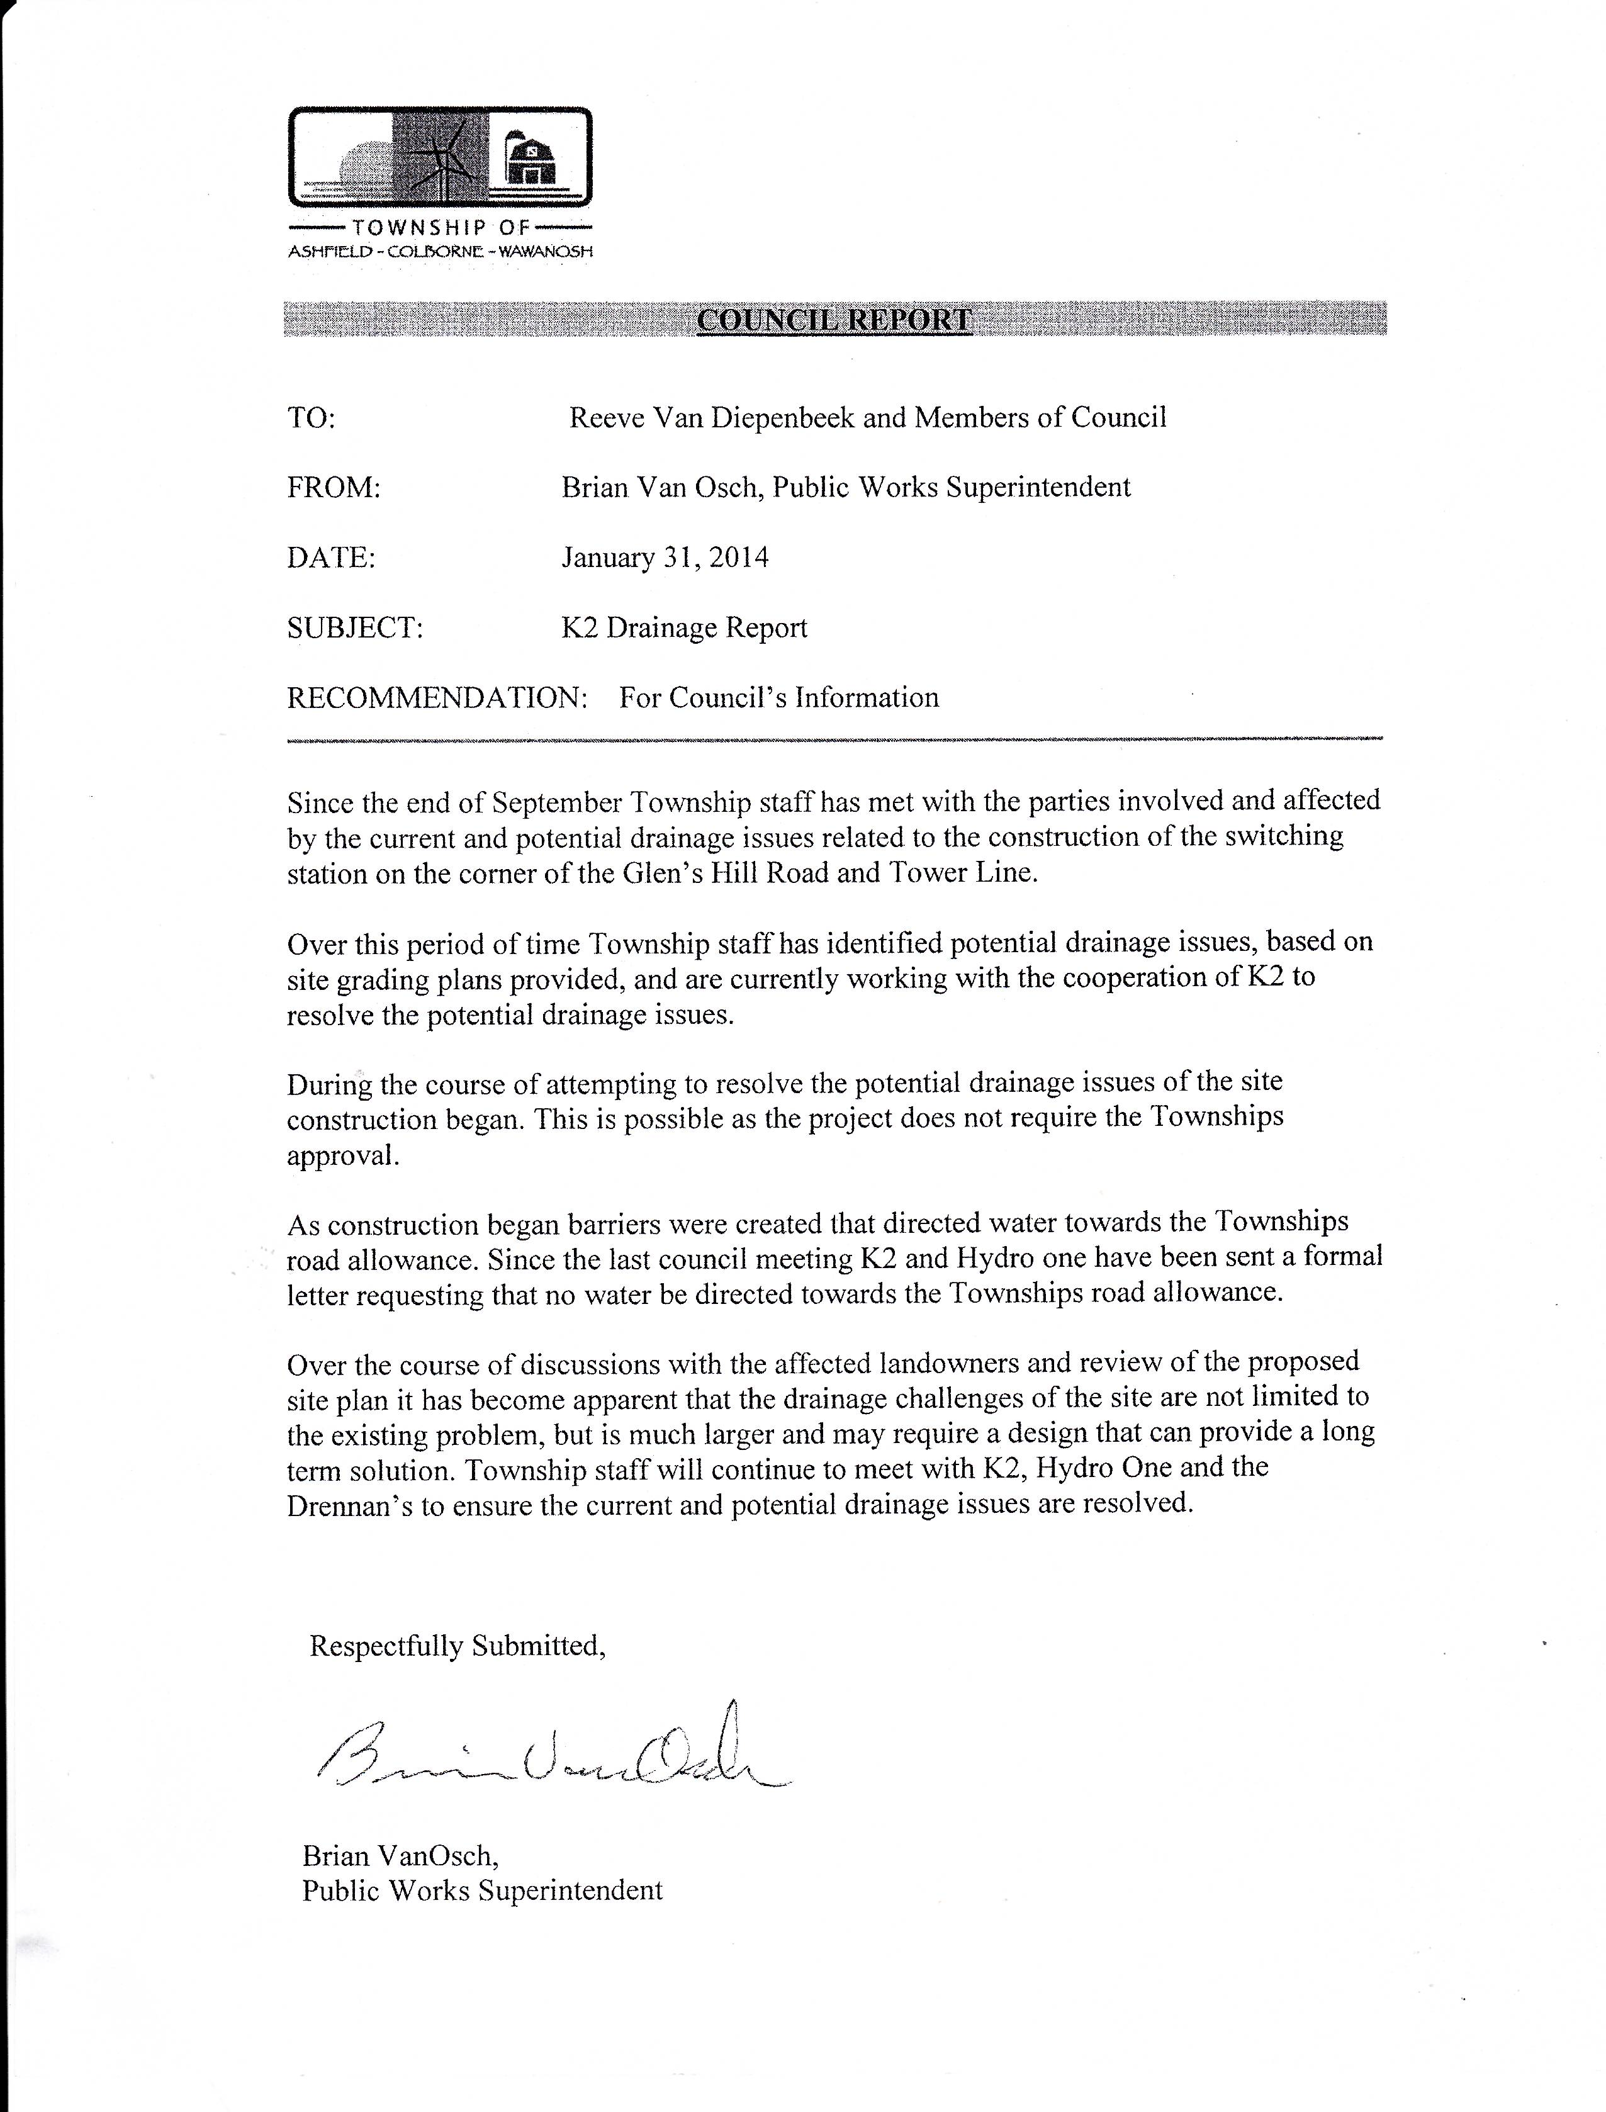

PHOTO 1: Photo taken on March 21, 2014 of K2 Wind property in ACW showing surface water problems with the site.

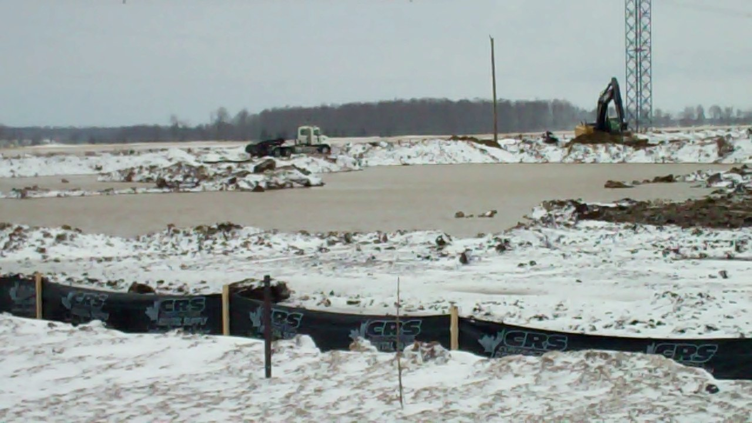

PHOTO 2: Photo taken on March 21, 2014 showing pumper truck and hose siphoning excessive water from K2 Wind property in ACW.

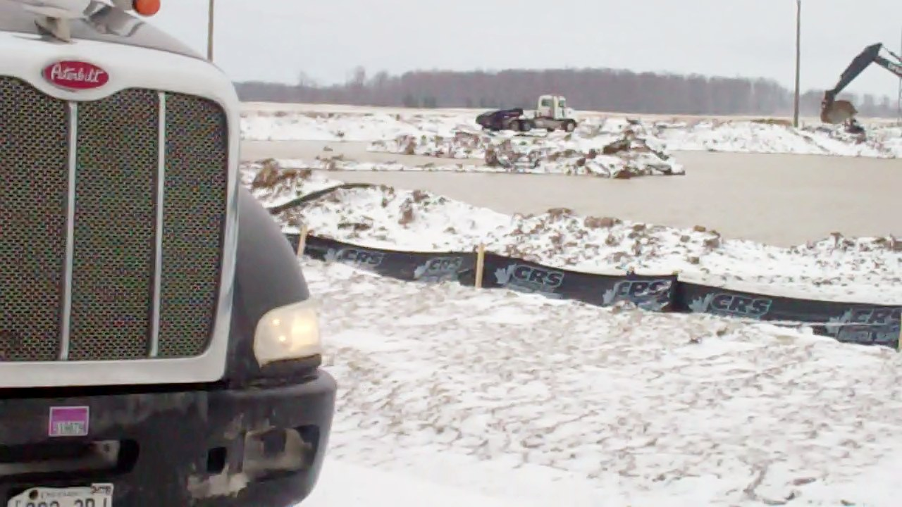
APPENDIX B: Photos of Trespassing Incident in ACW Related to Construction of K2 Wind Project. Photos were taken on March 14, 2014.

Photo 1: The white truck and attached trailer are parked without permission in the laneway of a non-participating landowner in ACW. The police have attended at the scene. The man in the orange safety vest is Glenn Hubbers of K2 Wind.

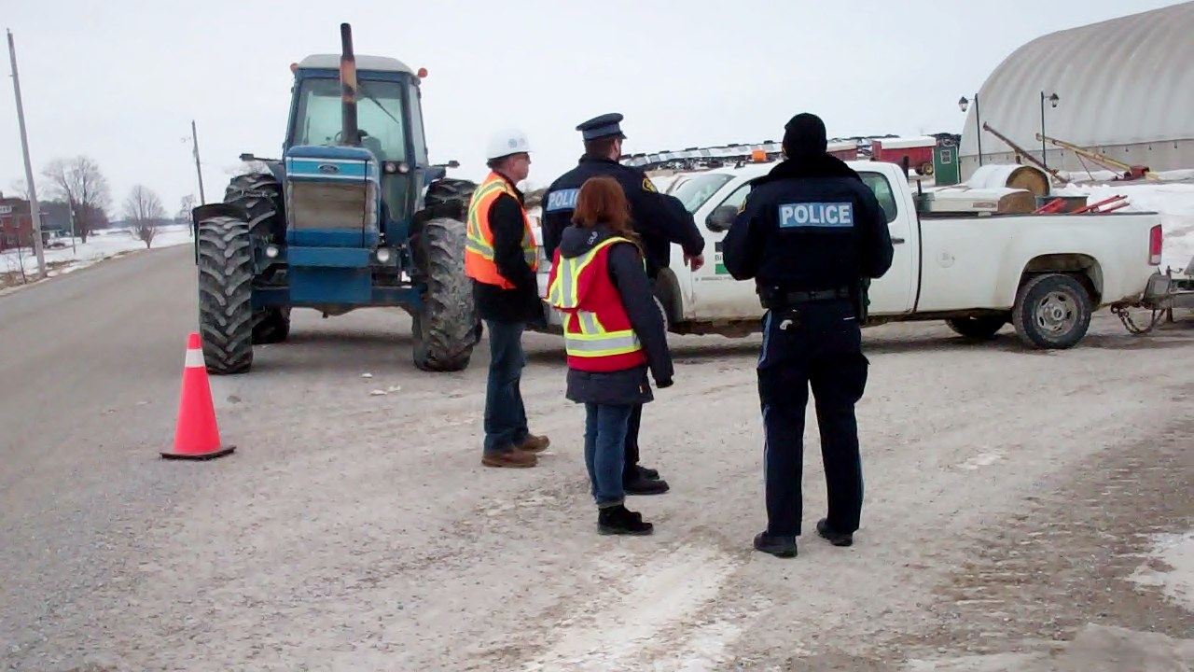

Photo 2: Glenn Hubbers of K2 Wind and a representative of Black & Macdonald
discussing the trespass incident with police.


Photo 3: The trailer is entirely located on private property.

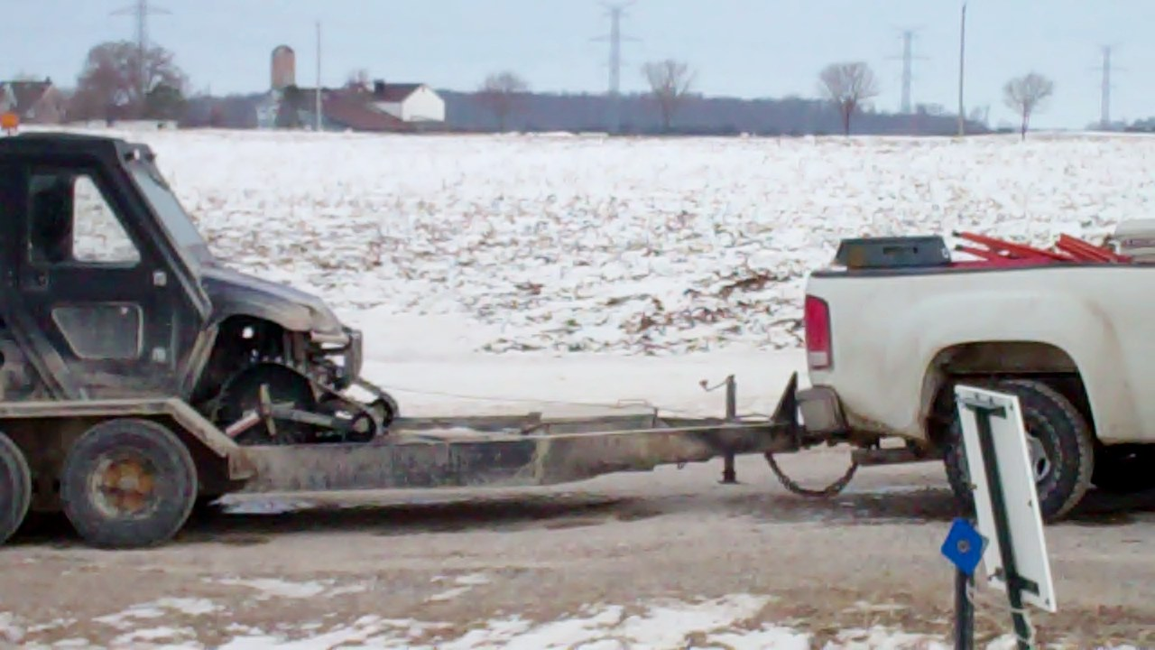

Photo 4: Mr. Alton’s farm is posted against trespassing.

