June 23, 2014

Marika Hare, Presiding Member
Ontario Energy Board
2300 Yonge Street, 27th Floor
Toronto, Ontario Canada M4P 1E4

In re: File No. EB-2013-0321
In the matter of: Application by Ontario Power Generation Inc. for an order
determining payment amounts for the output of certain of
its generating facilities

Submitted by: Electric Utility Cost Group, Inc. (EUCG)

To the Honorable Presiding Member Hare:

1. This letter objecting to the Board’s decision to deny confidentiality to certain data submitted by Ontario Power Generation Company (OPG) is submitted on behalf of the Electric Utility Cost Group (EUCG, Inc.), a not-for-profit corporation incorporated in the United States, in the State of Arizona, with its office in Virginia and recognized as a tax-exempt organization under §501(c)(6) of the Internal Revenue Code of the United States.

2. The Board denied OPG’s request to keep the EUCG data confidential because individual participants’ data were not identifiable and any confidentiality agreements among EUCG, its committees or its members are not binding on the OEB. The general policy of the OEB is that all records should be open for inspection by any person unless prohibited by law.

3. In response to this rationale, the EUCG respectfully points out to the OEB that the data submitted by OPG can be “reverse engineered” by a competent professional person to discern the identities of the utilities which participated in the study. Using the data submitted by OPG, a person who knew what he or she was doing could identify individual plant identities with the help of Google. At the same time, the data are impenetrable and hence of little value to an average ratepayer.

4. The essence and lifeblood of EUCG are its data gathering and exchange programs and its benchmarking work. Without these, EUCG would cease to exist. The two fundamental pillars of the EUCG data exchange programs, in turn, are confidentiality and what is termed the “give to get” policy.

5. With respect to confidentiality, a condition of confidentiality is written into the very bylaws of EUCG which, legally, are the equivalent of a contract between EUCG and its members; every year, members sign a confidentiality agreement promising to keep data they receive from the EUCG confidential.

6. With respect to the “give to get” policy, that policy simply says that in order to receive benchmarking data, the utility must participate in the gathering of those data.

7. Again, these two principles – confidentiality and “give to get” – are the indispensable underpinnings of EUCG’s entire data exchange program: without a promise of confidentiality, utilities would not submit any data; and without reciprocity, utilities would seek to avoid submitting any data, while seeking to obtain data from others. Moreover, without this incentive to participate, the statistical and empirical validity of the data would be in question due to small sample size.

8. EUCG’s data exchange programs comply strictly and literally with United States antitrust law: raw data are gathered by an independent third party contractor; all data are at least three months old; data are aggregated so that individual contributors and individual transactions are not readily identifiable.

9. Precisely because participation in EUCG data exchange programs is so high (for example, participation in EUCG’s Nuclear Committee is virtually 100%: every single nuclear facility in the United States (and even some plants in foreign countries), with perhaps one exception, participates in that committee’s benchmarking studies); and because the data gathered are so extensive, comprehensive and detailed; the EUCG databases have tremendous commercial value.

10. EUCG data surveys require extensive work to compile, verify, and store the data for retrieval by its members. If the hours expanded for that purpose by the Hydro Committee alone (one of the five constituent committees of EUCG) were tallied up and assigned a dollar value, that dollar value would approximate $500,000 to $800,000 CAD per year, every year. Ten years of data would thus represent an investment of $5 to $8 million. As a not-for-profit, tax-exempt corporation recognized by the United States Internal Revenue Service as organized to advance the interests of the entire utility/power industry, EUCG makes survey results available to members and even, to some extent, to the general public. This is a public service.

11. Indeed, EUCG has never sold its databases to anyone (even though it could do so at substantial profit), while being approached many times by for-profit consultants and firms to buy the databases or otherwise have access to them and EUCG has several significant for-profit competitors in the field of utility data exchange.

12. In light of the above, EUCG’s response to the OEB’s first question in §5.1.4 of its Practice Direction on Confidential Filings (Rev. Apr 24 2014) – why the information is considered confidential – is 1) because all data were submitted by participants – none of whom have any opportunity to object to the Board’s decision – under the premise and solemn, contractual promise of confidentiality; 2) participating utilities have submitted data which they classify as sensitive, confidential and proprietary and which they would not voluntarily share with any other utility under any circumstances; 3) as noted above, data submitted to the OEB can be “mined” or “manipulated” to identify which specific, named utilities submitted them; and 5) the database has tremendous commercial and competitive advantage in the private, for-profit sector which would be lost to EUCG’s detriment if the Board were to make the EUCG data submitted by OPG public.

13. EUCG’s response to the second question §5.1.4 of the Board’s Practice Direction directs requesters to answer – why public disclosure of the information would be detrimental – is 1) public disclosure of sensitive, proprietary information that other utilities submitted to EUCG with an expectation of confidentiality will discourage, “chill,” and inhibit – if not destroy outright – utilities’ willingness to participate in future date exchange programs, if they fear their identities, plant sites and individual data will become known to the general public, thereby jeopardizing EUCG’s very existence; and 2) public disclosure will enable for-profit, commercial entities to obtain access to information they regard as tremendously valuable, which EUCG would not sell to them willingly at any price, and which they may commercially exploit to EUCG’s detriment.

14. EUCG understands and concedes that its private, contractual agreements among member utilities and with the EUCG are not legally binding on the OEB. At the same time, EUCG respectfully asks the OEB to be mindful that in Western democracy, the “sanctity of contracts” is a virtually inviolable principle of law. Contract law is one of the oldest, most well-developed areas of law, whose jurisprudence goes back centuries and which makes possible our very way of life. As a general proposition, courts are reluctant to modify, void or overturn contracts negotiated by private parties. EUCG therefore respectfully requests the OEB to balance its rights as a regulatory agency and the rights of the public with the rights of private parties to make contracts, with the expectation that the terms will be honored by the parties and enforced by the courts.

15. With respect to OEB’s general policy that all records should be open for inspection by any person, EUCG respectfully but urgently reminds the Board that this “public policy” of transparency and open and public disclosure is not absolute; it must be balanced against equally legitimate, compelling but competing public policies.

16. EUCG data exchange programs and benchmarking studies serve the important public interest in health and safety, efficiency and in identifying and in helping to disseminate and implement “best practices” that serve the public. The power/energy industry itself, of course, is of fundamental importance to our entire civilization. Other entities – including agencies of the United States Government itself (and this Board itself, for that matter) – look to and rely upon EUCG as a valuable source of information because EUCG’s data exchange programs provide information that is not available anywhere else.

17. If the OEB were simply requiring OPG to put on the public record the final analyses and conclusions of its EUCG data, EUCG would have no objection and would not be writing this letter to the OEB. But as EUCG understands the situation from OPG, the OEB is insisting and demanding that OPG release all raw data underlying the analyses. It is to this wholesale, indiscriminate release of raw data to the “world at large” that EUCG respectfully, but strenuously, objects, for all of the reasons advanced above.

Respectfully submitted,
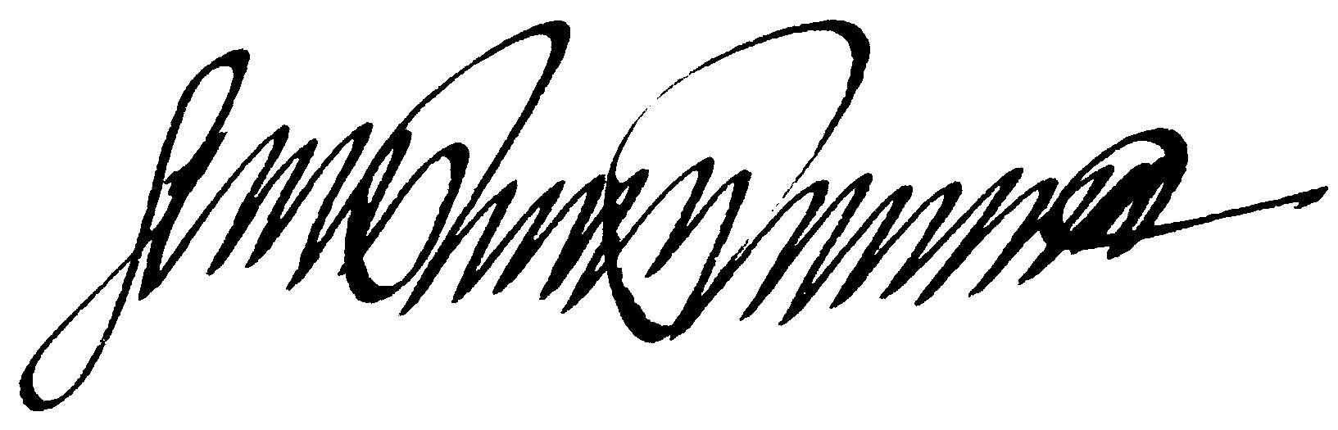
Gerard P. Panaro, Esq.,
General Counsel to EUCG, Inc.

