June 26, 2014

Marika Hare, Presiding Member
Ontario Energy Board
2300 Yonge Street, 27th Floor
Toronto, Ontario Canada M4P 1E4

In re: File No. EB-2013-0321
In the matter of: Application by Ontario Power Generation Inc. for an order
determining payment amounts for the output of certain of
its generating facilities

Submitted by: Electric Utility Cost Group, Inc. (EUCG)

Dear Ms. Hare:

You have requested the Electric Utility Cost Group, Inc. (EUCG) to address the sole issue of “whether or not that information [EUCG data submitted by OPG] can be reverse-engineered so that the identity [of participating utilities] can be made available.” (v. 9 Jun 24 2014, p. 195, lines 23-26.)

To avoid any doubt or confusion, I begin this response with a statement of my understanding, based on discussions with OPG, of what is referred to as “that information” in your statement quoted above. We understand the statement to refer to information that OPG has prepared in response to Interrogatory 84 submitted by the Energy School Consultants (SEC). We do not understand your statement to be referring to OPG’s prior submission (Appendix F1-1-1), which was fully compatible with the benchmarking code of conduct (Other utility data aggregated).

SEC #84 requests “copies of all documents, reports, presentations, and any other analysis for hydroelectric benchmarking undertaken by OPG,” including those conducted by EUCG, Inc. “[A]ll documents” would include EUCG database records such as cost, plant profile and performance data, all of which data are interlinked. Because the data elements are linked among themselves (to make a record, as it is normally done in databases), knowing to which plant one or two parameters belong (see below), allows the others, such as cost, to be associated with the specific plant. This is how databases are built.

EUCG benchmarking data contain a myriad of “parameters” defining the participants so as to put the data in context (and also comply with US antitrust law with respect to sample size and weighting). Such “parameters” include plant megawatt capacity, the number of active units, and the river system, some of which may be unique and may be used to identify the participant. In many cases, knowledge of even one of these parameters or “identifiers” is sufficient to allow the knowledgeable user to “reverse engineer” the data and identify the plant which submitted them. Once this is done, all other data submitted by that plant can be identified. While it is possible to speculate that removing some of the most telling data elements can result in additional difficulties in reverse engineering of plant identities, EUCG policy is not to allow its member utilities any release of other plants’ individual (not-aggregated) records.

If the Board directs, a representative of OPG should be able to demonstrate – simply and in a matter of minutes – how EUCG data can be used to yield utility participant identification. For obvious reasons, however, Madam Chair, we would insist that such demonstration be in camera and not on the public record. EUCG has no interest whatever – and we believe it would be highly detrimental and prejudicial to EUCG’s core interests – to have such techniques on the public record where any one could access and use them. We do not want to give the burglar the combination to the safe, so to speak.

Finally, Ms. Hare, please allow me to conclude by putting this response in a broader context. I think it bears noting that OEB and the intervenors have full access to EUCG data in the possession of OPG, including an explanation of the methodologies used in gathering the data. All that EUCG is urgently petitioning the Board to do, is to keep these databases confidential, and not disclose them “to the world at large,” so that they can potentially be exploited for commercial, competitive purposes, not in accord with the limited purpose of evaluating OPG’s performance. These databases are the property of EUCG, Inc., which owns them and releases them. The databases are not the property of OPG. The average ratepayer would be unable to make any practical use or sense of the databases, so that no legitimate public policy would be served by their indiscriminate and wholesale release.

Respectfully submitted,
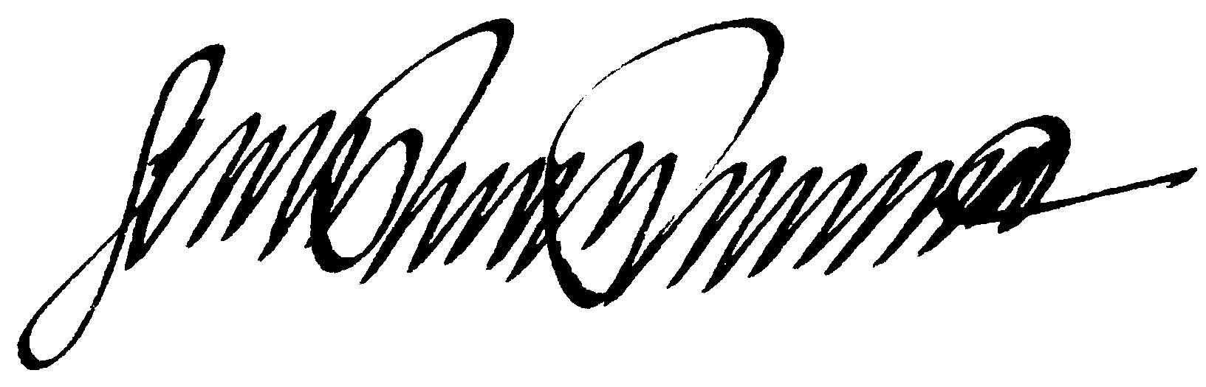
Gerard P. Panaro, Esq.,
Counsel for EUCG, Inc.

