J. Mark Rodger  T 416.367.6190  F 416.361.7088  mrodger@blg.com | Borden Ladner Gervais LLP  Scotia Plaza, 40 King Street W  Toronto, ON, Canada M5H 3Y4  T 416.367.6000  F 416.367.6749  blg.com | 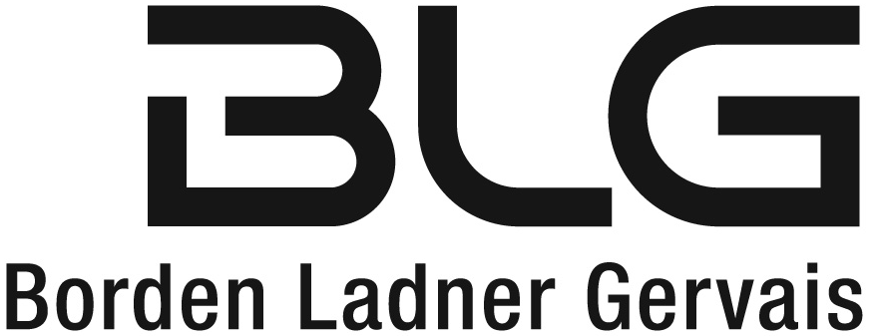
James Sidlofsky
T 416.367.6277
F 416.361.2751
jsidlofsky@blg.com
August 20, 2014
Delivered by Email
Ontario Energy Board
2300 Yonge Street
26th Floor, Box 2319
Toronto, ON M4P 1E4

Attention: Ms. Kirsten Walli, Board Secretary

Dear Ms. Walli:

Re: | EB-2014-0002  Horizon Utilities Corporation – Five Year Custom Distribution Rate Application
We are counsel to Horizon Utilities in the above captioned matter. Horizon Utilities and the intervenors are prepared to accept the issues list in the form circulated by Board Staff at 2:59 pm this afternoon (attached). As a result, we submit and request that it will not be necessary for the parties to appear at the Issues Hearing scheduled for tomorrow.
Should you require further information, please do not hesitate to contact me.
Yours very truly,
BORDEN LADNER GERVAIS LLP

original signed by Mark Rodger

J. Mark Rodger
Incorporated Partner*

*Mark Rodger Professional Corporation

JMR
Encls.

copy to: John G. Basilio, Horizon Utilities Corporation
Indy J. Butany-DeSouza, Horizon Utilities Corporation
Intervenors
Maureen Helt, OEB
Christie Clark, OEB

TOR01: 5683925: v1

