**Hydro Hawkesbury Inc. (EB-2014-0082)**

**Application Analysis**

**Tab 3 – Rate Class Selection**

* MicroFIT class not selected. Please confirm that this should be selected and staff will update the model.

**Response: Correct, could you please add MicroFIT to the list of classes.**

**Staff: Corrected.**

**Tab 4 – Current Tariff Schedule**



* The above line item is listed under all rate classes in the “Monthly Rates and Charges – Delivery Component”. It should be removed as it was only effective until April 30, 2014. Also – this is a regulatory component. Please confirm and staff will make the necessary adjustments to the model.

**Response: Correct, could you please remove rate riders which expire in April of 2014.**

**Staff: Corrected.**

**Tab 5 – Continuity Schedule**

**Staff: Staff is ok with all the explanations provided by Hydro Hawkesbury for Tab 5 re: continuity schedule. Board staff reviewed all applicable previous Board decisions re: DVA accounts including: EB-2009-0186 (2010 EDR), EB-2010-0090 (2011 EDR), EB-2011-0173 (2012 EDR), EB-2012-0134 (2013 EDR), EB-2013-0139 (2014 EDR).**

* 2010 - Staff is unable to reconcile the Board-approved disposition for interest in 2010 (column L) to Hydro Hawkesbury’s 2012 EDR Decision and Order (EB-2011-0173). Please provide an explanation for the discrepancy.

**Response: Hawkesbury Hydro believes that the balances it used at Tab 5 of the IRM Rate Generator are correct as they reconcile with the OEB’s approved balances. Screenshots are presented below. The only exception is account 1590 which shows a balance of $158 in the decision which is not in the model.**

**Hydro Hawkesbury has attached a letter from the Board issued on May 3, 2012 which indicated that the $158 was an error on the Board’s part (see appendix A).**

**Also note that some of the variances may be due to Hawkesbury Hydro following the model’s instructions which state that; *a utility must Include Account 1595 as part of Group 1 accounts for review and disposition if the recovery (or refund) period has been completed. If the recovery (or refund) period has not been completed, do not include the respective balance in Account 1595 for disposition at this time.***

**(excerpt from the Board Decision EB-2011-0173)**

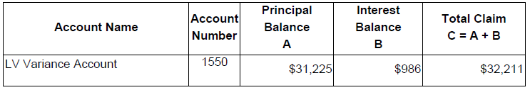

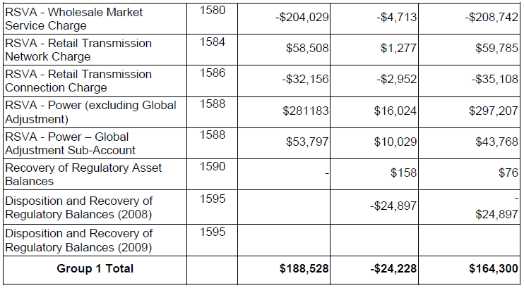

|  |  |  |  |  |  |  |  |  |  |
| --- | --- | --- | --- | --- | --- | --- | --- | --- | --- |
|  | **2012** | | | | | | | | |
|  | **Opening Principal Amounts as of Jan-1-12** | **Transactions Debit / (Credit) during 2012 excluding interest and adjustments 2** | **Board-Approved Disposition during 2012** | **Closing Principal Balance as of Dec-31-12** | **Opening Interest Amounts as of Jan-1-12** | **Interest Jan-1 to Dec-31-12** | **Board-Approved Disposition during 2012** | **Adjustments during 2012 - other 1** | **Closing Interest Amounts as of Dec-31-12** |
|  |
|  |
|  |  |  |  |  |  |  |  |  |  |
| 1550 | 69,327 | 47,720 | 31,225 | 85,822 | 1,178 | 1,136 | 986 |  | 1,328 |
| 1551 |  |  |  |  |  |  |  |  | 0 |
| 1580 | (375,862) | (113,568) | (204,029) | (285,400) | (6,127) | (4,900) | (4,713) |  | (6,314) |
| 1584 | 54,044 | (7,549) | 58,508 | (12,013) | 1,121 | 445 | 1,277 |  | 289 |
| 1586 | (66,046) | (20,931) | (32,156) | (54,821) | (3,384) | (917) | (2,952) |  | (1,349) |
| 1588 | 615,912 | 112,792 | 281,183 | 447,520 | 17,724 | 9,457 | 16,024 |  | 11,157 |
| 1589 | 574,082 | 266,286 | 53,797 | 786,571 | (3,090) | 9,482 | (10,029) |  | 16,421 |
| 1590 | 0 |  |  | 0 | 0 |  |  |  | 0 |
| 1595 | (452,430) | 305,003 |  | (147,428) | (87,817) | 16,812 | (24,897) |  | (46,108) |
| 1595 | 324,224 | (215,639) |  | 108,585 | 41,524 | (22,176) |  |  | 19,348 |
| 1595 | 0 | (106,978) | (196,426) | 89,447 | 0 | 14,698 | 25,036 |  | (10,339) |
| 1595 | 0 |  |  | 0 | 0 |  |  |  | 0 |
| 1595 | 0 |  |  | 0 | 0 |  |  |  | 0 |
|  |  |  |  |  |  |  |  |  |  |

* 2011 – Staff notes that the Board-approved disposition in 2011 is listed under the incorrect column (i.e. Transactions Debit/(Credit) during 2011 excluding interest and adjustments). Staff also is unable to reconcile the Board-approved disposition for interest in 2011 (column V) to Hydro Hawkesbury’s 2013 EDR Decision and Order (EB-2012-0134). Please provide an explanation for these discrepancies.

**Response: Hawkesbury Hydro believes that the balances it used at Tab 5 of the IRM Rate Generator are correct as they reconcile with the OEB’s approved balances. Screenshots are presented below.**

**(excerpt from the Board Decision EB-2012-0134)**

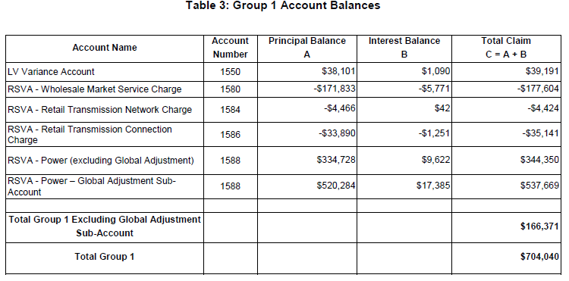

|  |  |  |  |  |  |  |  |  |  |
| --- | --- | --- | --- | --- | --- | --- | --- | --- | --- |
|  | **Opening Principal Amounts as of Jan-1-13** | **Transactions Debit / (Credit) during 2013 excluding interest and adjustments 2** | **Board-Approved Disposition during 2013** | **Closing Principal Balance as of Dec-31-13** | **Opening Interest Amounts as of Jan-1-13** | **Interest Jan-1 to Dec-31-13** | **Board-Approved Disposition during 2013** | **Adjustments during 2013 - other 1** | **Closing Interest Amounts as of Dec-31-13** |
|  |
|  |
|  |  |  |  |  |  |  |  |  |  |
| 1550 | 85,822 | 40,453 | 38,102 | 88,173 | 1,328 | 1,284 | 1,090 |  | 1,522 |
| 1551 | 0 | 3,542 |  | 3,542 | 0 | 52 |  |  | 52 |
| 1580 | (285,400) | (117,138) | (171,833) | (230,706) | (6,314) | (3,953) | (5,771) |  | (4,496) |
| 1584 | (12,013) | 43,349 | (4,466) | 35,802 | 289 | 281 | 42 |  | 528 |
| 1586 | (54,821) | 1,460 | (33,891) | (19,470) | (1,349) | (549) | (1,251) |  | (647) |
| 1588 | 447,520 | (187,454) | 334,729 | (74,663) | 11,157 | 5,939 | 9,622 |  | 7,473 |
| 1589 | 786,571 | 577,354 | 520,284 | 843,641 | 16,421 | 11,207 | 17,385 |  | 10,243 |
| 1590 | 0 |  |  | 0 | 0 |  |  |  | 0 |
| 1595 | (147,428) |  |  | (147,428) | (46,108) | (2,167) |  |  | (48,276) |
| 1595 | 108,585 | (76,506) |  | 32,080 | 19,348 | (10,797) |  |  | 8,551 |
| 1595 | 89,447 | (87,563) |  | 1,884 | (10,339) | 11,318 |  |  | 980 |
| 1595 | 0 |  |  | 0 | 0 |  |  |  | 0 |
| 1595 | 0 |  |  | 0 | 0 |  |  |  | 0 |
|  |  |  |  |  |  |  |  |  |  |

* 2012 – Same issue as above, although staff is also unable to reconcile the amounts for disposition in either column Z or AA to previous Decision EB-2013-0139. Please provide an explanation for these discrepancies.

**Response: Hawkesbury Hydro believes that the balances it used at Tab 5 of the IRM Rate Generator are correct as they reconcile with the OEB’s approved balances. Screenshots are presented below.**

**(excerpt from the Board Decision EB-2013-0139)**

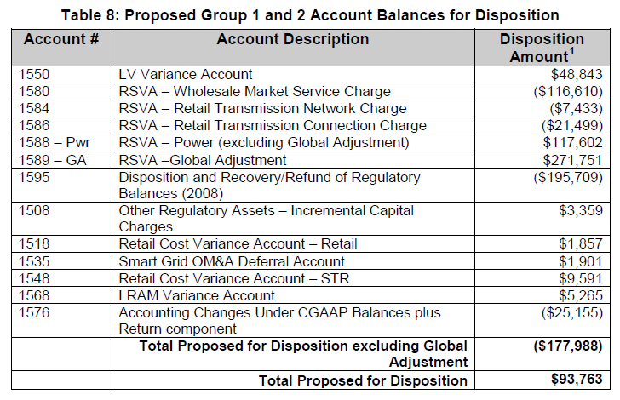

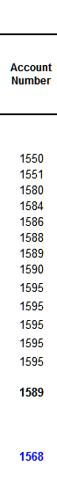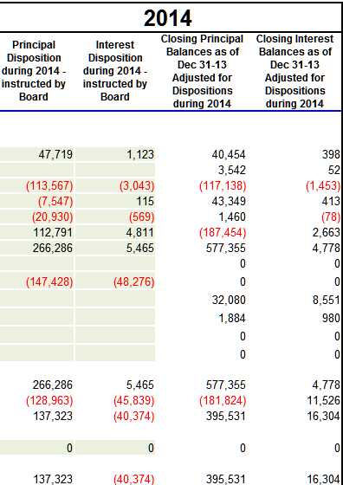

If a model update is required for the questions related to tab 5, please re-file an updated Rate Generator model making the necessary adjustments to this tab. Staff will update the remainder of the discrepancies as applicable.

**Response: A revised model including historical balances for account 1590 is being filed along with these responses.**

**Tab 9 – STS – Billing Det & Rates**



* Number of customers for the Street lighting rate class has been transposed – staff believes this should read 1215. Please confirm if Hydro Hawkesbury agrees, and staff will make the necessary correction to the model.

**Response: Correct, please make the necessary adjustment to the model**

**Staff: Corrected.**

**Tab 11 – STS Tax Change**



* Cell L19 of the above noted tab requires distributors to enter their Board-approved rate base. Staff notes that the above number entered is Hydro Hawkesbury’s allowance for working capital. Staff believes the correct figure should be $6,386,201. Please confirm if Hydro Hawkesbury agrees and staff will make the necessary adjustment to the model.

**Response: Correct, please make the necessary adjustment to the model**

**Staff: Corrected.**

**Tab 14 – RTSR RRR Data**



* For the Sentinel Lighting rate class, Hydro Hawkesbury’s RRR data shows a total metered consumption of 102,064 kWh. Please explain discrepancy and confirm the correct figure.

**Response: This discrepancy is due to a typing error. The correct amount is 102,064. Please make the necessary changes to the model.**

**Staff: Corrected.**

**Deferral and Variance Account Disposition**

Chapter 3 of the Filing Requirements note that “distributors must establish separate rate riders to recover the balances in the RSVAs from Market Participants (“MPs”) who must not be allocated the RSVA account balances related to charges for which the MPs settle directly with the IESO (e.g. wholesale energy, wholesale market services).”

Chapter 3 of the Filing Requirements also note that “distributors who serve Class A customers per O.Reg 429/04 (i.e. customers greater than 5 MW) must propose an appropriate allocation for the recovery of the global adjustment variance balance based on their settlement process with the IESO.

* Please confirm that Hydro Hawkesbury does not serve any MPs or Class A customers.

**Response: HHI confirms that it does not serve MPs or Class A customers**

**APPENDIX A**

