**Kingston Hydro Corporation (EB-2014-0088)**

**Application Analysis**

**Tab 5 – Continuity Schedule**

* Board staff notes that the 2010 amounts approved in EB-2009-0201 entered into the continuity schedule are correct, however the signs are reversed (i.e. debits are credits, and vice-versa). Please confirm if this is an error and Board staff will make the necessary corrections. If not, please provide an explanation.

**Taken from Decision and Rate Order (EB-2009-0201)**



**Kingston Hydro Reply:**

* If the signs are changed in the model, then based upon the workings of the model, the amounts effectively get added into those accounts since Column I is deducting anything in accounts in Column G. Whereas these amounts approved for disposition need to be taken out of the accounts. If the signs in the model are reversed from what they are currently then the effect is that the model balances will not equal the RRR balances at year end. So for example account 1550 there was a debit of 954,176.00 that is approved and can be credited and moved to 1595. The continuity schedule is deducting that. Kingston has purposely reversed the signs so as to achieve correct model balances that match the RRR balances.

**Staff – OK**

**Tab 5 – Continuity Schedule**

* Board staff is unable to reconcile the amounts in Accounts 1550, 1551, 1588 and 1589 to Kingston Hydro’s RRR 2.1.7 filing. The table below shows the figures. Please provide an explanation for the discrepancies.

|  |  |  |
| --- | --- | --- |
| **Account** | **2015 Continuity Schedule (Rate Generator Model)** | **2.1.7 RRR as Filed** |
| 1550 | $429,637 | $477,000 |
| 1551 | Blank | $44,617 |
| 1588 | -$10,219 | -$102,746 |
| 1589 | $6,028,533 | $5,748,967 |

* Board staff also notes that Account 1551 is missing inputs into the continuity schedule – no total claim or RRR figure entered. Please provide an explanation for the omission of data. If this is an error, please re-file the Rate Generator Model with the correct inputs.

**Kingston Hydro Reply:**

* The balances shown in the above table for the 2.1.7 RRR are from the original filing. Kingston refiled balances on August 22, 2014 for Accounts 1550, 1551, 1588 and 1589. The refiled balances match the balances in the Rate General Model continuity schedule. Kingston can provide a copy of the refile request to OEB staff and a copy of the email confirmation of changes if necessary.

**Staff – Confirmed**

* Kingston agrees that in the model, Account 1551- Smart Meter Entity charge is missing inputs. The data omission was an oversight. Kingston has via RESS refilled Rate Generator Model with the correct inputs.

**Staff – Re-submitted model confirmed to account for Account 1551.**

**Tab 11 – STS – Tax Change**

* Board staff is unable to reconcile the corporate tax rate entered on tab 11 to Kingston Hydro’s previous Revenue Requirement Work Form (EB-2010-0136). Board staff notes that the rate is 28.25% vs. the 25.90% currently entered in the 2015 Rate Generator Model. Please provide an explanation for this discrepancy. If changes are required, please confirm and Board staff will make the necessary corrections to the Model.

**Kingston Hydro Reply:**

* The corporate tax rate of 25.90% entered in Tab 11 of the 2015 Rate Generator Model is the correct rate. Evidence to support this rate may be found in Kingston’s 2011 COS Draft Rate Order Appendix K PILs Model, p. 22 Box M (Copy attached). Kingston noted in its Application that the Shared Tax Savings rate rider for rate classes Residential, General Service Less Than 50 kW, and Unmetered Scattered Load did not automatically populate in Rate Generator Model Tab. 27 Final Tariff Schedule. Kingston is in agreement with Board staff making the relevant update to Tab. 27 to show the Shared Tax Savings rate riders for these classes.

**Staff – Confirmed corporate tax rate as found in Kingston Hydro’s 2011 CoS Draft Rate Order, Appendix K PILs Model. Also, staff has made the corrections to Kingston Hydro’s 2015 IRM Model in order for the Tax Savings Rate Riders to pull onto tab 27 correctly.**

**Tab 15 – RTSR – UTRs & Sub-Tx**

* Board staff notes that the Hydro One Sub-Transmission Rate Rider 9A expires on December 31, 2014 and therefore the rates should be removed.

Board staff will make the necessary adjustments to Kingston Hydro’s Rate Generator Model.

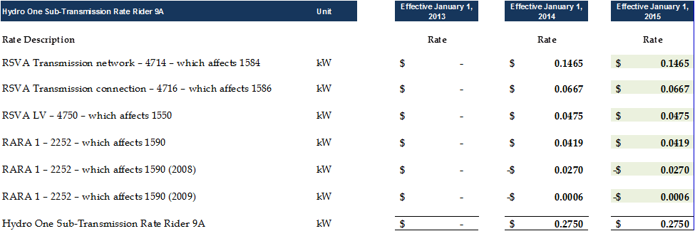

**Kingston Hydro Reply:**

* Kingston is in agreement with Board staff making the necessary adjustments to Kingston Hydro’s Rate Generator Model to reflect the expiry of the Hydro One Sub-Transmission Rate Rider 9A on December 31, 2014.

**Staff – Hydro One Sub-Transmission Rate Rider 9A removed.**

**Tab 27 – Final Tariff Schedule**

* Board staff notes that the Rate Riders for Deferral and Variance Account Disposition (2015) appear in the final tariff tab of the Rate Generator Model. Please confirm that, if approved by the Board, Kingston Hydro wishes for Board staff to remove these rate riders as per its request to move the balance of $3,240 into Account 1595 for future disposition.
* Board staff also notes that the Rate Rider for Global Adjustment Account Disposition (2015) on tab 27 for all rate classes does not reconcile to the rate riders as calculated by Kingston Hydro in its separate Excel model. Please confirm if Kingston Hydro wishes for Board staff to make the corrections in the updated model.

**Kingston Hydro Reply:**

* Kingston confirms that if approved by the Board, Kingston Hydro wishes for Board staff to remove the Deferral and Variance Account Disposition (2015) rate riders from the final tariff tab 27 of the Rate Generator Model, and move the balance of $3,240 into Account 1595 for future disposition.
* Kingston noted in its Application that the tariff (Tab 27) in the Rate Generator Model did not reconcile to the Global Adjustment rate riders as calculated by Kingston Hydro in its separate Excel model. Kingston confirms that it wishes for Board staff to make the corrections in the updated model such that the tariff Tab 27 reconciles to the Global Adjustment rate riders calculated in the separate Excel model.

**Staff – Board staff confirms that it will alter the Rate Riders for Deferral and Variance Account Disposition on Kingston Hydro’s draft tariff based on the Delegated Authority’s decision on Kingston Hydro’s request to move the balance of $3,240 into Account 1595 for future disposition. Kingston Hydro will have a chance to comment on the accuracy of this draft tariff once a draft Decision is issued on the Application.**

**Board staff confirms that at the stage of the draft Decision and tariff, staff will enter the Rate Riders for Global Adjustment Account Disposition as calculated in Kingston Hydro’s separate Excel document. Kingston Hydro will have a chance to comment on the accuracy of the draft tariff once a draft Decision is issued on the Application.**

**Class A Customer/Wholesale Market Participant – Deferral/Variance Account Calculation**

In calculating Deferral and Variance Account rate riders for sub-groups of customers within a class (e.g. WMPs and non-WMPs), distributors have used two approaches.

1. Rate riders grouped by the nature of the deferral and variance accounts (i.e. one set of rate riders for accounts related to transmission (e.g. 1584 and 1586) and another set of rate riders for accounts related to power (e.g. 1580 and 1588). For an example, see the EnWin Utilities Ltd. Final 2014 Tariff of Rates and Charges (EB-2014-0156).
2. Sets of rate riders calculated on the basis of the customer group to which they would apply (i.e. one rate rider for WMPs and one rate rider for non-WMPs). For an example, see Bluewater Power Distribution Corp.’s 2014 IRM application (EB-2013-0112).

Kingston Hydro has used method 2, as described above. Please explain why Kingston Hydro has chosen to use this method. Has Kingston Hydro considered the other approach, set out above? If so, please explain why it was rejected.

**Kingston Hydro Reply:**

* Kingston chose method #2, calculating rate riders on the basis of customer group, as a result of Kingston’s interpretation of the filing requirements, the EDDVAR Report, and a cursory review of some other filed applications and tariffs. At the time of the filing, Kingston did not consider the other approach.

**Staff - OK**