Peterborough Distribution Inc. (“PDI”)
2015 Electricity Distribution Rates
EB-2014-0107
Board Staff Application Analysis

- Service Territory

Ref: Rate Generator Model, Tab 1

As filed.
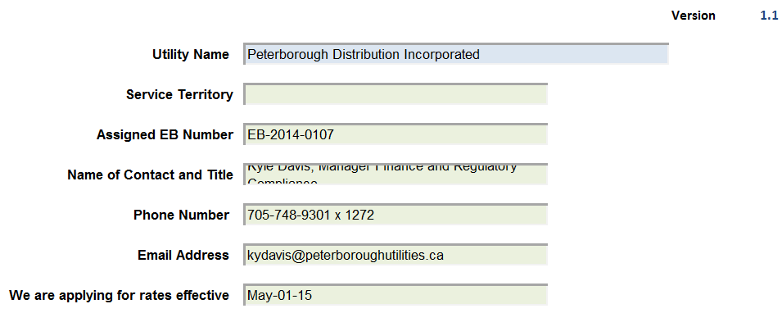

Service Territory populated.
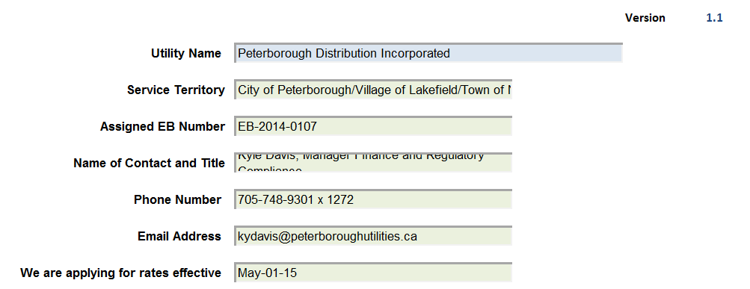

- Board-Approved Disposition During 2013

Ref: Rate Generator Model, Tab 5

As filed.
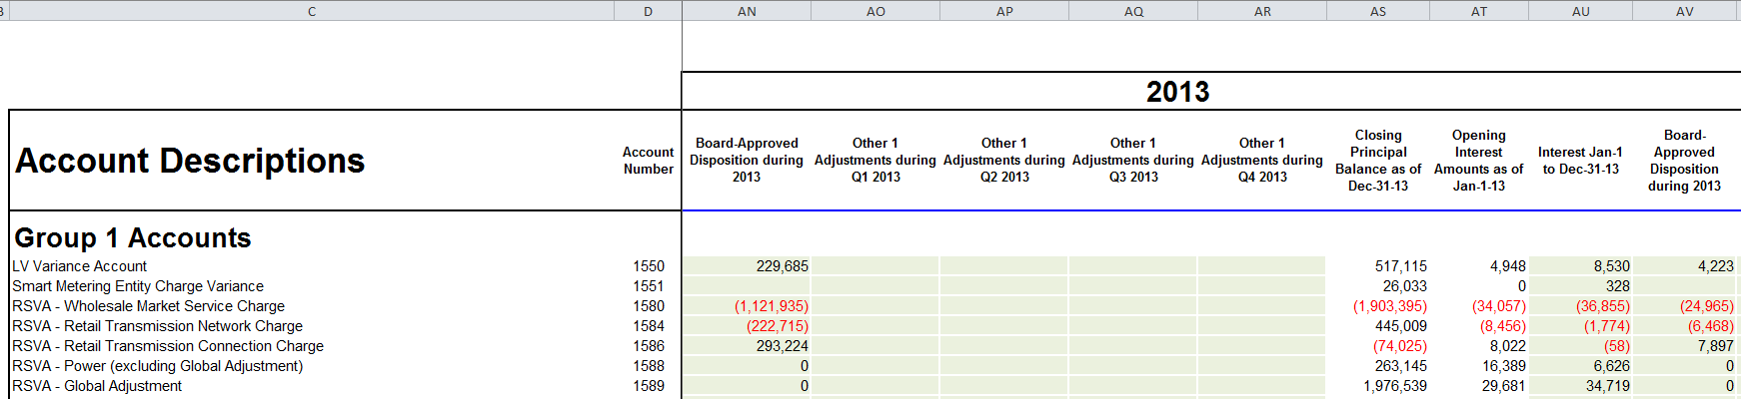

Missing Board-Approved Disposition during 2013 for Account Numbers 1588 and 1589 inserted in columns AN (principal) and AV (interest). Data extracted from continuity schedule filed in PDI’s 2013 cost-of-service rate application (EB-2012-0160).
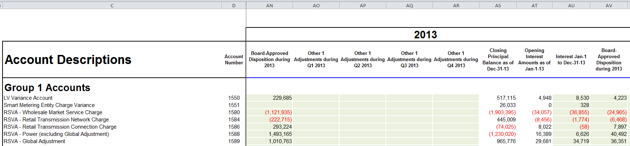

As shown below, this correction will change PDI’s total claim of Group 1 Deferral and Variance Account (“DVA”) balances as at December 31, 2013 from a debit of $1,229,508 (as filed) to a credit of $1,400,340 (after correction). The threshold test will change from a debit of $0.0015/kWh (as filed) to a credit of $0.0017 (after correction).

As filed.
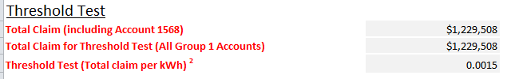

After correction.
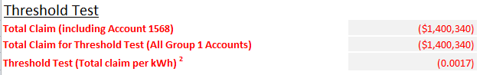
- Tax Sharing

Ref: Rate Generator Model, Tab 11

As filed.
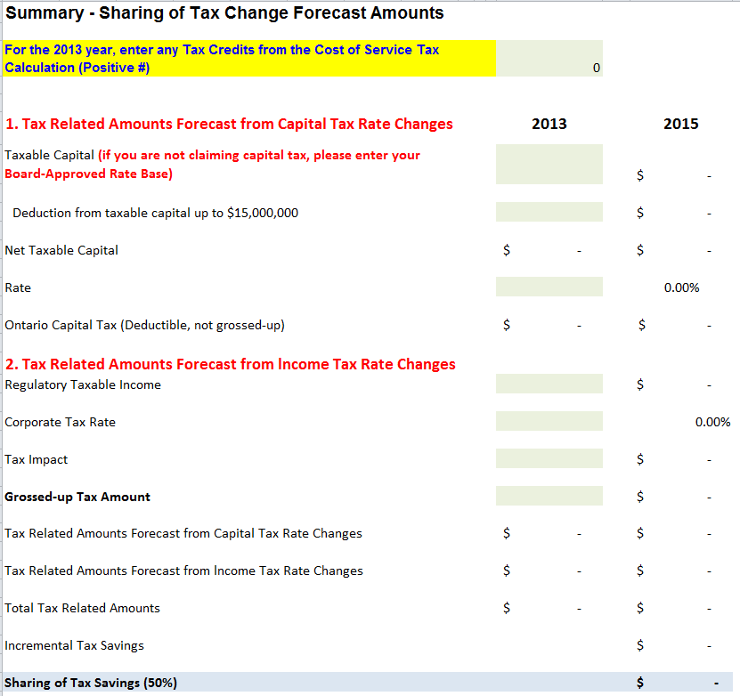

Tax sharing form populated. Data extracted from revenue requirement work form filed in PDI’s 2013 cost-of-service rate application (EB-2012-0160).

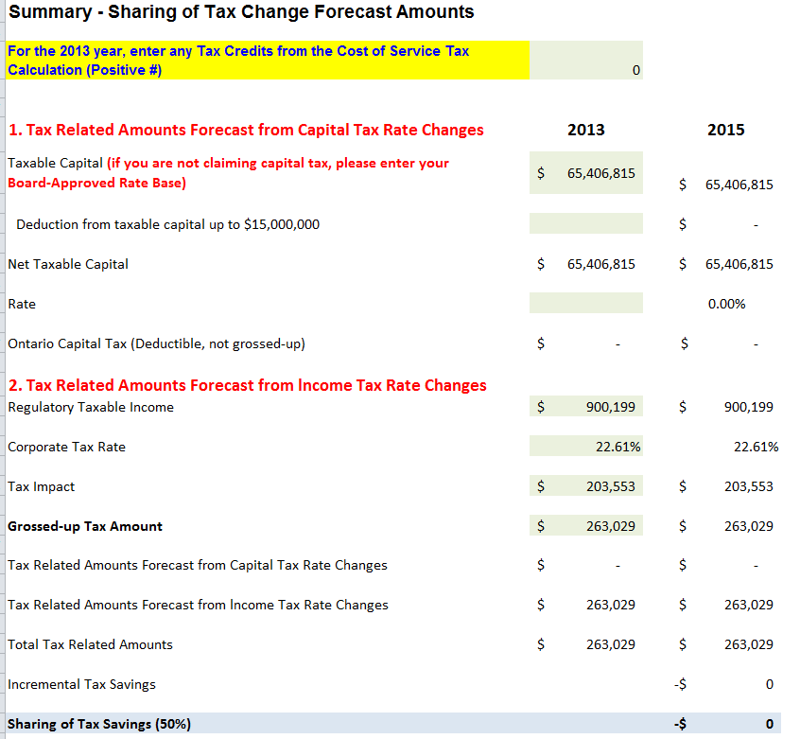

- Billing Determinants

Ref: Rate Generator Model, Tab 14

As filed.
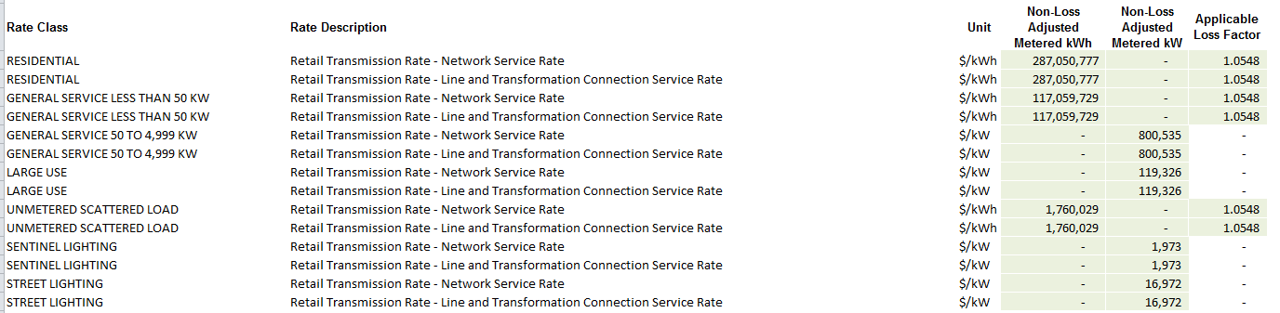

Billing determinants corrected to align with PDI’s most recent reported RRR billing determinants.
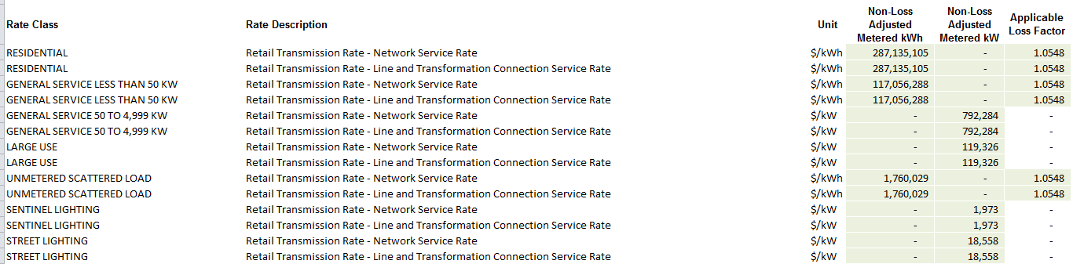

- Hydro One Sub-Transmission Rate Rider 9A

Ref: Rate Generator Model, Tab 15

As filed.
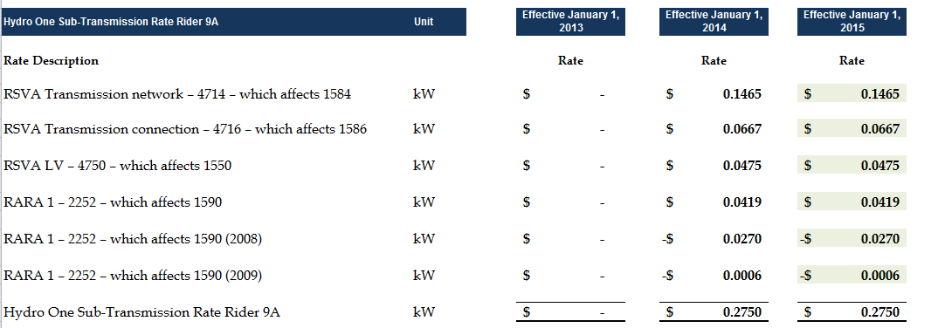

Hydro One Sub-Transmission Rate Rider 9A is effective until December 31, 2014 (Hydro One Networks tariff, p.10, EB-2013-0141). Therefore set to zero in the “Effective January 1, 2015” column.
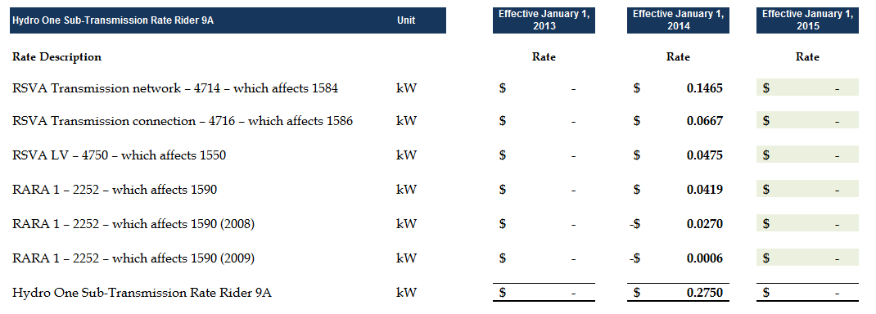
- Hydro One Wholesale Transmission Billing

Ref: Rate Generator Model, Tab 16

As filed.
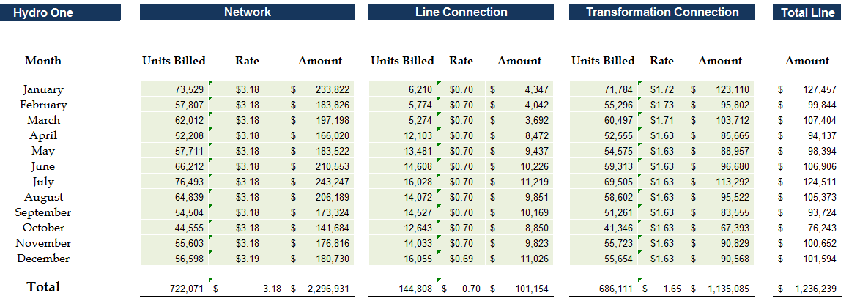

For January to March, corrections made to Units Billed and Amount for Line Connection, and Amount for Transformation Connection.
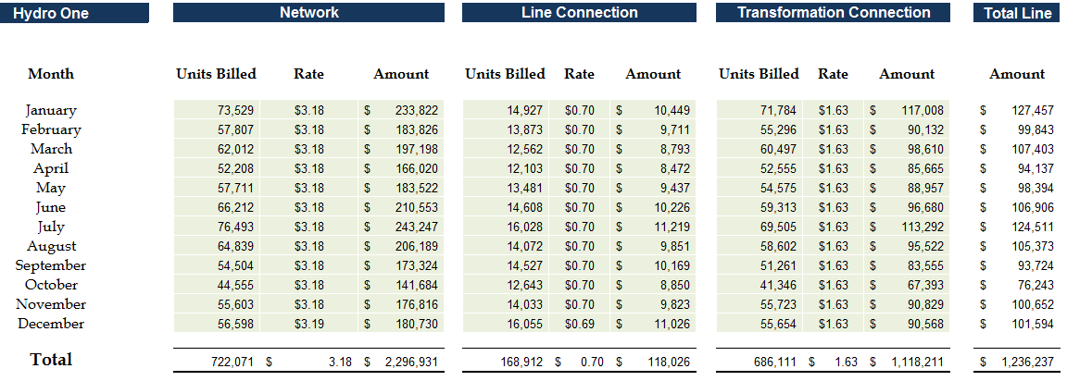
- Market Participants and Class A Customers

Chapter 3 of the Filing Requirements notes that “Distributors must establish separate rate riders to recover the balances in the RSVAs from Market Participants (“MPs”) who must not be allocated the RSVA account balances related to charges for which the MPs settle directly with the IESO (e.g. wholesale energy, wholesale market services).”

Chapter 3 of the Filing Requirements also note that “Distributors who serve Class A customers per O.Reg 429/04 (i.e. customers greater than 5 MW) must propose an appropriate allocation for the recovery of the global adjustment variance balance based on their settlement process with the IESO.”

- Please confirm whether or not PDI serves any consumers that are Wholesale Market Participants (“WMPs”). If yes:

- Have these consumers been WMPs throughout the entire time over which variances accumulated in the RSVA accounts proposed for disposition?
- Please confirm that RSVA account balances have not been allocated to WMP customers as they settle these charges directly with the IESO.

- Please confirm whether or not PDI serves any Class A consumers that settle energy charges directly with PDI. If yes, please explain how balances in account 1589 (Global Adjustment) have been allocated to these consumers.

http://www.ontarioenergyboard.ca/oeb/_Documents/Regulatory/Filing_Reqs_Dx_Applications_ch_3.pdf pages 8 & 9

