**Thunder Bay Hydro Electricity Distribution Inc. (EB-2014-0114)**

**Application Analysis**

**New Information**

Thunder Bay Hydro has recently identified an error and has initiated a review. In light of this review, we elect not to dispose of the DVA Group 1 Accounts. (The threshold test for deferral and variance account (“DVA”) disposal for Group 1 Accounts shows a total claim of $0.0002/kWh (owing) which is below the approved threshold of $0.001/kWh. Please note, in our application, we elected to dispose of this balance).

Below, the following questions below have been addressed.

**Tab 4 – Current Tariff Schedule**

* For the Residential rate class, under the description paragraph, Board staff notes that the words “No rates and charges for the distribution of electricity and charges to meet the costs of any work or service done or furnished…” are missing.
* For the General Service 50 to 999kW rate class, under the description paragraph, Board staff notes that the words “This classification refers to a non-residential account whose monthly average peak demand is equal to or greater than, or is…” are missing.
* For the Unmetered Scattered Load Service Classification, under the description paragraph, Board staff notes that the words “This classification refers to an account taking electricity at 750 volts or less whose monthly average peak demand is less…” are missing.

Please confirm that these omissions were in error and Board staff will make the necessary corrections.

It is confirmed that these omissions were in error.

Staff: Corrected

**Tab 5 – Continuity Schedule**

* Columns G and L (Board-Approved principal and interest during 2010, respectively) has not been entered.
* Column Q (Board-Approved principal during 2011) has not been entered.

Please confirm that these omissions were in error and provide the correct amounts, and Board staff will update Thunder Bay Hydro’s Rate Generator Model with the appropriate figures.

It is confirmed that these omissions were in error. The continuity schedule has been updated to reflect those amounts and is included in the revised IRM model attached.

Staff: Inputs confirmed.

**Tab 15 – RTSR – UTRs & Sub-Tx**

Board staff notes that the Hydro One Sub-Transmission Rate Rider 9A expires on December 31, 2014 and therefore the rates should be removed.

Board staff will make the necessary adjustments to Thunder Bay Hydro’s Rate Generator Model.

No further action.

Staff: Hydro One Sub-Tx rate riders removed.

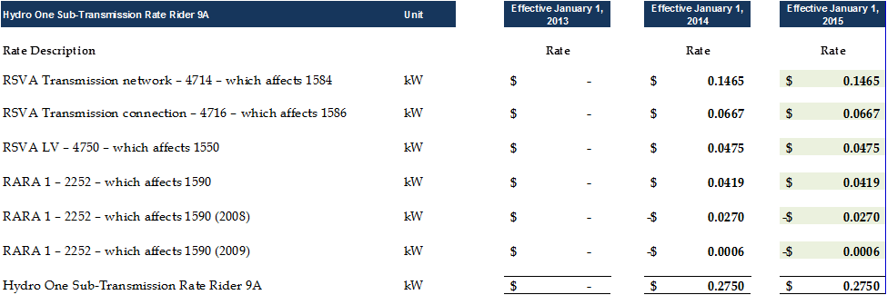

**Tab 16 – RTSR – Historical Wholesale**



Board staff notes that the following Uniform Transmission Rates were effective January 1, 2013:

* Network Service Rate: $3.63
* Line Connection Service Rate: $0.75
* Transformation Connection Service Rate: $1.85

Please provide an explanation for the varying rates entered on tab 16 on the Rate Generator Model. If any corrections are required, please confirm the correct figures, and Board staff will make the necessary corrections to the Model.

The volume used in the original submission was the IESO monthly peak average. The tables been updated to reflect the network, line and connection volumes. The updated volumes are below, and also included in the attached revised IRM model, tab 16.

Staff: Board staff thanks Thunder Bay Hydro for making the necessary corrections.



**Tab 27 – Final Tariff Schedule**

Board staff notes that in the final tariff schedule, effective May 1, 2015 provided by Thunder Bay Hydro, the Rate Rider for Deferral/Variance Accounts applicable to its Class A customer is entered under a separate rate class (i.e. General Service Greater Than 50kW – WMP Service Classification).

* Please confirm that this rate rider should be entered in the General Service 1,000 to 4,999kW Service Classification in Thunder Bay Hydro’s final Tariff of Rates and Charges.

Thunder Bay Hydro has 8 rate classes. In the 2015 IRM original submission, a 9th was added for the purpose to separate the volume of one Class A customer in the 1,000 – 4,999 rate class. This customer is not a WMP (each month, the IESO invoices Thunder Bay Hydro, who in turn, bills the customer for Global Adjustment, Class A, thus, the net is zero). To accommodate this Class A customer and to calculate proper rate riders, further changes were made to the IRM model (regarding allocation) in Tab 7, Column U.

However, the original submission has not calculated the correct rate riders among other classes. As a result, Thunder Bay Hydro is submitting a revised IRM model, that reverts back to original calculations for deferral and global adjustment rate riders, and has provided another worksheet to determine correct rate riders, considering the Class A customer. Given that the current IRM model is not able to accommodate this particular situation, please note, the revised IRM model that is attached, continues to include incorrect GA rate riders, which is the purpose for including the revised document (“Thunder Bay Hydro DVA RR Calculations.xls, Tab “34. DVA RR Cal””).

The results would be the following rate riders, as found in the file, “Thunder Bay Hydro DVA RR Calculations.xls, Tab “34. DVA RR Cal” “:



Staff: Board staff acknowledges that the IRM Rate Generator Model re-submitted contains the incorrect GA rate riders due to the fact that it does not accommodate the calculation of rate riders for Class A customers. Board staff has reviewed the calculations as provided in Thunder Bay Hydro’s separate Excel document and takes no issue with the calculations or methodology. Board staff acknowledges that Thunder Bay Hydro has retracted its request to dispose of its Group 1 Accounts.

* Please confirm that for labelling purposes, this rate rider should only be applicable to Class A customers in that service classification, and not Wholesale Market Participants as currently entered.

See above

Staff: Confirmed

**Deferral/Variance Account Calculations – Wholesale Market Participants**

Chapter 3 of the Filing Requirements notes that distributors must establish separate rate riders to recover the balances in the RSVAs from Wholesale Market Participants (“WMPs”) who must not be allocated the RSVA account balances related to charges for which the WMPs settle directly with the IESO (e.g. wholesale energy, wholesale market services).

Chapter 3 of the Filing Requirements also note that distributors who serve Class A customers per O.Reg 429/04 (i.e. customers greater than 5 MW) must propose an appropriate allocation for the recovery of the global adjustment variance balance based on their settlement process with the IESO.

1. Please confirm whether or not Thunder Bay Hydro serves any consumers that are WMPs.
   1. If yes:
      1. Have these consumers been WMPs throughout the entire time over which variances accumulated in the RSVA accounts proposed for disposition?
      2. Please confirm that RSVA account balances have not been allocated to WMP customers as they settle these charges directly with the IESO.

Thunder Bay Hydro does not serve any WMPs customers.

Thunder Bay Hydro added the GS > 50 Kw – WMP Service Classification in its 2015 IRM to separate out the Class A volume from Class B, for proper GA rate rider purposes, however, this classification is not required, as there is no balance to dispose (offsets to zero).

Staff: Board staff confirms that at the time of the final Tariff of Rates and Charges to be issued, staff will ensure that this rate class (i.e. GS>50kW – WMP) is omitted.

**Deferral/Variance Account Calculations**

In calculating Deferral and Variance Account rate riders for sub-groups of customers within a class (e.g. WMPs and non-WMPs), distributors have used two approaches in the past.

1. Rate riders grouped by the nature of the deferral and variance accounts (i.e. one set of rate riders for accounts related to transmission (e.g. 1584 and 1586) and another set of rate riders for accounts related to power (e.g. 1580 and 1588). For an example, see the EnWin Utilities Ltd. Final 2014 Tariff of Rates and Charges (EB-2014-0156).
2. Sets of rate riders calculated on the basis of the customer group to which they would apply (i.e. one rate rider for WMPs and one rate rider for non-WMPs). For an example, see Bluewater Power Distribution Corp.’s 2014 IRM application (EB-2013-0112).

Please explain which approach Thunder Bay Hydro would use and why.

Thunder Bay Hydro does not require a rate rider for its Class A customer because the settlement process with the IESO offset any balance in Account 1589 to zero at each month.

Staff: Confirmed.