

January 9, 2015

Ontario Energy Board
P. O. Box 2319
2300 Yonge Street
27th Floor
Toronto, Ontario M4P 1E4

Attention: Ms. Kirsten Walli
Board Secretary

Dear Ms. Walli:

Re: Interrogatory Response Filing Delay (EB-2014-0072)

Essex Powerlines is preparing a response to the Board staff submission dated December 15, 2014. We have been working diligently to respond to concerns from Board staff on the variance account variations and require additional time for an in depth review of the variance accounts.

The procedural order required a response from Essex by January 12, 2015. We are requesting an extension on the due date for our required response to January 19, 2015.

Yours very truly
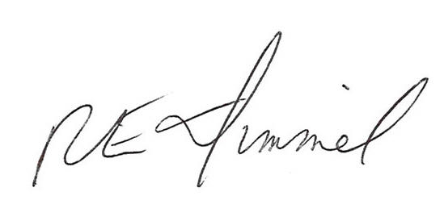

Richard E. Dimmel
VP Regulatory Affairs

Cc: Georgette Vlahos, Board Staff
Michael Janigan, VECC

