2730 Highway #3, Telephone (519) 737-9811
Oldcastle, ON N0R 1L0 Fax (519) 737-7064



July 31, 2026

Ontario Energy Board
Attn: Kirsten Walli, Board Secretary
PO Box 2319
27th Floor
2300 Yonge Street
Toronto ON M4P 1E4

Dear Ms. Walli,

Re: EB-2013-0421
Hydro One Networks Inc.
Notice of New Cost Allocation Issue and Procedural Order No. 3
Intervenor Request

Dear Ms. Walli,

Essex Powerlines Corporation (EPL) is an intervenor in this proceeding.

On January 30, 2015, the Board published the Notice of New Cost Allocation and Procedural Order No.3 which directs a phase 2 for the proceeding. With respect to phase 2 of the proceeding, Essex Powerlines (EPL) is part of the E3 Coalition to which the Board has already granted intervenor status and cost eligibility. While it is anticipated that most, if not all of EPL’s effort with respect phase 2 of this proceeding will be as part of the E3 Coalition, EPL would also like to maintain individual party status for phase 2 in case an issue arises that is unique to EPL.

For the purposes of EPL’s separate intervenor status for phase 2, please forward all correspondence to:

Richard Dimmel
VP Regulatory Affairs
Essex Powerlines Corporation
2730 Highway 3
Oldcastle ON N0R 1L0
Phone: 519-737-9811 x214
Fax: 1-519-737-7064
E-mail: rdimmel@essexpowerlines.ca

Regards,
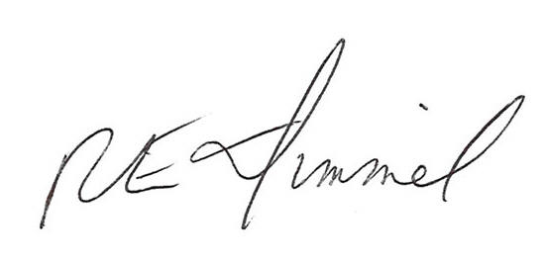
Richard Dimmel CPA, CMA
VP Regulatory Affairs

