CME INTERROGATORY #7

INTERROGATORY

Reference: Exhibit C1, Tab 1, Schedule 1, Table 1  
Exhibit C1, Tab 2, Schedule 1, Tables 1, 2 & 3, Figures 1, 2 & 3  
Exhibit C1, Tab 2, Schedule 1, Appendix A, pages 2, 3, 4 & 5  
Exhibit C1, Tab 2, Schedule 1, Appendix B, Tables 1, 2 & 3  
Exhibit C3, Tab 2, Schedules 1, 2, 3 & 4

For each of the above referenced Exhibits, please add columns to show 2014 actual amounts for each line item in each Exhibit.

RESPONSE

The Company is providing the response subject to the comments in EGD’s letter of February 26, 2015 which sets out EGD’s position as to the relevance of the 2014 actuals information being provided.

Tables are reproduced for each exhibit reference as indicated.

**Exhibit C1, Tab 1, Schedule 1, Table 1:**



**Exhibit C1, Tab 2, Schedule 1, Table 1**



**Exhibit C1, Tab 2, Schedule 1, Table 2**



**Exhibit C1, Tab 2, Schedule 1, Table 3**



**Exhibit C1, Tab 2, Schedule 1, Figure 1**

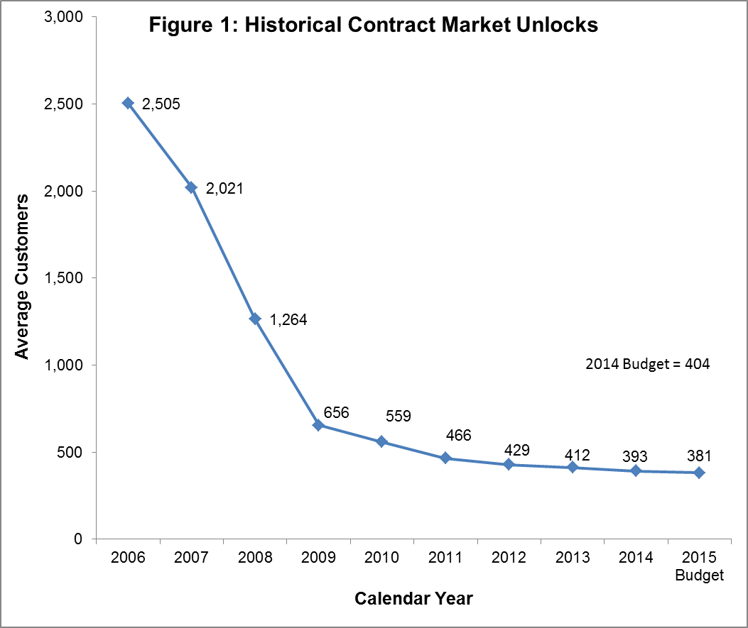

**Exhibit C1, Tab 2, Schedule 1, Figure 2**

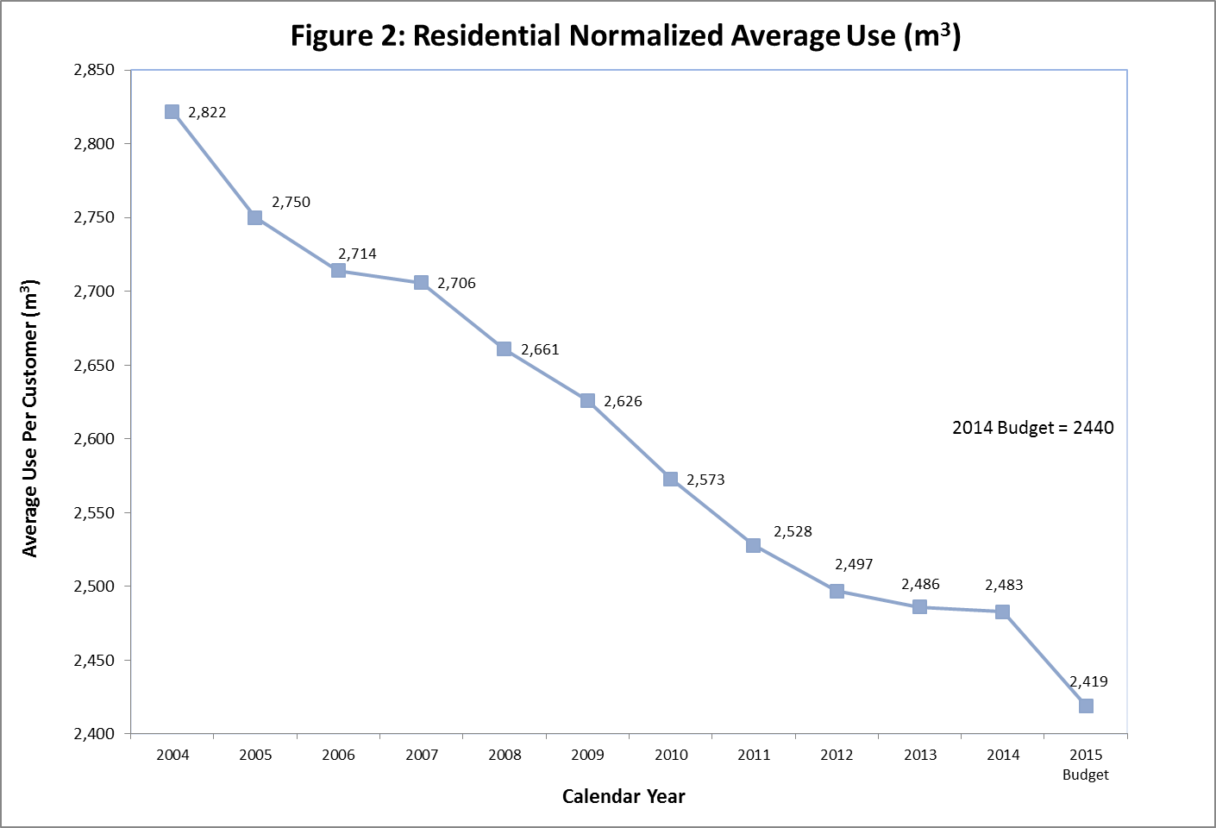

**Exhibit C1, Tab 2, Schedule 1, Figure 3**

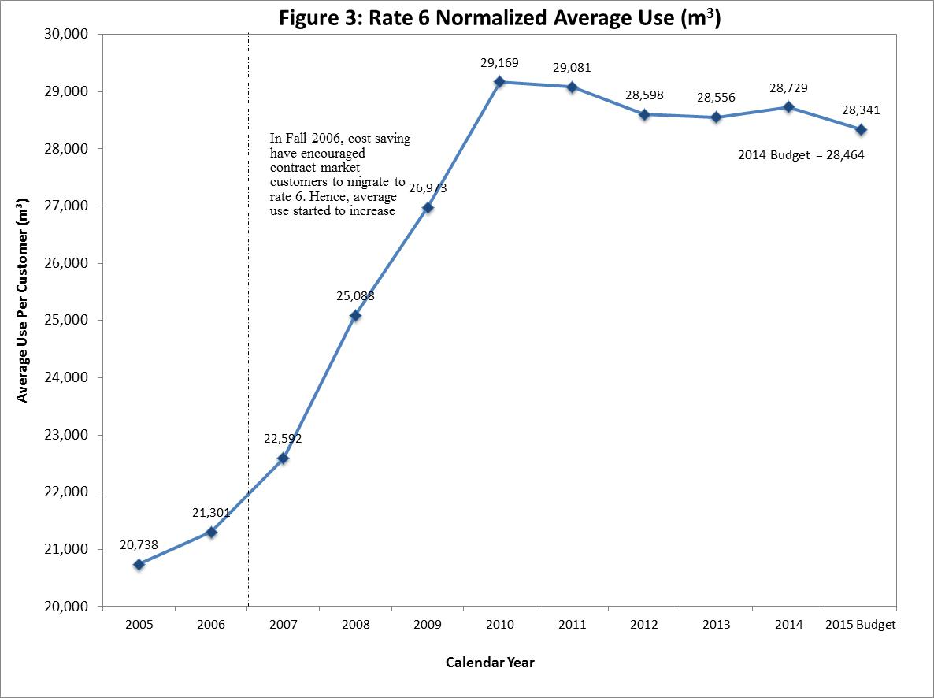

**Exhibit C1, Tab 2, Schedule 1, Appendix A, page 2**



**Exhibit C1, Tab 2, Schedule 1, Appendix A, page 3**

Witnesses: S. Qian

L. Stickles

M. Suarez



Updated: 2015-03-05

EB-2014-0276

Exhibit I.C1-C3.EGDI.CME.7

Page 8 of 19

**Exhibit C1, Tab 2, Schedule 1, Appendix A, page 4**

Witnesses: S. Qian

L. Stickles

M. Suarez



Updated: 2015-03-05

EB-2014-0276

Exhibit I.C1-C3.EGDI.CME.7

Page 9 of 19

**Exhibit C1, Tab 2, Schedule 1, Appendix A, page 5**



**Exhibit C1, Tab 2, Schedule 1, Appendix B, Table 1**



**Exhibit C1, Tab 2, Schedule 1, Appendix B, Table 2**



**Exhibit C1, Tab 2, Schedule 1, Appendix B, Table 3**



**Exhibit C3, Tab 2, Schedule 1**



**Exhibit C3, Tab 2, Schedule 2**



**Exhibit C3, Tab 2, Schedule 3, page 1**



**Exhibit C3, Tab 2, Schedule 3, page 2**



**Exhibit C3, Tab 2, Schedule 3, page 3**



**Exhibit C3, Tab 2, Schedule 3, page 4**

|  |  |  |  |  |
| --- | --- | --- | --- | --- |
| The principal reasons for the variances contributing to the weather normalized decrease of 152.5 106m3 | | | | |
| |  | | --- | | in the 2015 Budget over the 2014 Actual are as follows:  ** Less than 50,000 m³. Note:  ** Less than 50,000 m³. Note:  ** Less than 50,000 m³. Note:  ** Less than 50,000 m³. Note:  ** Less than 50,000 m³. Note:  ** Less than 50,000 m³. Note:  ** Less than 50,000 m³. Note:  ** Less than 50,000 m³. Note:  ** Less than 50,000 m³. Note:  ** Less than 50,000 m³. Note:  ** Less than 50,000 m³. Note:  ** Less than 50,000 m³. Note:  ** Less than 50,000 m³. Note:  ** Less than 50,000 m³. Note:  ** Less than 50,000 m³. Note:  ** Less than 50,000 m³. Note:  ** Less than 50,000 m³. Note:  ** Less than 50,000 m³. Note:  ** Less than 50,000 m³. Note:  ** Less than 50,000 m³. Note:  ** Less than 50,000 m³. Note:  ** Less than 50,000 m³. Note:  ** Less than 50,000 m³. Note:  ** Less than 50,000 m³. Note:  ** Less than 50,000 m³. Note:  ** Less than 50,000 m³. Note:  ** Less than 50,000 m³. Note:  ** Less than 50,000 m³. Note:  ** Less than 50,000 m³. Note:  ** Less than 50,000 m³. Note:  ** Less than 50,000 m³. Note:  ** Less than 50,000 m³. Note:  ** Less than 50,000 m³. Note: | | | | | |
|  | | | | |
| 1. The volumetric decrease of 45.2 106m3 in Rate 1 is due to lower average use per customer of | | | | |
| totaling 122.3 106m3, partially offset by customer growth of 77.1 106m3; | | | | |
| |  | | --- | | ** Less than 50,000 m³. Note: | | | | | |
| 2. The volumetric decrease of 24.3 106m3 in Rate 6 is due to lower average use per customer of | | | | |
| totaling 52.7 106m3, and partially offset by customer growth of 28.4 106m3; | | | | |
|  |  |  |  |  |
| ** Less than 50,000 m³. Note:  ** Less than 50,000 m³. Note:  ** Less than 50,000 m³. Note:  ** Less than 50,000 m³. Note:  ** Less than 50,000 m³. Note:  ** Less than 50,000 m³. Note:  ** Less than 50,000 m³. Note:  ** Less than 50,000 m³. Note:  ** Less than 50,000 m³. Note:  ** Less than 50,000 m³. Note:   |  | | --- | | 3. The volumetric decrease for Contract Sales and T-Service of 83.0 106m3 is due to the decreases | | | | | |
| in the apartment sector of 3.4 106m3, the commercial sector of 13.3 106m3, the industrial | | | | |
| sector of 62.5 106m3 and the Rate 200 of 3.8 106m3. | | | | |

**Exhibit C3, Tab 2, Schedule 4**

