Kenora Hydro Electric Corportion Ltd. (“Kenora Hydro”)
EB-2014-0087
Application Analysis
- Rate Generator Model, Sheet 5 – 2014 Continuity Schedule

Account 1595 – Disposition and Recovery/Refund of Regulatory Balances
Board staff notes that there is a discrepancy in the amount shown for Account 1595, which is zero and the equivalent amount shown in the RRR report 2.1.7 which is a credit of $174,079.00.

- Please provide an explanation for the difference in the 2013 accounts for this account between the Rate Generator Model and RRR report 2.17 and any other necessary explanation.

RESPONSE: Total reported in RRR $(174,079)
Total RRR reported 2015 IRM $(113,159)
Difference $ (60,920)

Total reported in RRR $(174,079)

This balance is:
The remaining 2011 RA balance of $(88,466)
Plus the remaining 2012 balance of $(24,693)
Plus 2013 RA balances in the GL of $(60,920) which is still being disposed of through an active rate rider, at the end of 2013. This rate rider ended April 30, 2014 and will be included for disposal in our next rate application.

Total RRR of Account 1595 (2 lines) as reported in Sheet 5 of 2015 IRM
The remaining 2011 RA balance of $(88,466)
Plus the remaining 2012 balance of $(24,693)

The discrepancy of $(60,920) between the RRR filing and the 2015 IRM RRR balance is the general ledger balance of the remaining 2013 RA balances, $(60,920).
Please provide a breakdown of the balance in account 1595 for the years 2011 (Cell Q35 - $469,211 and Cell V35 - $49,643) and 2012 (Cell AA36 - $204,716) and Cell AI36 - $172,001).

RESPONSE: From the 2010 COS application, Kenora was directed to dispose of the following from 2010 COS Exhibit 9, as approved by OEB page 35 of EB-2010-0135 Decision & Order.

Cell Q35 - $469,211 and Cell V35 - $49,643 = total of $518,854 as below:

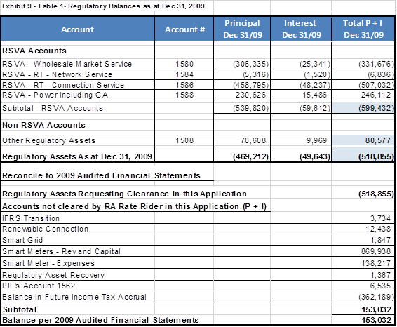

And (Cell AA36 - $204,716 and Cell AI36 - $172,001) are from the next rate application in 2012 IRM as follows:

Proof for total moved into 1595 for 2011 Principal $240,716
- RA Principal $(19,356) as above.
- PILS Principal $(188,270)
- Special Purpose Charge Principal $2,910
- TOTAL Principal disposed $(240,716)
Proof for total moved into 1595 for 2011 Interest $172,001
- RA Interest $(114,872) as above.
- PILS Interest $(57,251)
- Special Purpose Charge Interest $120
- TOTAL Interest disposed $(172,001) rounding

A portion of Sheet 5 is produced below.

The table from Kenora Hydro’s 2012 IRM Decision (EB-2011-0170, page 7) which identified the principal and interest amounts approved for disposition, is reproduced below.

- Board staff notes that “The Board-Approved disposition during 2012” in the Rate Generator Model does not reconcile with the “Interest Balance” in the 2012 IRM Decision.

RESPONSE: As noted on page 7 of the OEB Direction EB-2011-0177, “The Board approves, on a final basis, the disposition of a credit balance of $134,080 as of December 2010. The Board agrees with Kenora Hydro and Board staff that carrying charges should be updated to reflect the implementation date of the Decision and Order.”

Kenora Hydro updated the interest in that application and the final result was a total of $(134,225) for disposal.

If the input into the Rate Generator Model is an error, please make any necessary updates to the Model.
RESPONSE: Kenora Hydro does not see any error corrections to be made in this section.
Rate Generator Model, Sheet 11 – STS Tax Change (as filed)

Data extracted from revenue requirement work form filed in Kenora Hydro’s 2011 cost-of-service rate application (EB-2010-0135).

- If Kenora Hydro is in agreement, Board staff will make the relevant correction.

RESPONSE: Kenora Hydro agrees and the Board staff will make the relevant correction.
- Sheet 15 – RTSR – UTRs & Sub-Tx (as filed)
Hydro One Sub-Transmission Rate Rider 9A

Hydro One Sub-Transmission Rate Rider 9A is effective until December 31, 2014 (Hydro One Networks tariff, p.10, EB-2013-0141). Therefore set to zero in the “Effective January 1, 2015” column.

- If Kenora Hydro is in agreement, Board staff will make the relevant correction.

RESPONSE: Kenora Hydro agrees and the Board staff will make the relevant correction.

- A portion of Sheet 25 – Other Charges & LF is reproduced below.

- Board staff notes that the unit for “Primary Metering Allowance for transformer losses – applied to measured demand and energy” should be “%” instead of “$/kW”. If Kenora Hydro is in agreement, Board staff will make the relevant correction.

RESPONSE: Kenora Hydro agrees, this was an error, the Primary metering allowance is 1% and agrees that the Board will make this correction.

- Board staff notes that the description for “Distribution Loss Factor – Primary Metered Customer < 5,000 kW - 1.0325” should be “Total Loss Factor – Primary Metered Customer < 5,000 kW – 1.0325”. If Kenora Hydro is in agreement, Board staff will make the relevant correction.

RESPONSE: Kenora Hydro agrees and the Board staff will make this correction.

- Class A Consumers/Market Participants

Chapter 3 of the Filing Requirements note that “distributors must establish separate rate riders to recover the balances in the RSVAs from Market Participants (“MPs”) who must not be allocated the RSVA account balances related to charges for which the MPs settle directly with the IESO (e.g. wholesale energy, wholesale market services).”
Chapter 3 of the Filing Requirements also note that “distributors who serve Class A customers per O.Reg 429/04 (i.e. customers greater than 5 MW) must propose an appropriate allocation for the recovery of the global adjustment variance balance based on their settlement process with the IESO”.

- Please confirm that Kenora Hydro does not serve any MPs or Class A customers.

RESPONSE: Kenora Hydro confirms that it does not serve any MP’s or Class A customers.

