13 May, 2015

VIA EMAIL: boardsec@ontarioenergyboard.ca

Ms. Kirsten Walli
Board Secretary
Ontario Energy Board
2300 Yonge Street, 27th Floor
Toronto, Ontario
M4P 1E4

Dear Ms. Walli:

Subject: File: EB-2015-0141 – Procedural Order No. 1, May 1, 2015

- CCSA member companies are smaller cable, telephone and IPTV companies that operate networks across Canada, including throughout Ontario. They provide telephone, high-speed Internet and video services over their networks, primarily to rural communities. Many Ontario-based CCSA members have attached elements of their wireline networks to the support structures of Hydro One and pay its pole attachment rate.

- A list of CCSA members that operate in the Province of Ontario has previously been provided to the Board.

- Pursuant to Item 3 of the subject Procedural Order, the Canadian Cable Systems Alliance Inc. (“CCSA”), as a representative of its affected members, wishes to be added as a party to the motion for leave to bring a motion under Rule 40.01.

Sincerely,
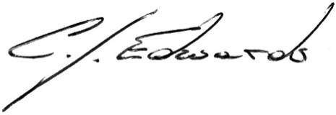
Christopher J. Edwards
Vice-President, Regulatory Affairs

cc. harold.thiessen@ontarioenergyboard.ca
jennifer.lea@ontarioenergyboard.ca
ian.richler@ontarioenergyboard.ca

