EB-2014-0099

North Bay Hydro Distribution Ltd. (“North Bay Hydro”)
Technical Conference Undertaking Responses

May 13, 2015

INDEX

Undertaking NO. JT1.1: 3
Undertaking NO. JT1.2: 5
Undertaking NO. JT1.3: 7
Undertaking NO. JT1.4: 8
Undertaking NO. JT1.5: 9
Undertaking NO. JT1.6: 13
Undertaking NO. JT1.7: 14
Undertaking NO. JT1.8: 16
Undertaking NO. JT1.9:. 18
Undertaking NO. JT1.10: 19
Undertaking NO. JT1.11: 20
Undertaking NO. JT1.12: 21
Undertaking NO. JT1.13: 22
Undertaking NO. JT1.14: 26
Undertaking NO. JT1.15: 27
Undertaking NO. JT1.16: 29
Undertaking NO. JT1.17: 34
Undertaking NO. JT1.18: 35

North Bay Hydro Technical Conference Undertaking Responses

Undertaking NO. JT1.1:

TO UPDATE THE RESPONSE AT 6-STAFF-19 AND PROVIDE AN UPDATED REVENUE REQUIREMENT WORK FORM IN WORKING EXCEL FORMAT FOR ANY ADDITIONAL CHANGES THAT ARE MADE AS A RESULT OF THE RESPONSE TO THE TECHNICAL CONFERENCE QUESTIONS, AND TO INCLUDE ANY SUCH CHANGES IN THE TRACKING SHEET.

Response:

An updated RRWF in working Microsoft Excel format is provided in the file named “NorthBay_Undertaking_Resp_JT1.1 - 2015_Rev_Reqt_Work_Form_V5_20150513”. The adjustments made to the Application are documented in tab “10.Tracking Sheet”. For completeness, all the adjustments made to the Application are listed below which include the first three steps outlined in response to 6-Staff-19 plus four additional steps. The adjustments reflect the following:

Step 1: Application with 2014 actual capital

Step 2: Step 1 with November 20, 2014 cost of capital parameters and new rate on 2015 SWAP

Step 3: Step 2 with updated load forecast as per response to 3-Energy Probe-34

Step 4: Step 3 with a second update to load forecast as per response to JT1.14 plus COP changes as per JT1.8

Step 5: Step 4 with reduced OM&A outlined in 1-Energy Probe-15

Step 6: Step 5 with the elimination of the small business tax credit

Step 7: Step 6 with CCA reclassification

The results of step 7 have also been included in the middle column of the updated RRWF.

With regards to Step 5, the following costs have been removed from USoA 5635 in the 2015 Test year OM&A in relation to the table provided in 1-Energy Probe-15:

North Bay Hydro Technical Conference Undertaking Responses

Undertaking NO. JT1.2:

TO PROVIDE AN EXPLANATION FOR ANY SIGNIFICANT DIFFERENCE BETWEEN THE 2015 BUDGET AS APPROVED BY THE EXECUTIVE AND AS SHOWN IN THIS EXHIBIT WITH WHAT WAS FILED IN THE APPLICATION.

Response:

The chart below reconciles the significant differences between the 2015 budget as approved by NBHDL’s Board and what was filed in the application. During the process of completing the application there were two budgets approved one on June 26, 2014 and the final on September 18, 2014. Both versions are included in the response for 1-SEC-1. Significant differences have been defined as NBHDL’s adopted materiality threshold of $65,000 as defined in the application.

For internal budget purposes, NBHDL included the full cost of an operational review in the amount of $208,000; for rate setting purposes the cost was amortized over a 5 year period resulting in a $166,400 reduction. Similarly, the fleet depreciation amount of $155,871 is an adjustment made for rate setting purposes that reflects the appropriate treatment for the capitalization of depreciation costs for NBHDL’s fleet to ensure a reduction in depreciation expense and the appropriate amount recovered through OM&A. NBHDL has continued to use the same method for fleet depreciation that was adjusted and approved during the 2010 cost of service settlement process.

During the technical conference working capital values from page 4 of the June 26, 2014 budget report were discussed and NBHDL incorrectly stated that the borrowing in 2014 was $6,000,000. The actual borrowing was $4,000,000; the $6,000,000 borrowing is scheduled for 2015. Confirmation of this correction can be found on page 6 of the budget presentation under the borrowing assumption.
North Bay Hydro Technical Conference Undertaking Responses

Undertaking NO. JT1.3:

TO PROVIDE A VERSION OF THIS TABLE WITH THE BELL FSA CONTRIBUTIONS AND GROSS ADDITION COSTS REMOVED.

Response:
A revised version of the table provided in 2-Energy Probe-22 is provided below with all contributions and gross additions costs related to the Bell FSA project removed. The 5 year (2010 – 2014) average ratio of contributions and grants to the gross addition costs is 53.3% when the Bell FSA project is removed.
North Bay Hydro Technical Conference Undertaking Responses

Undertaking NO. JT1.4:

TO RECONCILE THE DEPRECIATION EXPENSE SHOWN IN THE REVENUE REQUIREMENT WORK FORM FROM 6-STAFF-19 OF $2,569,662 WITH THE TWO FIGURES SHOWN IN APPENDIX 2-CE OF 2-SCHOOLS-13.

Response:

The depreciation expense shown in the Application column of the Revenue Requirement Work Form from 6-Staff-19 of $2,569,662 was the original amount proposed in NBHDL’s application; this was subsequently reduced through the submission of IRRs in the amount of ($57,411) for a revised proposed depreciation amount of $2,512,251 which is shown in the Interrogatory Responses column of the work form. NBHDL would refer to “10.Tracking Sheet” of the Revenue Requirement Work Form filed April 24, 2014 which provides the changes to depreciation as a result of the response to 2-Energy-28 in which NBHDL updated the capital additions to reflect 2014 actuals which in turn impacted the 2015 Test Year capital and depreciation amounts. The changes to depreciation resulted in a revised deprecation amount of $2,512,251 which can be found in the revised Appendix 2-CE in response to 2-SEC-13 d).
North Bay Hydro Technical Conference Undertaking Responses

Undertaking NO. JT1.5:
TO PROVIDE THE KILOMETRES OF TREE TRIMMING OF THE RIGHT-OF-WAYS FOR THE YEARS 2010-2014, AND 2015 FORECAST.

Response:

The kilometres of tree trimming of the right of ways for the years 2010-2014, and the 2015 forecast are summarized in the table below:

NBHDL prepared this table in response to this specific undertaking, but does not use this information as a metric or tool for the estimation of cycle costs. NBHDL does not believe the information to be indicative of the amount of work required, or the associated costs to perform the work required as the amount, type, size, and location of trees varies from cycle to cycle and from kilometer to kilometer. In addition, there can be a significant difference between the costs required to perform vegetation management activities in urban areas and rural areas. A few pictures have been included below illustrating the differences.

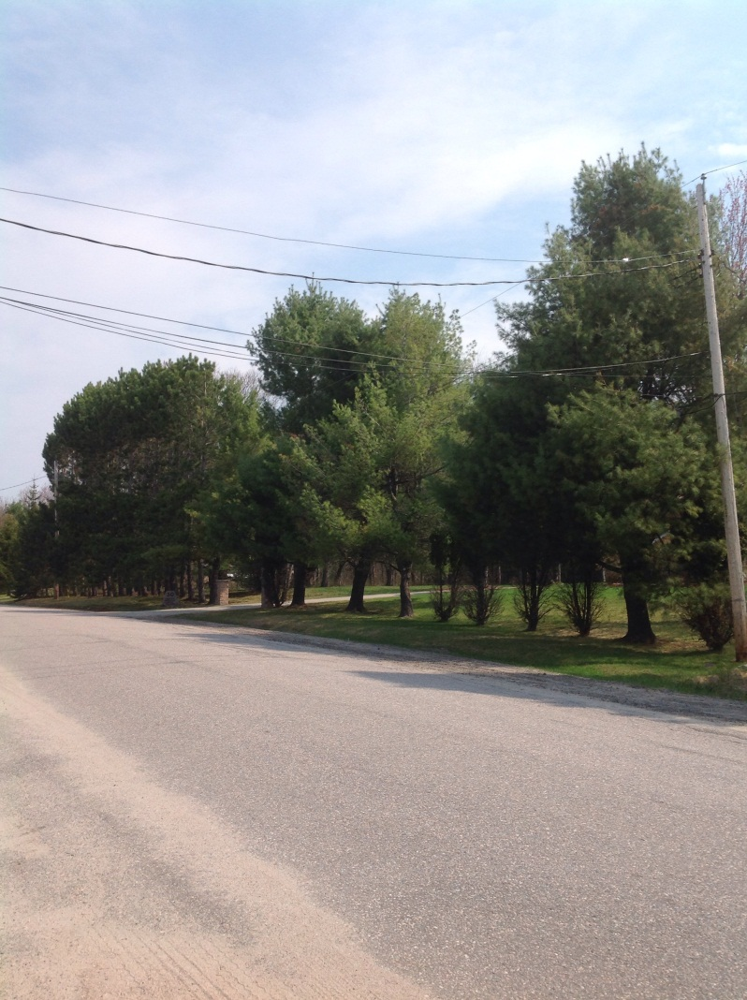

Cycle 1, Section A – 1 span in a rural area requiring the removal of 4 -14” white pines, and 23-10” red pines

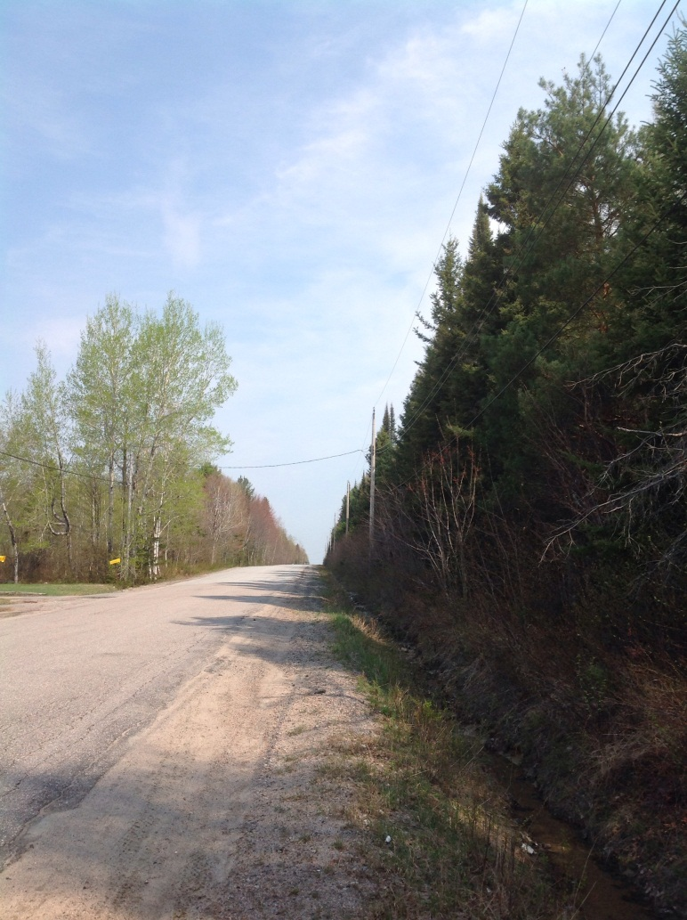

Cycle 1, Section A – 1 span in a rural area requiring the removal 63 trees varying from 4” to 26” in diameter

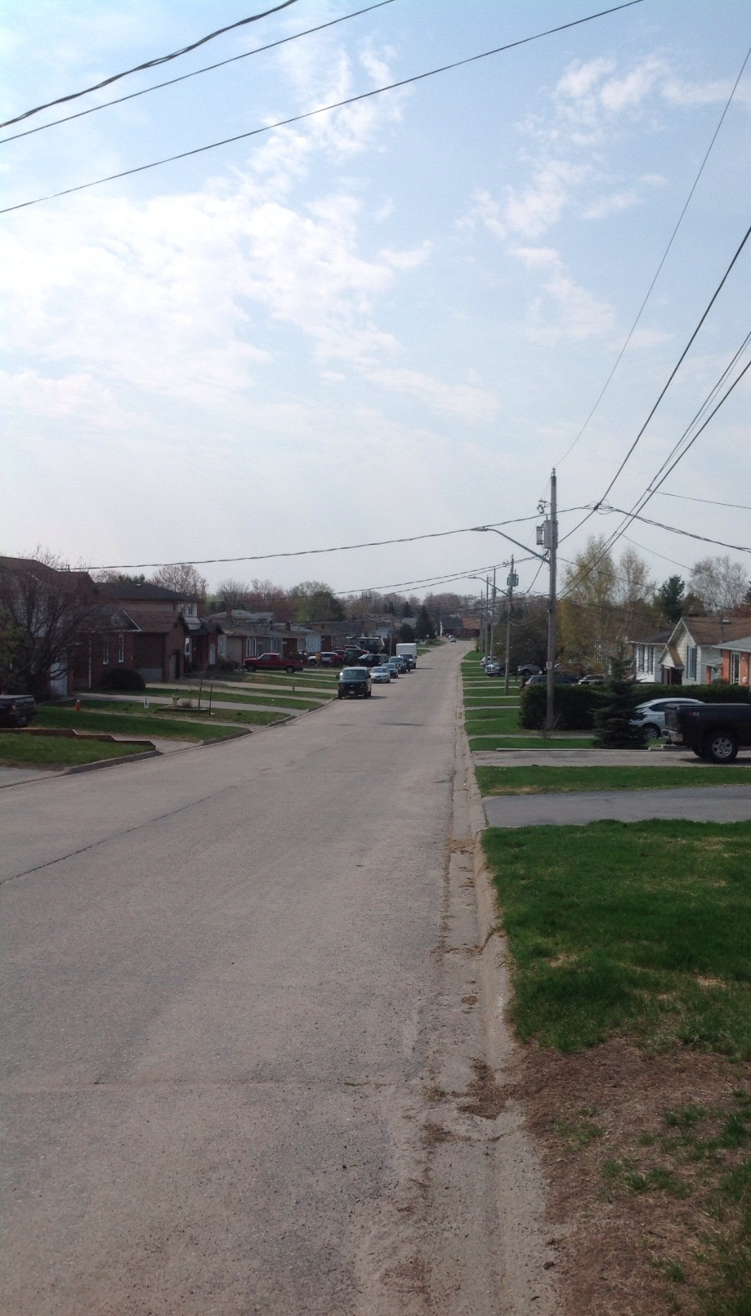
Cycle 1, Section A – 5 spans in an urban area requiring very minimal trimming

North Bay Hydro Technical Conference Undertaking Responses

Undertaking NO. JT1.6:

TO MAKE AN ATTEMPT TO FILL OUT THE TABLE, AND IF THERE ARE SOME BARRIERS TO REPORT BACK AS TO WHAT THOSE ARE.

Response:
NBHDL has completed the table circulated as Exhibit KT-1.2 to the best of its ability considering the data limitations with regards to the level of granularity NBHDL tracks at this point in time. A live Excel spreadsheet has been provided under file name “NorthBay_Undertaking_Resp_JT1.6_KT-1.2 – SEC ACA Summary_20150513”. Notes have been provided at the bottom of the table detailing what information is available and what is not.
North Bay Hydro Technical Conference Undertaking Responses

Undertaking NO. JT1.7:

WITH REFERENCE TO 2-SEC-33, APPENDIX 2-AA, THE CAPITAL PROJECTS TABLE, TO PROVIDE THE BREAKDOWN OF THE NUMBER OF TRANSFORMER PURCHASES AS BETWEEN UNDERGROUND AND OVERHEAD FOR THE HISTORICAL PERIOD (BROKEN OUT BETWEEN OVERHEAD AND UNDERGROUND), AND THE FORECAST; TO PROVIDE A BREAKDOWN OF THE TWO LINE ITEMS UNDER SYSTEM SERVICE RELATED TO METER INSTALLMENTS BY NUMBER, AS WELL AS FOR THE HISTORICAL PERIOD AS WELL AS FOR THE FORECAST; TO PROVIDE THE NUMBER OF WOOD POLES REPLACED FOR THE HISTORICAL PERIOD AND THE FORECAST; TO PROVIDE THE NUMBER OF CIRCUIT BREAKERS REPLACED IN THE LAST FIVE YEARS, AND PLANNED FOR REPLACEMENT, WITH THE CORRESPONDING COST.

Response:
NBHDL has filled out the table provided in 2-SEC-33 to the best of its ability considering the data limitations with regards to the level of granularity NBHDL tracks at this point in time. A live version of the spreadsheet is provided under file name “NorthBay_Undertaking_Resp_JT1.7 - 2-SEC-33 Table_20150513”.
As explained in the technical conference, direct comparisons between a category of dollars and a specific replacement cost cannot be made as there are more costs/multiple activities within a category than the specific unit/replacement cost. This is the case with the two line items under system service related to meter installations; these two line items are various projects that encompass costs from multiple work orders and NBHDL does not track meter quantities by work order. For the purposes of the 2015 Test Year forecast, the amounts included for “Meter Installs and Upgrades-Smart Meters” of $15,000 represents an estimated meter cost of $75/meter for 200 residential smart meters. The miscellaneous “Meters” line represents an estimate of 5 interval meters at a total estimate of $10,000.
North Bay Hydro Technical Conference Undertaking Responses

Undertaking NO. JT1.8:

TO UPDATE THE COST OF POWER CALCULATION, ASSUMING IT IS A MATERIAL CHANGE, TO REFLECT THE LATEST FORECAST FOR RPP PRICES.

Response:
NBHDL has updated the cost of power calculation to reflect the most recent RPP and non-RPP price obtained from the Regulated Price Plan Price Report for the period of May 1, 2015 to April 30, 2016 published by the Board April 20, 2015. For the purposes of calculating the 2015 Test Year, NBHDL has used an estimate of $.10210 per kWh for RPP customers. For non-RPP customers, NBHDL has used $.10186/kWh which includes $.01992 per kWh for the Forecast Wholesale Electricity Price and $.08194 per kWh for the Impact of the Global Adjustment charges. The calculation was derived using the proposed 2015 load forecast for the purposes of determining NBHDL’s 2015 proposed rates as provided in Undertaking NO. JT1.14. The following table has been provided to summarize the proposed cost of power expense.

North Bay Hydro Technical Conference Undertaking Responses

Undertaking NO. JT1.9:
TO PROVIDE THE IMPACT ON TAXABLE INCOME IN THE TEST YEAR, IF THE 2014 AND '15 ADDITIONS IN COMPUTER SOFTWARE WERE REMOVED FROM CCA CLASS 50 AND PUT IN CCA CLASS 12.

Response:
During the analysis for this undertaking NBHDL noted that a project amounting to $9,000 was included as Computer Hardware (Acct 1920) in the 2015 Continuity Schedule, but should be included in the additions for Computer Software (Acct 1611 – formally Acct 1925). As this amount is immaterial, NBHDL proposes to update the continuity schedule for 2015 when final rates are determined. For clarity, the additions to Computer Software (Acct 1611) for the 2015 Test Year should be $37,250 and additions to Computer Hardware (Acct 1920) for the 2015 Test Year should be $126,800.
If the 2014 (actual - $86,870) and 2015 (forecasted - $37,250) computer software additions are re-allocated to CCA Class 12, from CCA class 50, there would be a ($23,370) reduction to taxable income in the 2015 Test Year.
In reviewing the capital additions for 2014 and 2015 in more detail against the CCA Class definitions in the context of the comments made by Mr. Aiken in the Technical Conference, NBHDL has determined that a re-allocation of 2014 actual additions of $86,870 and 2015 forecasted additions of $37,250 to Class 12 is appropriate. NBHDL has made this revision and included the changes in the response to Undertaking NO. JT1.1. NBHDL is proposing a ($23,370) reduction to taxable income in the 2015 Test Year.
North Bay Hydro Technical Conference Undertaking Responses

Undertaking NO. JT1.10:

TO REFILE UPDATED SCHEDULES 2-JA, 2-JB AND 2-JC FOR 2014 ACTUALS.

Response:
Tables 2-JA, 2-JB and 2-JC are provided in a live Excel spreadsheet named “NorthBay_Undertaking_Resp_JT1.10 - Tables 2-JA_2-JB_2-JC - IRR 2-SEC-35_20150513”.

North Bay Hydro Technical Conference Undertaking Responses

Undertaking NO. JT1.11:
TO EXPAND THE TABLE AND PROVIDE A RESPONSE TO PART A TO INCLUDE 2014 ACTUALS FOR THE CUSTOMER THAT CLOSED SHOP IN 2014.

Response:

The table provided in 3-Energy Probe-37 a) has been updated below to include 2014 actual kWh and kW for the customer in the GS 3,000 to 4,999 kW class that has shut down its operations in North Bay.
North Bay Hydro Technical Conference Undertaking Responses

Undertaking NO. JT1.12:
TO UPDATE THE EQUATION IN ENERGY PROBE 35(B) ADD IN TWO ADDITIONAL EXPLANATORY VARIABLES, ONE OF WHICH -- THE FIRST ONE OF WHICH IS A DUMMY VARIABLE WITH A VALUE OF 1 IN AUGUST OF 2003 FOR THE BLACKOUT AND ZERO ELSEWHERE AND THE EMPLOYMENT VARIABLE, AND THE 8 MILLION CDM ADJUSTMENT (THE CURRENT NUMBERS) IN ONE LIVE EXCEL SPREADSHEET, AS IN 35(B).

Response:
The requested live Excel spreadsheet has been provided in the file named “NorthBay_Undertaking_Resp_JT1.12 - 2015 Load Forecast Model_20150513”. This version of the load forecast is the load forecast provided in response to Undertaking NO. JT1.14 with the following changes.
1) The North Bay Economy variable has been set to zero for August 2003.
2) The Blackout Flag variable has been added and set to 1 for August 2003. All other months are set to zero.
3) The Northeastern Employment variable used in response to 3-VECC-17 d).
North Bay Hydro Technical Conference Undertaking Responses

Undertaking NO. JT1.13:
TO DESCRIBE THE RELATIVE CHANGES IN RESIDENTIAL CDM ADJUSTMENT.

Response:

The CDM adjustment is a function of two factors: the estimated savings from CDM and the weighting factor used for the load forecast.

For results from 2011, 2012 and 2013 programs in 2015, there were minor changes to ensure consistency with OPA reported results (after adjustments), as documented in the final table provided in the response to VECC-53. These values do not affect the forecast, as these years are given a weighting factor of 0. In the original submission, a weighting factor of 0.5 was used for 2013 as the forecast did not originally use 2014 actual data. Because the revised forecast did make use of actual 2014 data, the weighting factor for 2013 was reduced from 0.5 to 0.

For 2014, estimated savings at the time of the original submission were revised from estimated savings to the amount necessary to meet NBHDL’s OEB specified 2011-2014 target, consistent with the instruction on Appendix 2-I Load Forecast CDM Adjustment Work Form (2015). The preliminary results for 2014 from the IESO suggest that NBHDL will realize savings close to the targets, but NBHDL expects that final results will indicate additional savings not captured in the preliminary results. As suggested by Energy Probe in its IR number 36, NBHL has estimated persistence of 2014 programs into 2015, even though the OEB’s Appendix 2-I Load Forecast CDM Adjustment Work Form (2015) does not do so. Because the revised forecast used actual 2014 energy use data, the appropriate weighting factor for 2014 program results in 2015 was reduced from 1.0 to 0.5.

For 2015, the target is expressed more precisely (20,258,133 kWh versus 20,300,000). As the programs from 2011 to 2014 are continuing in 2015, the share across rate classes is more likely to be consistent with that seen for 2013 when these programs were relatively mature, and this results in a greater allocation to the residential rate class, as discussed further below. Estimated savings in 2015 are based on the completion of the cogeneration project, and realization of one-sixth of the remaining 2020 target.

There is no change to the weighting factor for 2015 programs in 2015; it remains at 0.5.

Looking at individual classes, beginning with the Residential class, the anticipated CDM savings in 2013, 2014 and 2015 programs in 2015 are higher than originally estimated, even after incorporating loss of persistence of programs from 2013 and 2014. This is primarily due to higher than originally anticipated savings in 2014 and 2015 in this class, resulting in savings in 2015 from 2015 programs and 2013 and 2014 program persistence of 2,725,796 kWh versus the original estimate of 1,562,200 kWh. Where originally the residential class was anticipated to be responsible for 20% of overall savings, based on 2013 results that number is closer to 44% (excluding street lighting and GS 3000 – 4999 classes). However, by incorporating actual 2014 usage data into the load forecast, and thereby changing the weighting factors from 0.5, 1.0, and 0.5 in 2013, 2014 and 2015 respectively to 0.0, 0.5 and 0.5 in 2013, 2014 and 2015 respectively, the average weighting factor went from 0.628 for the three years in the original forecast to 0.325 in the revised forecast. Consequently, the load factor adjustment in the residential sector went from 981,146 kWh in the original forecast to 884,849 in the revised forecast.

In the case of the GS<50 rate class, there was a more significant reduction in anticipated savings over the three years. The 2013 results used to estimate the 2015 allocation across rate classes are showing about 25% of savings in this rate class, whereas it had previously been estimated at 35% (not including the REM). In addition, the overall savings across all rate classes in 2014 was reduced to just meet the 2011-2014 target. Thus the estimated savings before applying weighting factors for the adjustment were reduced from 2.7 GWh to 1.5 GWh. Due to the inclusion of the 2014 actual data in the load forecast, the average weighting factor for the three years for this rate class dropped from 0.628 to 0.327. Consequently, the adjustment factor needed went from 1.7 GWh to 0.5 GWh.

For the GS 50 to 2999 rate class, the overall reduction in 2014 estimated savings, the incorporation of loss of persistence for 2013 and 2014 programs, and the smaller share of total savings in this class observed in 2013 and used for 2015 estimates meant that the estimated savings for the three years of programs in 2015 fell from 17.3 GWh to 14.1 GWh. Significant savings (2.16 GWh) were anticipated from a program of Roving Energy Managers (REM) in 2014, but those are not being shown in the preliminary OPA report for 2014 so have been excluded. The cogeneration facility is still expected to come on stream in 2015. With the inclusion of the 2014 actuals in the load forecast, the average weighting factor for this rate class fell from 0.589 to 0.476 and the size of the manual adjustment required to the load forecast went from 10.2 GWh to 6.7 GWh.

Finally, the original forecast included estimated savings from the GS 3000 to 4999 rate class and for the street lighting program. Both of these are now excluded from the load forecast, and the manual adjustment for these rate classes is 0.

The following tables summarize these changes:
North Bay Hydro Technical Conference Undertaking Responses

Undertaking NO. JT1.14:

TO PROVIDE A REVISED VERSION OF TABLE 3-18 BASED ON THE MOST RECENT FORECAST VALUES.

Response:
The requested revised Table 3-18 is provided below. The version of the load forecast which supports this table is the revised version of the proposed 2015 load forecast for the purposes of determining NBHDL’s 2015 proposed rates. In this regard, a live Excel spreadsheet which is the revised proposed load forecast is provided under file name “NorthBay_Undertaking_Resp_JT1.14 - 2015 Load Forecast Model_20150513”.

North Bay Hydro Technical Conference Undertaking Responses

Undertaking NO. JT1.15:
TO UPDATE VECC 26 BASED ON THE NEW CDM ESTIMATES, BOTH IN TOTAL AND HOW YOU APPLIED THE HALF YEAR AND FULL YEAR RULES.

Response:
The following tables are provided with the updated 2015 CDM adjustments to be incorporated into the updated load forecast.

For all rate classes, a weighting factor of 0 has been used for years 2011 to 2013 since the CDM savings from programs in these years are captured by the use of actual energy use through 2014 in the load forecast. A weighting factor of 0.5 is used for 2014 persistence into 2015 to account for only about one-half of 2015 savings from 2014 programs being captured in the 2014 actual data due to the half-year rule, and a weighting factor of 0.5 is also used for 2015 since the actual impact on load is approximately one-half of the amount the IESO is expected to report, again based on the half-year rule.

For completeness, the comparable table for the Street Lighting rate class follows, but because no new CDM programs are anticipated for this rate class, and the programs implemented in 2012 and 2013 are fully captured by the use of actual data through 2014, there is no manual adjustment required, and no claim for lost revenues for this rate class is expected.

North Bay Hydro Technical Conference Undertaking Responses

Undertaking NO. JT1.16:
TO PROVIDE A VERSION OF APPENDIX 2-EB THAT REFLECTS A THREE-YEAR DISPOSITION PERIOD AND THEN, BASED ON THIS THREE-YEAR DISPOSITION PERIOD, CALCULATE THE AMOUNT TO BE RETURNED EACH YEAR AND THE APPROXIMATE IMPACT ON RATES FOR EACH OF 2015, '16, AND '17, AND TO EXPLAIN WHY NORTH BAY HYDRO'S PROPOSING A ONE-YEAR DISPOSITION PERIOD RATHER THAN A TWO- OR THREE-YEAR DISPOSITION PERIOD.

Response:

In preparing the response to this undertaking NBHDL noted that the WACC % used in 9-Staff-26 b) to determine the revised amount proposed for disposition in Account 1576 was the WACC % NBHDL utilized in the application as submitted December 12, 2014 of 6.28%. NBHDL has revised the amount proposed for disposition in Account 1576 using the proposed WACC of 6.18% as provided in the updated Revenue Requirement Work Form in Undertaking NO. JT1.1. NBHDL has updated the EDDVAR model for the change to the proposed disposition amount and to reflect changes to the load forecast as explained in Undertaking NO. JT1.14; the live Excel file is named “NorthBay_Undertaking_Resp_JT1.16 - North Bay 2015_EDDVAR_Continuity_Schedule_20150513”.

For ease of reference the revised proposed disposition amount of ($3,650,089) for Account 1576, for the purposes of determining rates, is provided in the following amended Table 2-EB. NBHDL is proposing to refund this amount to customers in a timely manner over a one-year disposition period. Considerations for NBHDL’s proposal are explained in Exhibit 9 (page 30) of the application.

A revised version of Appendix 2-EB is provided below – for illustrative purposes, NBHDL has revised the amount in Account 1576 using the proposed WACC of 6.18% and a 3 year disposition term as requested in this undertaking. Bill impacts on rates for each of 2015, 2016 and 2017 are also provided below. The assumptions made in order to provide the bill impacts are as follows:

2016 through 2017 distribution rates (i.e.; fixed and volumetric rates only) were increased by a Price Cap Index % only to reflect the IRM position that NBHDL will be in through that period. The increase was based on the assumption that the proposed 2015 rates would be approved by the Board.

NBHDL assumed a PCI of 1.3% based on the 2015 IRM rate proceeding.

All rate riders, excluding Account 1576, would have a one-year term and expire in 2016.

Costs outside of NBHDL’s control (i.e.; TOU, WMS, Network, 1 DRC, etc.) remained static at 2015 amounts.

North Bay Hydro Technical Conference Undertaking Responses

Undertaking NO. JT1.17:
TO UPDATE THE RETAIL TRANSMISSION SERVICE RATES TO REFLECT ANY CHANGES TO THE SUB-TRANSMISSION.

Response:
NBHDL has utilized the most recent Retail Transmission Service Rates in the cost of power calculation provided in Undertaking NO. JT1.8. NBHDL has provided a live version of the RTSR model under the file name “NorthBay_Undertaking_Resp_JT1.17 - North Bay 2015_RTSR MODEL_V4_0_20150513”.

North Bay Hydro Technical Conference Undertaking Responses

Undertaking NO. JT1.18:
WITH REFERENCE TO APPENDIX 2-BA, TO EXPLAIN THE DIFFERENCE IN NET ADDITIONS AND NET DEPRECIATION BETWEEN OLD CGAAP AND MODIFIED IFRS.

Response:

NBHDL understands that this undertaking is in relation to Table 9-9 of NBHDL’s application, specifically Appendix 2-EA for Account 1575, and the difference in the net additions between CGAAP and MIFRS. The difference in net additions is a reflection of the dispositions in distribution assets that NBHDL will record under MIFRS that would not be recorded under CGAAP. Table 9-8 within Exhibit 9 of NBHDL provides the disposition entry by USoA Account.

For ease of reference, NBHDL has included a revised Table 2-EA to account for 2014 actuals and to exclude WIP from the Net Book Value amount. The difference in net additions by USoA is provided below.

The reconciliation between Net Additions under CGAAP and Net Additions under MIFRS is as follows:

A revised Table 2-EA to account for 2014 actuals and to exclude WIP from the Net Book Value amount is provided below.

EB-2014-0099 Technical Conference – May 4, 2015 – page 10, line 17
EB-2014-0099 Technical Conference – May 4, 2015 – page 77, line 16-19

