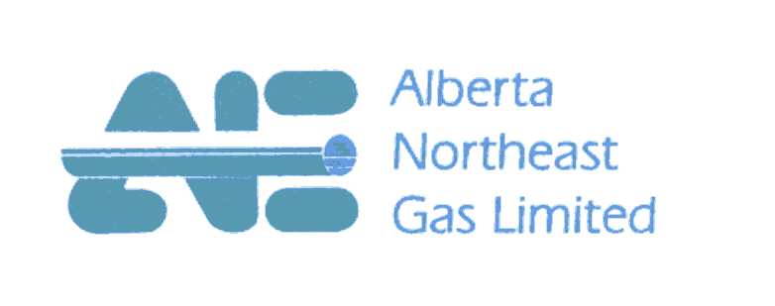July 31, 2015
FILED ELECTRONICALLY
Ontario Energy Board
2300 Yonge Street, 27th Floor
Toronto, ON
M4P 1E4

Attention: Ms. Kirsten Walli
Board Secretary

Dear Ms. Walli:

Re: Union Gas Limited – 2017 Dawn Parkway Project
OEB File No. EB-2015-0200
Alberta Northeast Gas Ltd. ("ANE") Intervention
Pursuant to the Ontario Energy Board's July 21, 2015 Notice of Application in Proceeding EB-2015-0200, please find attached ANE's request for intervenor status in the subject proceeding.

Yours truly,
(Original Signed By)
Jim Carmichael
President, ANE
c: Karen Hockin, Union Gas Limited
Crawford Smith, Torys LLP

