EB-2015-0049

Ontario Energy Board

ONTARIO ENERGY BOARD
IN THE MATTER OF the Ontario Energy Board Act, 1998,
S.O. 1998, c. 15 (Schedule B);

AND IN THE MATTER OF an Application by Enbridge Gas
Distribution Inc. pursuant to Section 36(1) of the Ontario
Energy Board Act, 1998, S.O. 1998, for an order or orders
approving its Demand Side Management Plan for 2015-2020

Compendium EGD Panels 1, 2, 4

Energy Probe Research Foundation

August 24, 2015

Compendium

Energy Probe Cross-Examination

EGDI PANEL 1

IRR I.T2.EGDI.CCC.11.

RESPONSE
Section 15.1 of the DSM Framework calls on the gas utilities to “…increase their
budgets, targets and shareholder incentive amounts in the same manner as they have
done throughout the current DSM Framework (i.e., 2013 updates to 2014 should now
apply as 2014 updates to 2015).”

To determine Enbridge’s 2014 targets in EB-2012-0394 the Board approved the
following increases from the targets of 2013:
• Resource Acquisition
o 2% for all targets
• Low Income
o 2% for the Single-Family Part 9 target
o 7% for the Multi-residential Part 3 target
o No increase to the target for the percentage of Part 3 participants which
enrolled in Run it Right / Utility Management
• Residential Savings by Design
o 9% for the lower band of the Builder Enrollment target
o 14% for the middle band of the Builder Enrollment target
o 11% for the upper band of the Builder Enrollment target
o 11% for all Completed Unit targets
• Commercial Savings by Design
o 33% for the lower band target
o 50% for the middle band target
o 27% for the upper band target
• Home Labelling
o No increase to the Realtor Commitment target
o 300% increase to the Ratings Performed target

In keeping with the Board’s direction in section 15.1 of the new DSM Framework and
the escalation factors approved in EB-2012-0394 to increase DSM targets from 2013 to
2014, Enbridge applied the above noted escalations to its 2014 scorecard targets to
establish 2015 targets

JT 1.36 Attachment EP Update 2016
Tab 2 FINAL 2014&15 Scorecards

Exhibit B/1/4 paragraph 14

IRR JT 1.36 EGDI Response Question 5

Exhibit B/1/4 Page 10 Table 8

JT 1.36 Attachment EP Update 2016
Tab 1 FINAL $ per CCM

JT1.36 EGDI Response Question 6

IRR Exhibit I.T3.EGDI.ED.13

Exhibit L GEC.1 page 18 Table 3 Corrected August 12 2015

Exhibit L GEC.1 Page 19 Corrected August 12 2015

B/1/6 Corrected Pages 2&3 Cost-Efficiency Incentive Deferral Account DSMCEIDA
IRR Response I.T10.EGDI.STAFF.29 Part c)

IRR Response Exhibit I.T10.EGDI.EP.12

EGDI PANEL 2

Exhibit M.OEB Staff Evidence Synapse Energy Economics Inc. Report
Appendix A3 Section 5.3

Exhibit B/1/4 pages 26 and 27

IRR Response Exhibit I.T5.EGDI. EP.22

IRR Response Exhibit I T5.EGDI BOMA 44
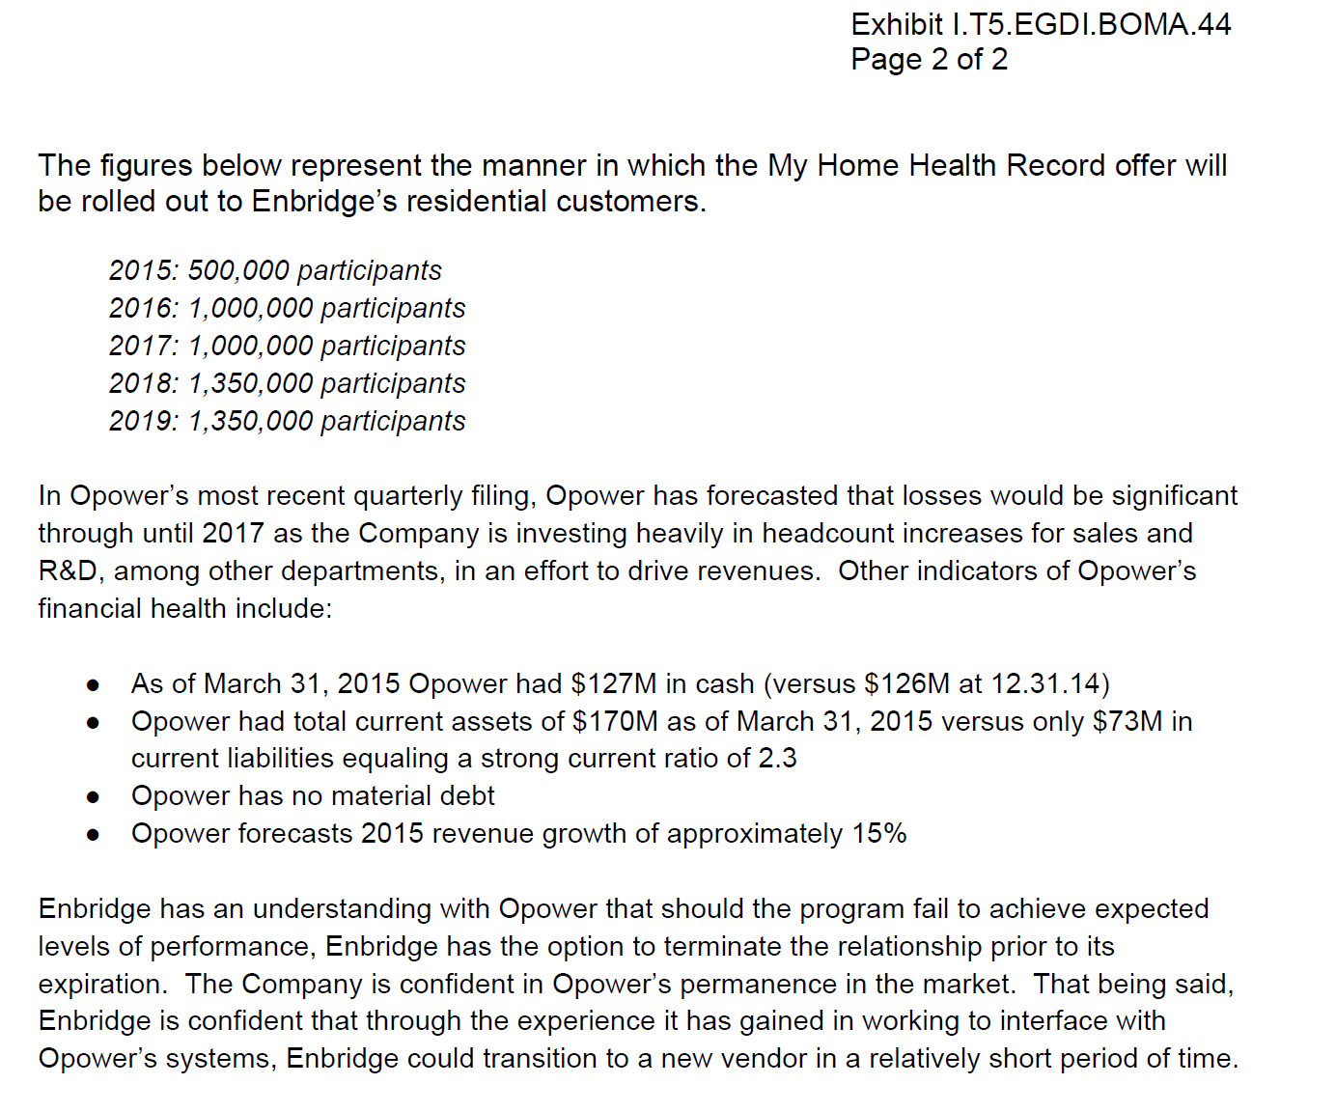

Exhibit M OEB Staff.1 Synapse Report Appendix A3
1.36 Attachment EP Update 2016 Tab2 2014&15&16 Scorecards

IRR Response I.T5 EGDI.EP.24 part c)
EGDI PANEL 4

Exhibit C Tab1 Schedule 1 Navigant Natural Gas Energy Efficiency Potential Study Table 5-19

Exhibit I.T2 EGDI.EP.34 Table1, Table 3, Figure 1

Response to JT1.36 Question 7 c)

Avoided Costs B/Tab2/S5 Corrected

Navigant Avoided Cost Study Exhibit C Tab1 Schedule 4 Table 2 the Summary of Levelized Avoided Distribution Costs

Excerpts Transcript TC3 Monday August 17
page 17.
Then in addition, Navigant used some fairly obscure methodology for levellizing the costs. Rather than using the normal economic carrying charge, the real levellized carrying charge, they did something that they didn't document very well. They had a lot of pretty graphs laying out the concept, but no real numbers.
And Enbridge refused to provide any of their work papers, so we don't know what they did or how they got the number. But it looked like they used too low a carrying charge, and they omitted any O&M related to having additional pipe in the ground.

Page 39
MR. CHERNICK: Enbridge had acknowledged that it had forgotten basically all the projects that we knew about from the GTA proceeding, and it also volunteered the information that it had forgotten to include a group of projects in its Appendix B.

Page 40
MR. CHERNICK: I think that Enbridge said that would increase their avoided cost by about 11 percent. But I'm just telling you that off the top my head.
DR. HIGGIN: That's good. So there is a smallish or relatively small increase that would be appropriate, in your opinion, based on those corrections.
Later Mr. Chernick Indicated that perhaps his recollection of11% was not correct
Page 103/104
MR. CHERNICK: There was some 11 percent someplace with some adjustment. It may have been units -- excuse me, what Union's -- I'd have to look it up. Eleven percent sounds like something I said in the past, but I can't remember in what context.
MR. O'LEARY: Rather than going back, can I just refer you to your response to Enbridge Interrogatory No.21?
In that, you were asked to confirm that Enbridge stated that the overall impact of the inadvertent errors resulting in a 27 percent increase to reinforcement cost resulted in a marginal increase of less than 1 percent in water heating and industrial load, and an increase of 1 percent in space heating -- space and water heating. And your answer is yes So to the extent that your earlier answer is incorrect, you'll stand by --
MR. CHERNICK: Oh, yes, you're right. And the 11 was a different number, which actually I mentioned in my testimony regarding Union's extrapolation from Enbridge's values. Thank you for that correction.

