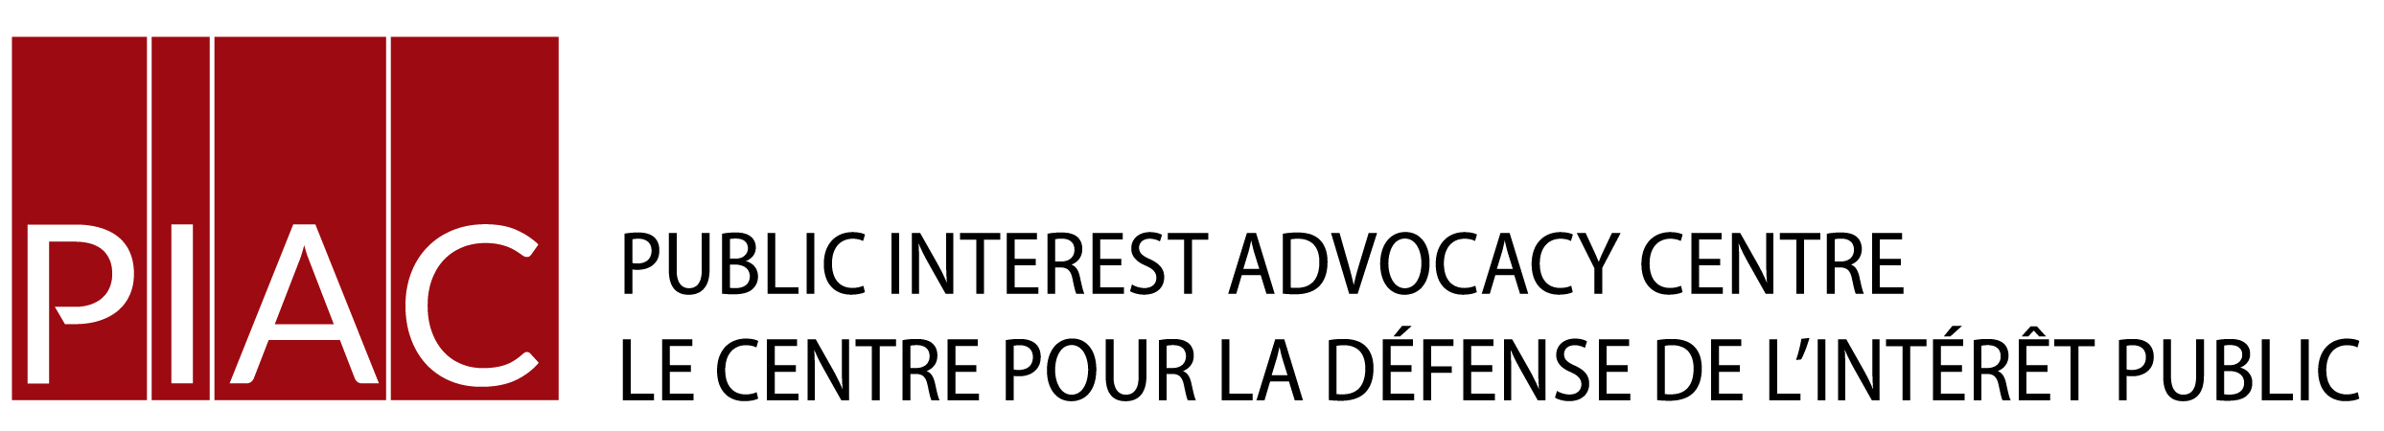

November 28, 2015

**VIA E-MAIL**

Ms. Kirsten Walli

Board Secretary

Ontario Energy Board

P.O. Box 2319

2300 Yonge St.

Toronto, ON

M4P 1E4

Dear Ms. Walli:

**Re: EB-2015-0090 & EB-2015-0328 – Niagara Peninsula Energy Inc.**

**Interrogatories of Vulnerable Energy Consumers Coalition (VECC)**

Please find enclosed the interrogatories of VECC in the above-noted proceeding.   
  
VECC acknowledges that interrogatories were to be filed Friday November 27, 2016. VECC apologies for its late filing and asks that the Board please accept its interrogatories.

Thank you.

Yours truly,



Michael Janigan

Counsel for VECC

Cc: Niagara Peninsula Energy Inc.

**EB-2015-0090  
EB-2015-0328**

**Niagara Peninsula Energy Inc. (NPEI)**

**Application for electricity distribution rates and other charges   
effective May 1, 2016.**

**VECC Interrogatories**

**Information Requests of the Vulnerable Energy Consumers Coalition (VECC)**

**LRAMVA**

VECC-1

**Ref:** Application Page 7 of 59

NPEI states “As indicated in the IndEco Report (Attachment A, page 3), NPEI’s CDM results as provided by the OPA include the calculation of demand reduction due to the Demand Response 3 (“DR3”) program in a manner that is consistent with other recent LRAMVA dispositions applications, which have been accepted by the Board.”

**Ref**: IndEco Report Page 3

IndEco states “In the case of demand response programs, in particular Demand Response 3 (DR3), the demand reduction may only apply to certain months in the year. These considerations have been factored into the lost revenue calculations.

There have been arguments advanced around the uncertainty regarding the impact of DR3 program results on LDC revenues. However, the OEB has considered these arguments and has been consistent in recent rate cases in ruling that the IESO’s analyses with respect to CDM results may be used to estimate lost revenues, including those related to DR3 programs.”

1. With respect to Demand Response 3 programs, please explain how “the demand reduction may only apply to certain months in the year” has been determined and factored into the lost revenue calculations”.
2. Please provide and explain IndEco’s previous position (prior to the PowerStream Decision EB-2014-0108) on the treatment of Demand Response 3 programs and provide the resulting impact on Deand Response 3 lost revenue calculations.
3. Please confirm that the kW savings values reported for the Demand Response 3 program are contracted values and not actual demand reductions in each year.
4. Does NPEI have any record as to how much actual demand reduction was achieved in each year due to the Demand Response 3 program? If so, how much was the actual demand reduction in each year and was the demand reduction coincident with the peak interval used to establish the customers’ billing demands?
5. If No to (d), does NPEI have the ability to track how much actual demand reduction was achieved in each year due to the Demand Response 3 program and if the demand reduction was coincident with the peak interval used to establish the customers’ billing demands.

**Bill Impacts**

VECC-2

a) Please provide bill impacts for each rate class that combine the impacts of EB-2015-0090 and EB-2015-0328, (including residential consumption at the lowest 10th percentile), and include the removal of the Debt Retirement Charge in 2016, the removal of the Ontario Clean Energy Benefit in 2016 and the addition of the Ontario Energy Support Program (OESP) starting January 1, 2016 that will be funded by all electricity ratepayers.