Thunder Bay Hydro Electricity Distribution Inc.
Application Analysis (EB-2015-0103)
Tab 15 – Rev2Cost_GDPIPI
This is to confirm that OEB staff will update the final model which will be sent back to Thunder Bay Hydro (following confirmation of any other changes resulting from the questions to follow) reflecting the updated price escalator of 2.10%.

Noted. Thank you.

Tab 3 – 2015 Continuity Schedule

OEB staff is unable to reconcile the following figures entered in the continuity schedule:
- Column Q – Board-Approved Disposition during 2012: $2,848,731

$2,848,731 is the net disposition of group one and group two accounts from the Board approved 2012 IRM Decision and Order ‘EB 2011-0197’. See details in Table below. Thunder Bay Hydro has entered the figure $2,848,731 into column ‘Q’ as it relates to the 2012 _1595 disposition balance. Entering the figure $2,848,731 generates the beginning principal balance for 1595_(2012) set apart from the debit/credit transactions in column ‘P’.

EB-2011-0197 Disposition Total:
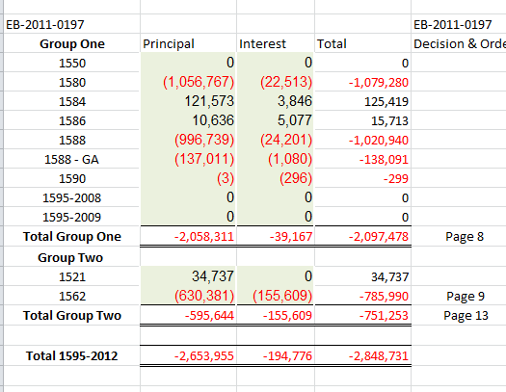

- Column AK – Board-Approved Disposition during 2013: the amounts entered for Account 1595 (2012) and 1595 (2013) are not found in the approved disposition amounts in Thunder Bay Hydro’s 2014 rates proceeding EB-2013-0172 (table reproduced below).

The figures entered into Column ‘AK’ for account 1595_2012 and 1595_2013 are principal activities that were inadvertently reported in the disposition column. A revised snap shot of the schedule below aligns the 1595 (2012) $3 and the 1595_2013 $178,938 figures into column “AJ“ (Transactions) resulting in an amended total transactions to be reported in column AJ of ($3+372 = $375) and ($709,476+$178,938 = $888,414). There is no impact to the initial closing principal balances or the final disposition claim.
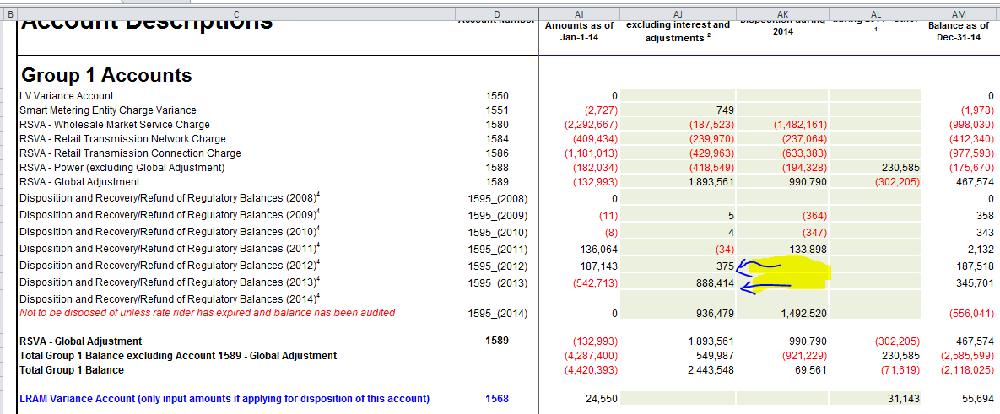

- Column AK – Board-Approved Disposition during 2013: the amount entered for Account 1595 (2014) is the reverse total Group 1 balance as seen above. OEB staff notes that while the amounts disposed in the continuity schedule can be represented in this manner, this is the only year in which this was entered in this manner.
Thunder Bay Hydro inadvertently treated the 1595_2014 principal and interest disposition separately. In keeping consistent with past presentation, the interest disposition of $69,561 should have been included in column AK, along with the principal disposition ($69,561 + $1,422,959 = $1,492,520). The schedule presentation would be revised, as per below. The change in presentation has no impact to the total disposition balance initially submitted.
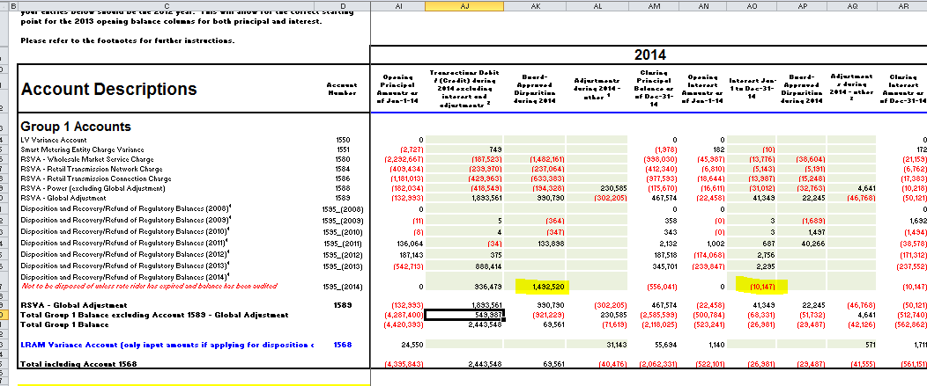
EB-2013-0172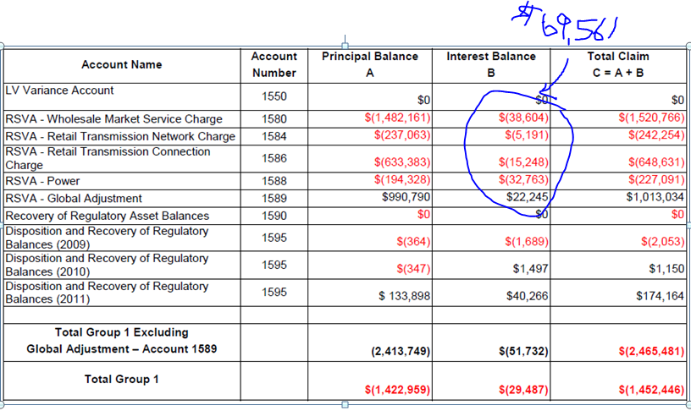

Please provide an explanation for all the discrepancies noted above. If changes are required to the continuity schedule, please confirm and OEB staff will update the model.
See responses in orange above.

Manager’s Summary, Page 8 – Rate Design for Electricity Customers
Chapter 3 of the Filing Requirements section 3.2.3 states “The OEB has established that, when assessing the combined effects of the shift to fixed rates and other bill impacts associated with changes in the cost of distribution service, a utility shall evaluate total bill impact for a residential customer at the distributor’s 10th consumption percentile.”
In order to evaluate the true bill impact for the 10th percentile (for both RPP and Non-RPP customers) excluding the effect of the Ontario Clean Energy Benefit (OCEB), Sub-Total C: Delivery $ Change should be divided by the Total Bill on TOU.
- Please confirm the Residential RPP bill impacts at the 10th percentile for Thunder Bay Hydro are 2.43%.
Thunder Bay Hydro confirms at 2.43%.

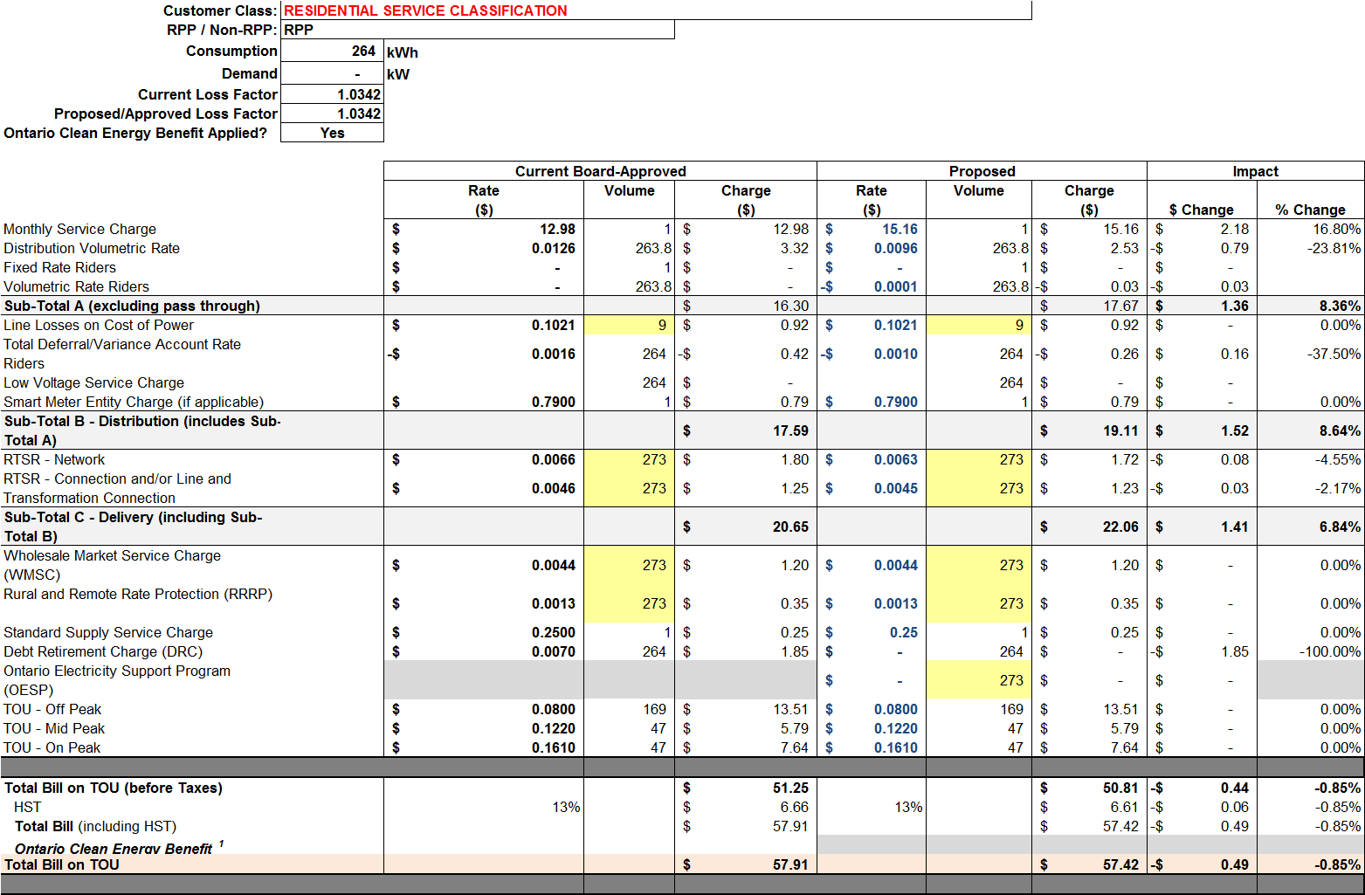

- Please confirm the Residential Non-RPP bill impacts at the 10th percentile for Thunder Bay Hydro are approximately 5.58%.
Thunder Bay Hydro confirms at 5.58%.
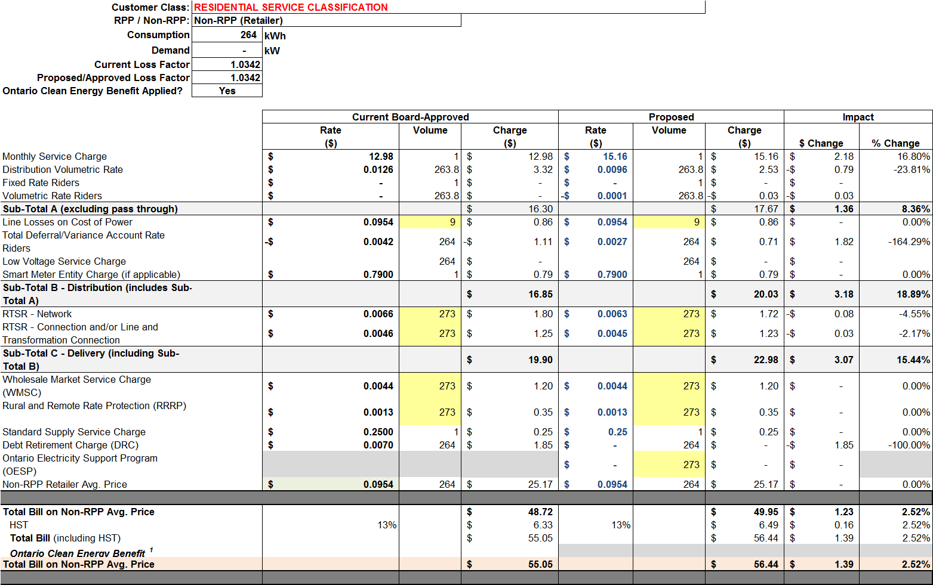

LRAMVA

Ref: Appendix E: LRAMVA, Table 1: Summary of lost revenues by rate-class

OEB Staff is unable to verify Thunder Bay Hydro’s lost revenues by CDM initiative over the course of the 2011 to 2014 period. Please provide a supplementary table that shows the savings amounts, corresponding volumetric rate and resulting LRAMVA value for each CDM initiative included in Thunder Bay’s LRAMVA request. The Excel spreadsheet attached to the initial email should be used as an example and should be expanded to include all initiatives over the 2011 to 2014 period.

Thunder Bay Hydro has attached an excel workbook that includes worksheet “1. LRAMVA 2011-2014” which provides the requested details.

