Thunder Bay Hydro Electricity Distribution Inc.
Application Analysis (EB-2015-0103)

Tab 3 – 2015 Continuity Schedule

Thunder Bay Hydro would like to restate its yearly principal disposition setups in the transaction debit/credit columns to be consistent with the presentation of interest disposition balance setup. Following the attached revision there are not any changes to the final claim for the EB-2015-0103 ‘2016’ IRM application.

The second change to the continuity schedule is related to the interest disposition for the year 2014. While responding to board questions Thunder Bay Hydro based on the inconsistency above combined the principal and interest disposition whereas it should have been as applied, and the presentation should have been revised.
$69,561 is required to be reallocated from principal columns ‘AJ/AK’ back to the column ‘AO’.

Please see the following screen shots for the changes which have been described above.

2012
2012 Principal activity as Filed:
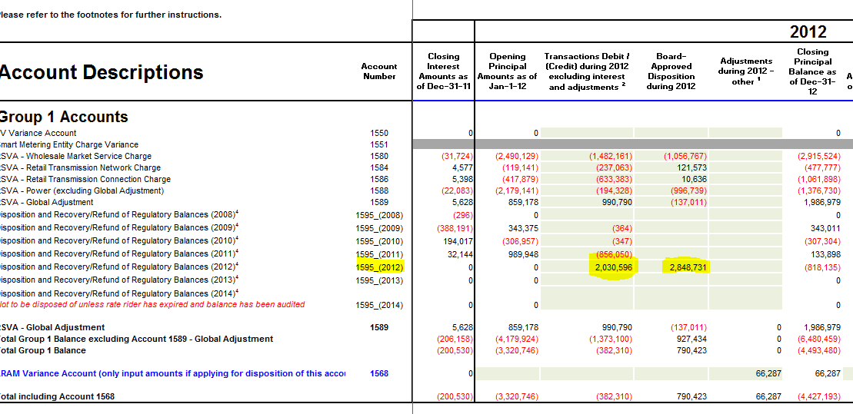

2012 Principal Activity as Revised November 30th 2015:

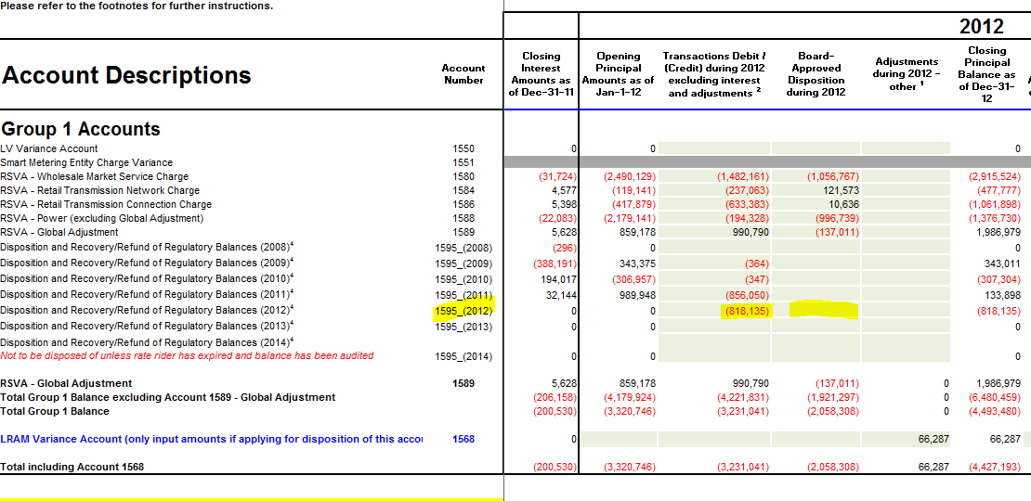

2013
2013 Principal activity As Filed:

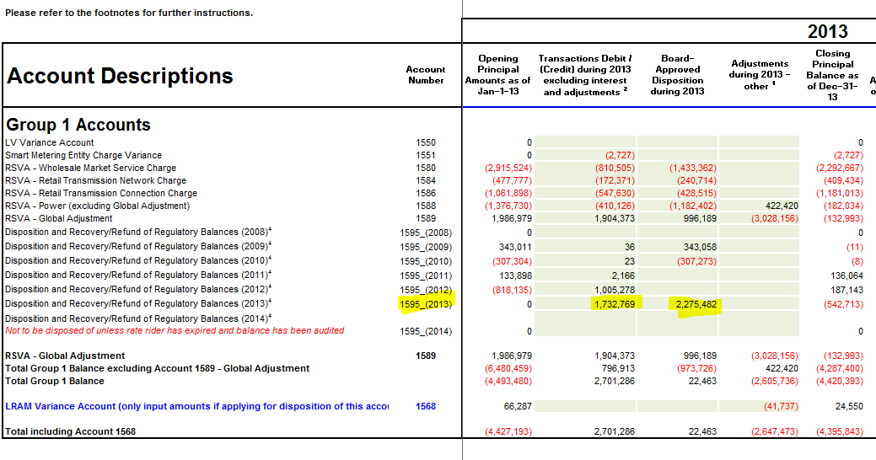

2013 Principal activity as Revised November 30th 2015:

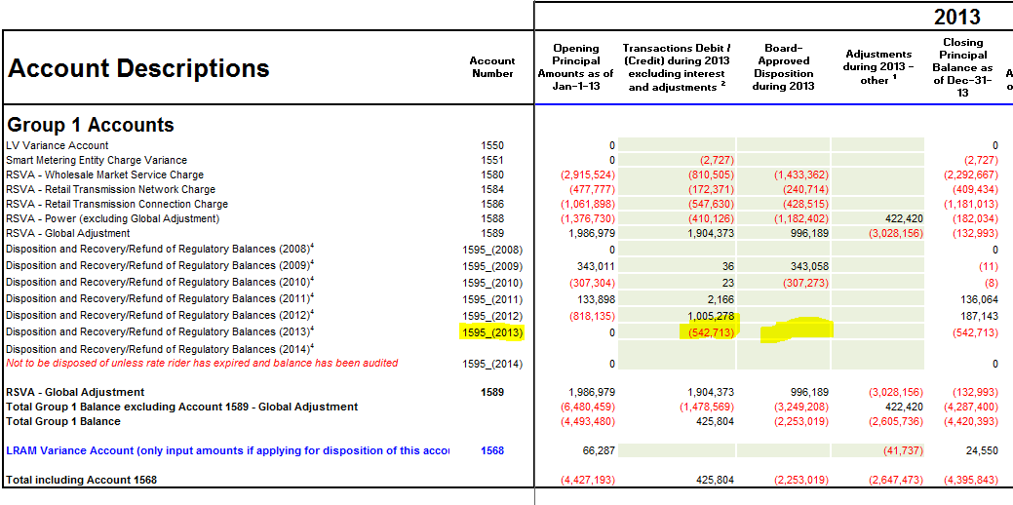
2014
2014 Principal activity as Filed:

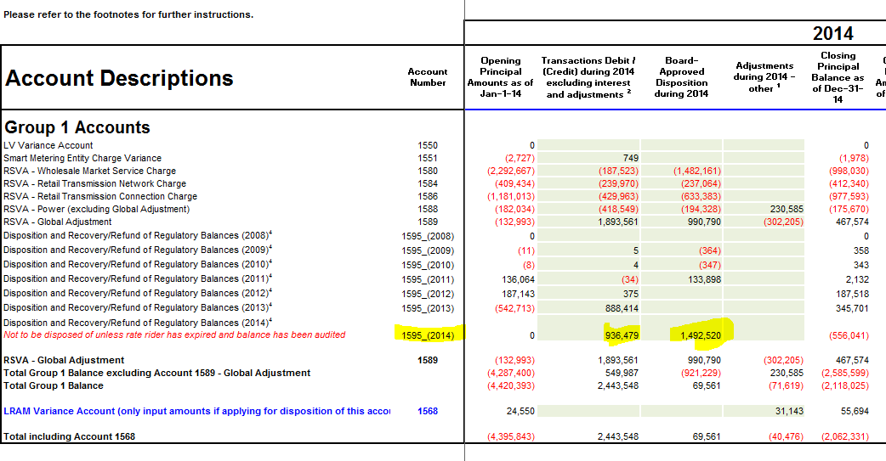

2014 Principal activity as Revised November 30th 2015:
**Remove $69,561 from principal and reallocate to interest balance.

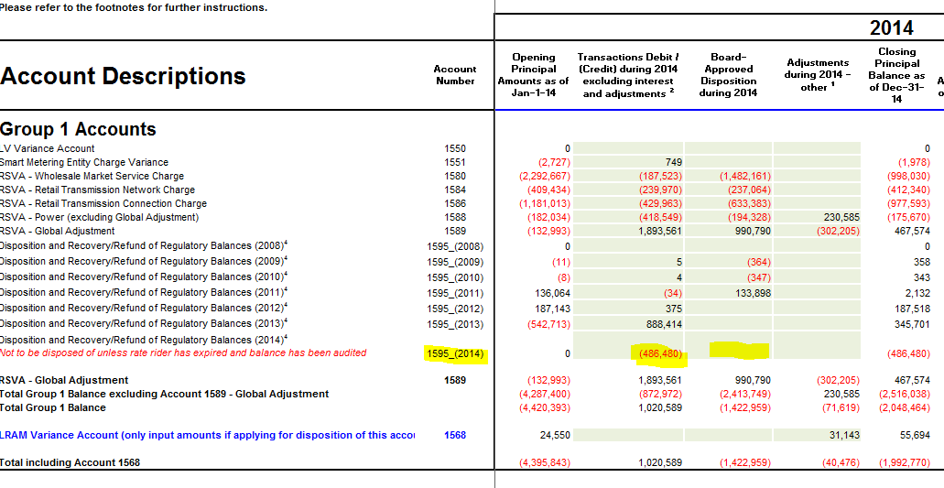

2014 Interest activity As Filed:
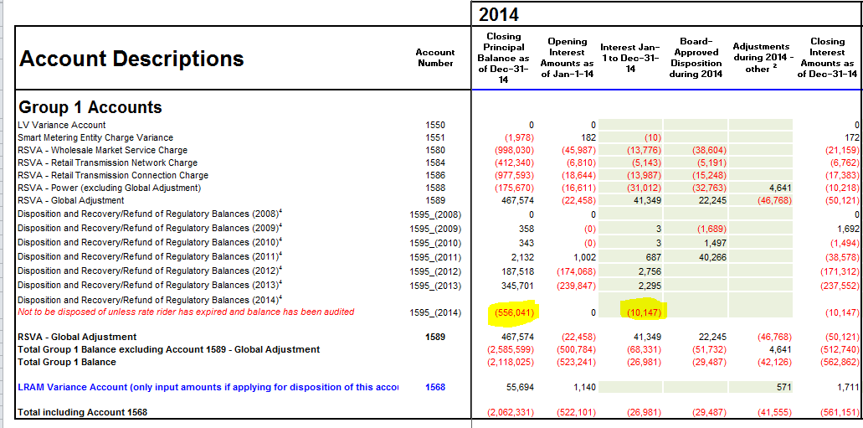

2014 Interest activity as Revised November 30th 2015:
**Remove $69,561 from principal and reallocate to interest balance.

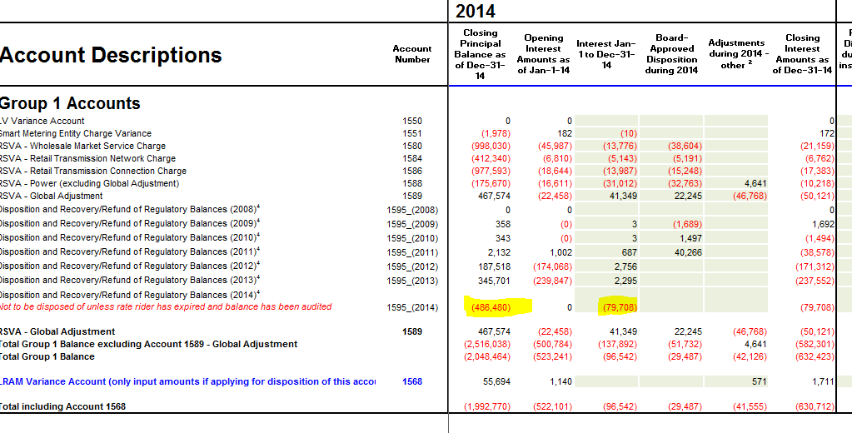

Balances as Filed:

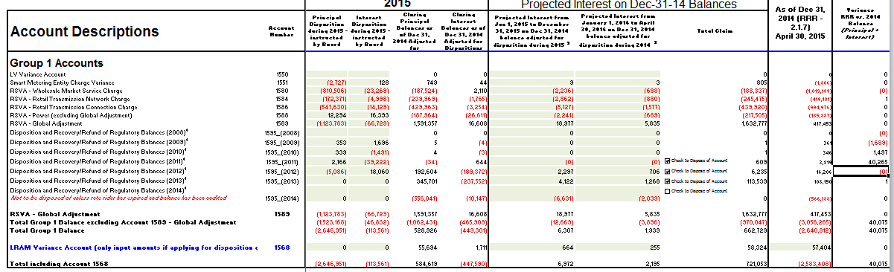

Balances as filed in attached rate generator (final):

