Hydro One Remote Communities Inc.
Application Analysis (EB-2015-0080)

Ref: Rate Model, Tab – Information Sheet
At the above reference, OEB staff notes that Hydro One Remote’s has entered “Annual IR Index” in the line item “Rate Setting Method”. OEB staff notes that under the Annual IR mechanism, the associated stretch factor is automatically set at 0.6%. OEB staff will amend Hydro One Remotes’ rate model to change the setting to “Price Cap IR” as Hydro One Remote’s associated stretch factor is 0.0%.
OEB Staff: Revised

Ref: Application, Exhibit B, Tab 2, Schedule 1, Page 35
Ref: Rate Model, Tab – Bill Impacts

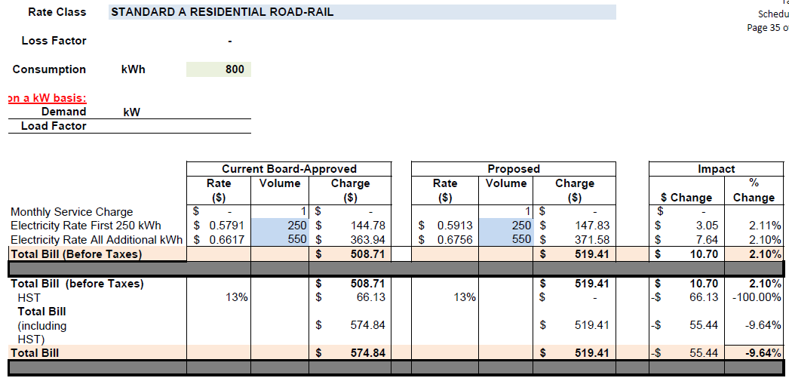
At the above reference, the HST applied seems to have been erroneously omitted in the proposed rates column for the Standard A Residential Road-Rail rate class. Please confirm if this is an error and OEB staff will update the bill impacts sheet of Hydro One Remotes’ Rate Generator model.
OEB Staff: Revised

