Erie Thames Powerlines Corporation
Application Analysis (EB-2015-0067)

Tab 3 – 2015 Continuity Schedule
Account 1589 – Global Adjustment

OEB staff notes an adjustment of $1,623,815 in column AL and an offsetting adjustment in column AB of the continuity schedule with respect to Account 1589 Global Adjustment.
- Please provide an explanation for the nature of this adjustment. If changes are required to the continuity schedule, please confirm and OEB staff will update the model.
  - Erie Thames Powerlines had a large solar generator connect to its distribution system in 2013 and as a result a large proportion of the generators load leaving Erie Thames distribution territory. The IESO settlement process uplifted the GA costs it billed Erie Thames for the total embedded generation produced within Erie Thames service territory as opposed to the net amount it should have billed in this situation.
  - Erie Thames worked with the IESO to resolve this issue in 2014 and was able to demonstrate the amount of the financial impact. Since the IESO had agreed to reimburse Erie Thames for the overbilled amounts an adjustment was applied to the values within Erie Thames 2015 IRM application to ensure its customers did not pay for 2013 DVAD variances that would eventually be recovered through the IESO.
  - Erie Thames included the debit to offset the credit it applied in its 2015 IRM application since the actual credit received from the IESO in 2014 is included as part of the transactions in 2014, therefore the debit applied in 2014 is removing the previous adjustment and the actual credit is applied to the transactions and flows through to the customers. Without the debit amount in the adjustments in 2014 the credit from the IESO would have been applied in this application twice.
  - The actual credit was received from the IESO in January 2014 and is included in the 2014 Transactions (column AI). Therefore the adjustments in columns AB-2013 and columns AL-2014 cancel each other out.

STAFF: Confirmed.

- Do any changes in billing patterns or settlement practices explain the change in the Global Adjustment value from 2013 to 2014? Please explain any other reasons for the change in the balances.

  - No changes in billing patterns explain the change in GA value from 2013 to 2014 only the above noted correction in the application of how the IESO uplifts the GA for embedded generation.
- Has Erie Thames Powerlines experienced a decrease in non-RPP consumption?

  - Erie Thames Powerlines has not experienced a decrease in non-RPP consumption.

- Please state if Erie Thames Powerlines’ billing systems have changed materially during the past two years.

  - Erie Thames Powerlines billing systems have not changed materially in the preceeding two years.
Tab 4 – Billing Det. for Def-Var
This is to confirm that OEB staff has corrected Erie Thames Powerlines’ Rate Generator Model so it does not calculate a rate rider for Global Adjustment for the Large Use rate class. This is a Class A customer which settles directly with Erie Thames Powerlines.
- Erie Thames Powerlines concurs that this correction performed by Board staff should be completed.
STAFF: Correction completed.

Tab 10 – RTSR – UTRs & Sub-Tx
OEB staff notes that the Hydro One Sub-Transmission Rate Rider expired effective January 1, 2015. OEB staff will update the IRM model to remove these riders.

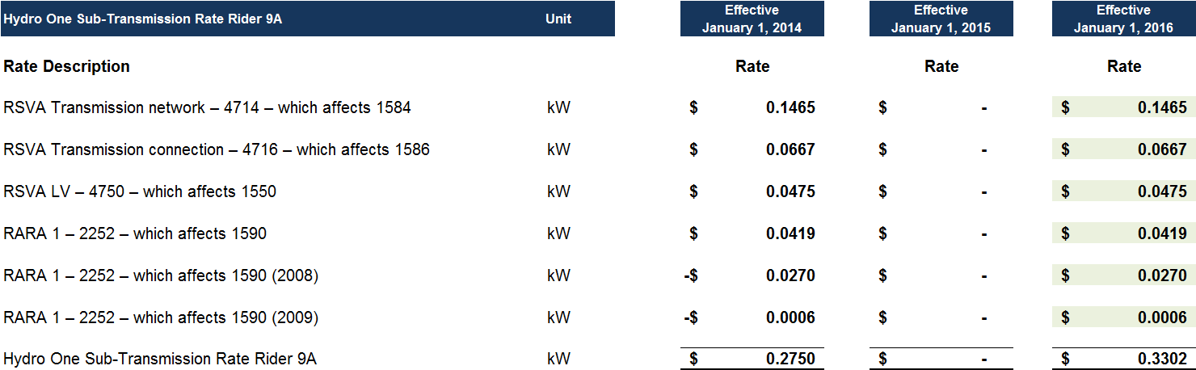
- Erie Thames Powerlines concurs that Board staff should update the IRM model to remove these rate riders.
STAFF: Rate riders removed.
Manager’s Summary, Page 8 – Rate Design for Electricity Customers
Chapter 3 section 3.2.3 states “The OEB has established that, when assessing the combined effects of the shift to fixed rates and other bill impacts associated with changes in the cost of distribution service, a utility shall evaluate total bill impact for a residential customer at the distributor’s 10th consumption percentile.”
In order to evaluate the true bill impact for the 10th percentile (for both RPP and Non-RPP customers) excluding the effect of the Ontario Clean Energy Benefit (OCEB), Sub-Total C: Delivery $ Change should be divided by the Total Bill on TOU.
- Please confirm the Residential RPP bill impacts at the 10th percentile for Erie Thames Powerlines are 4.1%.

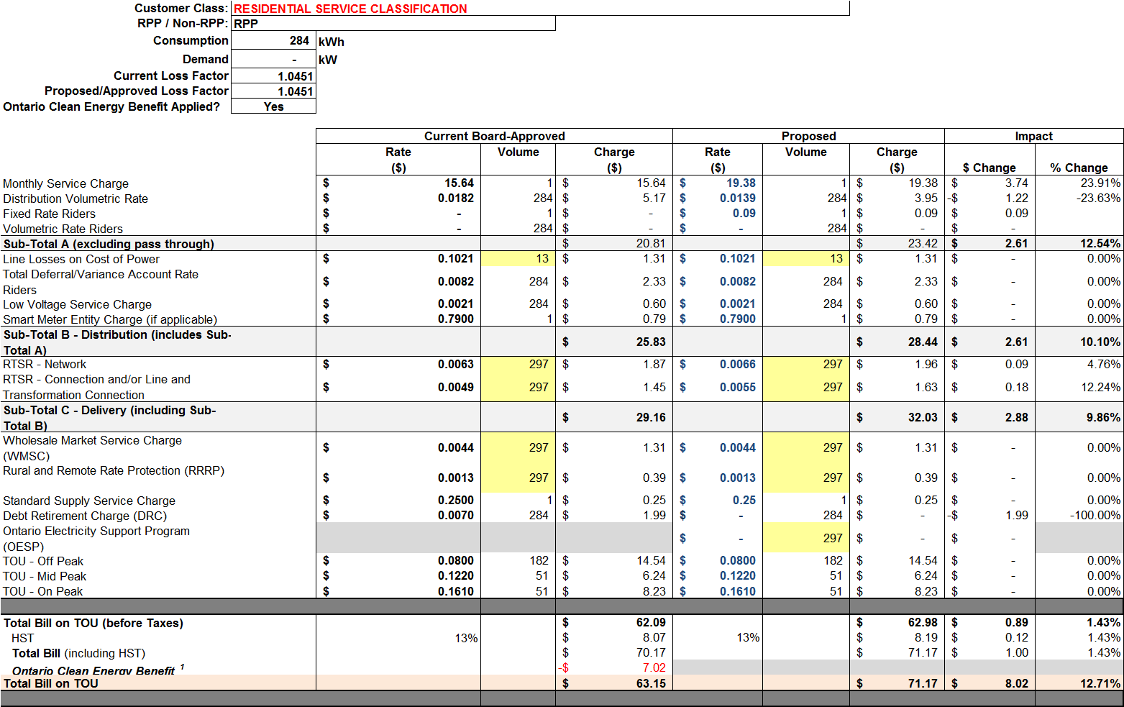

- Erie Thames Powerlines confirms that the bill impacts for RPP customers at the 10th percentile are approximately 4.1%.

- Please confirm the Residential Non-RPP bill impacts at the 10th percentile for Erie Thames Powerlines are approximately 9.3%.
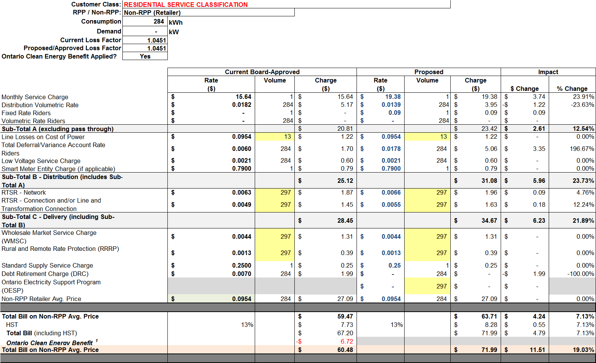

- Erie Thames Powerlines confirms that the bill impacts for Non-RPP (retailer) customers at the 10th percentile are approximately 9.3%.

