**2016 Price Cap IR Application (EB-2015-0101)**

**Response to Application Analysis**

**And Interrogatories**

**November 20, 2015**

**Interrogatories**

**Interrogatory #1**

**IRM Model – Tab 3: 2015 Continuity Schedule – 2012 Closing Principal**

The Closing Principal in 2012 in Account 1595 (2011) has a credit balance of $136,254 in the 2016 IRM model Sioux Lookout Hydro filed. However, the same account had a credit balance of $138,243 on the final rate model in Sioux Lookout Hydro’s 2015 rate application (EB-2014-0112). The variance between the two balances is $1,989.

1. Please review the balance of account 1595 (2011) – 2012 closing principal, and confirm the correct balance of this account. OEB staff will update the model.
2. If the correct account balance is different than the credit balance of $138,243 shown on 2015 final rate model, please explain why there is a discrepancy.
3. After the correction in part a), if there is a variance between RRR data and 2014 year-end balance (column BA on Tab 3) in account 1595 (2011), please provide explanation for the variance.

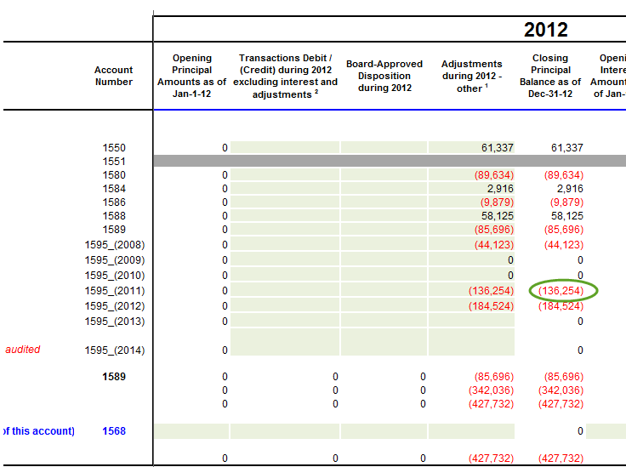

***Response***

*a), b) and c)*

*Upon reviewing the 2012 closing balance of account 1595(2011) it was found that the variance of $1,989 was the amount of the shared tax savings from decision EB-2010-0114. This amount was correctly reported in account 1595(2011) in 2011 and 2012. It was incorrectly reported for the 2.1.1 RRR filings in account 1595(2012) in 2013 and 2014.*

*The 2015 IRM Model has the value reported under the 2.1.7 December 31, 2013 column for account 1595(2011) as $(148,361). The value reported for December 31, 2013 in the 2.1.1 reporting is $(146,371) which includes the adjustment where the $(1,989) was erroneously transferred from account 1595(2011) to account 1595(2012). Since the 2.1.7 filing for 2013 did not include the 1595 sub accounts, the amount for control account 1595 was in balance.*

*In order to correct this, the amount of $(1,989) should be included in the 2012 ending balance for 1595(2011) and the balance corrected to $(138,243), and under column Z for account 1595(2012) an adjustment of $1,989 added to transfer the amount back to account 1595(2011). This will result in a variance between the RRR data and the 2014 year-end balance in account 1595(2011) of a debit of $1,989 and a credit of $1,989 in account 1595(2012).*

**Interrogatory #2**

**IRM Model – Tab 3: 2015 Continuity Schedule – 2015 Interest Disposition**

The Interest Disposition during 2015 in Account 1595 (2008) has a balance of $0 in the 2016 IRM model Sioux Lookout Hydro filed. However, the same account had a credit balance of $436 in the OEB-approved Group 1 accounts disposition table in Sioux Lookout Hydro’s 2015 rate application (EB-2014-0112).

1. Please review the balance of the above account, and confirm if the credit balance of $436 should be entered in the continuity schedule. If yes, OEB staff will update the model.
2. Otherwise, please provide explanation for the discrepancy.

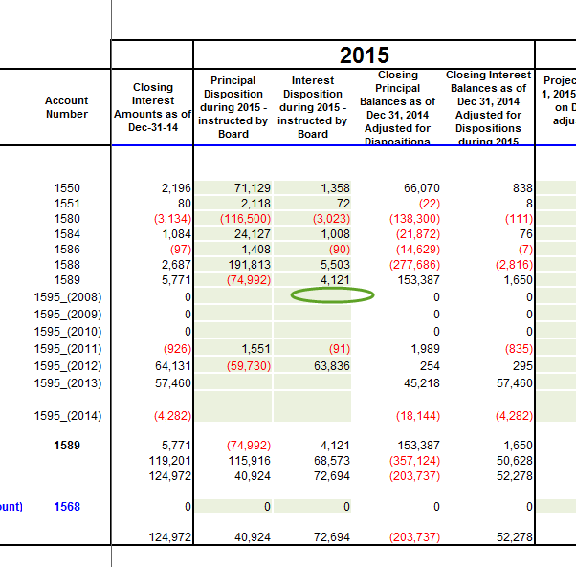

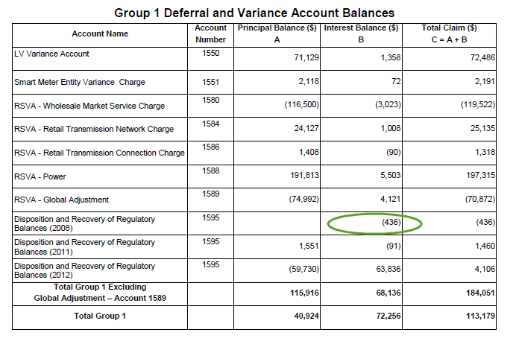

***Response***

1. *and b)*

*After reviewing the balance of account 1595(2008) there was an entry discovered that transferred the interest amount of $436 to account 1595(2014) in 2014 after decision EB-2013-0170 was issued as an immaterial amount without realizing this amount was included in the 2015 IRM(EB-2014-0112) Group 1 disposition accounts. Therefore the credit of $436 should either be transferred back to account 1595(2008) from the transactions in 2014 under account 1595(2014) and the credit included in the 2015 interest disposition column for account 1595(2008), or the credit should be included under account 1595(2014) in the Interest Disposition allowed in 2015 column so as not to apply for the amount for disposition twice. The first option will result in a variance of the amounts reported to the Board under 2.1.7 of $436 for each of those accounts, but would net out to zero.*

**Interrogatory #3**

**IRM Model – Tab 3: 2015 Continuity Schedule – 2014 Transaction – Account 1595 (2013)**

In the 2016 IRM model, Sioux Lookout Hydro reported a debit transaction of $270,000 in 2014 in account 1595 (2013) (with associated interest in a credit amount of $1,043). Account 1595 records the difference between the amount approved by the OEB for disposition and the amount collected form customers. The OEB-approved total amount to be disposed in 2013 rates was a credit balance.

1. Please provide explanation for the debit transaction of $270,000 in 2014 in account 1595 (2013) and its associated interest in a credit amount of $1,043.

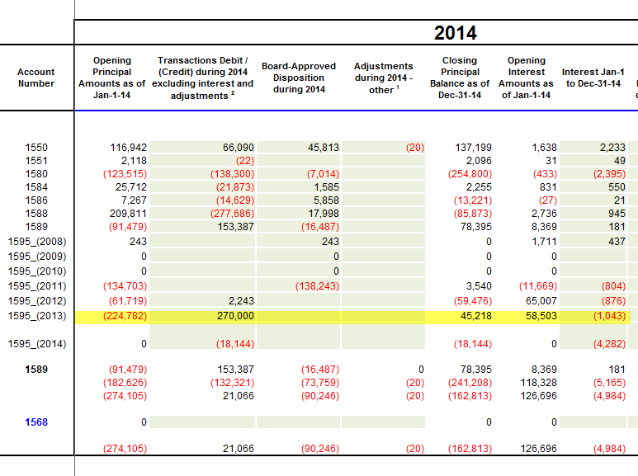

**Response**

1. *The debit balance of $270,000 represents the amount refunded to customers for the OEB approved amount for 2013. Of this amount there was $70,182 refunded for the 1595 Sub-account GA Principle amount and $199,818 refunded for 1595 Sub-account excluding GA. Since the Principle balance remained a credit until July of 2014 the interest calculated on the principle balances each month was a credit. The amount of interest transactions to the end of July totalled $(1,214.82) for 2014. From August to December 2014 the interest transactions totalled $172.17. Since the rate riders are volumetric, SLHI feels that the extremely cold winter experienced in 2013/2014 contributed to the over-refund for the amounts approved for disposition.*

**Interrogatory #4**

**IRM Model – Tab 11: RTSR – Historical Wholesale – January 2014 Hydro One Sub-Transmission Rates**

In the Hydro One Sub-Transmission table on Tab 11 of the model, Sioux Lookout Hydro entered $3.2 and $0.68 as the network charge and line connection charge for January 2014. These two rates are different than the rates applied to all other months in 2014, which are $3.23 for network and $0.65 for line connection.

1. Please provide explanation for the discrepancy described above.
2. Please confirm the correct rates that should be applied for the two entries. OEB staff will update the model if necessary.

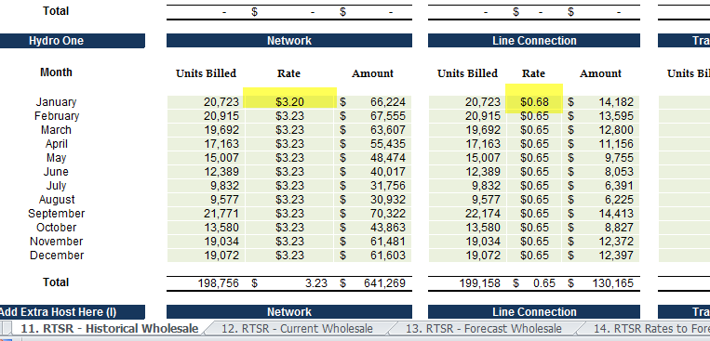

***Response***

1. *The model calculates the rates for these charges based on the entered units billed and the amount charged. SLHI is billed by Hydro One and the January 2014 bill was from December 9, 2013 to January 10, 2014 therefore there was consumption at the old rate and the new rate for January 1st. The December 2013 units and charges should be removed from this table as they were included in the 2015 IRM rate generator model. SLHI switched to true monthly billing with Hydro One in October of 2014 to eliminate the need for proration. The transition period was September where you can see the Units billed are higher.*
2. *The Units billed and Amount Charged should be corrected to the amounts shown in the table below for January. This change results in the correct rate being calculated and will change the total amounts.*



**Updates to IRM Model made by OEB staff**

1. **Tab 15: Rev2Cost_GDPIP - Price Escalator**

The OEB has calculated the value of the inflation factor for the incentive rate setting under the Price Cap IR and Annual Index plans, for rate changes effective in 2016, to be 2.1%. The derivation of this is shown on OEB’s webpage: <http://www.ontarioenergyboard.ca/oeb/Industry/Regulatory%20Proceedings/Applications%20Before%20the%20Board/Electricity%20Distribution%20Rates/2016%20Electricity%20Distribution%20Rate%20Applications>

This new inflation factor has been applied to Tab 15 of the IRM model as the Price Escalator.

1. **Tab 18: Bill Impacts – Ontario Clean Energy Benefit (OCEB) and Debt Retirement Charge (DRC) to Residential Class**

Sioux Lookout Hydro’s 2016 electricity distribution rates are effective on May 1, 2016. Therefore, the “Current Board-Approved” section of the individual bill impact table should include the rates as of April 30, 2016 (the day before the effective date). The OCEB will be ending on December 31, 2015, thus it is not applicable to any individual bill impact table. OEB staff has changed the “OCEB Applicable?” option from “Yes” to “No” for Residential, GS<50 kW and USL classes, so that the OCEB amount will not appear in any bill impact table.

Also, as the DRC will be removed from Residential customers’ bills after December 31, 2015, the model has been fixed to show $0 DRC rate under Current Board-Approved section for Residential Classification.