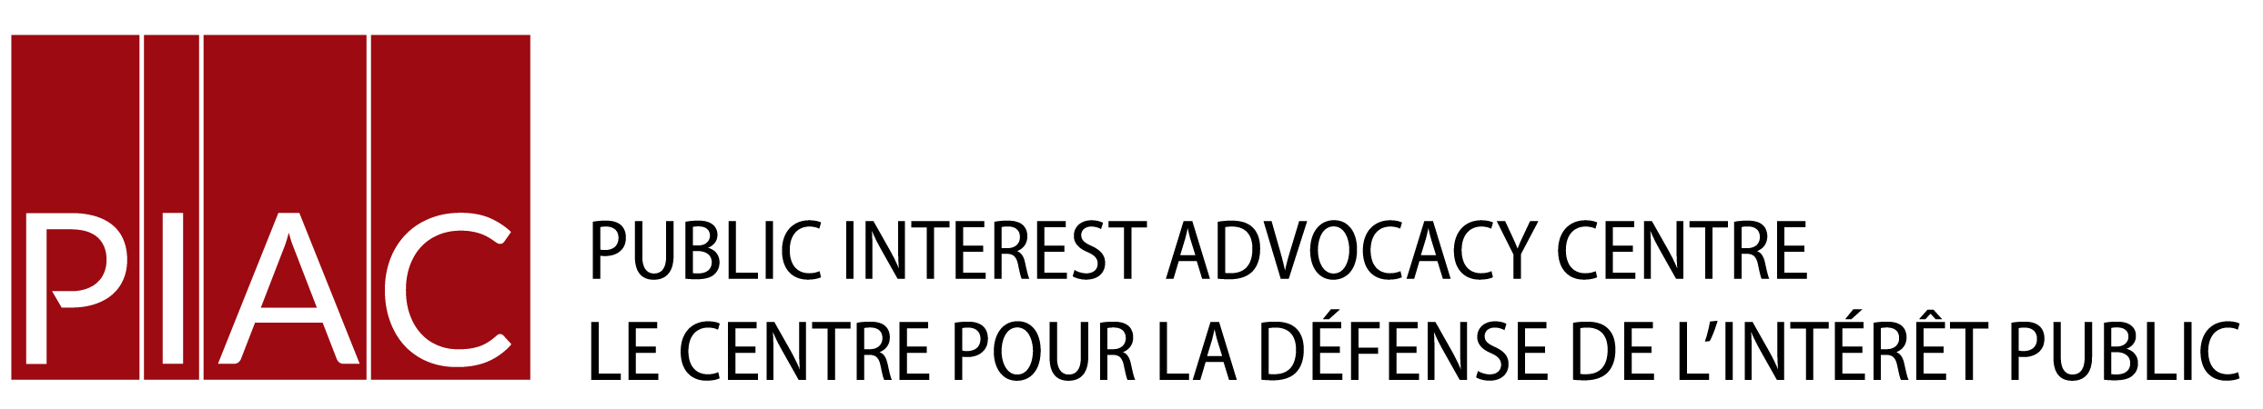
March 12. 2016
VIA E-MAIL
Ms. Kirsten Walli
Board Secretary
Ontario Energy Board
P.O. Box 2319
2300 Yonge St.
Toronto, ON
M4P 1E4

Dear Ms. Walli:

Re: Milton Hydro Distribution Inc. – 2016 Cost of Service Distribution Rate
Application
Board File No. EB-2016-0089

We are in receipt of correspondence from counsel for the applicant with respect to the treatment of the Lost Revenue Adjustment Mechanism Variance Account (“LRAMVA”) given the Board’s intention to examine the issue on a generic basis with respect to the treatment of demand savings. We agree with Milton’s counsel suggestion that the issue should not be dealt with as a Milton Hydro-specific issue but should await the resolution of the matter by the Board in the generic hearing.
However, we think that the more expeditious solution is for Milton to withdraw the application for LRAM recovery, and re-apply after the policy has been sorted out. Proceeding with interim rates is a second best solution as it requires more accounting to track the interim payments by customer class which would then have to be factored into the amount to be refunded/recovered from customers once the policy established and the final rates are determined.

Yours truly

Michael Janigan
Counsel for VECC

Cc. James Sidlofsky, Frank Lasowski, Milton Hydro Distribution Inc.
Cameron McKenzie, Milton Hydro Distribution Inc.
Intervenors of Record

