**Westario Power Inc.**

**2016 Price Cap IR Application (EB-2015-0104)**

**Application Analysis**

**December 7, 2015**

**Interrogatories**

**Interrogatory #1**

**IRM Model – Tab 3: 2015 Continuity Schedule**

1. Please explain the principal adjustment during 2011 in account 1595 (2011) in amount of ($686,282).

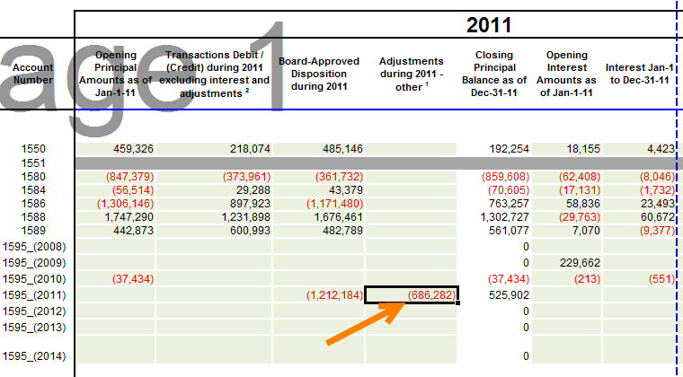

WPI – This represents the amounts recovered from customers in 2011 from the DVA and GA DVA (non-RPP) rate rider approved on the 2011 IRM (EB-2010-0122) for rates effective May 01, 2011. WPI notes that this has been previously filed (2014 and 2015 IRM’s) under the adjustment column rather than the transactions column, and have kept it there for consistency. We apologize if this resulted in any misunderstanding. This would also apply to question b) below. If the OEB requires a re-file with this amount in the transactions column, WPI will complete and re-send the respective excel file. WPI notes that a re-file as indicated above will not alter the variance calculation in column BA.

1. Please explain the interest adjustment during 2011 in account 1595 (2009) in amount of ($227,410).

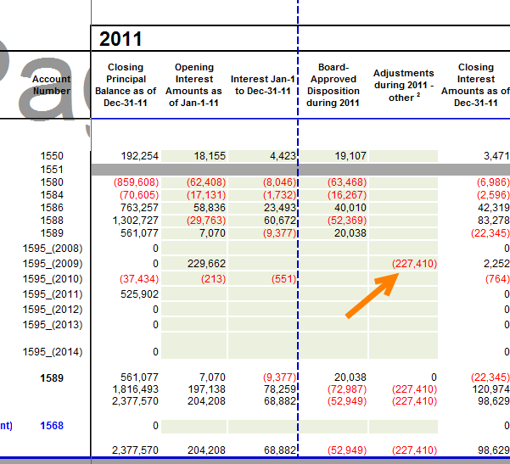

WPI – This represents the recovery of interest from our customers through the DVA rate riders approved in the 2009 Cost of Service Application over a 2 year period (EB-2008-0250) starting in May 1, 2009, ending April 30, 2011.

1. OEB staff notes that the Opening Principal balance in account 1595 (2009) in 2012 is $0 as shown on Westario Power’s 2016 IRM model. The transaction balance in the same account in 2012 was reported as ($1,067). Please provide explanation for this transaction balance.

WPI – The transaction balance represents long term load transfers that were invoiced in 2012 but covered the period of the rate rider in 2011, and the reversal and re-invoice during 2012 for the 2011 period that the rate rider was effective for a total of ($1,067).

1. Please provide explanations for the following account balances in year 2012:
   * 1. transaction balance of $413,547 in account 1595 (2012)

WPI – The transaction balance represents repayment received under the approved rate rider (EB-2011-0205) for the disposition of the DVA, DVA (GA), Special Purpose Charge and Deferred PILs.

* + 1. OEB-approved disposition (principal) in the amount of $676,961 in account 1595 (2012)

WPI – The following table provides a synopsis of the approved (EB-2011-0205) 2012 IRM and the impact on the 1595 (2012) principal:



* + 1. interest amount of ($4,084) in account 1595 (2012)

WPI – The transaction represents interest on the net principal at the prescribed rate of 1.47% for the year.

* + 1. OEB-approved disposition (interest) in the amount of $36,649 in account 1595 (2012)

WPI – The following table provides a synopsis of the 2012 IRM and the

impact on the 1595 (2012) interest:



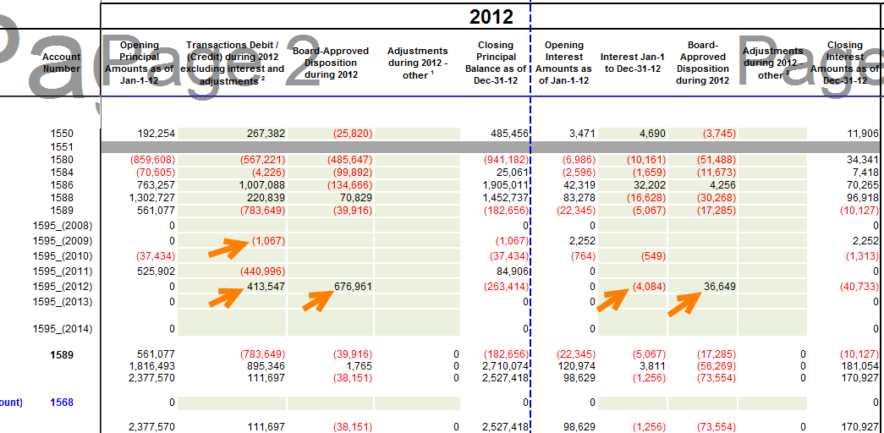

1. Westario Power has reported OEB-approved disposition (principal) amount of ($1,067) in account 1595 (2009) in year 2013 on the continuity schedule. This balance cannot be reconciled with Westario Power’s 2013 Settlement Agreement (EB-2012-0176). Please provide explanation for the balance.

WPI – The ($1,067) was recorded in 2012 under the principal transaction but was posted subsequent to the filing of the Cost of Service for 2013, and thus did not make it on the Settlement Table #17: Deferral and Variance Accounts in the EB-2012-0176. WPI acknowledges that this account is part of the agreed final disposition of accounts in Group 1 and Group 2. The amount was written off in 2013, bringing the balance to $0, respecting the agreement for final disposition. WPI has reported this amount in this manner based on the belief that any subsequent event that generated either a debit or credit was to be written off, as already approved through the EB-2012-0176 Decision and Order.

WPI acknowledges that if this not accurate and should have been reported as a transaction in 2013 and not as a OEB-approved disposition (principal) amount we apologize if this resulted in any misunderstanding. If the OEB requires a re-file with this amount in the transactions column, WPI will complete and re-send the respective excel file. WPI notes that a re-file as contemplated above will not alter the variance calculation in column BA.

1. Please provide explanations for the following account balances in year 2013:
   * 1. Transaction balance of ($891,039) in account 1595 (2013)

WPI – The transaction balance represents repayment received under the approved rate rider (EB-2012-0176) for the disposition of the Group 1 and Group 2 Accounts.

* + 1. OEB-approved disposition (principal) in the amount of ($2,638,476) in account 1595 (2013)

WPI – The EB-2012-0176 page 37 of 43 provides a Settlement Table #17: Deferral and Variance Accounts that has a total under the Closing Principal as at Dec 3, 2011 adjusted for dispositions during 2012 the $2,638,476. A copy is provided below for your reference.

* + 1. Interest amount of $21,111 in account of 1595 (2013)

WPI – The transaction represents interest at the prescribed rate of 1.47% for the year.

* + 1. OEB-approved disposition (interest) in the amount of ($233,018) in account 1595 (2013)

WPI – The EB-2012-0176 page 37 of 43 provides a Settlement Table #17: Deferral and Variance Accounts that has totals for interest of the various periods of $140,832 + $78,933 + $13,251 supporting the ($233,018). A copy is provided below for your reference.

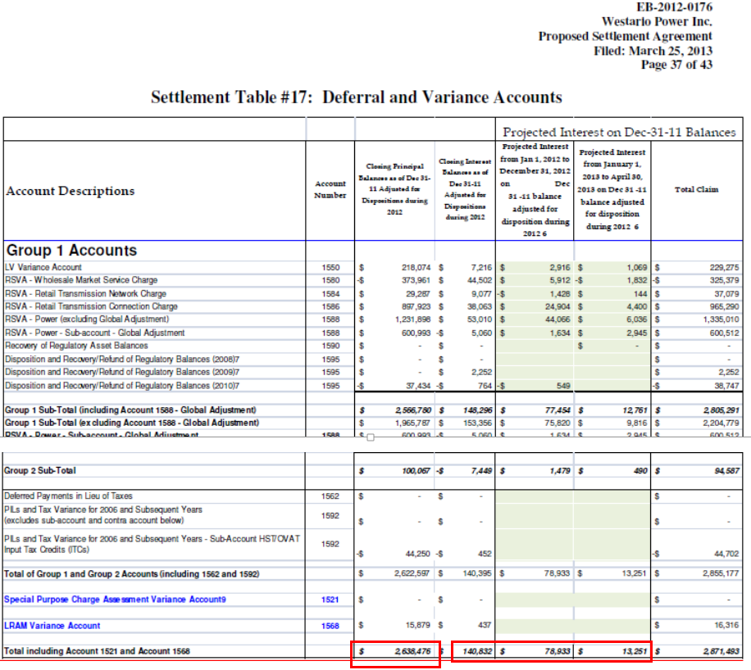

1. In case there are data changes on the continuity schedule related to the above questions (in part a) to f)) and the change(s) result in variance balance (RRR vs. 2014 - column BA on Tab 3), please provide explanation for the variance.

WPI – The above provides support for the transactions and balances. WPI respectfully considers that there is no change in the filed information that would change the variance calculation in column BA, thus no further explanation is required.

**Interrogatory #2**

OEB staff will make the following updates to Westario Power’s 2016 IRM model. Please review and confirm the changes.

1. **Tab 15: Rev2Cost_GDPIP - Price Escalator**

The OEB has calculated the value of the inflation factor for the incentive rate setting under the Price Cap IR and Annual Index plans, for rate changes effective in 2016, to be 2.1%. The derivation of this is shown on OEB’s webpage: <http://www.ontarioenergyboard.ca/oeb/Industry/Regulatory%20Proceedings/Applications%20Before%20the%20Board/Electricity%20Distribution%20Rates/2016%20Electricity%20Distribution%20Rate%20Applications>

This new inflation factor will be applied to Tab 15 of the IRM model as the Price Escalator.

WPI – Confirmed.

1. **Tab 18: Bill Impacts – Debt Retirement Charge (DRC) - Residential Class**

As the DRC will be removed from residential customers’ bills after December 31, 2015, the model will be updated to show $0 DRC rate under Current Board-Approved section for residential classes.

WPI – Confirmed.

1. **Regulatory Charges on Tab 16, 17 & 18**

The OEB has determined that the RRRP charge for 2016 shall be $0.0013 per kWh; the WMS rate shall be $0.0036 per kWh; and the OESP charge shall be $0.0011 per kWh. Westario Power’s 2016 IRM model will be updated with these 2016 regulatory charges.

WPI – Confirmed.