May 6, 2016

Delivered by RESS and Courier

Ms. Kirsten Walli, Board Secretary Ontario Energy Board
P.O. Box 2319, 27th Floor
2300 Yonge Street Toronto, Ontario M4P 1E4

Dear Ms. Walli:
Grimsby Power Incorporated
231 Roberts Road Grimsby, ON L3M 5N2
PH: 905.945.5437 x 221
FX: 905.945.9933

Re: EB-2015-0072
Grimsby Power Incorporated
Electricity Distribution Rate Application for 2016 Rates

Pursuant to Procedural Order No. 1 please find enclosed Grimsby Power’s Interrogatory Responses in regard to the above noted matter.

Following the interrogatory responses and required changes, Grimsby Power has updated several models and submitted them in Excel version. Please refer to the Revenue Requirement Workform (RRWF) for 2016 Filers – 10. Tracking_Sheet tab for a list of updates.

If additional information is required by the Board please contact myself via e-mail (dougc@grimsbypower.com) or by phone at 905-945-5437 Ext. 221.

Regards,

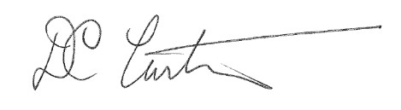

Doug Curtiss, P.Eng. Chief Executive Officer Grimsby Power Inc.

