Regulated Price Plan Roadmap
Pilot Program Project Overview Application

- Review all eligibility criteria to confirm that your project is eligible for the Regulated Price Plan Pilot Program.

- All fields must be completed. Incomplete submissions will not be considered. Maximum 10 pages excluding attached documents.

- All answers, rationale and substantiation must be provided in this document in the space provided. Do not provide attachments unless letters of support from project partners, links or other references as these will not be considered in the review of your application.

- Attach this completed document, in Word format (no PDFs) to an email and submit to:
BoardSec@ontarioenergyboard.ca citing “EB-2016-0201: RPP Pilot Application” in the subject line.

- Within one week of submission, you will receive a response confirming that your application was received with further information regarding the timeline for review.

- If you have questions you may reach the OEB by calling 1-888-632-6273 or by emailing IndustryRelations@ontarioenergyboard.ca citing “EB-2016-0201: RPP Pilot Program” in the subject line.

A. Key Information

Project title: | REAL TIME DATA EMPOWERED CUSTOMER EXPERIENCE  Assessment of real-time energy information impact on customer behavior.
Distributor(s): | London Hydro
Applicant(s) Contact name: | Syed Mir
Applicant(s) Contact title: | VP of Corporate Services and CIO
Mailing address: | 111 Horton Street, PO Box 2700, London ON, N6A 4H6
Phone: | 519-661-5800 x 5102
Email: | mirs@londonhydro.com
Submission date: | August 22nd, 2016

Receipt of an application does not constitute a commitment by the Ontario Energy Board to approve the application.

B. Project Overview (check all that apply)
Regulated Price Plan Roadmap Category
__ Price | X Non-Price
Target Market(s): Residential Market Only
X Existing Homes | X High Usage Customers
__ New Homes | __ Other: _
__ Multi-family
X Single-family
X Low Income Customers
Project Type
__ Time-of-use | __ Other Pricing
__ Critical Peak Pricing
__ Appliance/Household Automation
X Information Provision

Expected Project Duration: 18 months

Funding***: Applicants are encouraged, but not required, to contribute support or have project partners contributed support to the proposed project. Differentiate between cash and in-kind support to the proposed project. Please indicate if the funding is confirmed. “Requested Funding” represents your funding request to the OEB.
IF THIS SECTION IS LEFT BLANK YOUR APPLICATION WILL NOT BE CONSIDERED
 | Cash ($) | Cash (% of total project value) | In-kind ($) | In-kind (% of total project value)
London Hydro - Hardware | $100,000 | 16.4 % | $58,400 | 9.6 %
London Hydro -  Software | $132,000 | 21.6 % | $60,000 | 10 %
London Hydro- Program Management, Support and Administration | $150,000 | 24.6 % | $20,000 | 3.3 %
LH Marketing and Recruitment | $30,000 | 5 % | $ | %
Navigant - EM&V | $60,000 | 10 % | $ | %
Other(s)** | $ | % | $ | %
Subtotal  (non-OEB funding contribution) | $472,000 | 77.3 % | $ | %
Requested Funding | $472,000 | % | N/A | N/A
Totals | $ |  | $138,400 | 22.7 %
Total project value (all cash costs + in kind) | $610,400

* Provide actual name
**Add rows as necessary
***These fields may be amended at a later stage if required.

1. PROJECT CONCEPT AND RATIONALE
A. In one sentence, state the ultimate goal of this project. How will the objectives of the Regulated Price Plan Roadmap be achieved as a result of this project?
Goal:

Determine the cost benefit of providing <1 minute real-time energy information compared to existing 24 hour delayed data and the impact on consumer behaviour in shifting and reducing their consumption.

How:

Pilot results from 500 residential customers to test drive the RPP roadmap with in-home real time energy monitoring and leveraging London Hydro’s existing customer portal and Green Button platform.

B. Discuss in detail the specific objectives of the Regulated Price Plan Roadmap that this project addresses (e.g. technical challenge, energy literacy gap, etc.).
Our project addresses following objectives of the RPP Roadmap:

1. Consumer awareness and understanding of existing TOU price structures. As stated in BeWorks behavioral economics review, people do not review and comprehend all types of information equally. London Hydro’s customer engagement portfolio includes robust (desktop and mobile) customer portal and a notification engine powered by Green Button data platform. With more than 40,000 registered users, our platform offers a flexible foundation for development and testing of new and innovative customer engagement solutions. Our IT development and progress to date offer a great stepping stone for real-time data provisioning and ensures that existing programs and infrastructure is fully leveraged, providing more value for the same investment. For example, London Hydro is currently offering HomeBeat, energy disaggregation program and proposes to leverage its control groups and EM&V findings towards this project.

2. Real-time systems technical implementation challenges and cost/benefit analysis. London Hydro strongly believes that the value of ‘ behind the meter’ smart devices and energy disaggregation solutions increases exponentially as data approaches real-time and will have a significant impact on consumer behavior. It enables moving from a “passive” information /no response to an “active” information / active response culture. As part of peaksaver plus program, London Hydro implemented a pilot based on the Energate Foundation smart thermostat which offers real time Zigbee data collection in fine granularity. We have successfully integrated our smart meters with the Energate data API and are now able to provision this granular (1 minute) high frequency data in our Green Button Platform. This investment will be further leveraged for our proposed project and will significantly reduce effort and number of required hardware installations proposed for this engagement.

3. Creation of incentives and opportunities to reduce electricity bills through energy shifts and peak demand reduction. London Hydro’s Aeroplan loyalty program provides customer incentive for paperless billing and other engagement programs such as Homebeat. Our existing loyalty program will be incorporated in real-time data customer engagement project.

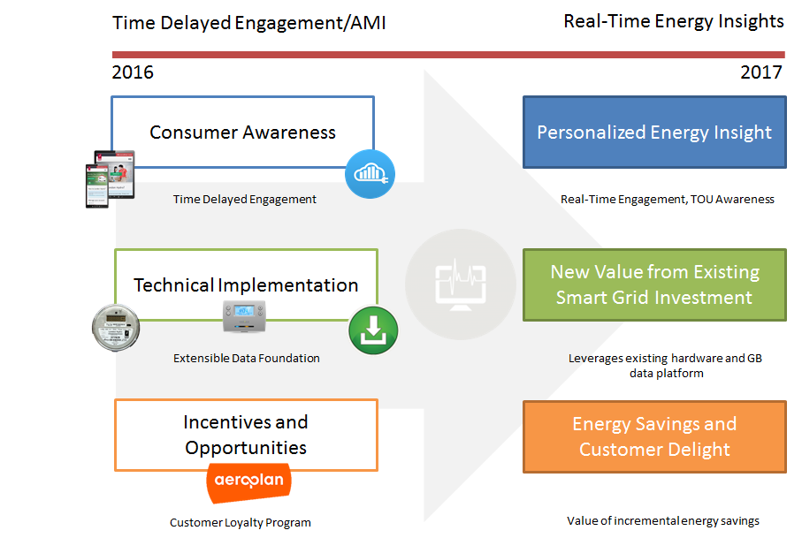

C. How will your project’s activities and outputs address the objectives of the Regulated Price Plan Roadmap outlined above? What solution is this project designed to develop?
Our project and study will be based on following two experimental / control consumer groups:

1. Time-delayed engagement treatment group ( Active London Hydro Homebeat Program participants incorporating basic energy disaggregation, AMI time-delayed data and customer notifications via mobile App). This group and findings will provide baseline for studies comparison.

2. Real-time engagement treatment group 500 homes equipped with Zigbee connected home energy router or equivalent. Existing mobile customer experience will be enriched with real-time functionality.

Real-time energy information will eliminate surprises with up-to-the minute tracking, alerts and notifications. Users will be able to access real-time usage information and receive high-usage alerts in order to take immediate actions. This will give the consumer a better understanding of energy options in relation to TOU and a greater look into their home by allowing them to fine-tune energy disaggregation insights by turning appliances on and off in real time and marking this behavior in the app.

Project deliverable(s) include EM&V backed study/white paper outlining:

- Value and quantities (%) of incremental energy savings achieved through real-time energy data empowerment, in comparison to delayed-data experimental/treatment group (existing London Hydro Program and Navigant EM&V Assessment).
- Real-time customer responsiveness to TOU and load shifting in comparison to delayed-data experimental group (existing London Hydro Program and Navigant EM&V Assessment).
- Incentive programs cost benefit analysis for customer engagement and TOU responsiveness.

Navigant is currently evaluating London Hydro’s “Homebeat” pilot that utilizes Bidgely technology leveraging AMI data delayed 24 hours. Given their familiarity with the Homebeat pilot and depth of evaluation experience, particularly with respect to these types of “reporting and information” programs, London Hydro plans to utilize Navigant to provide the EM&V for the proposed RPP Pilot.

In the development of the EM&V plan for the proposed RPP Pilot, Navigant will leverage the approach and data currently being utilized for the Homebeat pilot to the maximum extent possible, but also ensure that the results of the RPP Pilot are robust and distinct from the Homebeat pilot.

D. Explain how your project compares to other initiatives/ technologies already deployed/ piloted in Ontario and elsewhere. Provide diagrams, etc. as necessary (within this document).
This project fully aligns with existing London Hydro customer experience initiatives that includes providing more real time data to customers. For example, LH customer portal provides 4 hours delayed data using our Green Button platform to take actions to reduce their consumption and see the results in a timely fashion.

It will leverage our existing Green Button data foundation, processes, EM&V and learnings from AMI Optimization projects. London Hydro is currently offering the Homebeat program to all of our customers. Homebeat program utilizes Green Button provisioned, 24 hour delayed AMI data and offers limited energy disaggregation to our customers. Navigant has been retained to evaluate program effectiveness for energy savings through customer information empowerment.

Furthermore, London Hydro peaksaver + program utilizes Energate thermostat foundation. Aside from meeting program’s goals, Energate offers scalable API interfaces for Zigbee or blueline collected whole home energy data. This minute energy data has been integrated with our Green Button platform and London Hydro plans to utilize this hardware investment towards the proposed real time data project. This approach will provide significant savings in hardware segment as we currently have more than 200 active Energate data points.

London Hydro initiatives will support proposed project through:

- EM&V study for Homebeat program offers great foundation and stepping stone for real-time study. Value-add includes both savings and persistence of behavioral change for real-time information.
- London Hydro Green Button Platform offers secure and scalable way for data sharing and integration. All London Hydro customer facing tools utilize GB as data source.
- Existing peaksaver + devices data foundation capability provides value add and reduces cost in-home hardware cost requirement for overall project
- London Hydro customer loyalty program (Aeroplan) has proven track record for marketing and pilot user recruitment segments.
- Time-delayed engagement – MyLondonHydro portal and notifications have been in place since 2013.
- Common Green Button Data Platform Project will provide insights and benefit analysis for implementations at other utilities that share Green Button Standard. Assessment can be applied to Festival Hydro and Whitby Hydro Green Button Platform implementations.

London Hydro - Real Time vs. Time Delayed Engagement Evolution

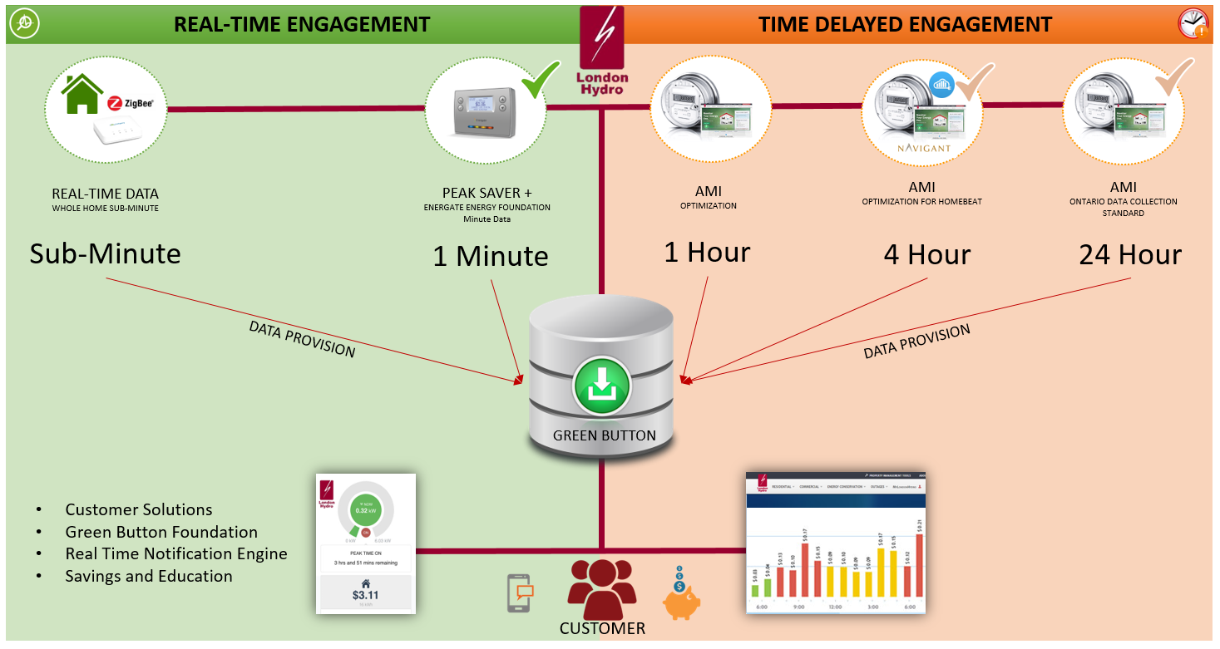

2. PROJECT PLAN
A. In no more than ten sentences, outline the project plan.
A program of approximately 18 months’ duration is recommended in order to capture the energy management behavior and samples associated with all seasons. Project Plan includes following steps:
Program architecture
- Customer experience goals
- Procurement and EM&V design/update
Hardware deployment:
- Existing data stream integration (Energate) – 1-minute data
- In-home hardware implementation and integration – 1-minute data
Customer solution updates and deployment
· Integration with MyLondonHydro
Training and Support
- Customer support and education
Marketing and Incentives
- Advertising, recruitment and customer communications
Monitoring and Reporting
- Staged EM&V findings and reporting
- Program recommendations

B. Describe each of the major task areas for this project (e.g. program design, development of training, measurement and verification, research, communications, knowledge transfer, etc.).
- Program Design – Customer segmentation (ie. Low-income, electric heat) would be evaluated and selected. Steering Committee and Project Management Teams would be established, overall time lines and project deliverables set.

- Evaluation & In-Home Hardware Specifications – in-home real time systems would be specified in conjunction with data integration and Energy Consultant needs.

- Installation and Data Integration – process build for in-home hardware installation

- Customer Solutions upgrade – real-time presentment and energy disaggregation updates. This task would define most impactful messaging and energy disaggregation needs.

- Training, Recruitment and Communications – marketing plan development. Support a client support plan built.

- Reporting, Monitoring, and Program Implementation – Evaluation, measurement and verification reports would be provided in most meaningful and timely manner as established with OEB and Energy Consultant.

- Post Project Analysis - At the end of the project period, a report would be prepared by the Energy Consultant with support from London Hydro. Lessons learned would be summarized, and the savings data extrapolated across London and Ontario populations and assessed against implementation cost projections to provide OEB with an overall assessment of the Energy Conservation gains that could be achieved through more aggressive implementation of Real-Time programs, and the costs necessary to achieve these gains.

C. Describe each of the major deliverables that will be provided to the OEB as part of this project.
Deliverables
- Customer Experience Report to describe the behavioral changes and associated benefits
- EM&V Report outlining energy savings and behavioral impact of real-time data
- Cost Benefit Analysis to determine the value of information provisioning (e.g. real-time data, Green Button) for the RPP Roadmap that could be applied across Ontario

3. PROJECT TEAM & PARTNERS
A. In this section, please outline the composition of the project team and list any project partners. Discuss the role that each person and organization participating in the project will play. Include the applicant organization in this table. If a 3rd party is not yet part of the team, please identify the accountability they will be responsible for and enter TBD for the name and organization.
PROJECT TEAM
Project team member | Organization and job title | Major accountability
Syed Mir | London Hydro | Project Sponsor
Zoran Stojanovic | London Hydro | Project Lead
Stuart Smith | London Hydro | Solution Architecture & Design
Connor Graham | London Hydro | BSA/Developer Lead
Ali Juma | London Hydro | RT Hardware Specialist/Support
Nancy Hutton | London Hydro | Customer Communications & Marketing
Susmita Haldar | London Hydro | Quality Assurance Lead
Andrew Bishop | Navigant | EM&V Lead
Rob Neumann | Navigant | EM&V Technical Advisor
PROJECT PARTNERS
Organization | Project role (e.g. participant, funder) | Financial or in-kind contribution (indicate if confirmed). Please note that if you are invited to submit a proposal your partner must confirm their contribution in writing to the IESO.
London Hydro | Funder | In-Kind Confirmed
Navigant | EM&V

Attach this completed document, in Word format (no PDFs) to an email and submit to:
BoardSec@ontarioenergyboard.ca citing “EB-2016-0201: RPP Pilot Application” in the subject line.

