|  |  |  |
| --- | --- | --- |
| **Ontario Energy**  **Board**  P.O. Box 2319  27th. Floor  2300 Yonge Street  Toronto ON M4P 1E4  Telephone: 416- 481-1967  Facsimile: 416- 440-7656  Toll free: 1-888-632-6273 | **Commission de l’énergie**  **de l’Ontario**  C.P. 2319  27e étage  2300, rue Yonge  Toronto ON M4P 1E4  Téléphone; 416- 481-1967  Télécopieur: 416- 440-7656  Numéro sans frais: 1-888-632-6273 |  |

**BY E-MAIL**

October 14, 2016

John Pickernell

Board Secretary

Ontario Energy Board

2300 Yonge Street, 27th Floor

Toronto, ON M4P 1E4

Dear Mr. Pickernell:

**Re: Festival Hydro Inc.**

**2017 IRM Distribution Rate Application**

**OEB Staff Interrogatories**

**OEB File No. EB-2016-0070**

In accordance with Procedural Order #1, please find attached OEB Staff interrogatories in the above proceeding. The applicant and the intervenor have been copied on this filing.

Festival Hydro’s responses to interrogatories are due by October 27, 2016.

Yours truly,

*Original Signed By*

Katherine Wang

Incentive Rate-setting and Accounting

Encl.

**Festival Hydro Inc.**

**EB-2016-0070**

**October 14, 2016**

**Staff Interrogatory #1**

**Ref: Manager’s Summary – page 6, 7: Disposition of WMS – Sub Account CBR Class A**

In the above section of the Manager’s Summary, Festival Hydro requests to dispose a debit balance of $18,397 in account 1580 sub-account CBR Class A to its Class A customers.

In section 3 of the [Accounting Guidance](http://www.ontarioenergyboard.ca/oeb/_Documents/Regulatory/CBR_Accounting_Guidance_20160725.pdf) that OEB issued on July 25, 2016, it states that for the period of April 1, 2015 to the date of the Supplementary Decision and Order, distributors should apply billing adjustments equal to the difference between the CBR billed by the LDC and the CBR charged by the IESO, plus applicable carrying charges on the transactions. The total of the billing adjustments should equal the balance in Account 1580 Variance – WMS, Sub-account CBR Class A, including carrying charges. Once the billing adjustment is processed, the balance in the sub-account should be $0. The billing adjustment calculation for 2016 variance in account 1580 sub-account CBR Class A is included in this Accounting Guidance on page 5.

Therefore, if the recent billing adjustments have been applied properly to customers, there shouldn’t be any balance in account 1580 sub-account CBR Class A for disposition in this IRM application. However, it is appropriate to record the balances in the continuity schedule in account 1580 sub-account CBR Class A (row 24), as the continuity schedule reflects the year-end balances of 2015.

1. Please review and confirm that no disposition of account 1580 sub-account Class A is required.

**Staff Interrogatory #2**

**Ref: IRM Model – tab 3: Account 1580 Variance WMS – Sub-account CBR Class B; Manager’s Summary – page 7, 8: Disposition of WMS – Sub Account CBR Class B; Manager’s Summary tables excel file – tab CBRE B**

OEB staff notes that as Festival Hydro has Class A customers, the balance in account 1580 sub-account CBR Class B must be disposed through a rate rider calculated outside the IRM model.

1. Account 1580 WMS sub-account CBR Class B is part of Group 1 Accounts. Although the rate rider of this sub-account is calculated outside the model, the claim balance of $144,899 in sub-account CBR Class B should be included in the total Group 1 disposition. Therefore, the checkbox in cell BT25 in the continuity schedule should be checked. (This action will NOT include $144,899 in the DVA rate rider calculation in the model.) Please review and confirm this change. OEB staff will make the change in the model.
2. As per the continuity schedule, the total amount to be disposed in account 1580 sub-account CBR Class B is $144,418. This amount should be applied into the rate rider calculation on tab “CBRE B” of the “Manager summary tables” that Festival Hydro provided with its application. As shown in the screenshots below, OEB staff corrected the disposition amount from $144,899 (as filed) to $144,418. This correction will not affect the value of the rate rider ($0.0004/kWh) calculated. But it will change the monthly payments to the 4 former Class B customers. Please review the corrected “Manager summary tables” and confirm the changes.
3. On tab “CBRE B” of the Manager’s Summary tables excel file, it’s noted that the “Total metered non-RPP consumption minus WMP” has been used as the consumption base to calculate current Class B consumption. The RPP consumption has been excluded in the calculation. Both RPP and non-RPP customers contribute to the balance in sub-account CBR Class B. Please explain why the consumption from RPP customers has been excluded?

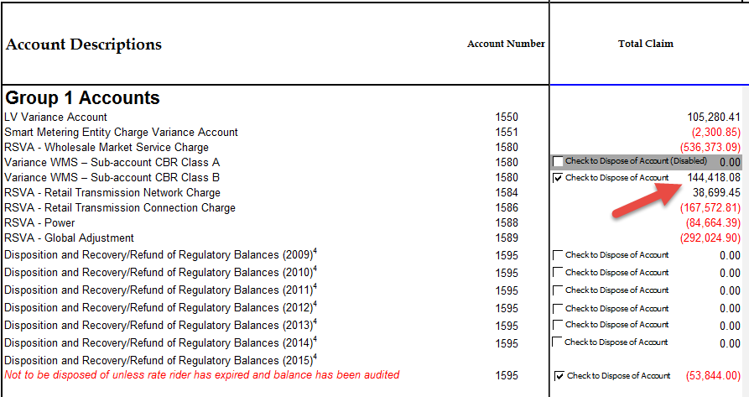

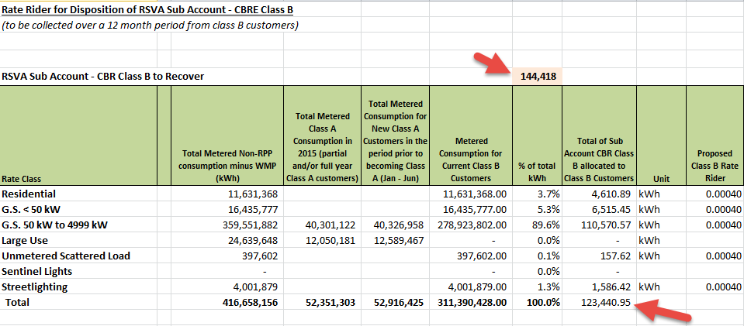

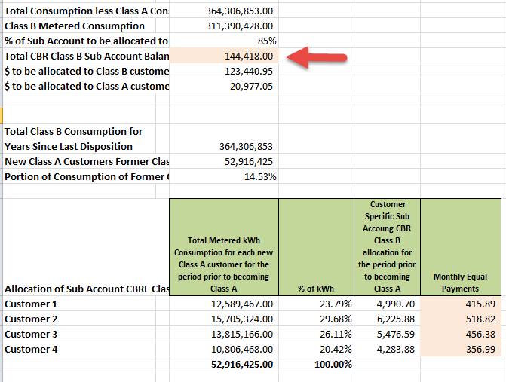

**Staff Interrogatory #3**

**Ref: IRM Model – Tab 10: Demand data for GS 50 to 4,999kW class (non-interval)**

OEB staff notes that in row 21 and 22 on tab 10 of the IRM model, Festival Hydro entered a higher demand amount (metered kW) for Network Service Rate compared to the demand for Line and Transformation Connection Service Rate for GS 50 to 4,999 Class (non-interval).

1. Please confirm that the demand for Network Service is greater than the demand for Line and Transformation Connection for the above class with reference to Festival’s Transformer Station if applicable.

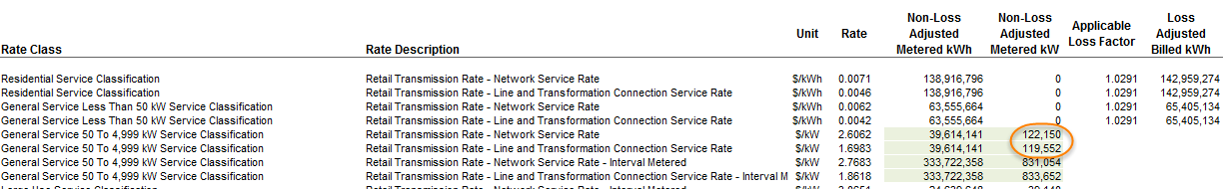

**Staff Interrogatory #4**

**Ref: IRM Model – Tab 18: Sub-total label for CBR Class B rate rider**

In column G on tab 18, Festival Hydro entered sub-total “A” for the CBR Class B rate rider. As account 1580 sub-account CBR Class B is part of Group 1 deferral and variance accounts, the amount associated with this rate rider should be included in sub-total B (in the bill impact calculation).

1. Please confirm this change and OEB staff will update the sub-total label to “B” on tab 18. Please note on tab 20 Bill Impacts, for GS 50 to 4,999 kW and Street Lighting classes, the CBR Class B rate rider will be allocated to the “GA Rate Riders” row; for other classes, this rate rider will be allocated to “Total DVA Rate Riders” row.

**Staff Interrogatory #5**

**Ref: Manager’s Summary – page 10, 11 Rate Rider for Recovery of Permanent Bypass Expenditure**

In this section of the Manager’s Summary, Festival Hydro states that at the time of filing of this application, the amount in question has been finalized with Hydro One at $932,094.

1. Please indicate when the final invoice was received, and provide a copy of the final invoice.

**Staff Interrogatory #6**

**Ref: IRM Model – Tab 20: Demand kW associated with Sentinel Lighting Class**

Festival Hydro’s Sentinel Lighting class is a demand (kW) based class. In order for the bill impact table to calculate the rates impact correctly, the demand kW number should be entered in table 1 of tab 20. As shown in the screenshot below, this kW number is missing in table 1.

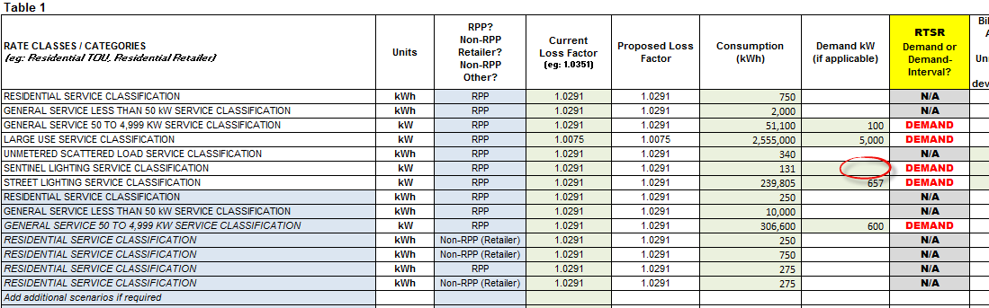

1. Please provide the demand kW number for Sentinel Lighting Class. OEB staff will update the model with the number provided.

**Staff Interrogatory #7**

**Ref: IRM Model – Tab 20: Residential 10th percentile consumption level**

As per the IRM filing requirements, distributors are required to calculate the combined impact of the fixed rate increase and any other changes in the cost of distribution service for residential customers at the 10th percentile of overall consumption (to a minimum of 50 kWh per month). In the application, Festival Hydro does not indicate the kWh value of the 10th percentile residential consumption level. (OEB staff notes that Festival Hydro has populated the bill impact tables for Residential – 250 kWh and 275 kWh.)

1. Please provide the kWh value of the 10th percentile consumption level for Festival Hydro’s residential RPP customers.

**Staff Interrogatory #8**

**Ref: Regulated Return on Equity (ROE) in 2015**

According to Festival Hydro’s 2015 RRR 2.1.5.6 ROE filing, Festival Hydro’s 2015 achieved ROE measuring 14.24% was 194 basis points above the 300 basis points dead band.

1. Given Festival Hydro’s overearning in 2015, has Festival Hydro considered filing to not increase (price cap adjustment) its base rates for the 2017 rate year?
2. Please explain what the main drivers are to the overearning.
3. Please explain if any of the drivers are expected to continue in 2016 and 2017.

**Staff Interrogatory #9**

**Ref: Tab 1 of “Festival Hydro_FST-LRAMVA-WORKFORM-2015_08182016” (OEB LRAMVA workform)**

**Appendix C: LRAMVA Third Party Report (Burman Report)**

Preamble:

The third party report prepared by Burman Energy (Burman Report) indicates that Festival Hydro is requesting $131,948.54 in lost revenues for CDM activities in 2015, inclusive of carrying charges. This amount represents the actual 2015 lost revenues and the persisting amounts from 2011, 2012, 2013 and 2014 into 2015, and is net of the forecast CDM amounts in the load forecast from the 2015 Cost of Service application.

Questions:

1. Please confirm that $131,948.54 in LRAMVA balances is requested for approval. The OEB LRAMVA workform shows that a total of $410,798.34 is requested for OEB approval, and is inclusive of amounts from 2011 that were previously approved by the OEB.
2. Staff is of the understanding that the LRAMVA request pertains to 2015.
3. Please reconcile the differences in the amount claimed in the Burman Report in Table 7 (i.e., Summary of Lost Revenue Adjustments) ($131,948.54) and the OEB LRAMVA workform from rows 119-124 (i.e., Tab 5 of the OEB LRAMVA workform) ($156,732) for the 2015 year.

**Staff Interrogatory #10**

**Ref: 2014 CDM Annual Report, Table 12**

**Appendix C: LRAMVA Third Party Report, pages 12 and 13**

**Tabs 4, 5 and 6 of “Festival Hydro_FST-LRAMVA-WORKFORM-2015_08182016” (OEB LRAMVA workform)**

Preamble:

Overall persistence levels were provided in Tab 6 of the OEB LRAMVA workform, but it appears that initiative level persistence rates were used by Burman when calculating the LRAMVA balance of $131,948.54.

Question:

Please confirm that Festival Hydro has relied on the initiative level persistence as provided by the IESO and provide this information if it is available.

**Staff Interrogatory #11**

Ref: Tab 1 of “Festival Hydro_FST-LRAMVA-WORKFORM-2015_08182016” (OEB LRAMVA workform)

EB-2009-0263 Decision, page 10

Preamble:

Festival Hydro indicates that it was approved $330,763.00 in lost revenues for the past 4 years. In its application, Festival Hydro confirmed that no CDM adjustment was included in the 2010 load forecast and a CDM adjustment was only made to the 2015 load forecast at the time of 2015 Cost of Service.

Question:

1. For Staff to have a better understanding of the current LRAMVA request, please complete the following table.

|  |  |  |  |  |  |  |  |  |  |
| --- | --- | --- | --- | --- | --- | --- | --- | --- | --- |
|  |  | **Rate Year** | | | | | | | |
|  |  | **2011** | **2012** | | | **2013** | **2014** | **2015** | **Eligible Totals ($)** |
| **Program Year** | **2011** |  |  | | |  |  |  |  |
| **2012** |  |  | | |  |  |  |  |
| **2013** |  |  | | |  |  |  |  |
| **2014** |  |  | | |  |  |  |  |
| **2015** |  |  | | |  |  |  |  |
|  | **Totals** | $ - | $ - | | | $ - | $ - | $ - | $ - |
|  |  |  |  | | |  |  |  |  |
|  |  | Approved | | | |  |  |  |  |
|  |  | Claimed as part of current application | | | | | |  |  |
|  |  |  | |  |  | |  |  |  |

1. Please confirm that the 2010 load forecast did not have a CDM adjustment (and LRAMVA threshold).
2. Please provide a table that clearly indicates the LRAMVA threshold (both kWh and kW) that was approved as part of the 2015 Cost of Service application.

**Staff Interrogatory #12**

**Ref: Appendix C: LRAMVA Third Party Report, pages 13**

On page 13 of Appendix C, the LRAMVA calculation includes a summary of the demand and energy savings by rate class, one of which is the Large Use Customers class.

When reviewing the OEB LRAMVA workform, Tab 5, there does not appear to be any savings allocated to the Large Use class. Please discuss and clearly indicate what program savings were allocated to the large use class.