**Cooperative Hydro Embrun Inc. (Cooperative Hydro Embrun)**

**EB-2016-0065**

**Application Analysis**

**Interrogatory #1**

**Ref: Manager** Summary, page 1

1. OEB staff notes that the EB number shows EB-2016-0063. Please confirm that Cooperative Hydro Embrun’s application is EB-2016-0065.

Response: Confirmed. The EB number used should have been EB-2016-0065

**Interrogatory #2**

**Ref: Manager’s Summary, page 14**

1. OEB staff notes that Cooperative Hydro Embrun did not state the recovery period

for its Group 1 Deferral and Variance Accounts in its Manager’s Summary. Please confirm that Cooperative Hydro Embrun is proposing a one-year disposition of Group 1 Deferral and Variance Account.

Response: Confirmed. The disposition period should be of one-year.

1. If the answer to a) is no, please provide explanation.

Response: N/A

**Interrogatory #3**

**Ref: A portion of “Sheet 2 – Current Tariff Schedule” is reproduced below**



1. OEB staff notes that under “Non-Payment of Account” section of Cooperative Hydro Embrun’s current Tariff of Rates and Charges, the line item labelled as “Disconnect/reconnect charge at meter during regular hours - $185.00”. Staff believes the correct labelling is “Disconnect/reconnect charge at pole during regular hours - $185.00”.

If Cooperative Hydro Embrun agrees, and also agrees that this is in error, please confirm and staff will update the model with the correct labelling.

Response: CHE confirms that the table reproduce above corresponds to the Board Approved Tariff Sheet and as such should remain as indicated in the table.

**Interrogatory #4**

**Ref: Sheet 16 “Rev2Cost_GDPIPI”**

On August 4, 2016, the OEB has posted the Pacific Economics Group Research (PEG) Report to the Ontario Energy Board "Empirical Research in Support of Incentive Rate-Setting: 2014 Benchmarking Update” for the electricity distributors’ 2016 stretch factor assignments in rates. Cooperative Hydro Embrun was assigned a stretch factor of 0% based on the updated benchmarking study.

OEB staff notes that on Sheet 16, Cooperative Hydro Embrun chose Stretch Factor Group II instead of Group I in cell B13.

1. If Cooperative Hydro Embrun agrees that this is in error, please confirm and staff will update the model.

Response: Confirmed. The Stretch Factor should be set to 0%.

1. If the answer to a) is no, please provide a full explanation.

Response: N/A

**Interrogatory #5**

**Ref: A portion of Sheet 3 “Continuity Schedule” is reproduced below**

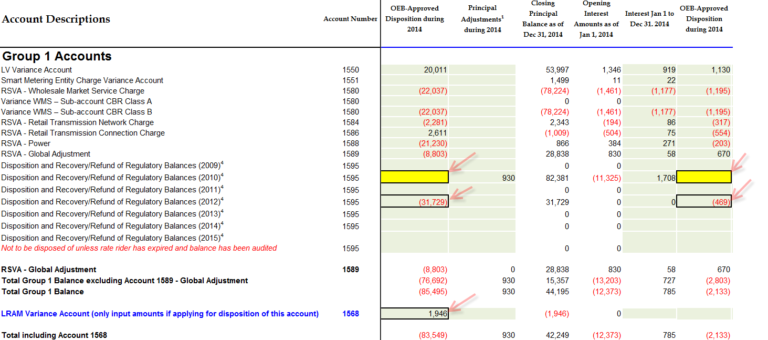

The table below from Cooperative Hydro Embrun’s 2014 Cost of Service, Draft Rate Order, Revised January 15, 2014 (EB-2013-0122, page 10) which identifies the principal and interest amounts approved for disposition, is reproduced below.

**Group 1 Deferral and Variance Account Balances**

|  |  |  |
| --- | --- | --- |
| **Account** | **Acct**  **Number** | **Balance** |
| LV Variance Account | 1550 | 21,141 |
| RSVA - Wholesale Market Service Charge | 1580 | (23,233) |
| RSVA - Retail Transmission Network Charge | 1584 | (2,598) |
| RSVA - Retail Transmission Connection Charge | 1586 | 2,056 |
| RSVA - Power (excluding Global Adjustment) | 1588 | (21,435) |
| RSVA - Global Adjustment | 1589 | (8,133) |
| Disposition and Recovery/Refund of Regulatory Balances (2010) | 1595 | (111,894) |
| **Total of Group 1 Accounts (excluding 1589)** |  | **(135,963)** |
| **Total of Group 2 Accounts** |  | **0** |
| **Total of Account 1562 and Account 1592** |  | **0** |
|  |  |  |
| LRAM Variance Account **(Enter dollar amount for each class)** | 1568 | 3,855 |
|  |  |  |
| **Total Balance Allocated to each class (excluding 1589)** |  | **(131,593)** |
| **Total Balance Allocated to each class from Account 1589** |  | **(8,133)** |
|  |  |  |
| Accounting Changes Under CGAAP Balance + Return Component | 1576 | (39,272) |
| **Total Balance Allocated to each class for Accounts 1575 and 1576** |  | **(39,272)** |

OEB staff is unable to reconcile columns AU and AZ (i.e. OEB-Approved Disposition during 2014 for both principal and interest) to Cooperative Hydro Embrun’s 2014 cost of service proceeding balances approved for disposition.

1. Please confirm the balances approved for disposition in 2014 are the same as those entered in the continuity schedule for the current proceeding. If any changes are required, please confirm and OEB staff will update the Rate Generator Model.

Response **from BDO**:

In previous applications, CHEI’s auditors missed the footnote which stated that a utility should include accounts 1595 as part of Group 1 for review and disposition if the recovery period had been completed. CHEI incorrectly included balances event if the recovery period was not complete.

The following Group 1 accounts were included in columns AU and AZ of the continuity schedule:

1550 $21,141 represents the $20,011 and $1,130

1580 ($23,233) represents the ($22,037) and the ($1,195)

1584 ($2,598) represents the ($2,281) and the ($317)

1586 $2,056 represents the $2,611 and the ($554)

1588 ($21,435) represents the ($21,230) and the ($203)

1589 ($8,133) represents the ($8,803) and the $670

Sum of above = $32,202 and sum in continuity schedule for these accounts is $32,198 (difference of $3).

1595 ($111,894) was not included since the amount was already in the accounts 1595. Nothing should had been put on line 1595 in 2013 since the recovery period was not completed. The rate rider associated with this amount created a debit in account 1595 for which there was no credit amount already in this account to offset. The 111,894 should not have beenallowed for disposition in 2014. The recovery period for 1595 are now all completed and there is 114,404 remaining in this account which most of it is because of the disposition of 111,894 in 2014.

The LRAM variance account of $1,948 was added to this continuity schedule since it had not been recorded in the Cooperative Hydro Embrun’s books but was highlighted as an amount that should have been included in the schedule (from the

EB-2013-0122 disposition dated December 23, 2013 (page 12 of document)).

1. Please provide explanation for the OEB-approved disposition during 2014 in the amount of -$31,729 in account 1595 (2012).

Response **from BDO**

$31,729 plus the $469 = $32,198. This amount represent the portion of the disposition of Group 1 account as described in question a) above.

**Interrogatory #6**

**Ref: A portion of Sheet 3 “Continuity Schedule”**



1. Account 1580 - Variance WMS – Sub-account CBR Class A ($73,327)

Account 1580 - Variance WMS – Sub-account CBR Class B ($73,327)

Cooperative Hydro Embrun stated that the balances in account 1580 was incorrectly unpopulated. The balance should be under Class B as Cooperative Hydro Embrun does not have any Class A customers. Please file a RRR data revision request online with the OEB’s e-Filing services.

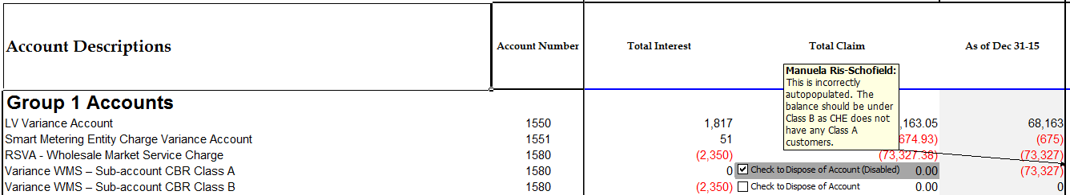

1. OEB staff notes that Cooperative Hydro Embrun did not provide the calculation and resulting rate riders for Account 1580 – Sin-account CBR Class B customers. The rate riders need to be calculated separately from IRM model and added into Sheet 18 “Additional Rates” for each applicable rate class. Please provide the rate riders for Class B customers and staff will update the Rate Generator model.

Response: The accounting guidelines for treatment of CBR was not followed and as such the utility updated its balances for account 1580 and Sub-Account CBR Class B in both the IRM model and its RRR 2.1.7.

**Interrogatory #7**

**Ref: A portion of Sheet 3 “Continuity Schedule” is reproduced below**



OEB staff notes that Cooperative Hydro Embrun has not calculated projected interest on its Group 1 balances for the period from January 1, 2016 to December 31, 2016.

1. Please calculate carrying charges for the period noted above, and provide these amounts for each account. Board staff will update the model accordingly.

Response: Interest for 2016 added – see revised column BQ of the Continuity schedule

**Interrogatory #8**

**Ref: A portion of Sheet 4 “Billing Det. For Def-Var” is reproduced below**



1. As Cooperative Hydro Embrun is proposing to dispose balances in account 1595 (2010) and 1595 (2012), please provide the above required recovery share proportion figures in Sheet 4. OEB staff will update the model using the figures provided.

Response: Tab 4 of the attached IRM model has been updated to reflect the following changes.

|  |  |  |  |
| --- | --- | --- | --- |
|  |  | **1595 Recovery Proportion (2010) 1** | **1595 Recovery Proportion (2012) 1** |
| **Rate Class** | **Unit** |
| RESIDENTIAL SERVICE CLASSIFICATION | kWh | 69% | 68% |
| GENERAL SERVICE LESS THAN 50 kW SERVICE CLASSIFICATION | kWh | 15% | 16% |
| GENERAL SERVICE 50 TO 4,999 KW SERVICE CLASSIFICATION | kW | 14% | 14% |
| UNMETERED SCATTERED LOAD SERVICE CLASSIFICATION | kWh | 0% | 0% |
| STREET LIGHTING SERVICE CLASSIFICATION | kW | 1% | 1% |
|  | **Total** | 100% | 100% |

1. OEB staff notes that Cooperative Hydro Embrun did not enter any data in Sheet 4 in account 1595, as result of this, Sheets 5 & 7 are unpopulated.

Response: See response above

**Interrogatory #9**

**Ref: A portion of Sheet 20 “Bill Impacts” is reproduced below**



OEB staff notes that in order for the bill impacts tables to populate the current and proposed Retail Transmission Rates for the Residential, GS <50 kW, Unmetered Scattered Load rate classes, the drop down button “N/A” needs to be selected in column “M” in table 1.

1. Please confirm and staff will make the changes.

Response: Confirmed. Please make the changes as indicated above.