Cooperative Hydro Embrun Inc. (EB-2015-0063)
Application Analysis

- Manager’s Summary - Appendix 1: Current Tariff Sheet
It appears the current Tariff sheet attached to the Manager’s Summary in Appendix 1 is the incorrect version (not the most recent version). Please provide the correct current Tariff EB-2014-0066 sheet.

Response: the tariff sheet from the OEB’s website is presented at Appendix A

Staff: Please note the current tariff sheet presented at Appendix 1 of the Manager’s Summary is an incorrect version.

- Deferral and Variance Account Disposition (Manager’s Summary & Model)
Section 3.2.5.1 of Chapter 3 of the Filing Requirements for Electricity Transmission and Distribution Applications dated July 16, 2015 (Chapter 3) states that:

“A wholesale market participant refers to any entity that participates directly in any of the IESO-administered markets. These participants settle commodity and market-related charges with the IESO even if they are embedded in a distributor’s distribution system. As a consequence, a distributor must not allocate any account balances in Account 1588 RSVA - Power, Account 1580 RSVA - Wholesale Market Services Charge and Account 1589 RSVA - Global Adjustment to a wholesale market participant.

A distributor must also ensure that rate riders are appropriately calculated for the following remaining charges that are still settled with a distributor. These include Account 1584 RSVA – Retail Transmission Network Charge, Account 1586 RSVA – Retail Transmission Connection Charge and Account 1595 – Disposition/Refund of Regulatory Balances.”
- Please confirm whether or not Cooperative Hydro Embrun serves any consumers that are WMPs. (Tab 4 – column G & H)
If yes:
    - Have these consumers been WMPs throughout the entire time over which variances accumulated in the RSVA accounts proposed for disposition?
    - Please confirm that RSVA account balances have not been allocated to WMP customers as they settle these charges directly with the IESO.
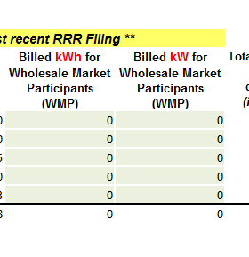

Section 3.2.5.2 of Chapter 3 states that:

“As a new addition for 2016 applications, a distributor must now provide a description of its settlement process with the IESO or host distributor. It must specify the GA rate it uses when billing its customers (1st estimate, 2nd estimate or actual) for each rate class, itemize its process for providing consumption estimates to the IESO, and describe the true-up process to reconcile estimates of RPP and non-RPP consumption once actuals are known. The description should detail the distributor’s method for estimating RPP and non-RPP consumption, as well as its treatment of embedded generation or any embedded distribution customers. Distributors are reminded that they are expected to use accrual accounting.”
- Cooperative Hydro Embrun has not filed the above required settlement process description with its 2016 rate application. Please provide this settlement process description with the required information.

Section 3.2.5.2 of Chapter 3 also states that:
“As of July 1, 2015, per O.Reg 429/04, an eligible customer with a maximum hourly demand over three megawatts, but less than five megawatts, can elect to become a Class A for an applicable adjustment period of one year.

Any distributor who serves any eligible Class A customers is asked to identify the number of Class A customers it served in 2014 and is serving as of July 1, 2015, if different. If more than two Class A customers are served, the distributor must report the combined peak demand factor of its Class A customers for each period.

A distributor with one of these newly Class A-eligible customers should also propose an appropriate allocation for the recovery of the global adjustment variance balance based on their settlement process with the IESO or host distributor for any residual GA variance balances that might have accrued prior to those customers being classified as Class A customers. This information will be used to inform future disposition of GA variance account balances.”
- Please confirm whether or not Cooperative Hydro Embrun serves any class A consumers that settle energy charges directly with Cooperative Hydro Embrun.
If yes:
- Please identify the number of Class A customers Cooperative Hydro Embrun served in 2014 and was serving as of July 1, 2015, if different.
- Please explain how balances in Account 1589 (Global Adjustment) have been allocated to these Class A customers, and provide the figures to be entered on Tab 4 – column K to M.
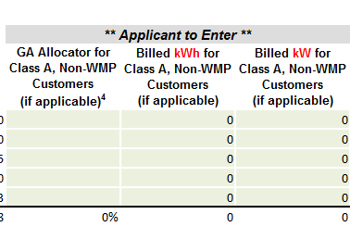
Response: CHE confirms that it does not have any wholesale market participant nor does it have any Class A Customers

Staff:
Part a): As confirmed, Cooperative Embrun does not have any WMP customers. Cooperative Embrun will have to request the adjustment be completed through OEB’s Performance Assessment group. This does not have an effect on the processing of this application; however, Cooperative Embrun should request this change as soon as possible.
Part b): Cooperative Embrun will need to provide the Settlement Process information required in part b).
Part c): As confirmed, Cooperative Embrun does not have any Class A customers.

- Tab 3 – 2015 Continuity Schedule
OEB staff notes that at column Q “Board-Approved Disposition during 2012”(principal), row 29 and 30 (Account 1588 and 1589) – the amounts entered do not match the table on page 8 of the Decision and Order issued in March 2012 in Cooperative Hydro Embrun’s 2012 rates application (EB – 2011 – 0164). OEB staff notes that the figures should be -$24,450 for Account 1588 and $27,114 for Account 1589.
- Please confirm if Cooperative Hydro Embrun agrees, and staff will update the model.
- If answer to a) is no, please provide an explanation for the discrepancy.
Response: a) Please make the necessary adjustment to Board approved dispositions for 2012.
Staff: Adjustment made in the model. Cooperative Embrun will need to verify if the same adjustment is necessary on its RRR filing. If so, Cooperative Embrun will have to request the adjustment be completed through OEB’s Performance Assessment group. This does not have an effect on the processing of this application; however, Cooperative Embrun should request this change as soon as possible.
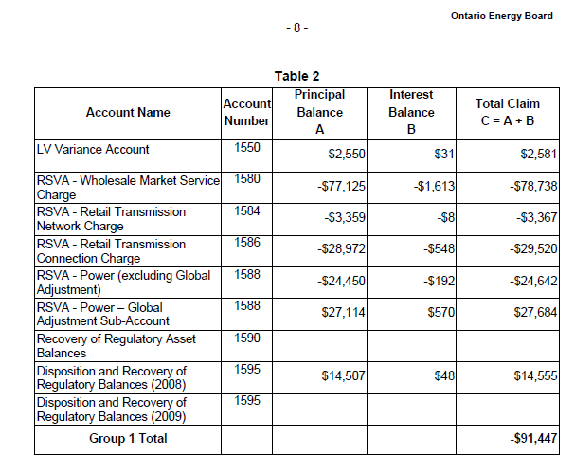

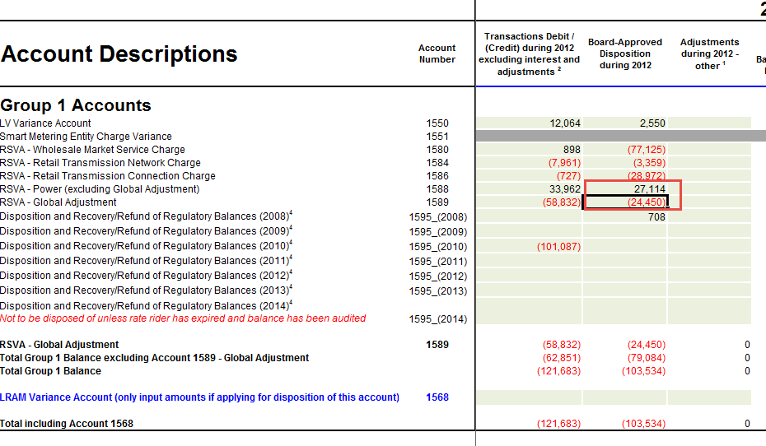

- Tab 4 – Billing Det. For Def-Var
The proportion figures entered in “1595 Recovery Share Proportion” fields (column P to V) are to be used to allocate the residual account balance of 1595 in Tab 5. As Cooperative Hydro Embrun is seeking disposition of Account 1595(2010) and 1595(2012), please provide “1595 Recovery Share Proportion” figures for year 2010 (column R) and 2012 (column T). OEB staff will update the model using the figures provided.

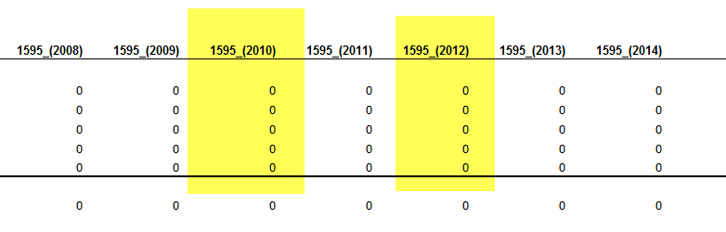
Response: Please make the necessary adjustment to 1595 Recovery Share Proportion.
Staff: Cooperative Embrun provided the following 1595 Recovery Share Proportion numbers for year 2010 and 2012 as per email date September 28, 2015. These proportion numbers have been applied into the model.

 | 2010 | 2012
Res | 69.06% | 68.19%
GS<50 | 15.35% | 16.23%
GS>50 | 14.24% | 14.03%
USL | 0.34% | 0.30%
StreetLights | 1.03% | 1.23%

- Manager’s Summary – Section 6. Rate Design For Residential Electricity
In Table 2 of the application - Current VS Proposed Distribution Rates, the title of the 5th column reads “2014 Board Approved Fixed Ratio”. Please confirm the title should be “2014 Board Approved Variable Ratio”.
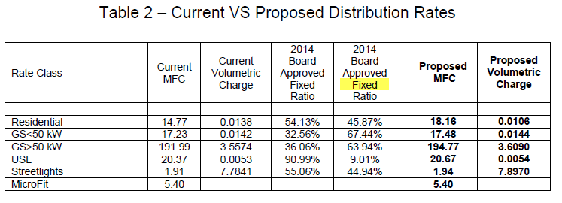

Response: Correct, the column heading should say Variable rather than Fixed.
Staff: Corrected.

Other updates to the model:
- The OEB has calculated the value of the inflation factor for the incentive rate setting under the Price Cap IR and Annual Index plans, for rate changes effective in 2016, to be 2.1%. The derivation of this is shown on OEB’s webpage: http://www.ontarioenergyboard.ca/oeb/Industry/Regulatory%20Proceedings/Applications%20Before%20the%20Board/Electricity%20Distribution%20Rates/2016%20Electricity%20Distribution%20Rate%20Applications
This new inflation factor has been applied to Tab 15 of the model as the Price Escalator.

