|  |  |  |
| --- | --- | --- |
| **Ontario Energy**  **Board**  P.O. Box 2319  27th. Floor  2300 Yonge Street  Toronto ON M4P 1E4  Telephone: 416-481-1967  Facsimile: 416-440-7656  Toll free: 1-888-632-6273 | **Commission de l’énergie**  **de l’Ontario**  C.P. 2319  27e étage  2300, rue Yonge  Toronto ON M4P 1E4  Téléphone: 416-481-1967  Télécopieur: 416-440-7656  Numéro sans frais: 1-888-632-6273 |  |

**BY EMAIL**

November 9, 2016

Ontario Energy Board

P.O. Box 2319

27th Floor

2300 Yonge Street

Toronto ON M4P 1E4

[Kirsten.Walli@ontarioenergyboard.ca](mailto:Kirsten.Walli@ontarioenergyboard.ca)

Attention: Ms. Kirsten Walli, Board Secretary

Dear Ms. Walli:

**Re: Festival Hydro Inc.**

**2017 IRM Distribution Rate Application**

**OEB Staff Submission**

**OEB File No. EB-2016-0070**

In accordance with Procedural Order No.1, please find attached the OEB Staff Submission in the above proceeding. This document is being forwarded to Festival Hydro Inc. and to all other registered parties to this proceeding.

Festival Hydro is reminded that its Reply Submission is due by November 21, 2016, should it choose to file one.

Yours truly,

*Original Signed By*

Katherine Wang

Analyst, Incentive Rate Setting & Accounting

Encl.



**ONTARIO ENERGY BOARD**

**STAFF SUBMISSION**

2017 ELECTRICITY DISTRIBUTION RATES

Festival Hdyro Inc.

EB-2016-0070

**November 9, 2016**

**OEB Staff Submission**

**Festival Hydro Inc.**

**2017 IRM Rate Application**

**EB-2016-0070**

**Introduction**

Festival Hydro Inc. (Festival Hydro) filed an application with the Ontario Energy Board (OEB) on August 15, 2016 under section 78 of the *Ontario Energy Board Act*, *1998* seeking approval for changes to the rates that Festival Hydro charges for electricity distribution, effective January 1, 2017.

The purpose of this document is to provide the OEB with the submissions of OEB staff based on its review of the evidence submitted by Festival Hydro.

OEB staff makes submissions on the following:

* Permanent Bypass Rate Rider
* Earnings Performance in 2015
* Deferral and Variance Account Disposition
* Retail Transmission Service Rates
* Lost Revenue Adjustment Mechanism Variance Account (LRAMVA) Balance

**Permanent Bypass Rate Rider**

**Background**

As part of Festival Hydro’s 2015 Cost of Service (COS) proceeding, EB-2014-0073, the OEB approved the recovery of costs for a permanent bypass of a Hydro One Networks Inc. (HONI) transformer station through a rate rider. The permanent bypass agreement (PBA) rate rider was established to collect $1,230,026 over a 31-month period from May 1, 2015 to December 31, 2017. The OEB approved the PBA rate rider on an interim basis, as the final invoiced amounts were not known at the time of the decision. The OEB ordered that the amount be trued-up as part of Festival Hydro’s 2016 IRM proceeding.

By the time of Festival Hydro’s 2016 IRM application (EB-2015-0069), the final invoice had still not been received. In Festival Hydro’s 2016 IRM proceeding, the OEB approved the continuation of the current PBA rate rider in 2016 on an interim basis. The OEB ordered that a true-up and rate rider adjustment would be made once the final invoice is received.

Festival Hydro noted in its application and in response to OEB staff interrogatory #5(a) that, at the time of filing this application, the final invoice has been received and the amount in question has been finalized with Hydro One Networks Inc. at $932,094. Festival Hydro calculated the remaining amount that needs to be recovered in 2017 is $181,341.

Festival Hydro further calculated its proposed reduced final PBA rate rider by class to recover the remaining permanent bypass cost by the end of 2017.

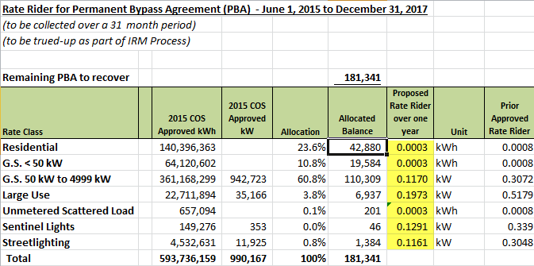

**Submission**

OEB staff has reviewed the evidence and calculations that Festival Hydro provided for the proposed reduced final PBA rate rider. OEB staff has no concerns with Festival Hydro’s request dispose of the proposed final PBA rate rider effective January 1, 2017 to December 31, 2017.

**Earning Performance in 2015**

**Background**

Section 3.3.5 of Chapter 3 of the Filing Requirements[1] states that, for each of the OEB’s three rate-setting options, a regulatory review may be triggered if a distributor’s earnings are outside of a dead band of ± 300 basis points from the OEB-approved return on equity. The OEB monitors results filed by distributors as part of their *Reporting and Record-keeping Requirements* (RRR) and determines if a regulatory review is warranted. A distributor whose earnings are in excess of the dead band is expected to refrain from seeking an adjustment to its base rates through a Price Cap IR or Annual IR Index plan. If a distributor, whose earnings are in excess of the dead band, nevertheless applies for an increase to its base rates, the OEB expects the utility to substantiate its reasons for doing so.

As indicated in Festival Hydro’s 2015 RRR filing 2.1.5.6, Festival Hydro’s 2015 ROE reported of 14.24%, was in excess of the 300 basis points dead band by 194 basis points (i.e., 494 basis points over the approved ROE of 9.3%). Therefore, the expectation was that Festival Hydro should substantiate why it was applying for an increase to its base rates.

In its 2017 IRM application, Festival Hydro notes that the disposition of the Incremental Capital Module (ICM) rate rider was the major contributor to the overage. If the ICM revenues are removed, Festival Hydro’s ROE for 2015 would be within the 300 basis points dead band. As such, Festival Hydro applied for the Price Cap adjustment to its base rates.

In its responses to OEB staff interrogatory #8 and Vulnerable Energy Consumers Coalition (VECC) interrogatories #2 and #3, Festival Hydro provided the 2015 RRR 2.1.5.6 ROE that was filed with the OEB on June 24, 2016, and recalculated the regulatory ROE using the RRR 2.1.5.6 ROE Excel template. In the interrogatory responses, Festival Hydro noted that the ROE over earnings is directly a result of the disposition of the ICM variance account and additional ICM rate rider recovery for the seven month period June 1 to December 31, 2015. Both of these items were approved in Festival Hydro’s 2015 COS proceeding, EB-2014-0073.

Festival Hydro explains that, as noted in its 2015 RRR 2.1.5.6, the overage is due to $1,389,599 in distribution revenue collected from May 1, 2013 to April 30, 2015 approved by the OEB for disposition from the ICM variance account. In addition, $529,558 in distribution revenues related to the new OEB approved ICM rate rider collected from June 1, 2015 to December 31, 2015. These revenues were offset by the ICM carrying charges and ICM depreciation expenses for a net overstatement of distribution income due to the ICM variance account of $1,299,999.

Festival Hydro indicated that it recalculated the 2015 Regulatory ROE by removing the impact of the regulatory accounting implications for the ICM disposition using the RRR 2.1.5.6 ROE Excel Template. Once Festival removed the ICM related amount of $1,299,999, the resulting ROE was reduced to 10.41%, which was below the 300 basis points dead band (comparing to the 9.30% deemed ROE from the last COS decision).

Festival Hydro confirmed in its responses to the interrogatories that the drivers to its 2015 overearnings are not expected to continue in 2016 or 2017 as the ICM rate riders ended as of December 31, 2015, and as such Festival Hydro does not expect overearnings beyond 2015 (as per the 2016 pro-forma ROE provided by Festival Hydro) and feels it’s reasonable to request base rates adjustment in its 2017 IRM proceeding.

**Submission**

OEB staff is of the view that Festival Hydro’s explanations are not entirely clear but OEB staff believes that it understands Festival Hydro’s approach to normalizing its ROE and accepts it, subject to an adjustment as noted below.

In short, Festival Hydro tracked its ICM revenues in account 1508 (a balance sheet account) along with its approved costs pursuant to the OEB’s accounting directions. But, Festival Hydro did not recognize revenues (less ICM carrying charges and ICM depreciation expense) associated with the approved ICM until 2015. Therefore, Festival Hydro needed to remove the impact of ICM distribution revenue collected (less ICM carrying charges and ICM depreciation expense) for the period from May 1, 2013 to December 31, 2014 from the 2015 ROE calculation. In OEB staff’s view, Festival Hydro may be overstating the amount that it removed from the 2015 ROE calculation and should retain revenues associated with the January 1, 2015 to April 30, 2015 period, plus the amounts collected from the new ICM rate rider for the period from June 1, 2015 to December 31, 2015 related to the disposition for the residual balance in the 1508 variance account (less ICM carrying charges and ICM depreciation expense).

The ICM net revenue effects relating to 2015 should not have been deducted when recalculating the 2015 Regulatory ROE. Festival Hydro may wish to confirm in its reply submission that its regulatory ROE calculation, taking the above adjustment into account, results in a 2015 ROE that is still within the dead band. If so, then OEB staff does not oppose Festival Hydro’s request for a price cap adjustment for 2017.

**Retail Transmission Service Rates**

In reviewing tab 10 of Festival Hydro’s 2017 IRM Rate Generator Model, OEB staff noted the demand amount applied for Network Service Rate was higher than the demand amount applied for Line and Transformation Connection Service Rate for GS 50 to 4,999 rate class (non-interval). In an interrogatory, OEB staff asked Festival to explain why the demand used for Network charges was greater than the demand used for Connection charges.

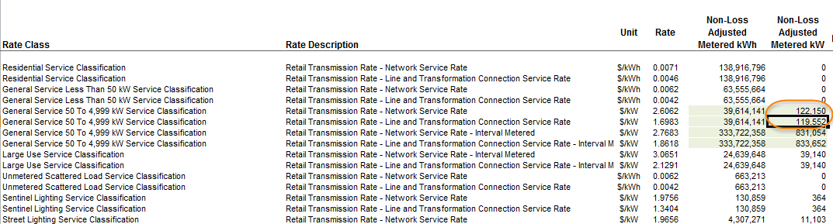

In its response to OEB staff interrogatory # 3, Festival Hydro noted that customer Network charges are based on a 7:00 a.m. to 7:00 p.m. peak demand; and customer Connection charges are based on a 24-hour peak demand. While these peaks often are coincidental, there are occasions when the transformation connection peak occurs outside of the 7:00 a.m. to 7:00 p.m. period.

OEB staff agrees with the above statement that Festival Hydro provided. However, with a longer time-range for the peak demand, the Connection peak demand can only be equal to or greater than the Network peak demand. OEB staff thus requests that Festival Hydro provide the correct Network and Connection peak demand amounts for GS 50 to 4,999 rate class (non-interval) with its reply submission.

Pursuant to the OEB’s Guideline G-2008-0001, OEB staff notes that OEB staff will update the applicable data at the time of the OEB’s Decision on the application based on the Uniform Transmission Rates in place at that time.

**Deferral and Variance Account Disposition**

Festival Hydro completed the Deferral and Variance Account continuity schedule included in the 2017 IRM Rate Generator Model at Tab 3 for its Group 1 Deferral and Variance Accounts. Festival Hydro’s total Group 1 Deferral and Variance Account balances amount to a credit of $848,382. The balance of Account 1589 – Global Adjustment (GA) is a credit of $292,025 and is applicable only to Non-RPP Class B customers. The remaining deferral and variance accounts excluding GA amounted to a credit of $556,357. These balances also include interest calculated to December 31, 2016. Based on the threshold test calculation, the Group 1 Deferral and Variance Account balances equate to a credit of $0.0014 per kWh which exceeds the pre-set disposition threshold. Festival Hydro requested disposition of these accounts over a one-year period.

The GA balances being requested for disposition in this application were incurred for all Group 1 accounts during the year of 2015. During this period, Festival Hydro had four customers transitioned from Class B to Class A as of July 1, 2015 as part of the Industrial Conservation Initiative (ICI). Festival Hydro proposes to dispose a total credit balance of $42,417 related to GA to the four newly-eligible Class A (former Class B) customers for their Class B portion of consumption in 2015. Festival Hydro used tab 6a of the IRM Rate Generator Model to allocate the amount to each of the four customers and proposed to dispose of these amounts via 12 equal monthly payments.

The Group 1 balances to be disposed include the recovery of charges for Capacity Based Recovery (CBR) relating to bringing in contracted Demand Response (DR) providers from the Demand Response 3 (DR3) program into the wholesale energy market. Festival Hydro paid the IESO CBR charges in 2015 and recorded these to a dedicated sub-account. The disposition of this sub-account is impacted by whether or not a distributor has any Class A customers.

In this application, Festival Hydro had Class A customers so it requested that the balance of the sub-account CBR Class B be disposed through a separate rate rider in order to ensure proper allocation between Class A and Class B customers. As Festival Hydro had four customers transitioned from Class B to Class A in 2015, Festival Hydro requested to recover a portion of the CBR Class B costs from these customers (for the period they were Class B customers) through 12 equal monthly charges.

OEB staff has reviewed Festival Hydro’s Group 1 Deferral and Variance Account balances and notes that the principal balances and interest as of December 31, 2015 reconcile with the balances reported as part of the RRRs. Also, the pre-set disposition threshold has been exceeded. Accordingly, OEB staff has no issue with Festival Hydro’s request to dispose of the Deferral and Variance Accounts.

**Lost Revenue Adjustment Mechanism Variance Account (LRAMVA) Balance**

**Background**

In its application, Festival Hydro proposed to dispose of a debit balance in Account 1568 - LRAMVA of $131,949. Festival Hydro’s LRAMVA amount consists of lost revenues from new CDM programs in 2015, as well as persisting savings in 2015 from CDM programs delivered between 2011 and 2014, and associated carrying charges. Festival Hydro’s LRAMVA balance is net of the 2015 forecasted CDM savings that were embedded into rates as part of its 2015 cost of service application.

In response to OEB Staff interrogatories, Festival Hydro updated its LRAMVA balance in order to make certain minor corrections and to incorporate IESO verified savings adjustments that were not included in Festival Hydro’s initial LRAMVA balance. Festival Hydro’s updates to the LRAMVA balance results in a decrease of $462 and an updated LRAMVA amount of a debit of $131,487. Festival Hydro’s LRAMVA balance is supported by a third party review, which calculated Festival Hydro’s LRAMVA balance using information provided by the IESO, including initiative level persistence rates.

**Submission**

OEB staff supports the updated LRAMVA debit balance of $131,487, which consists of lost revenues from new CDM programs in 2015, persisting savings in 2015 from CDM programs delivered between 2011 and 2014, and carrying charges. OEB staff submits that Festival Hydro has calculated its LRAMVA balance in accordance with the CDM Guidelines (EB-2012-0003) and updated LRAMVA policy (EB-2016-0182).

All of which is respectfully submitted

1. *Filing Requirements For Electricity Distribution Rate Applications; Chapter 3 Incentive Rate-Setting Applications*, issued July 14, 2016, page 23