**Staff IRs on Guelph Hydro’s LRAMVA Model**

File: Guelph_App 7_2017IRM_Generic_LRAMVA_Work_Form_updated 20160815

**Staff IR-1**

Ref: Tab “1. LRAMVA Summary”

Based on the information submitted by Guelph, it appears that $302,621 in lost revenues has been recovered by Guelph Hydro from 2011 to 2013 (highlighted in pink below). As a result, the lost revenues in this application should pertain to recovering LRAM amounts for 2014 and 2015. The LRAM amount should include the carrying charges related to the years in which LRAM is being claimed, and the persistence of savings from prior years, up to the year of rebasing.

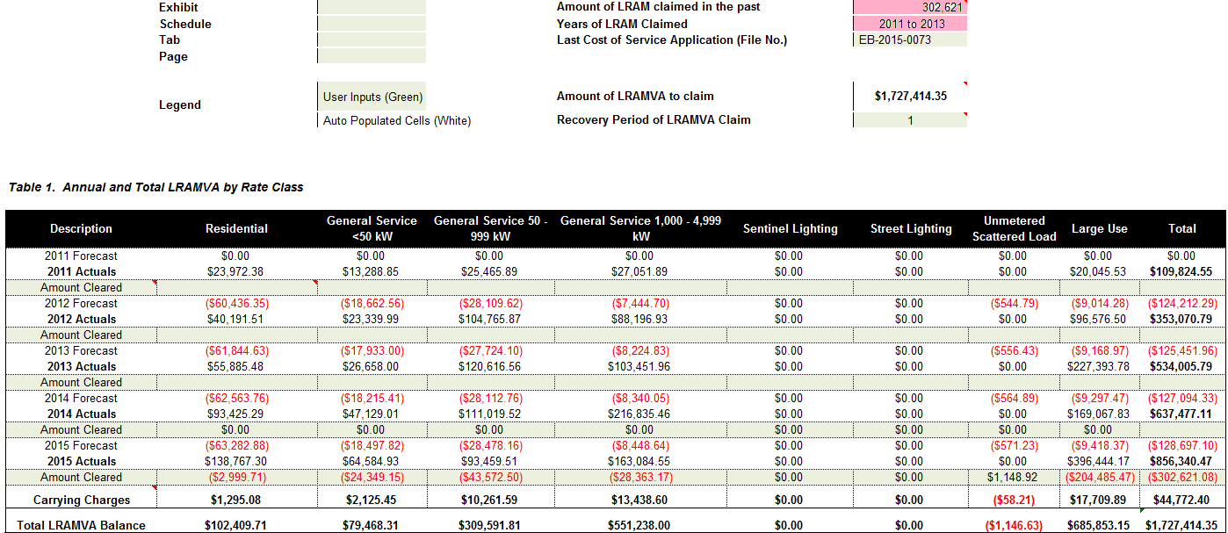

Questions:

1. Please confirm that $302,621 in lost revenues has been claimed for the 2011 to 2013 period.

**Guelph Hydro’s response:**

Guelph Hydro confirms that $302,621 in lost revenues ($288,940.89 principal and $13,680.19 carrying charges) has been claimed for the 2011 to 2013 period.

1. Please re-calculate the LRAMVA balance for the outstanding period by excluding the lost revenue amounts that were recovered in past years. This can be done by adjusting the “Total LRAMVA Balance” formula to include the years 2014 and 2015, or entering into approved amounts in the “Amount Cleared” cells. This would ensure that the total reflects the outstanding lost revenues to be claimed.

**Guelph Hydro’s response:**

The amount of $302,621 claimed for the 2011 to 2013 period and disposed during 2016 was and is entered into tab 1, row 36, “Amount Cleared” cells. There is no need to adjust or change the “Total LRAMVA Balance” formula; it reflects correctly the remaining balance (row 39).

1. Please re-calculate the interest amounts for the period of the LRAM claim, taking into consideration the interest amounts that have been cleared in the past.

**Guelph Hydro’s response:**

Guelph Hydro received approval to dispose 2011 to 2013 LRAMVA balances during 2016 year; there are no other historical approved dispositions, and therefore, a re-calculation of the interest amount is not necessary.

1. Please re-calculate the proposed rate rider adjustments based on the revised LRAM claim. Please file the updates in Tab “12. Guelph_Proposed Rate Riders”.

**Guelph Hydro’s response:**

Guelph Hydro updated the LRAMVA claim in Tab “12_Guelph_Proposed Rate Riders”. The proposed LRAMVA rate riders are presented below:



In order to calculate the January 1, to December 31, 2016 carrying charges, Guelph Hydro added rows 38 and 40 in Tab 1 “LRAMVA Summary”. The total claim per customer class was input in 2017IRM Rate Generator, tab 4 “Billing Det. For Def var”, column R.

**Staff IR-2**

Ref: Tab “4. 2011-14 LRAM”, Table 10. 2014 Lost Revenues Work Form

In accordance with the OEB’s policy review in [EB-2016-0182](http://www.ontarioenergyboard.ca/oeb/_Documents/EB-2016-0182/Report_Policy_LRAMVA_Calculation_20160519.pdf), the demand savings from demand response programs cannot be claimed. However, demand savings from all energy efficiency programs are eligible to be recovered (note: demand savings from the Building Commissioning program are only applicable for three months of the year. Demand savings from all other energy efficiency programs are applicable for the entire year, or 12 months).

For the calculation of peak savings in the business programs, Staff is of the understanding that the “Business Subtotal” of 2,477 kW and “Industrial Subtotal” of 3,686 kW include the peak savings from all programs (including demand response).

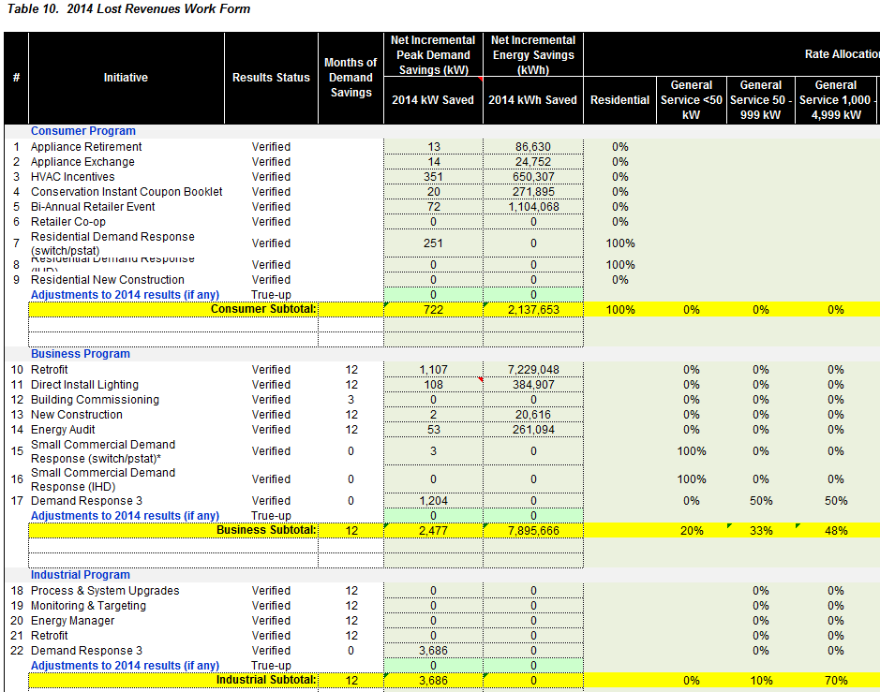

Questions:

1. In the “Business Subtotal” of 2,477 kW, please provide rationale on why the peak demand savings from the Small Commercial Demand Response (3 kW) and Demand Response 3 program (1,204 kW) have been included (and applied over 12 months).
   1. Please remove all peak demand savings from demand response programs and re-calculate the Business Sub-total

**Guelph Hydro’s response:**

For the 2014 LRAM Work Form “Business Subtotal”, Guelph Hydro had removed all peak demand savings from demand response and other non-or partially eligible programs in tab 4 “2011-2014 LRAM”, in the cells in row 309 titled “Total GS > 50 kW (excludes DR & Building Commissioning)”. As columns “H” and “I” are energy based rate classes, no demand reductions are identified in H309 and I309. The cell J309 formula, however, is for the GS50-999 rate class, and does remove 50% of the DR3 and Small Commercial Demand Response contribution, as well as the appropriate Building Commissioning contribution (if there were one for this rate class) through its calculation. Similarly, the formula in cell K309 removes the other 50% of the DR3 and Small Commercial Demand Response contribution, as well as the appropriate Building Commissioning contribution (if there were one) for the GS1000-4999 rate class, through its K309 calculation.

The reason for using this methodology is for simplified data entry verification when auditing the LRAM results model data against the OPA/IESO final verified results reports, as these reports have the various non-eligible LRAM program results embedded within their report totals. There is better probability of accuracy when the Program Subtotal results can be easily validated against the LRAM Tab 4 model, where columns “F” and “G” were used by Guelph Hydro as full data input columns.

1. In the “Industrial Subtotal” of 3,686 kW, please provide rationale on why peak demand savings of 3,686 kW from the industrial DR3 program have been included (and applied over 12 months).
2. Please remove all peak demand savings from demand response programs and re-calculate the Industrial Sub-total.

**Guelph Hydro’s response:**

For the 2014 LRAM Work Form for “Industrial Subtotal”, Guelph used the same methodology as described for the “Business Subtotal”, with OPA/IESO CDM verified results reporting quantities entered into columns F and G, for reasons described in the above response to Staff IR-2 (1), and DR peak demand savings deducted in Row 309. In reviewing the model, Guelph Hydro acknowledges spreadsheet formula errors which did not properly deduct the DR component. These formula errors have been corrected in cells J309, K309 and O309.

1. After making the changes requested above, please file all updates to the lost revenues in an updated copy of the LRAM work form.

**Guelph Hydro’s response:**

Please see the updated LRAM work form posted in Excel version on the OEB’s secure FTP (file name “Guelph_IRRs_ on LRAMVA_Work_Form_updated_20160921.xls”).

**Staff IR-3**

Ref: Tab “4. 2011-14 LRAM”, Table 10. 2014 Lost Revenues Work Form

Staff is of the understanding that Guelph Hydro last rebased in 2012. Once the utility rebases, the distributor should have included the persistence of historical savings into the new load forecast (e.g. 2011 savings persistence into the 2012 load forecast). As a result, the distributor cannot claim the lost revenues of historical years after the year of rebasing.

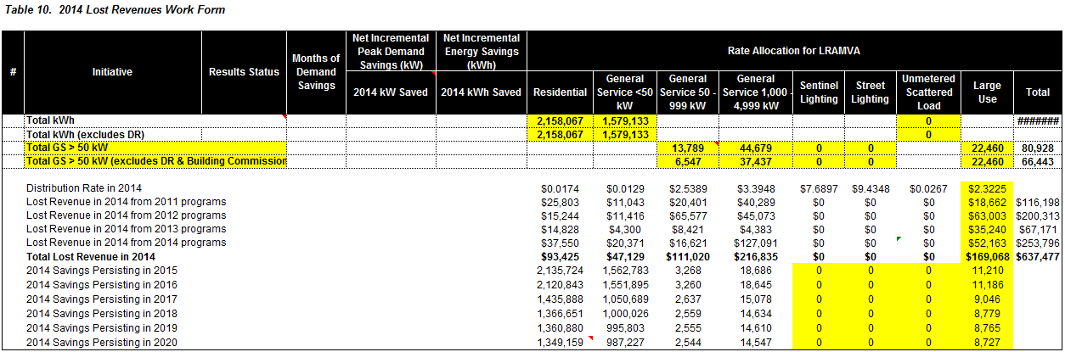

Questions:

1. Please explain why the persistence savings of 2011 programs into the 2014 year were included in the 2014 LRAM claim.

**Guelph Hydro’s response:**

Guelph Hydro last rebased in 2016. In the 2012 rebasing, Guelph Hydro included CDM adjustments in its Board-approved load forecast to be considered in the LRAMVA calculation for the 2012 to 2015 period. At the time of its 2012 rebasing, the load forecast did not capture the persistence of 2011 savings; the 2011 forecast trend was not adjusted for CDM. Only the 2012 forecast was adjusted at the wholesale level.

1. Please re-calculate the lost revenue for 2014 excluding the persistence of savings from 2011 programs.

**Guelph Hydro’s response:**

Guelph Hydro believes that 2011 CDM programs persistence should not be excluded. In accordance with the Board Decision and Order issued on November 26, 2015 (file number EB-2015-0073), the Board approved Guelph Hydro’s LRAMVA disposition which included the 2011 CDM programs persistence. Please also see the OEB’s Guidelines for Electricity Distributor - Conservation and Demand Management (EB-2012-0003), issued on April 26, 2012, Appendix A – LRAM Eligibility Table. The referred table states that 2011 persistence is eligible for LRAMVA recovery (please see the snapshot below).



**Staff IR-4**

Ref: Tab “5. 2015 LRAM”, Table11-a. 2015 LRAM Work Form

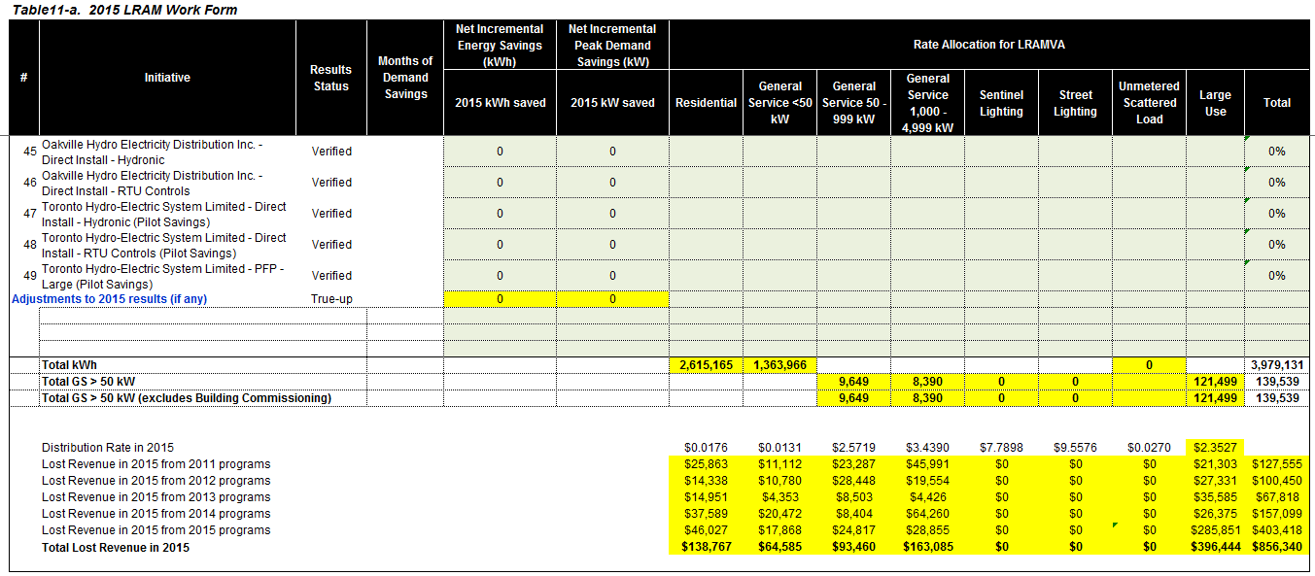

Questions:

1. Please explain why the persistence savings of 2011 programs into the 2015 year were included in the 2015 LRAM claim.

**Guelph Hydro’s response:**

Please see the response to Staff IR-3.

1. Please re-calculate the lost revenue for 2015 excluding the persistence of savings from 2011 programs.

**Guelph Hydro’s response:**

Please see the response to Staff IR-3.

**Staff IR-5**

Ref: Tab “10. Guelph_CDM Prgs”

In reviewing the persistence rates used for energy and peak demand savings from 2011 to 2015, Staff noticed some inconsistencies in the persistence rates for certain years that were much lower than prior years.

1. Please confirm the source of the persistence rates and whether this reflects the information provided by the IESO.

**Guelph Hydro’s response:**

The persistence rates for energy and demand savings were all derived from OPA/IESO provided information, but the methodology has changed from early days under the 2011-2014 CDM framework.

Initially Guelph Hydro calculated persistence from the OPA/IESO’s Guelph Hydro Final Annual Report under the “Summary – Progress Towards CDM Targets” Tab. This summary tab provided annual energy and demand savings persisting by year to be reflected against the 2014 CDM targets. This information is replicated in Tab 10 – “Guelph CDM Prgs” in cells A86-E106. Persistence by year was calculated by taking the ratio of the year against the base program year. For example, the 2011 base year demand savings was 3.42 MW as per cell B99. The 2012 demand persistence was calculated as 0.8734, by dividing the 2.99 MW persisting in 2012 (cell C99) into the 2011 base year. The same methodology was used for other demand base years (eg. 2012, 2013 and 2014), and well as the energy savings persistence.

One significant issues with the above approach is that no visibility is provided for persistence beyond 2014. As a result, Guelph Hydro approached the OPA/IESO to obtain more detailed program persistence results data. The OPA/IESO subsequently provided more detailed program results persistence data, when available. Some of these files included adjustments to previous years’ “final verified” program results from CDM projects put into service in earlier years, but not recognized through formal reporting until some time later. Guelph Hydro believes that these “retroactive” reporting adjustments may explain some of the differences between the initial persistence calculations and the more detailed persistence data files.

The more detailed persistence data covering the 2011-2020 timeframe is included in Tab 10 – “Guelph CDM Prgs” in cells A108-L130. This persistence information is reflected in Tab 6 – “Persistence Rates.”

1. Please discuss how Guelph has developed the persistence factors.

**Guelph Hydro’s response:**

Please see the response to Staff IR-5 (1).

**Staff IR-6**

Ref: Tab “9. Guelph_Lost Revenue”

Please discuss why the distribution rates used to estimate the value of the lost revenues has included the impact of rate riders for tax changes and/or foregone revenues. -

**Guelph Hydro’s response:**

In accordance with the OEB’s Guideline for Electricity Distributor Conservation and Demand Management (EB-2012-0003) issued on April 26, 2012, section 13.2 LRAM Mechanism for 2011- 2014, page 13:

“*The calculation of the LRAM should not include any volumetric rate riders or adders that are subject to their own independent true-ups. For example, volumetric rate riders for disposition of deferral and variance account balances should not be included in the calculation; however,* ***volumetric rate riders for tax sharing or related to foregone revenue should be included.”*** [emphasis added]