**Guelph Hydro Electric Systems Inc.**

**2017 Price Cap IR Application (EB-2016-0075)**

**Application Analysis**

**September 21, 2016**

**Question #1**

**Ref: IRM Model – Tab 3: Account 1580 Variance WMS – Sub-account CBR Class B**

On tab 3 of the 2017 IRM model, Guelph Hydro includes the balance of account 1580 sub-account CBR Class B in amount of $355,984 in the total group 1 disposition. As indicated in the model, if a distributor has Class A customer(s), 1580 sub-account CBR Class balance will be disposed through a rate rider calculated outside the model if significant.

1. Please confirm whether or not Guelph Hydro proposes to dispose the balance of $355,984 in account 1580 sub-account CBR Class B in the 2017 IRM process.

**Guelph Hydro’s response:**

Guelph Hydro confirms that it proposes to dispose the balance of $355,984 in account 1580 sub-account CBR Class B in the 2017 IRM process.

1. If your answer to a) is yes, please provide the associated rate rider (to be entered on tab 18 “Additional Rates” of the model) and its calculation.

**Guelph Hydro’s response:**

Guelph Hydro calculated the CBR rate rider as presented below (the CBR rate riders were entered on tab 8 “Additional Rates” of the rate generator model).

Guelph Hydro noted that the CBR rate rider description is not reflected correctly in tab 19 “Final Tariff Schedule”; only the effective date is shown (the cell can’t be enlarged).

In addition, the CBR rate rider is not shown in sub-total B in tab 20 “Bill Impacts”.



1. If your answer to a) is no (including the scenario where the balance is not significant to be disposed), the checkbox in cell BT25 on tab 3 should be unchecked to exclude the balance in 1580 sub-account CBR Class B from total group 1 disposition. And the balance in this sub-account should be moved to account 1595 for future disposition.

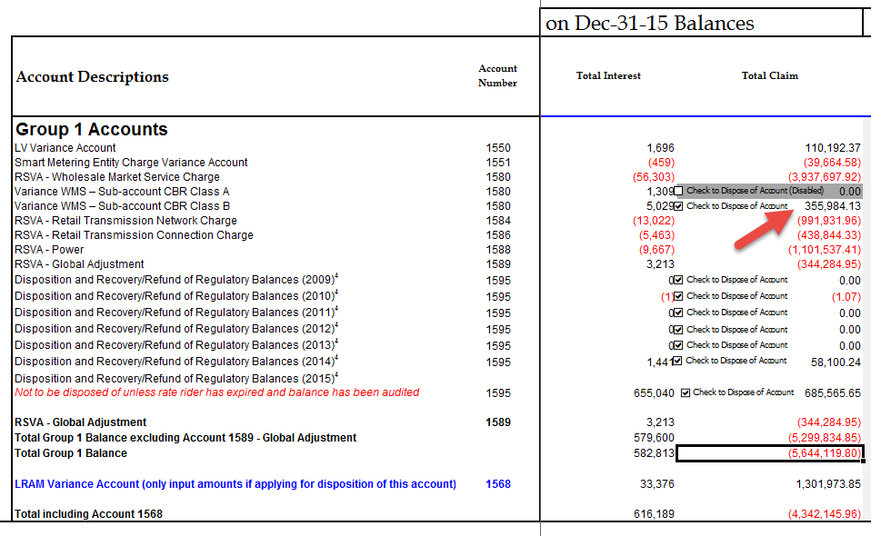

**Guelph Hydro’s response:**

The 1580 sub-account CBR Class B balance is considered significant, therefore the checkbox in cell BT25 on tab 3 remains checked.

**Question #2**

**IRM Model – Tab 3: account 1595 (2015) interest balance**

Guelph Hydro proposes to dispose total group one balance in amount of -$1,698,517 in the 2017 IRM application. OEB staff notes that account 1595 (2015) has a relatively big balance in amount of $685,566. And the major part of this balance is from the interest component of this account – closing interest of 1595 (2015) as of Dec 31, 2015 was $654,704.

1. Please explain why the 2015 closing interest balance in account 1595 (2015) is relatively high.

**Guelph Hydro’s response:**

Guelph Hydro is unable to verify the -$1,698,517 total group one balance noted above. On tab 3 of the 2017 IRM model, Guelph Hydro is showing a total group one balance of -$5,644,120.

The 2015 closing interest balance in account 1595 (2015) is relatively high for the following reason. In its 2015 IRM application, Guelph Hydro received approval to recover a total group one balance of $ 6,965,880. This amount was comprised of a principal balance of $6,347,694 and an interest balance of $618,186. The actual amount recovered on this balance amounted to $6,317,168 which was first applied to the principal balance of $6,347,694. This left a principal balance of $30,526 which when combined with the original interest balance of $618,186 plus $36,854 additional carrying charge accrued up to December 31, 2016 amounts to the $685,566 balance.

**Updates to IRM Model made by OEB staff**

1. **Tab 20: Bill Impacts – RTSR Demand Interval**

OEB staff notes that the Retail Transmission Rates in Guelph Hydro’s GS1,000 to 4,999 kW and Large Use classes are for the interval metered customers only. In order for the bill impacts tables to populate the current and proposed RTSR rates of these two classes, “Demand – Interval” needs to be selected in column M in table 1 for the two classes.

OEB staff has updated tab 20 to reflect this change in Guelph Hydro’s IRM model. Please review and confirm the change.

**Guelph Hydro’s response:**

Guelph Hydro reviewed the change and confirms that the Retail Transmission Rates in Guelph Hydro’s 1,000 to 4,999 kW and Large Use are reflected correctly in tab 20 “Bill Impacts”.