**Niagara Peninsula Energy Inc. (Niagara Peninsula)**

**EB-2016-0094**

**Application Analysis - Responses**

**Interrogatory #1**

**Ref: Sheet 3 Continuity Schedule, Account 1580 Variance WMS – Sub-account CBR Class B**

1. Please confirm that Niagara Peninsula did not report Sub-Account Class B in its RRR filing Account 1580 in Reporting and Record-keeping Requirements (“RRR”) report 2.1.7 Trial Balance, or if not, please explain.
2. If the answer to a) is yes, please file a RRR data revision request online with the OEB’s e-Filing Services to reflect the adjustment discussed in part a).

**Response**

1. The balance of Account 1580 RSVA – Wholesale Market Service Charge of ($2,759,401.03) that was reported in the Asset section of NPEI’s 2015 RRR 2.1.7 Trial Balance does include the balance of CBR Sub-Account Class B. Please see the table below for details.



However, NPEI did not report the Sub-Account Class B Principal or Interest separately on the ‘Sub-Account’ tab of the RRR 2.1.7 template.

1. No revision is required to NPEI’s Account 1580 RSVA Wholesale Market Services balance of ($2,759,401.03) that was reported in the Asset section of the RRR 2.1.7 Trial Balance, as this balance does include the Sub-Account CBR Class B amounts.

NPEI will file a revision request to report the CBR Sub-Account Class B balances, both principal and carrying charges, on the ‘Sub-Account’ tab of RRR 2.1.7.

OEB staff: No further question.

**Interrogatory #2**

**Ref: Manager’s Summary, pages 24 to 26 of 194 “Electricity Distribution Retail Transmission Service Rates”**

**Ref: IRE-2016-1025**

On page 26 of its Manager’s summary, NPEI stated that **“**At the time of filing this Application, Grimsby Power Inc. (GPI) is preparing a proposal for the implementation of the transfer of market participant for the Niagara West station. However, the anticipated date of market participant transfer has not yet been established.”

OEB staff notes that on September 29, 2016, a response was provided to NPEI’s enquiry (IRE-2016-1025) regarding the appropriate accounting treatment for charges that will be billed to NPEI by Grimsby Power Inc. under the embedded distributor service classification. Charges from the “Retail Transmission Rate – Network Service Rate” rider would be recorded in account 4714, Charges – NW. Charges from the “Retail Transmission Rate – Line and Transformation Connection Service Rate” rider would be recorded in account 4716, Charges CN. The charges arising from the “Service Charge” and “Distribution Volumetric Rate” would be booked in account 4750, Charges – LV. In order to ensure full recovery of these costs, NPEI would adjust its RTSR and LV rates accordingly”.

1. Please provide the status update of GPI’s market participant proceeding.
2. Please update the Rate Generator Model based on the RTSR for the assumed start date, if possible.

On page 25 of its Manager’s summary, NPEI stated “With the implementation of GPI’s new Embedded Distributor rates, NPEI will pay distribution charges to GPI for the transformation service previously provided by Niagara West Transformation Corporation as a transmitter. NPEI has requested clarification from Board Staff whether NPEI should continue to record these charges in Account 4716 Charges – Connection, or whether the charges should be recorded in Account 4750 Charges – Low Voltage. Accordingly, NPEI has entered a Transformation Connection Service Rate of $1.77 / kW for 2015 and 2016 for Niagara West in Sheet. 11 RTSR – UTRs and Sub-Tx of the 2017 IRM Rate Generator Model, but has not entered a rate for 2017.”

1. OEB staff notes that GPI’s approved 2016 rates are effective September 1, 2016. Please update Sheet 13 “RTSR – Current Wholesale” from September onwards.

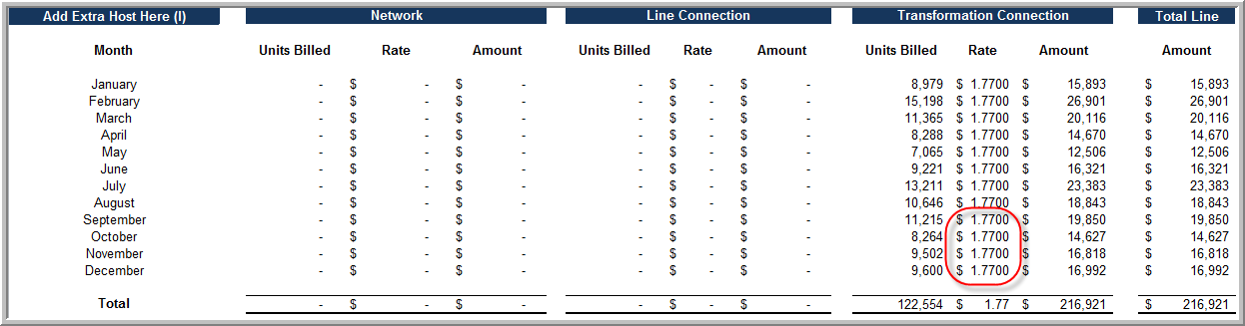

**Response**

1. On October 27, 2016, GPI forwarded to NPEI a copy of the Registration Approval Notice from the IESO confirming that the transfer of Metered Market Participant designation would be effective November 1, 2016.
2. In the 2017 IRM Rate Generator Model, NPEI has revised the Network and Line Connection rates for November and December 2016 on Sheet 13. RTSR – Current Wholesale, and also updated Sheet 11 RTSR – UTRs & Sub-Tx for 2017, to reflect GPI’s approved RTSRs. The demand relating to NPEI’s utilization of the Niagara West station was previously included in the IESO section of Sheet 12. RTSR – Historical Wholesale. In order to apply the approved GPI rates, NPEI has removed the Niagara West demand from the IESO section, and included it in the GPI – Niagara West section.
3. NPEI has updated Sheet 13.RTSR – Current Wholesale of the 2017 IRM Rate Generator Model to reflect the effective date of GPI’s 2016 rates, by removing the $1.77 / kW rate for September – December 2016 under the Transformation Connection section.

OEB staff: NPEI requested a follow-up call (November 4, 2016).

**Interrogatory #3**

**Ref: Tab “4. 2011-14 LRAM” of the LRAMVA work form**

Please provide documentation (preferably in excel format) of the IESO final verified savings adjustments for the 2011 to 2013 period in support of the LRAMVA claim.

**Response**

NPEI is submitting the 2011 – 2014 Final Results Report, as provided by the IESO, in Excel format. Please see the file ‘2011-2014 Final Results Report_Niagara Peninsula Energy Inc..xlsx’.

OEB Staff: No further question.

**Interrogatory #4**

**Ref: Tab “5. 2015 LRAM” of the LRAMVA work form**

Please confirm the year that final actual data was available for the 2015 CDM manual adjustment made as part of Niagara Peninsula’s 2015 COS. In the 2015 LRAM work form, Niagara Peninsula’s 2015 lost revenue claims include the persisting revenues from 2014 into 2015, but explicitly excluded any past savings from 2011 to 2013 into 2015 as those savings were embedded in the 2015 load forecast. It appears as though actual data up to and including 2013 was the best available information.

**Response**

The 2015 CDM manual adjustment that was made as part of NPEI’s 2015 COS Application included 2015 results, and persistence of 2014 results into 2015. The Final Verified results for 2014 were available from the IESO in September 2015. The Final Verified results for 2015 were available from the IESO in July 2016.

NPEI confirms that, at the time of completing the 2015 Load Forecast, actual data up to and including 2013 was the best information available.

OEB Staff: No further question.