Ontario Energy Board
Commission de l’énergie de l’Ontario

OEB STAFF summary of community MEETING
Eb-2016-0166

rENFREW HYDRO INC.
Application for 2017 Rates

November 24, 2016

TABLE OF CONTENTS
1 INTRODUCTION 2
2 the PROCESS 3
3 Summary of the Meeting 4
SCHEDULE A 5
SCHEDULE B 13

INTRODUCTION
Renfrew Hydro Inc. (Renfrew Hydro) filed a cost of service application with the Ontario Energy Board (OEB) on August 22, 2016 seeking approval for changes to the rates that Renfrew Hydro charges for electricity distribution, to be effective January 1, 2017.
A Notice of Hearing was issued on September 21, 2016.
Further to the Notice of Hearing, the OEB hosted one community meeting on October 6, 2016 in Renfrew, Ontario regarding Renfrew Hydro’s 2017 application.
This is an OEB staff report summarizing the outcomes of this community meeting. This report will be placed on the public record of the OEB hearing of this application along with copies of any written presentations made at the meeting. This report includes a summary of comments, questions and concerns raised during the community meeting by customers who attended the meeting. This summary is intended to capture the range of perspectives that were shared, rather than to provide a verbatim transcript of the meeting.
Customers are also able to submit individual written letters of comment with the OEB, either during a community meeting or any other time during the course of the OEB’s review of an application. The OEB places written letters of comment on the public record of the specific proceeding. All comments must be submitted to the OEB before the decision-makers in that case begin to consider their decision on the application. In making its decision, the OEB considers everything on the public record, including all comments when determining whether to grant the requests made by Renfrew Hydro in this application.

the PROCESS
The OEB convenes community meetings in the service territories of local distribution companies that have applied to the OEB to change their rates through a cost of service proceeding.
Community meetings are part of the OEB’s process of reviewing a rate application. The OEB has established a Consumer Engagement Framework to ensure that the perspectives of customers served by rate-regulated entities are considered in the OEB’s decision-making process.
Community meetings are hosted by OEB staff who inform customers about the role of the OEB in rate-setting and the processes involved. OEB representatives explain the various ways that customers can become involved in the adjudicative process. A copy of OEB staff’s presentation is attached to this report as Schedule A.
To assist customers in better understanding the application, the utility makes a presentation explaining its proposals for capital, operations and other spending that result in the requested rate change. A copy of Renfrew Hydro’s presentation is attached to this report as Schedule B.
Customers and municipal officials are also invited to make presentations outlining their thoughts on the utility’s proposals.
Following the presentations, customers have the opportunity to ask questions of the OEB and the utility about the application and the regulatory process. The issues raised by customers in the community meetings are documented and used by OEB staff in reviewing the application, asking interrogatories and making submissions to the OEB panel hearing and deciding the application. Any verbal comments provided to OEB staff at the community meeting are summarized in this report with no attribution.
In addition to providing verbal comments to OEB staff, customers attending the meetings may express their concerns directly to the OEB by providing individual comments (with attribution) through an online form on the computers provided or by filling in a hard copy comment form, which is then submitted to the OEB by OEB staff.

Summary of the Meeting
The Renfrew meeting was held at the Days Inn and Conference Center in Renfrew, Ontario on October 6, 2016 from 6:30 p.m. to 8:00 p.m. Approximately 15 customers attended the meeting to hear presentations from OEB staff and Renfrew Hydro. Prior to the presentations, OEB staff and Renfrew Hydro staff were available to informally talk to attendees and answer questions. OEB and Renfrew Hydro representatives responded to questions from attendees during and following the presentations.
The following OEB staff and Renfrew Hydro representatives attended the meeting:
OEB Staff
Theodore Antonopoulos, Director - Rates
Maureen Helt, Legal Counsel
Donald Lau, Project Advisor – Rates, Major Applications
Sylvia Kovesfalvi, Manager - Stakeholder Relations
Andrew Bodrug, Senior Stakeholder Relations Advisor

Renfrew Hydro
Bill Nippard, CEO
Cindy Marshall, Secretary/Treasurer

The OEB and Renfrew Hydro presented at the meeting. There were no customer presentations at the meeting.

Meeting participants had questions related to why Renfrew Hydro's costs are increasing and how the additional revenues will be spent as noted below. There were also general questions around government initiatives such as the 8% tax reduction, the methodology for calculating LEAP threshold criteria, statistics on energy savings coupons redeemed, whether there will be relief from bill increases in the future, and the importance of human interaction when it comes to customer service.

Specific Concerns Raised
- Justification for requested capital and maintenance increases
- Status of distribution projects that seem to have dragged on for an extended period of time, specifically the Argyl St line construction project
- Labour-related inquiries, such as skills, salary increases, the existence of management bonus incentives, and efficiencies
- Details on smart meter costs, maintenance/replacement strategy, and operation details
- The strategy for the forestry program efficiency and other specific projects, including project timing and resource sharing
- How Renfrew Hydro's overall costs compare to other LDC's
- Explanation of increases to costs moving from bi-monthly to monthly billing
- Explanation of the bill line items such as delivery and electricity
- Concerns that continued bill increases will lead to increase in bad debt resulting in further bill increases
- Comment on community engagement participation levels for any Renfrew community meetings by both the company and the OEB

SCHEDULE A

Ontario Energy Board Presentation
Renfrew hydro inc.
EB-2016-0166
October 6, 2016

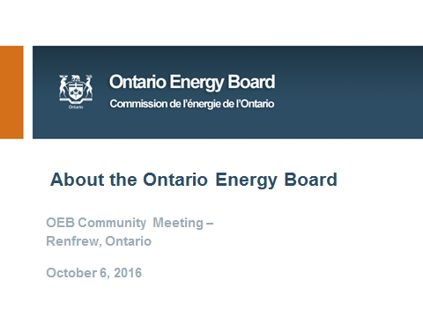

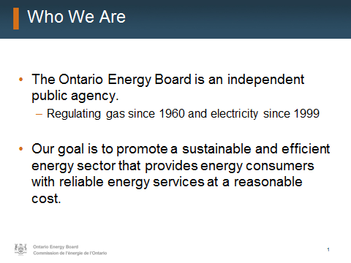

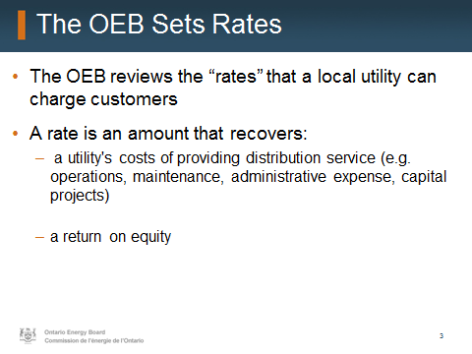

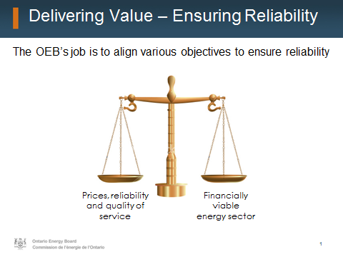

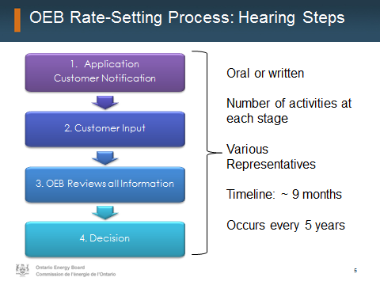

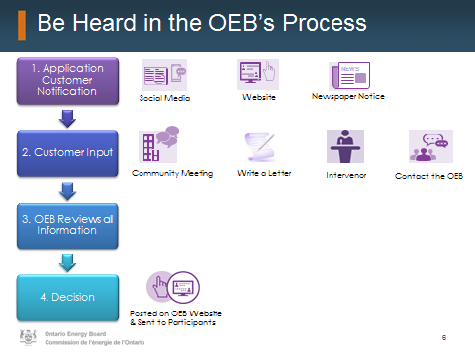
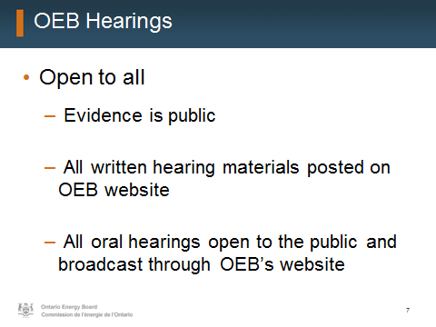

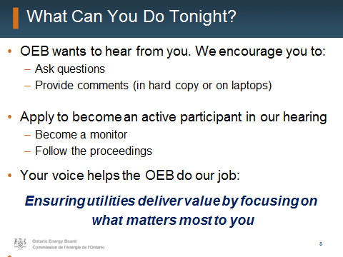
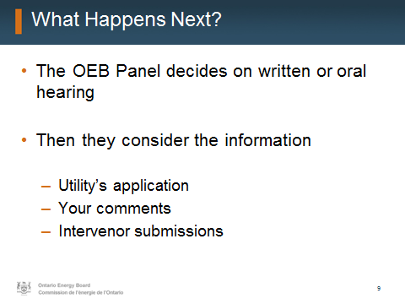.

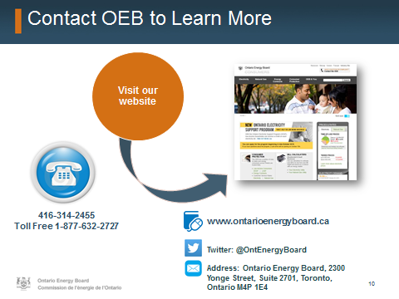
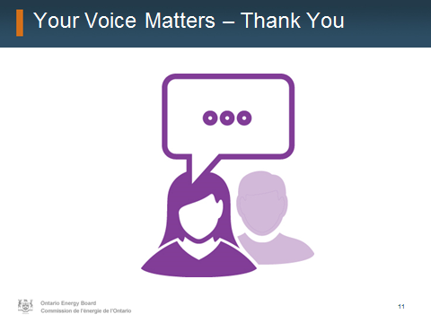

SCHEDULE B
Renfrew Hydro Presentation
Renfrew Hydro Inc.
EB-2016-0166
october 6, 2016

