Wasaga Distribution Inc.
EB-2016-0108
November 21, 2016
Question #1
Ref: IRM Model – tab 3 Continuity Schedule: OEB-approved disposition balances in 2016
- On the continuity schedule of the 2017 IRM model, Wasaga Distribution reported $1,879 in account 1550 OEB-approved interest disposition in 2016. This amount does not match the total interest of $2,295 to be disposed in account 1550 in Wasaga Distribution’s 2016 CoS EDDVA model. Please confirm the correct interest disposition amount for this account. OEB staff will update the model accordingly.

WDI Response – Agreed

- It’s also noted that, as per the EDDVAR model in Wasaga Distribution’s 2016 CoS application, there were disposition balances in accounts 1595(2011), 1595(2012) and 1595(2014) included in the total 2016 group 1 disposition. These balances are not reported on the continuity schedule of the 2017 IRM model. Please provide explanation for the discrepancies. OR please provide the correct account balances that should be reported on the continuity schedule and OEB staff will update the model accordingly.

WDI Response – There were balances in accounts 1595(2011), 1595(2012) and 1595(2014), however, as seen on Tab 5 of the EDDVAR Cost of Service Settlement Document, none of these balances were included for request to be disposed of as the Allocator was set to zero.

2017 IRM model – continuity schedule
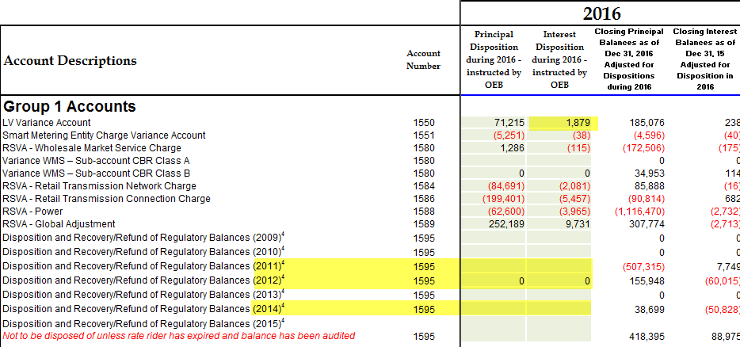

2016 CoS EDDVAR model – continuity schedule
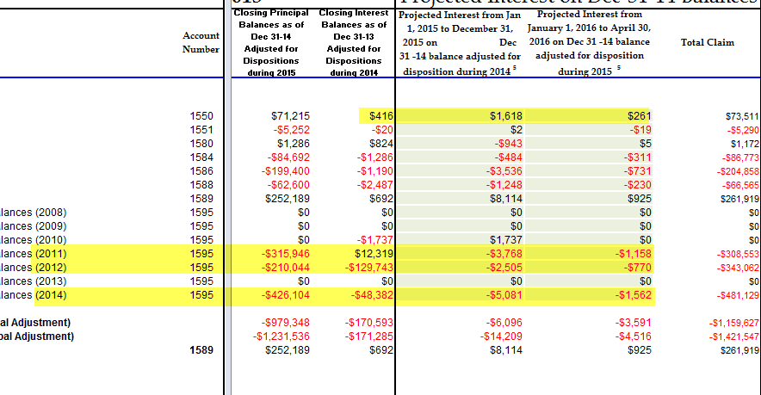

Question #2
Ref: IRM Model – tab 3 Continuity Schedule: RRR 2.1.7 – account 1580 Sub-account CBR Class B
It’s noted that Wasaga Distribution filed a zero balance in RRR 2.1.7 in account 1580 CBR Class B. OEB staff understand that the balance filed in RRR 2.1.7 under control account 1580 includes the amount in sub-account CBR Class B. However, the 2015 year-end balance in sub-account CBR Class B should still be filed in this sub-account in RRR. (The variance in cell BT23 on the continuity schedule is expected due to the difference in filing requirements between RRR and continuity schedule.)
- Please revise the RRR filing accordingly and notify OEB staff when the revision is processed. (No action is required on the IRM model.)

WDI Response – The RRR revision request has been made and the changes have been made by WDI in the RRR 2.1.7 balances for Account 1580 CBR Class B.
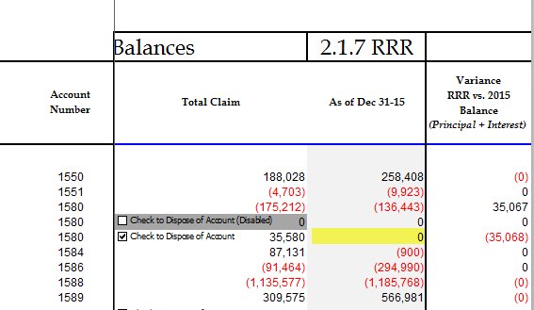

Question #3
Ref: IRM Model – tab 3 Continuity Schedule: variances in account 1595 (2010), 1595 (2011) and 1595 (2012)
As shown in the screenshot below, there’re variance amounts between RRR and 2015 year-end balances on the continuity schedule in account 1595 (2010), 1595 (2011) and 1595 (2012). Please review and provide explanations for these variances.
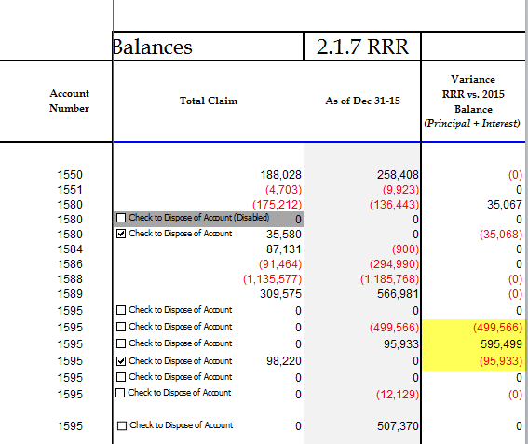

WDI Response - The balances for these accounts were inadvertently entered on the wrong lines on Tab 3. WDI has received the IRM model back from the OEB and made the appropriate changes on Lines 30, 31 and 32 which now agrees with the RRR 2015 year end balances. The amount now asked for disposition is the Account 1595 (2011) balance. WDI is also resubmitting this revised model through the RESS portal.

Question #4
Ref: balances in account 1588 and account 1589
Wasaga Distribution has a total GA claim of $309,575 resulting a rate rider of $0.0153/kWh. This results in a charge of $11.48 for a typical Non-RPP customer at 750kWh. OEB staff also notes that Wasaga Distribution had a large credit Transaction balance of $1,116,470 in account 1588 in 2015.
- Please explain the reasoning for the large total GA claim in the 2017 application.
- Please explain the reasoning for the large credit transaction balance of $1,116,470 in account 1588 Power in 2015.
WDI Response (a) & (b) – WDI has experienced a large credit balance in Account 1588 (Power) and an increasingly large debit balance in Account 1589 (GA) for several years. As WDI has an 85% residential population and the TOU rates continue to increase compared to the Weighted Average Price – WDI largely residential class will continue to see this difference being returned to them in as a Rate Rider. The same holds true for the GA – as the GA rate continues to climb and our Residential non-RPP, GS<50, GS>50 and Street Light profile is relatively small – this debit needs to be recovered from this population.

Question #5
Ref: IRM Model – tab 12, 13, 14 RTSR: Line Connection Charge
Please confirm if Wasaga Distribution only receive two rates from Hydro One Networks Inc.: 1) Retail Transmission - Network and 2) Retail Transmission – Transformation Connection. The Line Connection rate is not applicable. If this is true, OEB staff will need to update the model tab 12 to remove the units entered under Line Connection, so that the Line Connection $ amounts will not be calculated on tab 13 and tab 14.
WDI Response - Confirmed

Question #6
Ref: IRM Model – tab 18 Additional Rates: CBR rate rider
As noted on tab 3 continuity schedule (in the blue textbox), if a distributor has only Class B customers, the balance in sub-account 1580 CBR Class B will be allocated and disposed with the control account 1580. If Wasaga Distribution has only Class B customers, the balance in account 1580 sub-account CBR Class B, $35,580 has been added to the control account 1580 balance of ($175,212) when allocating account balance to each class (see screenshot below of tab 5). Therefore, Wasaga Distribution should not calculate a separate rate rider outside the model to dispose of sub-account CBR Class B. It has been allocated and disposed with the control account 1580 in the group 1 DVA disposition. The CBR rate rider should be removed from tab 18.
- Please confirm Wasaga Distribution has no Class A customers, and in 2015, Wasaga Distribution had no customers moved between Class A and Class B.

WDI Response – WDI has no Class A customers and WDI had had no customers move between Class A and Class B.

- Please review and confirm the above description of disposition of sub-account 1580 CBR Class B. OEB staff will update the model to remove the CBR rate rider on tab 18.
WDI Response - Confirmed
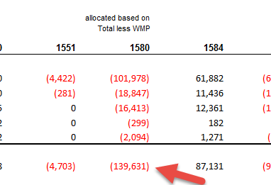

Question #7
Ref: IRM Model – tab 20 Billing Determinant for Unmetered Classes
Wasaga Distribution’s USL and Street Lighting classes are billed based on the number of connections. In Column N of tab 20 Bill Impacts, the number of connections of a typical customer in these two classes should be entered. Please provide the two numbers of connections for USL and Street Lighting classes. OEB staff will update the model.
WDI Response – WDI has updated the revised IRM model that will be submitted through the portal with the appropriate numbers on Tab 20. The USL number is “1” and the Street Light number is “2,899.”
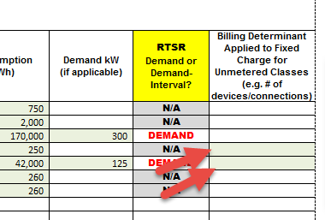

Question #8
Ref: Tab “2. CDM Allocation” of LRAMVA Work Form
EB-2011-0103, Wasaga Responses to Interrogatories – VECC #18
Tab “5. 2015 LRAM” of LRAMVA Work Form
Pre-amble:
Based on Wasaga’s interrogatory responses to VECC (#18) in the 2012 cost of service application (EB-2011-0103), Wasaga confirmed that the CDM adjustment of 802,000 kWh to the load forecast was to account for estimated 2012 CDM savings. This is shown in Tab “2. CDM Allocation” of Wasaga’s LRAMVA workform.
In Tab “5. 2015 LRAM” of LRAMVA Work Form, the persistence of 2011 CDM savings are claimed into future years, although it appears that the 2011 CDM savings persistence were captured in the 2012 load forecast.
Questions:
- Please indicate what year of actual data was used to develop Wasaga’s load forecast as part of its 2012 cost of service proceeding.
- In the event that 2011 actual data was used to develop the load forecast, please discuss the appropriateness of claiming 2011 persisting CDM savings into 2015 as these savings would already be built into Wasaga’s rates through its load forecast.
- Please exclude all savings related to 2011 CDM programs from the LRAM claim and provide an updated LRAMVA workform.

WDI Response:
- Wasaga used 2011 actual data as part of its 2012 cost of service proceeding in developing Wasaga’s load forecast
- Due to the methodology used in Load Forecasting and adoption of the 2011-2014 CDM programs, starting in 2011 – particularly for residential CDM programs. WDI does not feel that the impact on CDM on the overall load was significant enough for the regression analysis to accurately identify the impact on CDM in 2011 and correctly predict what this impact would have had in 2012 and therefore it is WDI’s belief that CDM has had a larger impact on revenues beyond what has been asked. With respect to this issue, WDI would not dispute OEB staff position.
- Wasaga has removed 2011 CDM persistence savings from the LRAMVA model (2012-2015) and submitted a revised LRAMVA workform in response.

Updates to IRM Model made by OEB staff
- Tab 16: GDP-IPI
Consistent with the policy determinations set out in the Report of the Board on Rate Setting Parameters and Benchmarking under the Renewed Regulatory Framework for Ontario's Electricity Distributors (EB-2010-0379) (Issued November 21, 2013 and updated December 4, 2013), the OEB has calculated the value of the inflation factor for incentive rate setting under the Price Cap IR and Annual Index plans, for rate changes effective in 2017, to be 1.9%. OEB staff has updated the price escalator on tab 16 of Wasaga Distribution’s IRM model.

Thank you

- Tab 20: save additional rate classes
OEB staff has fixed the IRM model to save the additional rate classes on tab 20. “Residential Service Classification” has been saved in row 35 and 36.
Thank you

Respectfully submitted.
November 24, 2016

