**Centre Wellington Hydro Ltd.**

**Follow up questions to Application Analysis (EB-2016-0062)**

**Tab 3 – Continuity Schedule – Interrogatory #2**

*The OEB asked: “The figures reported for approved disposition in 2013 are slightly different from those reported in the 2013 Decision and Rate Order, please verify your submission.”*

*CWH replied: “In 2009 the principle amount recorded included the carry charges, therefore the total is correct but the allocation between principle and interest is different.”*

Could you please explain further how the 2009 principle ties into this, looking at the model, the values in the decision do not balance.

*Response:*

*CWH has reviewed all the figures in the Continuity Schedule and revised them to reflect the correct OEB Decision and Rate orders for each year and balanced the amounts to our General Ledger. The overall figures were correct, but not in all cases did they reflect the OEB decision. Some of the amounts were incorrectly recorded in the wrong columns.*

*An updated copy of the “CWH EB-2016-0062_2017_IRM_RateGen_Model_Revised 20170201” has been included with this submission.*

*CWH has made the decision that the Group 1 Deferral Variance will not be disposed of during the 2017 IRM model but will be included in the values for the 2018 Cost of Service application.*

*With regards to the disposal of the LRAMVA revised amount of $73,766 for the CDM period of 2011-2014, please see CWH’s response in question number 2 below.*

**Manager’s Summary – 8. Deferral and Variance Accounts**

*The OEB asked: “OEB staff notes that Centre Wellington wishes to dispose of its deferral and variance account over the period of one year. However, they are below the agreed threshold and do not provide justification or report what the rate riders would be. Please provide a justification and amend the application to include the proposed rate riders.”*

*CWH replied: “CWH agrees that the deferral and variance of Group 1 accounts are under the agreed threshold and is willing to postpone the disposal of the balance of Group 1 until its 2018 Cost of Service application.*

*However, CWH would like to proceed with the disposal of the LRAMVA amount of $82,489.55. This amount is for the CDM period of 2011 to 2014 and the amounts has been adjusted to agree with OEB process as established in the review.*

*CWH originally applied for disposition of the LRAMVA amount in the 2016 IRM (EB-2015-0059), however, the OEB Board requested that the disposal be deferred until the OEB had the opportunity to review its LRAMVA policy.”*

If CWH would like to dispose, please provide a request and justification. Referring to filling requirements (pg 10-11 and Appendix B pg 26) could be helpful to this end.

*Response to the Disposition of Group 1 balances:*

*Given CHW’s responses above, the utility is in full compliance with the Chapter 3 of the MFR which state that “Group 1 audited account balances will be reviewed, and disposed if the pre-set disposition threshold of $0.001 per kWh (debit or credit) is exceeded”. The utility’s total balance for Group 1 accounts does not meet the threshold” therefore, as explained above, “CHW is willing to postpone the disposal of the balance of Group 1 until its 2018 Cost of Service application.”*

*Response to the Disposition of LRAMVA balances:*

*With respect to account 1568 LRAMVA, the utility has also complied with Section 3.2.6.1 of Chapter 3 of the MFR which state; A Distributors may apply for the disposition of the balance in the LRAMVA on an annual basis, as part of their IRM rate applications, if the balance is deemed significant by the applicant.”. CWH is of the view that a disposition of $73K is significant enough for the utility to seek disposal during this proceeding.*

**LRAMVA**

1. In the LRAMVA workform (Tab 2), it appears that Centre Wellington is using the CDM adjustment (986,133 kWh) as the CDM savings forecast in the LRAMVA calculation.  However, in CWH’s IRRs to “3-Staff-51s” in the 2013 COS proceeding (EB-2012-0113),  2,288,799 kWh was determined to be the annualized impact used for the LRAMVA calculation.

Staff summarized findings, as follows:

Tab 2 of the LRAMVA Workform

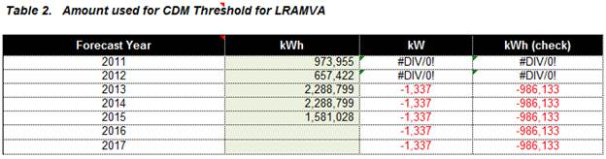

CWH Response to “3-Staff-51s,  c) ” in 2013 COS – Reference: CWH_IR Response_Combined Suppl_20130308 (1).PDF

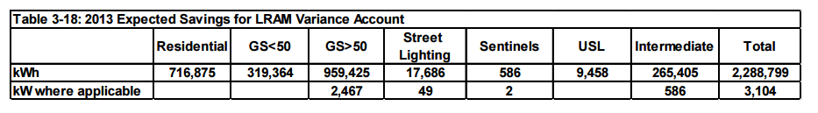

Tab 2 Rate Allocation in the LRAMVA Workform

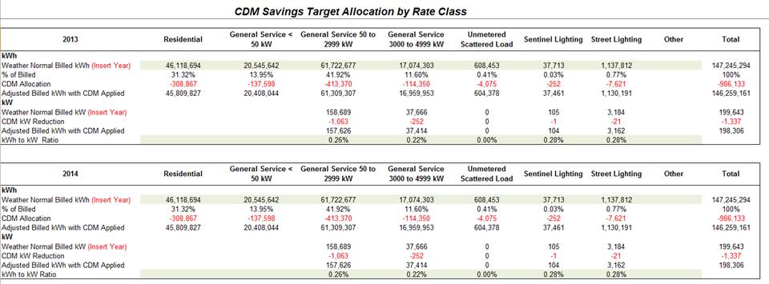

Please confirm that Centre Wellington should be using the LRAMVA threshold value of 2,288,799 kWh as shown above.  In the event Centre Wellington continues to believe it is appropriate to use the CDM adjustment amount of 986,133 kWh as the basis of the CDM forecast for the LRAMVA, please provide the supporting rationale for this approach as it differs from the OEB’s policy.

1. Please confirm the rate class allocation using 2,288,799 kWh as the LRAMVA forecast.

*Response:*

*The per class allocation as approved in CWH’s last Cost of Service is shown in the question above and replicated below.*



1. Please re-file the LRAMVA workform, with the changes noted above

*Response:*

*Please find attached a revised LRAMVA WorkForm.*