**EnWin Utilities Ltd.**

**EB-2016-0067**

**December 14, 2016**

**Question #1**

**Ref: IRM Model – tab 4 Billing Determinant for Account 1595 (1595 Recovery Proportion)**

On tab 4 of the IRM model, EnWin Utilities provided the recovery proportion % numbers by rate class for account 1595 (2010), 1595 (2011), 1595 (2012) and 1595 (2014). OEB staff has replicated this data into a separate excel table (as shown below) to display the full decimal places entered.

1. It’s noted that, for each rate class, the proportion number entered has not been changed among the four years. Please confirm and explain why the allocation of account 1595 has not been changed during 2010, 2011, 2012 and 2014.
2. It’s also noted that the proportion numbers entered for Sentinel Lighting and Street Lighting classes are all negative. In case a rate class has no allocation of any 1595 account balance, distributor should enter 0% (or leave it blank) as the recovery proportion. Please explain why the allocation proportions of these two classes are negative.

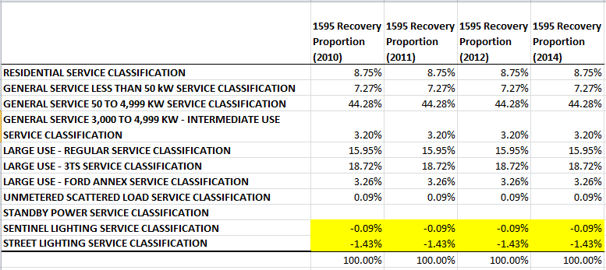

**Question #2**

**Ref: IRM Model – tab 6, 6a Global Adjustment; Manager’s Summary – page 8, 9 Account 1589 Global Adjustment**

1. It’s stated in the Manager’s Summary that EnWin Utilities had two customers moved from Class B to Class A as of July 1, 2015. On tab 6 of the IRM model, Class A consumption was reported under three rate class (in column E). Please indicate the total number of Class A customers EnWin Utilities had in 2015 (including both full-year and half-year Class A customers in 2015).
2. Please confirm whether or not EnWin Utilities had any customers moved from Class **A** to Class **B** in 2014 and 2015 (not in 2016).
3. Please provide the consumption data (in the format similar to the table below) for EVERY Class A customer in the year of **2014 and 2015** (including Class A customers for the whole period of the two years, or for part of the two years).



1. For the Large Use – Regular customers that moved from Class B to Class A as of July 1, 2015 and opted back to Class B as of July 1, 2016, EnWin Utilities noted in the Manager’s Summary that this customer will receive the Class B GA rate rider as calculated on tab 6. OEB staff noted that this customer only contributed in the first half year of 2015 to the Class B consumption. Applying the regular Class B GA rate rider to this customer may cause over-payment to him/her.

Also, in the Tariffs and Rate Orders that the OEB issued on December 8, 2016 (for the January 1, 2017 effective date applications), the Global Adjustment rate rider has now been defined as “not applicable to WMP and customers that transitioned between Class A and Class B in the period of last Global Adjustment disposition to 2015. These transition customers are to be charged or refunded their share of the variance disposed through customer specific billing adjustments. This rate rider is to be consistently applied in accordance with a customer’s Class A or Class B classification as at December 31, 2015 and the above noted exception for 2015 transition customers, for the entire period to the sunset date of the rate rider.”

Therefore, has EnWin Utilities considered billing this one Class B customer directly in a one-time settlement (similar as for the 3,000 to 4,999 new Class A customer)?

1. For the GA amounts calculated on tab 6a for customers moved between Class B and Class A, please indicate whether EnWin Utilities proposes to settle with customers with one-time payment or through 12 equal monthly payments.

**Question #3**

**Ref: Manager’s Summary – page 6 to 8: Account 1580 Sub-account CBR Class B**

As indicated in the Manager’s Summary, the balance in account 1580 sub-account CBR Class B is for the period Apr 1, 2015 to Dec 31, 2015. The calculation of CBR Class B rate rider provided on page 7 and 8 allocated the full amount of the account balance, $509,131, to all the current Class B customers. OEB staff understands that EnWin Utilities had two customers moved from Class B to Class A as of July 1, 2015. Therefore, these customers contributed for three months for the CBR Class B balance.

1. Please indicate how EnWin Utilities proposes to determine and settle the CBR Class B amount to the customers moved from Class B to Class A.
2. Similar as the GA rate rider, in the Tariffs and Rate Orders that the OEB issued on December 8, 2016 (for the January 1, 2017 effective date applications), the CBR Class B rate rider has now been defined as “not applicable to wholesale market participants (WMP) and customers that transitioned between Class A and Class B in 2015. These transition customers are to be charged or refunded their share of the variance disposed through customer specific billing adjustments. This rate rider is to be consistently applied in accordance with a customer’s Class A or Class B classification as at December 31, 2015 and the above noted exception for 2015 transition customers, for the entire period to the sunset date of the rate rider.”

Has EnWin Utilities considered billing these customers directly in a one-time settlement (similar as the GA settlement)?

**Question #4**

**Ref: IRM Model – tab 20 Bill Impacts: Table 1**

1. Please indicate what the two additional rate classes highlighted in yellow in the screenshot below should be. OEB staff will enter and save them in the IRM model accordingly.

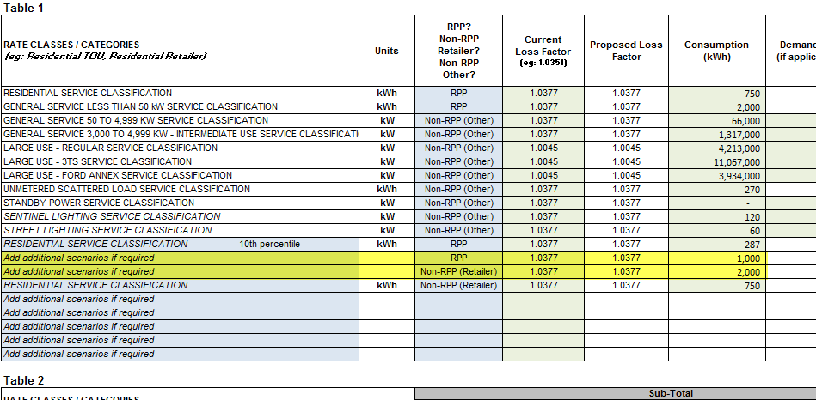

1. The monthly service charge for EnWin Utilities’ USL, Street Lighting and Sentinel classes are applied on a per connection basis. Please provide the number of connections of a typical customer in each of these classes. OEB staff will update and save the IRM model accordingly.

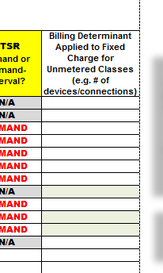

**Updates to IRM Model made by OEB staff**

1. **Tab 16: GDP-IPI**

Consistent with the policy determinations set out in the Report of the Board on Rate Setting Parameters and Benchmarking under the Renewed Regulatory Framework for Ontario's Electricity Distributors (EB-2010-0379) (Issued November 21, 2013 and updated December 4, 2013), the OEB has calculated the value of the inflation factor for incentive rate setting under the Price Cap IR and Annual Index plans, for rate changes effective in 2017, to be 1.9%. OEB staff has updated the price escalator on tab 16 of the IRM model.

1. **USL, Sentinel Lighting and Street Lighting – “per connection” rates and charges**

For certain rates and charges that are billed on per connection basis under the above three classes, OEB staff will adjust the unit and decimal places while preparing the 2017 tariff for the Draft and Final Decision and Rate Order.