Hydro 2000 Inc.
EB-2016-0078
January 3, 2017
Question #1
Ref: IRM Model – tab 1 Information Sheet
As per the Decision and Rate Order issued for Hydro 2000’s 2016 rates application, the balances of Group 1 accounts were disposed in the 2016 rate year. The year entered in row 30 of tab 1 (when Group 1 accounts were last cleared) should be 2016, not 2015.
- Please confirm the above and OEB staff will update the model.
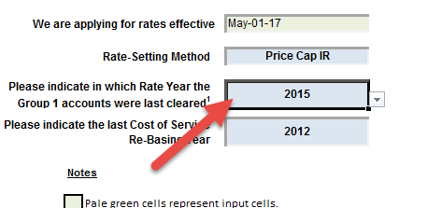
Hydro 2000 Response: Board Staff is correct in that the last Rate Year Group 1 was disposed of was in 2016.
Question #2
Ref: IRM Model – tab 3 Continuity Schedule:
- Account 1595 (2009)
It’s noted that on tab 3 of the IRM model, the account balances of Account 1595 (2008) might have been erroneously entered in row 30 for Account 1595 (2009).

Please review and confirm the balances for Account 1595 (2009). OEB staff will update the model accordingly.

Hydro 2000 Response: (Response provided by Deloitte auditor)
All the amounts on row 30 1595 (2009) are for 2008. There is no row in the template for 2008. All those amounts should be on a row for 2008 and the row for 2009 would be blank. There were no amounts approved for that year.

- Account 1595 (2012) Adjustments
Please provide explanations to the Adjustment amounts of $33,308 and $639 entered in Account 1595 (2012) in 2015.
Hydro 2000 Response: (Response provided by Deloitte auditor)
The adjustments were amounts for stranded meters and smart meters which had to be transferred to revenues.

- Account 1595 (2012) Adjustments
Please provide explanations to the Adjustment amounts of $33,308 and $639 entered in Account 1595 (2012) in 2015.
Hydro 2000 Response: (Response provided by Deloitte auditor)
see Hydro 2000’s response to #2c

- Interest Disposition in 2016 – Account 1595
The OEB staff cannot reconcile the 2016 interest disposition amounts entered in Account 1595 (2010), 1595 (2011) and 1595 (2012) with Hydro 2000’s 2016 Decision and the final 2016 IRM model.

Please provide explanations to the three numbers (as highlighted below).
Hydro 2000 Response: (Response provided by Deloitte auditor)
The 5 amounts of interest for account 1595 equals $88,735 which is the total which was approved for 1595.

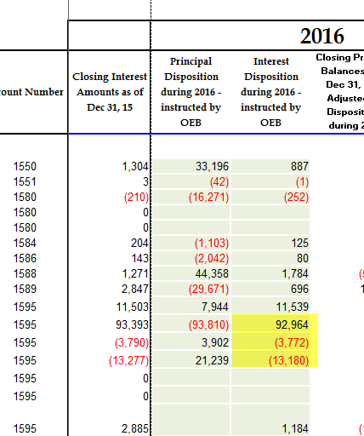

- Projected Interest
Please note that the projected interest amounts in column BQ and BR should be both based on December 31, 2015 Principal balances adjusted for 2016 disposition – column BO; column BQ is the interest projected for one year (BO*1.1%), and column BR is the interest projected for four months (BO*1.1%*4/12). In each column, the same calculation of interest should be applied to all the Group 1 accounts consistently.

Please review and adjust the calculations for projected interest in column BQ and BR.
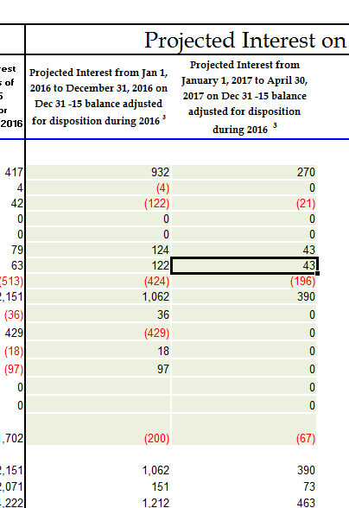

Hydro 2000 Response: (Response provided by Deloitte auditor)
The amounts approved for 2016 were effective on May 1. Therefore, formula used in column BQ = BG * 1.1% * 4/12 + BO * 1.1% * 8/12. Formula used in column BR = BO * 1.1% * 4/12. The only exceptions are for accounts 1595 (2009) to 1595 (2012). Since amounts were considered in the amounts approved on May 1, 2016, interest

Question #3
Ref: Class A customers
- Please confirm whether or not Hydro 2000 had any Class A customers in 2015.
Hydro 2000 Response: Hydro 2000 did not have any Class A Customers 2015.

- Please confirm whether or not Hydro 2000 had any customers transitioned between Class A and Class B in 2015.

Hydro 2000 Response: No. Hydro 2000 has never had any Class A Customers

Question #4
Ref: IRM Model – tab 3 Continuity Schedule: Account 1580 sub-account CBR Class B
It’s noted that on tab 3 of the IRM model, there’s a variance of ($22,189) in sub-account CBR Class B between 2015 year-end balance on the continuity schedule and RRR.
- Please confirm whether or not Hydro 2000 had a balance in sub-account CBR Class B in 2015.
Hydro 2000 Response: Hydro 2000 is a fully embedded utility and as such is invoiced for Power by Hydro One. Hydro 2000 confirms that in 2015, there was no CBR component built into WMSR in 2015. Hydro 2000 was only being charged WMS rate of $0.0044/ kWh. Therefore, for 2015, no amounts was recorded in the CBR sub-accounts.

- If the answer to a) is yes, please enter the balances in row 25 for CBR Class B, and make sure the balances in the control Account 1580 exclude any balances in sub-account CBR Class B.
Hydro 2000 Response: N/A

- If the answer to a) is no, please explain why.
Hydro 2000 Response: See response to a).

Question #5
Ref: IRM Model – tab 3, tab 6: GA Balances
OEB staff notes that Hydro 2000 has a total GA claim of $110,007 resulting in a rate rider of $0.0258/kWh. For a typical Non-RPP customer at 750kWh consumption level, the GA charge will be $19.35 per month. It’s also noted that Hydro 2000 had large balances in GA transactions in 2013, 2014 and 2015.
- Please explain the reasoning for the large GA transactions in previous years and large total GA claim in the 2017 application.
Hydro 2000 Response: Hydro 2000 is still investigating the reasons for the unusually large variances in historical years but the utility’s preliminary investigation shows that there would have been an error in the reconciliation back in 2014 but that the error has since then been rectified. The utility does not expect any issues going forward but as mentioned, the findings are still preliminary and the utility is still working with its auditors to find the exact explanation.

Question #6
Ref: IRM Model – tab 20: Billing Determinant for Unmetered Classes
In table 1 on tab 20, distributors need to enter the billing determinants for the unmetered classes (USL and Street Lighting) in column N. These values are missing in Hydro 2000’s IRM model for the Street Lighting and USL classes (N33 and N34).
- Please provide the numbers of connections of a typical customer in each of these two classes. OEB staff will update and save the model.
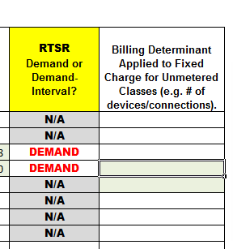
Hydro 2000 Response:

Updates to IRM Model made by OEB staff
- Tab 16: GDP-IPI
Consistent with the policy determinations set out in the Report of the OEB on Rate Setting Parameters and Benchmarking under the Renewed Regulatory Framework for Ontario's Electricity Distributors (EB-2010-0379) (Issued November 21, 2013 and updated December 4, 2013), the OEB has calculated the value of the inflation factor for incentive rate setting under the Price Cap IR and Annual Index plans, for rate changes effective in 2017, to be 1.9%. OEB staff has updated the price escalator on tab 16 of the IRM model.
Hydro 2000 Response: Hydro 2000 has no issues with Board Staff’s proposed updates.

