Hydro 2000 Inc. (EB-2016-0078)
OEB Staff Follow-up Questions
January 26, 2017
Question #2
Ref: IRM Model – tab 3 Continuity Schedule:

- Account 1595 (2012) Adjustments
Please provide explanations to the Adjustment amounts of $33,308 and $639 entered in Account 1595 (2012) in 2015.
Hydro 2000 Response: (Response provided by Deloitte auditor)
The adjustments were amounts for stranded meters and smart meters which had to be transferred to revenues.
OEB staff: please provide more details about the adjustments. Were the amounts approved in an OEB order?
Hydro 2000 Response: (Response provided by Deloitte auditor)
In its 2012 COS, Hydro 2000 was approved $31,633 for Smart Meters and $18,242 for Stranded Meters. Both Smart Meters and Stranded Meters were in capital assets. Revenues collected were recorded to account 1595. When Hydro 2000 did a detailed analysis of its 1595 accounts, they realized that those amounts were not being netted against the cost. Hydro 2000 therefore transferred those amounts collected to revenues.
- Interest Disposition in 2016 – Account 1595
The OEB staff cannot reconcile the 2016 interest disposition amounts entered in Account 1595 (2010), 1595 (2011) and 1595 (2012) with Hydro 2000’s 2016 Decision and the final 2016 IRM model. Please provide explanations to the three numbers (as highlighted below).
Hydro 2000 Response: (Response provided by Deloitte auditor)
The 5 amounts of interest for account 1595 equals $88,735 which is the total which was approved for 1595.
OEB staff: please explain why there’s interest disposition of $1,184 in account 1595 (2015) in 2016. As per the 2016 IRM rate generator model, there were account 1595 disposition amounts only in 1595 (2008), 1595 (2010), 1595(2011) and 1595 (2012).
Hydro 2000 Response: (Response provided by Deloitte auditor)
The $1,184 is the difference between the projected carrying charges and the actual carrying charges.

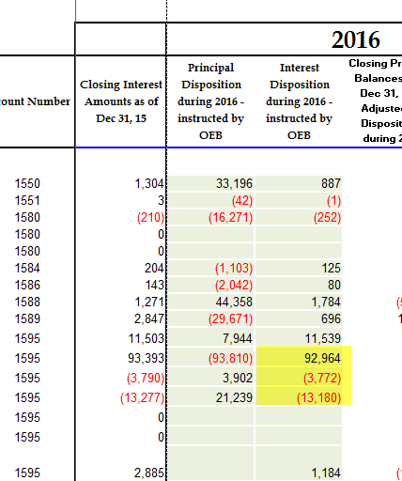

Question #4
Ref: IRM Model – tab 3 Continuity Schedule: Account 1580 sub-account CBR Class B
It’s noted that on tab 3 of the IRM model, there’s a variance of ($22,189) in sub-account CBR Class B between 2015 year-end balance on the continuity schedule and RRR.
- Please confirm whether or not Hydro 2000 had a balance in sub-account CBR Class B in 2015.
Hydro 2000 Response: Hydro 2000 is a fully embedded utility and as such is invoiced for Power by Hydro One. Hydro 2000 confirms that in 2015, there was no CBR component built into WMSR in 2015. Hydro 2000 was only being charged WMS rate of $0.0044/ kWh. Therefore, for 2015, no amounts was recorded in the CBR sub-accounts.
OEB staff: As per the above response, there was no CBR component built into WMSR in 2015 for Hydro 2000. Therefore, no balance should be recorded in sub-account 1580 CBR Class B. Please revise the RRR 2.1.7 filing accordingly, to remove the balance reported in sub-account 1580 CBR Class B. Please inform OEB staff once this revision has been processed.
Hydro 2000 Response: Hydro 2000 as filed a Revision Request to update its 2015 2.1.7. Once the revision is approved, the filing will be updated zero balances is the CBR sub accounts of 1580.

Question #5
Ref: IRM Model – tab 3, tab 6: GA Balances
OEB staff notes that Hydro 2000 has a total GA claim of $110,007 resulting in a rate rider of $0.0258/kWh. For a typical Non-RPP customer at 750kWh consumption level, the GA charge will be $19.35 per month. It’s also noted that Hydro 2000 had large balances in GA transactions in 2013, 2014 and 2015.
- Please explain the reasoning for the large GA transactions in previous years and large total GA claim in the 2017 application.
Hydro 2000 Response: Hydro 2000 is still investigating the reasons for the unusually large variances in historical years but the utility’s preliminary investigation shows that there would have been an error in the reconciliation back in 2014 but that the error has since then been rectified. The utility does not expect any issues going forward but as mentioned, the findings are still preliminary and the utility is still working with its auditors to find the exact explanation.
OEB staff: OEB staff expects to receive more info/explanation related to the GA and the GA analysis worksheet from Hydro 2000.
Hydro 2000 Response: Hydro 2000 has completed the GA Analysis Worksheet for 2015 which is being filed in conjunction with these responses. In populating the Worksheet, the utility found discrepancies between its reported balances and the results calculated in the Worksheet. As such, the utility is prepared to make any necessary adjustments if Board Staff deems it necessary to do so. The utility seeks accounting guidance in how these adjustments should be made.

Question #6
Ref: IRM Model – tab 20: Billing Determinant for Unmetered Classes
In table 1 on tab 20, distributors need to enter the billing determinants for the unmetered classes (USL and Street Lighting) in column N. These values are missing in Hydro 2000’s IRM model for the Street Lighting and USL classes (N33 and N34).
- Please provide the numbers of connections of a typical customer in each of these two classes. OEB staff will update and save the model.
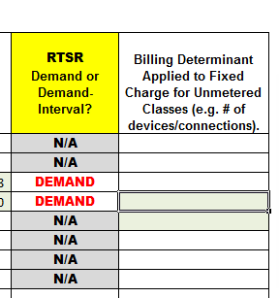
Hydro 2000 Response: 370 Streets lights and 4 USL
OEB staff: Please provide response.
Hydro 2000 Response: 370 Streets lights and 4 USL

