CONFIDENTIAL

March 1, 2017

Sent: via Email and Courier

Kirsten Walli
Board Secretary
Ontario Energy Board
P.O.Box 2319
2300 Yonge Street, 27th Floor
Toronto, ON M4P 1E4

Dear Ms. Walli:

Re: Sunwave Gas & Power Inc.
Application for a Gas Marketer Licence
OEB File Number EB-2017-0020
Application for an Electricity Retailer Licence
OEB File Number EB-2017-0021

As of March 1, 2017, the French version and the English versions of the notices, as directed by the Board in its February 16, 2017 letter to Sunwave, have been posted on Sunwave Gas & Power’s signup Website. The link can be found at https://signup.gosunwave.com. All other conditions in the letter have been met.

The links will be available shortly for the US website GoSunwave.com

If you have any questions or require anything further, please contact the undersigned. Thank you.
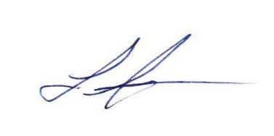

Laura Jurasek
Regulatory Compliance
Sunwave Gas & Power Inc.
Atria III, 2225 Sheppard Ave. E., Suite 1600
Toronto, Ontario M2J 5C2
Dir: +1 (416) 992-0700
Email: Ljurasek@gosunwave.com

