Essex Power Corporation

OEB Staff Questions

EB-2016-0069

**Essex Power Corporation**

**EB-2016-0069**

**Staff IR - 1**

1. Please confirm that Essex Power did not have any Class A customers during 2015.

It is confirmed that Essex Powerlines did not have any Class A customers during 2015.

1. IfEssex Power did have Class A customers in 2015 please check the box at the top of Tab 3 in the Rate Generator Model and adjust the Continuity Schedule for Principle and Interest in row 24 and 23 in Tab 3, and the RRR filing 2.1.7 for 2015.

Essex Powerlines did not have any Class A customers during 2015 and has appropriately not selected the box shown below within the rate generator model.

.

1. Did Essex Power have any customers that switched between Class A and Class B in 2015?

Essex Powerlines did not have any customers that were switched between Class A and Class B during 2015.

1. If yes, please check the box at the top of Tab 6 in the Rate Generator Model and complete Tab 6.a GA Allocation Class A also include customers that switched into Class B from Class A during 2015 if any.

Essex Powerlines did not have any customers that switched from Class A to Class B during 2015 and has appropriately not selected the box shown below within the rate generator model.

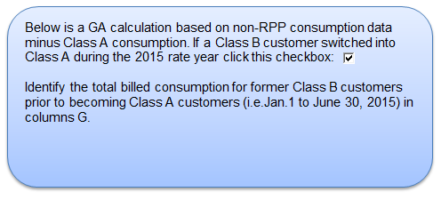

Staff IR – 2

1. The Variance WMS – Sub – account CBR Class B is reported as $0.00 in the continuity schedule in Row 25 of Tab 3 and RRR filing 2.1.7 for 2015. The OEB expects all distributors to report an amount for this account as the IESO bills all distributors for CBR Class B.

OEB staff notes that Essex Power is fully embedded in Hydro One. Please confirm Hydro One did not charge Essex Power CBR.

This is confirmed. Essex Powerlines was charged .0044 per adjusted kilowatt hour for wholesale market charges. As identified within the Accounting Guidance on Capacity Based Recovery, there was not a CBDR component included in this wholesale market rate.

1. If Hydro One did charge Essex Power for CBR, the amounts related to WMS – Sub – account CBR Class B should have been reported separately in the continuity schedule Row 25, the amount reported in the RSVA – Wholesale Market Service Charge should not include the CBR Class B amounts for principal and Interest in Row 23. Please update Essex Power’s continuity schedule and submit through RESS, if needed. RRR filing 2.1.7 should also be updated to reflect this correction if needed.

An adjustment to RRR filing 2.1.7 will not be required as Hydro One did not charge Essex Powerlines CBDR charges within 2015.

1. Please confirm Essex Power has followed the Accounting Guidance on Capacity Based Recovery released on July 25, 2016.

As identified within the manager’s summary under the deferral and variance account explanation, Essex Powerlines is presently finalizing an OEB audit. Based on the results of this audit, Essex Powerlines will make any necessary adjustments related to CBDR charges for Class B customers for 2015.

1. If Essex Power did have customers switch between Class A and Class B and was charged CBR in 2015 please prepare a calculation similar to that of the one in Tab 6.a to allocate the amount of WMS – CBR Class B to these customers.

This calculation will not be required as Essex Powerlines did not have any customers switch classes between Class A and Class B during 2015.