CONFIDENTIAL

May 8, 2017

Sent: via Email

Kirsten Walli
Board Secretary
Ontario Energy Board
P.O.Box 2319
2300 Yonge Street, 27th Floor
Toronto, ON M4P 1E4

Dear Ms. Walli:

Re: Reply to OEB Staff Submission - Sunwave Gas & Power Inc. - Applications for Gas Marketer & Electricity Retailer Licence EB-2017-0020/0021

It has recently come to our attention that the final flow date for low volume contracts with Sunwave Gas & Power are due to expire December 2019 and not May, 2019, which was originally stated in our submission. This was due to later flow dates than expected on a small amount of accounts.

Sunwave respectfully requests that the licences Sunwave is seeking be issued by the OEB with terms that expire December 31, 2019 and not June 1, 2019 as submitted by OEB staff.

If you have any questions or require anything further, please contact the undersigned.

Thank you.
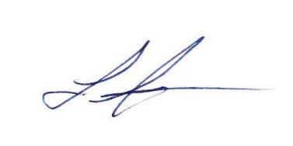

Laura Jurasek
Regulatory Compliance
Sunwave Gas & Power Inc.
Atria III, 2225 Sheppard Ave. E., Suite 1600
Toronto, Ontario M2J 5C2
Dir: +1 (416) 992-0700
Email: Ljurasek@gosunwave.com

